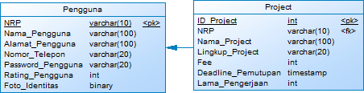

DROP DATABASE IF EXISTS `itsproject`;

CREATE DATABASE IF NOT EXISTS `itsproject`;

USE `itsproject`;

DROP TABLE IF EXISTS pengguna;

CREATE TABLE pengguna

(

NRP varchar2(10) NOT NULL,

Nama_Pengguna varchar2(100) DEFAULT NULL,

Alamat varchar2(100) DEFAULT NULL,

Nomor_Telepon varchar2(20) DEFAULT NULL,

Password_Pengguna varchar2(20) DEFAULT NULL,

Rating int,

Foto_identtas blob,

PRIMARY KEY NRP

);

DELETE FROM pengguna;

DROP TABLE IF EXISTS project;

CREATE TABLE project

(

ID_Project int NOT NULL auto increment,

NRP varchar2(10) DEFAULT NULL,

Nama_Project varchar(50) DEFAULT NULL,

Lingkup_Project varchar(100) DEFAULT NULL,

Fee int DEFAULT NULL,

Deadline_Penutupan timestamp DEFAULT NULL,

Lama_Pengerjaan int DEFAULT NULL,

PRIMARY KEY ID_Project,

FOREIGN KEY(NRP) REFERENCES pengguna(NRP) ON DELETE SET NULL ON UPDATE CASCADE,

);

DELETE FROM project;