Kategori fashion wanita

1. Atasan

Brand

Nevada

1. Nevada Women's Small Checkered Shirt - Biru

~~Rp 199.900~~Rp 99.900

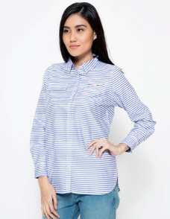

* Bahan katun
* Motif garis
* Detail kantong depan
* Lengan panjang
* Detail kerah
* Detail potongan samping

# 2. Nevada Cupcake Desserts Long Tee - Pink

~~Rp 129.900~~Rp 69.900



* Kerah bulat
* Lengan panjang
* Detail tipografi
* Cartoon print
* Regular fit
* Bahan katun
* Warna pink

Connexion

Adidas

Levi’s

1. Dress
2. Bawahan
3. Overall
4. Sepatu
5. Jeans
6. Baju tidur
7. Kacamata
8. Baju muslim
9. Pakaian dalam
10. Baju hamil
11. Sport