Footprinting with Kali Tools

NetworkWalks — Week 2 Cybersecurity Project

1. Introduction
As part of my Week 2 Cybersecurity training with NetworkWalks, I performed a practical footprinting exercise using several reconnaissance tools available in Kali Linux.
The purpose of the exercise was to understand how publicly available information about a target can be collected and analyzed during the reconnaissance phase of a security assessment.
The exercise covered domain registration information, web technologies, DNS information, HTTP response headers, Web Application Firewall detection, and DNS record enumeration.

2. Objectives
The objectives of this exercise were to:
- Understand the reconnaissance and footprinting phase of a security assessment.
- Gather publicly available information about authorized targets.
- Identify technologies used by a target web application.
- Resolve domains to their associated IP addresses.
- Examine HTTP response headers.
- Identify potential Web Application Firewall (WAF) technologies.
- Enumerate publicly accessible DNS records.
- Document reconnaissance findings in a structured manner.

3. Tools Used
Tool | Purpose
WHOIS | Domain registration and ownership information
WhatWeb | Web technology identification
NSLookup | DNS and domain-to-IP resolution
cURL | HTTP response/header analysis
WAFW00F | WAF detection
DNSRecon | DNS record enumeration
Kali Linux | Security testing environment

4. Target and Authorization
The reconnaissance activities were performed against targets for which I had obtained permission to conduct security reconnaissance.
The testing was conducted within the scope authorized for the exercise and was intended for cybersecurity training and learning purposes.
Target: networkswalks.com
Authorization: Permission was obtained from the appropriate target/network owner before reconnaissance activities were conducted.

5. Footprinting Activities

5.1 WHOIS Enumeration
WHOIS was used to obtain publicly available domain registration information.

Command
whois networkwalks.com

Information examined
- Registrar
- Domain creation date
- Domain expiration date
- Domain status
- Name servers
- Public registration information

Result
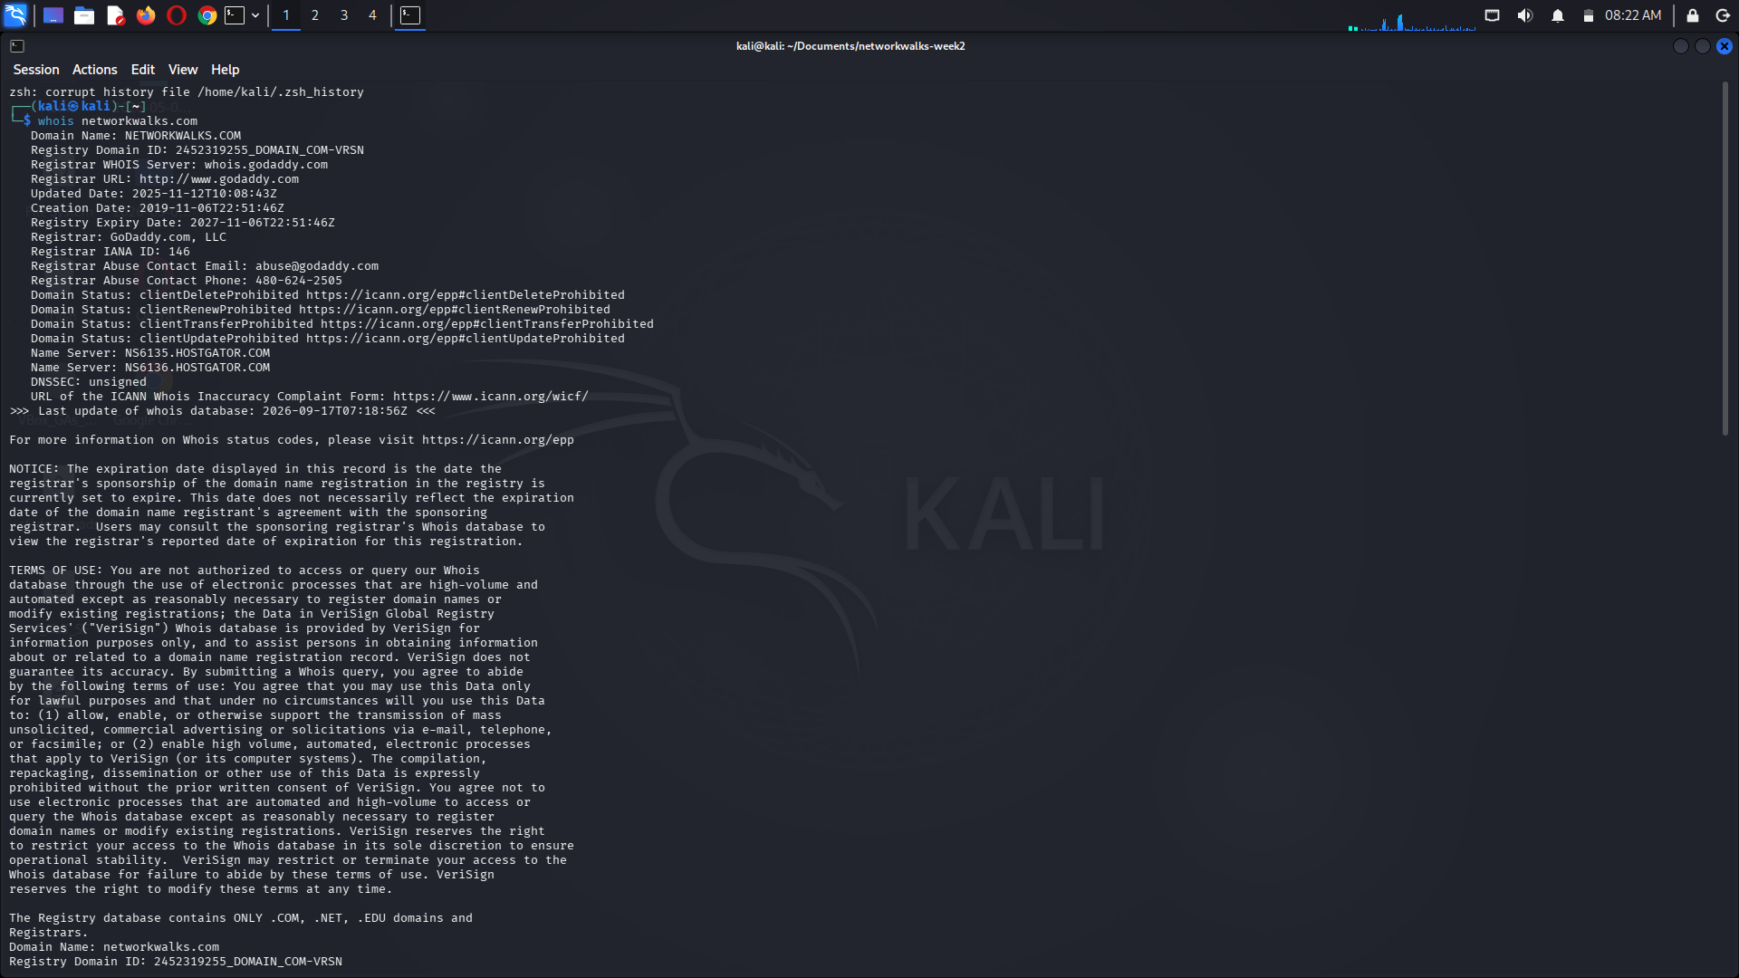

Observation
The WHOIS investigation provided information about the target's domain registration and associated infrastructure.

5.2 Web Technology Identification with WhatWeb
WhatWeb was used to identify technologies exposed by the target website.

Command
whatweb networkwalks.com

Result
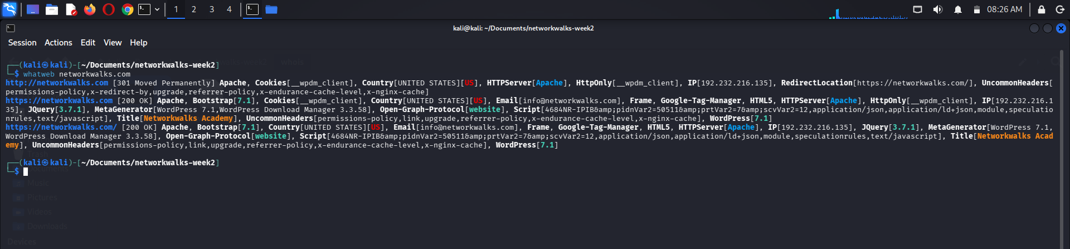

Observation
The results provided information about technologies and services that could be identified from the target's web application.
Examples of information that may be identified include:
- Web server technology
- JavaScript frameworks
- CMS platforms
- Web technologies
- Cookies
- HTTP headers
- Server-side technologies

5.3 DNS Enumeration with NSLookup
NSLookup was used to resolve the target domain and inspect DNS records.

Commands
nslookup networkwalks.com

Result
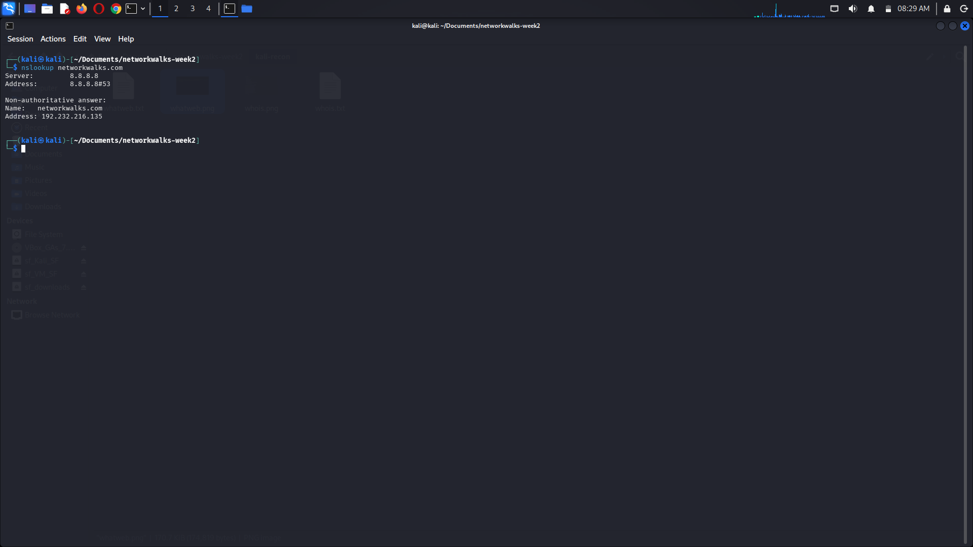

Observation
DNS enumeration provided information about the target's domain resolution and DNS infrastructure.

5.4 HTTP Header Analysis with cURL
cURL was used to inspect HTTP response headers from the target web server.

Command
curl -I https://networkwalks.com

Result
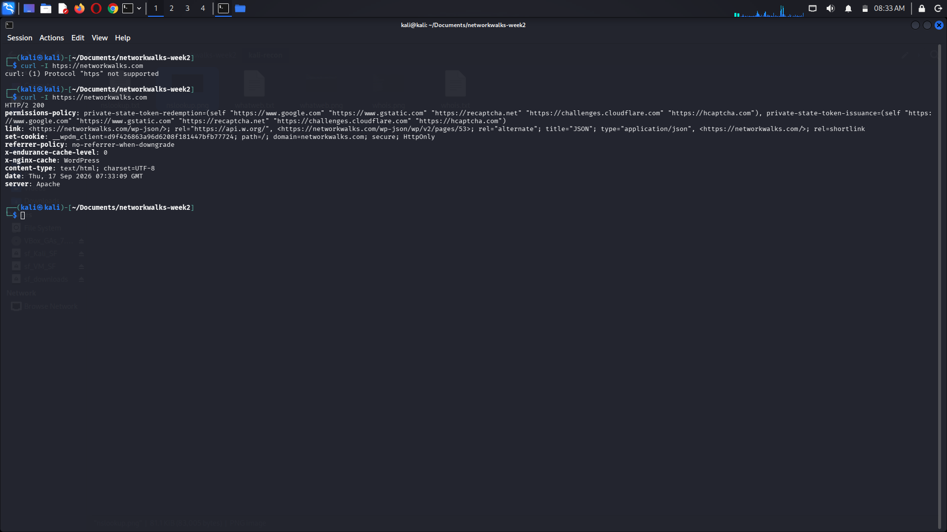

Information examined
- HTTP status code
- Server information
- Security headers
- Cache-related headers
- Redirect behavior
- Cookies and other response metadata

Observation
The HTTP headers provided additional information about how the target web application responds to HTTP requests.

5.5 WAF Detection with WAFW00F
WAFW00F was used to determine whether a Web Application Firewall could be identified.

Command
wafw00f https://networkwalks.com

Result
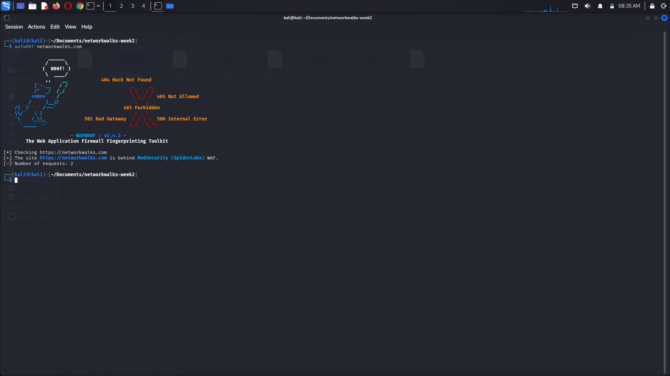

Observation
The result indicated:
WAF detected: YES
Identified WAF: ModSecurity (SpiderLabs) WAF
WAF detection results should be interpreted carefully because a WAF may be customized, hidden behind another service, or otherwise not identifiable by automated fingerprinting.

5.6 DNS Enumeration with DNSRecon
DNSRecon was used to perform additional DNS enumeration.

Command
dnsrecon -d networkwalks.com

Result
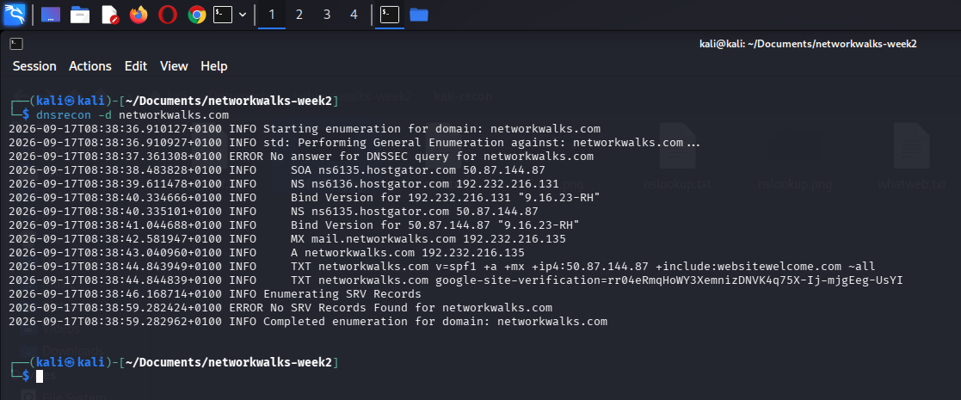

Observation
DNSRecon provided additional information about DNS records associated with the authorized target.
The findings were reviewed to understand the externally visible DNS infrastructure without attempting unauthorized access.

6. Evidence Collected
The following evidence was collected during the exercise:
01-kali-footprinting/
├── README.md
├── Module1-Report-Recon-with-Kali
├── docs/
├── whois.txt
├── whatweb.txt
├── nslookup.txt
├── curl-headers.txt
├── wafw00f.txt
├── dnsrecon.txt
├── screenshots/
├── whois.png
├── whatweb.png
├── nslookup.png
├── curl-headers.png
├── wafw00f.png
└── dnsrecon.png
The raw output files contain the command results, while the screenshots provide visual evidence of the individual activities.

7. Key Learning Outcomes
Through this exercise, I gained practical experience with:
- Passive reconnaissance
- Domain enumeration
- DNS reconnaissance
- Web technology fingerprinting
- HTTP header analysis
- WAF identification
- Security information gathering
- Reconnaissance documentation
The exercise demonstrated how seemingly small pieces of publicly available information can be combined to build an understanding of a target's externally visible infrastructure.

8. Security and Ethical Considerations
Reconnaissance can reveal sensitive information about organizations and their infrastructure. For this reason, all activities were conducted within an authorized security-testing scope.
No attempt was made to gain unauthorized access, disrupt services, bypass security controls, or access private information.
Findings that could expose sensitive information should be appropriately redacted before being published in a public repository.

9. Disclaimer
I obtained permission from the relevant target/network owners before carrying out reconnaissance activities against the target networks used in this exercise.
All footprinting activities documented in this report were conducted for authorized cybersecurity training, assessment, and educational purposes.
The techniques demonstrated in this project should only be used against systems, networks, domains, and applications for which the tester has explicit authorization.
Unauthorized reconnaissance or security testing may violate organizational policies and applicable laws.

10. Conclusion
The Footprinting with Kali Tools exercise provided practical experience with the reconnaissance phase of a cybersecurity assessment.
By combining WHOIS, WhatWeb, NSLookup, cURL, WAFW00F, and DNSRecon, I was able to examine different aspects of an authorized target's externally visible infrastructure.
This exercise forms a foundation for subsequent activities involving enumeration, vulnerability assessment, and security testing within authorized environments.

