Network Scanning with Zenmap

NetworkWalks — Week 2 Cybersecurity Project

1. Introduction
As part of my Week 2 Cybersecurity training with NetworkWalks, I performed a network-scanning exercise using Zenmap, the graphical interface for Nmap.
The objective was to identify active hosts on an authorized local network, collect basic information about discovered systems, and visualize the network topology.
This exercise provided practical experience with network discovery and asset identification within an authorized environment.

2. Objectives
The objectives of this exercise were to:
- Install and configure Zenmap.
- Identify the local machine's IP address.
- Determine the local LAN subnet.
- Discover active hosts on the authorized network.
- Identify the IP addresses of discovered hosts.
- Collect available MAC address information.
- Examine discovered host information.
- Generate a visual representation of the network topology.
- Document the results of the network scan.

3. Tool Used
Tool | Purpose
Zenmap | Graphical network scanning and visualization
Nmap | Host discovery and network scanning
Windows | Scanning workstation

4. Target and Authorization
The network scanning activities were performed only against networks for which I had obtained permission to conduct security testing.
The scan was limited to the authorized local network and was conducted for cybersecurity training purposes.
Authorized Network: 192.168.56.1
Subnet: 255.255.255.0
Authorization: Permission was obtained from the relevant network owner before the network scanning activities were performed.

5. Local Network Identification
Before performing the scan, the local network configuration was identified.

Command
On Windows:
ipconfig

Information collected
- Local IPv4 address
- Subnet mask
- Default gateway
- Network adapter information

Results
Parameter | Value
Local IP | 10.0.0.5
Subnet Mask | 255.255.255.0
Default Gateway | 10.0.0.1
LAN Subnet | 10.0.0.0

Screenshot
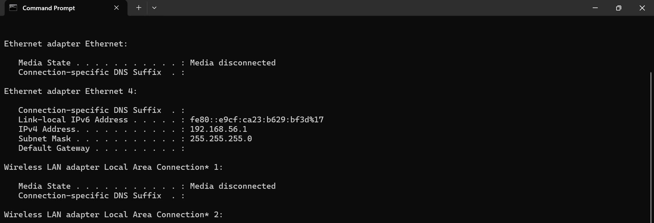

6. Host Discovery
Zenmap was used to discover active hosts within the authorized subnet.
A host discovery scan was performed to identify systems that were responding on the network.

Example Nmap command
nmap -sn 10.0.0.0
The example subnet above is only an example. The actual scan used the authorized network identified during the exercise.

7. Live Hosts Discovered
The scan identified the following active hosts:
No. | IP Address | Hostname | Status
1 | 10.0.0.1 | VMware | Up
2 | 10.0.0.5 | VMware | Up
3 | 10.0.0.10 | VMware | Up
4 | 10.0.0.100 | VMware | Up

Total live hosts: 4

Screenshot
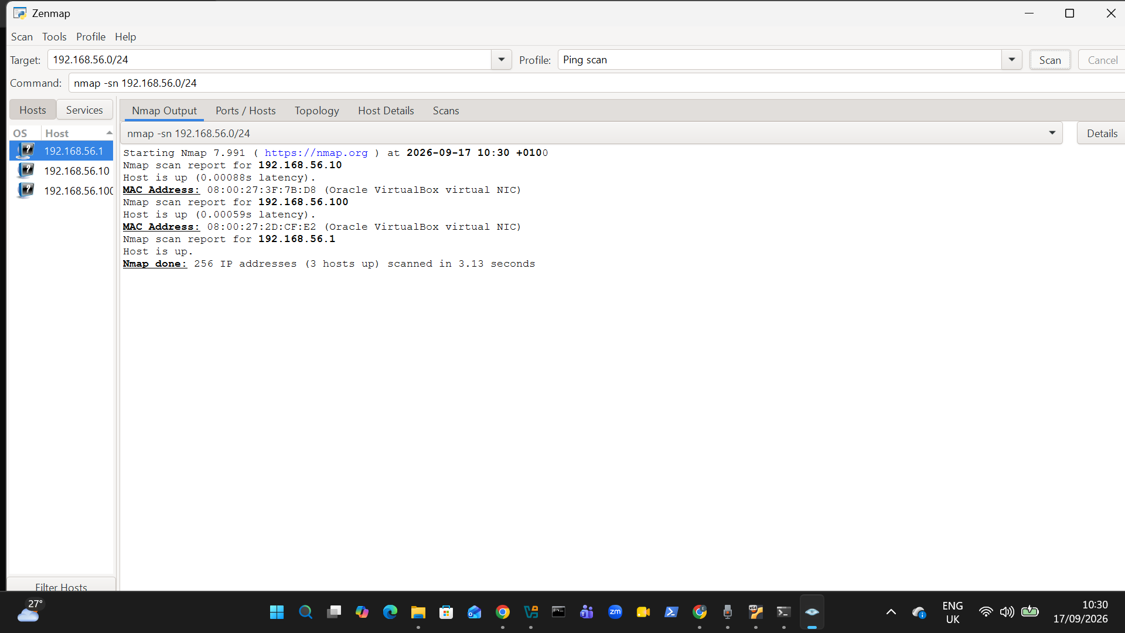

8. Host Information
Additional information was examined for the discovered hosts where permitted by the assessment scope.
IP Address | MAC Address | Hostname
10.0.0.5 | 00:0C:D4:28:6B:A3 | VMWare
10.0.0.10 | 00:51:3D:EA:F5:6C | VMWare
10.0.0.100 | 00:08:5C:3F:63:A1 | VMWare

Observation
The scan demonstrated how network discovery can identify active systems and provide additional information about devices visible within an authorized network.

9. Network Topology
Zenmap was used to visualize the discovered network environment.
The topology view provided a graphical representation of relationships between the scanning system and discovered hosts.

Topology Evidence
./topology.pdf

Screenshot
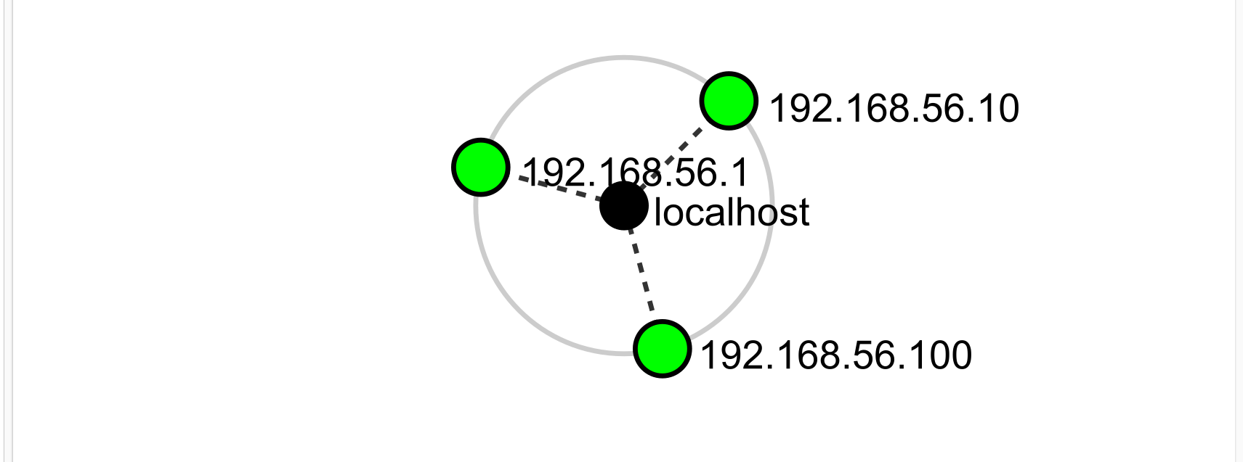
The topology diagram helps provide a high-level understanding of the network structure observed during the authorized scan.

10. Scan Results
The raw scan results were documented in:
./scan-results.txt
The results include:
- Authorized subnet
- Scan command
- Number of discovered hosts
- IP addresses
- Host information
- MAC addresses where available
- Relevant observations

11. Key Learning Outcomes
This exercise provided practical experience with:
- Network discovery
- LAN identification
- IP addressing
- Subnet identification
- Host discovery
- Nmap/Zenmap usage
- MAC address identification
- Network topology visualization
- Security assessment documentation
The exercise also demonstrated the importance of understanding the network being assessed before performing more detailed security testing.

12. Security and Ethical Considerations
Network scanning can generate traffic and reveal information about systems connected to a network. Therefore, scanning was restricted to an authorized environment.
No unauthorized networks were intentionally scanned, and no attempt was made to access, modify, disrupt, or compromise discovered systems.
Sensitive information such as internal IP addresses, MAC addresses, hostnames, or device details should be redacted when publishing evidence publicly where appropriate.

13. Disclaimer
I obtained permission from the relevant network owner before carrying out network reconnaissance and scanning activities against the target network used in this exercise.
All scanning activities documented in this report were performed for authorized cybersecurity training, assessment, and educational purposes.
The techniques demonstrated in this project should only be used against networks, systems, and devices for which the tester has explicit authorization.
Unauthorized network scanning or security testing may violate organizational policies and applicable laws.

14. Conclusion
The Network Scanning with Zenmap exercise provided hands-on experience with identifying and documenting systems within an authorized network.
The exercise covered local network identification, live-host discovery, IP and MAC address collection, host analysis, and network topology visualization.
This provided a practical foundation for progressing from reconnaissance and asset discovery toward more detailed vulnerability assessment and security testing in controlled and authorized environments.

