

Clover Deployment & Config

Date: 11.04.2023

**Contents**

Deployment 3

■ Requires plug-in 3

■ Place plug-in path 3

■ XML file placement path 3

■ Execute SQL 3

Config 4

■ Admin 4

**Shop Configuration 4**

**Till configuration 4**

**Clover till template configuration 5**

**Clover config configuration 7**

## Deployment

* Requires plug-in

|  |  |
| --- | --- |
| * Plugin.Clover.Admin.dll | V7.1.4 |
| * Plugin.Clover.FrontEnd.dl | V7.1.4 |
| * CloverSqlScript.txt |  |
| * UserTablesCloverPayment.xml |  |

* Place plug-in path

|  |  |
| --- | --- |
| FrontEnd | \FrontEnd\Executables\7.1\Plugins |
| Admin | \Admin\Executables\7.1\Plugins |

* XML file placement path

|  |
| --- |
| After copying the XML file to the root directory of ServerService, restart the ServerService service |

* Execute SQL

Execute the SQL statements in CloverSqlScript.txt in the SQL server client

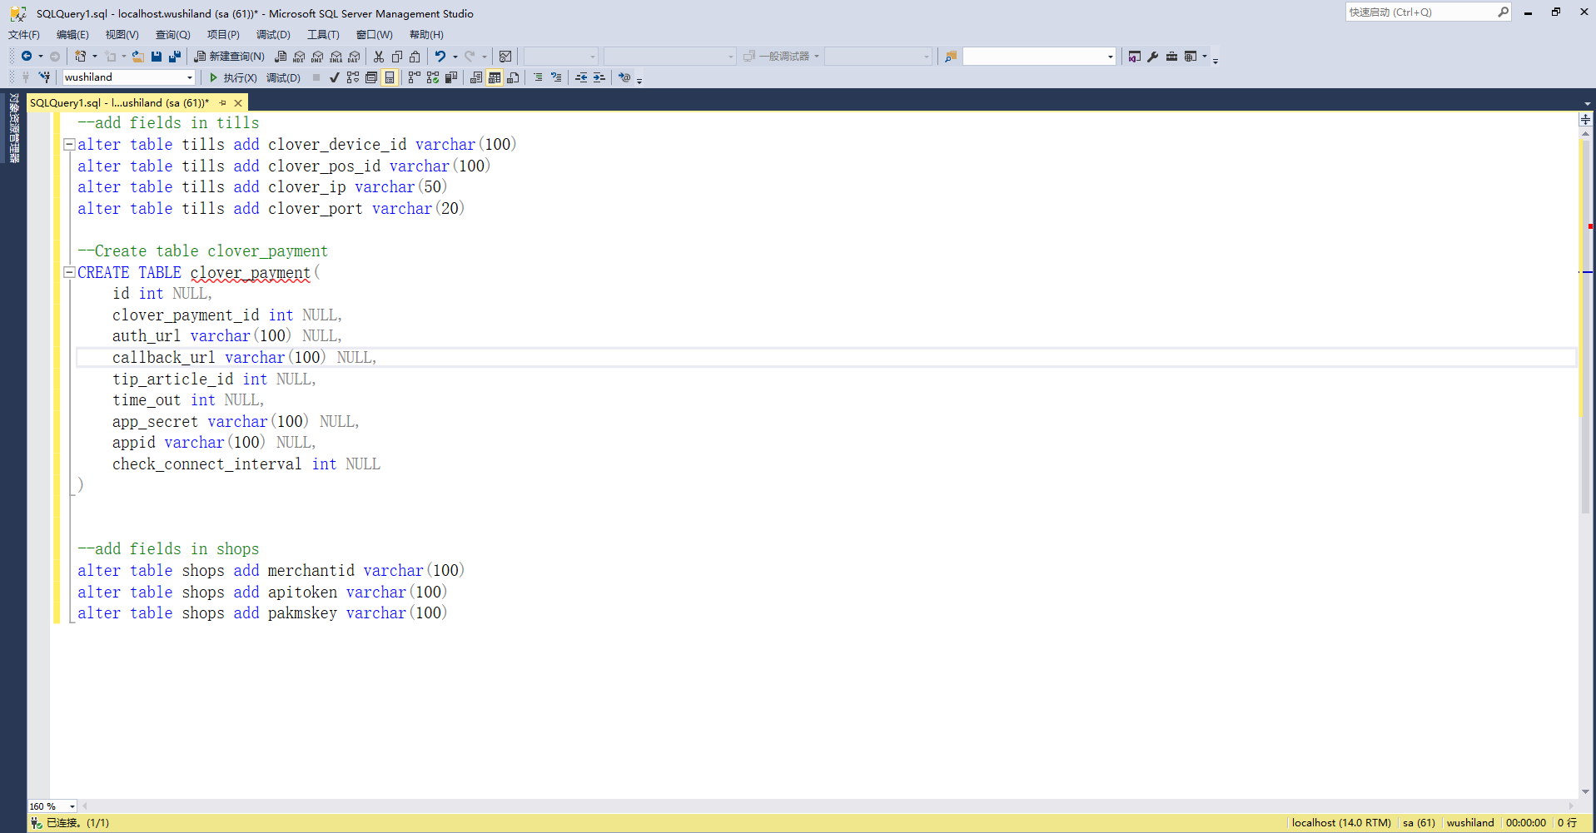

* After the execution is completed, the deployment of this plugin is completed.

## Config

* Admin

|  |  |
| --- | --- |
| Shop Configuration | |
|  | * Merchant ID: Merchant id number in clover admin, (unique) |

|  |  |
| --- | --- |
| Till configuration | |
|  | * Clover Device id   Device id (unique) |
| * Pos-id   Request POS ID |
| * Device Ip   Device IP address |
| * Device Port   Device Port of equipment (fixed) |
| The above 4 parameters are used to connect the Clover card reader |

|  |  |
| --- | --- |
| Clover till template configuration | |
|  | * Open till template menu * Select a template that needs to be configured and click on Configure Keyboard |
|  | * Enter template   Select Total in the keyboard layer |
|  | * Press the existing button twice or click New Button to create a new button |
|  | * Enter Clover in Filter * Select cloverfunction * Select Pay from the Parameters on the right side * The text displayed in the button can be set in the bottom key text * Click on Save   The above deployment can complete the Clover button setting in the till template. After the till synchronizes data, the Clover payment button will be displayed in the Total interface |

|  |  |
| --- | --- |
| Clover config configuration | |
|  | * App Secret   This identifier (ID) is the key assigned by Clover to the application |
| * App Id   ID used to identify the application |
| * Clover Payment Id   Clover payment ID in the mapping system |
| * Tip Article   Tip products in the mapping system |
| * Time out   Payment waiting timeout setting |
| * Check Connect Interval   Regular polling to check the connection status of implements |
| * Auth URL * CallBack URL   URL address used for Clover merchant authorization |