**Clover Interaction API**

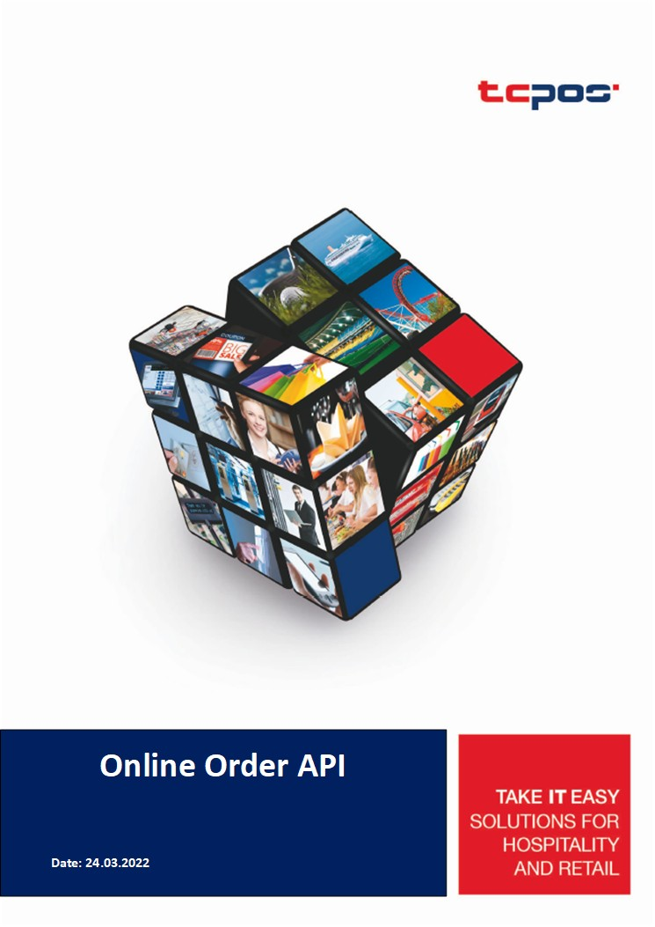

The information contained in this document is proprietary to SBM Tech.

The information in this document shall not be reproduced, shown or disclosed outside the SBM Tech without written permission.

Copyright © 2022 SBM Tech

All rights reserved

Pay 3

● CloverInteraction_Pay 3

Refund 5

● CloverInteraction_Refund 5

Order 7

● Create_Order 7

● Pay_Order 9

● Refund_Order 10

● Refund_Order _Item 11

Error Codes 12

● API only errors 12

# Pay

## CloverInteraction_Pay

|  |  |  |
| --- | --- | --- |
| **Test URL** | | |
| https://198.11.172.117:8093/CloverInteraction_Pay.aspx | | |
| **Purpose:** | | |
| Charges a credit card or other payment source using the data in the provided object | | |
| **Usage:** | | |
| Use a JSON-formatted string as the request parameter | | |
| **Request Parameters:** | | |
| trans | ecomind | Indicates whether the card data used for a charge was entered by the customer (ecom) or merchant (moto) |
| amount | Charge amount in cents. If the charge request includes tax (tax_rate_uuid or tax_amount), this value must be the sum of any items' prices and any tax or tip. For example, if the items costs $10 and the tax is $1, the value of amount would be 1100 ($11) |
| currency | Three-letter ISO 4217 currency code. (e.g usd ) |
| capture | Specifies if the charge is to be captured immediately. The default value is true. If the value is set to false, the charge transaction type is AUTH (or PRE-AUTH), and the charge can be captured at a later point using the /v1/charges/{id}/capture endpoint |
| tax_amount | Amount paid in taxes. This value is *not* automatically added to the total amount, so apps must ensure the value of the amount property is the correct final charge |
| tip_amount | Amount paid in tips. This value is automatically added to the total amount when the transaction is finalized |
| card | number | Card primary account number (PAN). |
| brand | Card brand |
| exp_year | Card expiration year in two or four-digit format |
| exp_month | Card expiration month in two-digit format |
| cvv | Card verification value |
| last4 | Last four numbers of the PAN |
| first6 | First six numbers of the PAN |
| address_zip | ZIP or postal code |
| **Request Demo** | | |
|  | {  "shopid": "11"  "trans": {  "ecomind": "ecom",  "amount": "1300",  "currency": "usd",  "tax_amount": "100",  "tip_amount": "100"  },  "card": {  "number": "6011361000006668",  "exp_month": "12",  "exp_year": "22",  "cvv": "123",  "brand": "DISCOVER",  "last4": "6668"  "first6": "601136"  "address_zip": "200435"  }  } | |
| Response Demo | | |
| Retrn Value | {  "id" : "6EZGEQ7QMYCF6",  "amount" : 1300,  "tip_amount" : 100,  "tax_amount" : 100,  "amount_refunded" : 0,  "currency" : "usd",  "created" : 1649399717717,  "captured" : true,  "ref_num" : "209800500050",  "auth_code" : "OK7085",  "outcome" : {  "network_status" : "approved_by_network",  "type" : "authorized"  },  "paid" : true,  "status" : "succeeded",  "source" : {  "id" : "clv_1TSTSH1y9kzKPkxQNYxtMRaZ",  "brand" : "DISCOVER",  "cvc_check" : "pass",  "exp_month" : "12",  "exp_year" : "2022",  "first6" : "601136",  "last4" : "6668"  },  "ecomind" : "ecom"  } | |
| Note |  | |

# Refund

## CloverInteraction_Refund

|  |  |
| --- | --- |
| **Test URL** | |
| https://198.11.172.117:8093/CloverInteraction_Refund.aspx | |
| **Purpose:** | |
| A new refund must be associated with an existing charge. Refunds are applied to the source used for the original payment. Partial refunds can be performed up to the original charge amount | |
| **Usage:** | |
| Use a JSON-formatted string as the request parameter | |
| **Parameters:** | |
| shopid | Unique ID of shop |
| charge | Unique ID of the charge to refund |
| amount | Refund amount in cents. You can only refund the remaining, unrefunded amount of the charge |
| reason | User-selected explanation for the refund   * Duplicate * fraudlent * requested_by_customer |
| **Request Demo** | |
|  | {  "shopid": "1",  "refund": {  "charge": "6EZGEQ7QMYCF6",  "amount": "2000",  "reason": " requested_by_customer "  }  } |
| **Response Demo** | |
| Retrn Value | {  "id": "re_1039VV2eZvKYlo2CadhQUrEZ",  "object": "refund",  "amount": "100",  "charge": "ch_1036sv2eZvKYlo2CnBcJSUV8",  "created": "1387481419000",  "currency": "usd,",  "reason": " requested_by_customer",  "receipt_number": "null",  "status": "succeeded"  } |
| Note |  |

# Order

## Create_Order

|  |  |  |  |  |  |  |
| --- | --- | --- | --- | --- | --- | --- |
| **Test URL** | | | | | | |
| https://198.11.172.117:8093/CloverInteraction_Create_Order.aspx | | | | | | |
| **Purpose:** | | | | | | |
| Create a new order object. | | | | | | |
| **Usage:** | | | | | | |
| Use a JSON-formatted string as the request parameter | | | | | | |
| **Parameters:** | | | | | | |
| shopId | int | required | | |  | |
| **order** | | | | | | |
| currency | string | required | | | Three-letter ISO 4217 currency code. Format: Lower case Length: Max 3 | |
| email | string | required | | | Email address of the customer placing the order. | |
| item | Array | required | | | * Article list of items in the order. An order can have 25 items * Each JSON represents an article in the transaction | |
| **[** | | | | | | |
| **{** | | | | | | |
| amount | int64 | required | | Amount of an item | | |
| currency | string | required | | Currency for the item amount | | |
| description | string | required | | Description of the item | | |
| quantity | int64 | required | | Unit quanity of an item | | |
| type | string | required | | Item type. Values:  - Shipping  - SKU | | |
| tax_rates | Array | Optional | | Tax rate applicable on an item | | |
| **[** | | | | | | |
| **{** | | | | | | |
| name | string | Label for the tax rate | | | | |
| rate | int | Item-specific tax where a 10% rate is defined as 1000000 | | | | |
| **}** | | | | | | |
| **]** | | | | | | |
| **}** | | | | | | |
| **]** | | | | | | |
| **card** | | | | | | |
| number | string | | required | | | Card primary account number (PAN). |
| brand | string | | required | | | Card brand |
| exp_year | string | | required | | | Card expiration year in two or four-digit format |
| exp_month | string | | required | | | Card expiration month in two-digit format |
| cvv | string | | required | | | Card verification value |
| last4 | string | | required | | | Last four numbers of the PAN |
| first6 | string | | required | | | First six numbers of the PAN |
| address_zip | string | | required | | | ZIP or postal code |
| **Request Demo** | | | | | | |
| **{**  **shopId:** "1",  **order: {**  "items": **[**{  "amount": 1500,  "currency": "usd",  "description": "boba milk tea",  "quantity": 1,  "type": "sku"  }**]**,  "tax_rates": **[**  {  "name": "percentage",  "rate": 1000000  }**],**  "email": "elven_shao@sina.com",  "currency": "usd"  **},**  **card: {**  "number": "2223000010280284",           "exp_month": "12",           "exp_year": "23",           "cvv": "123",           "brand": "MC",           "last4": "0284",            "first6": "222300",           "address_zip":  "200435"  **}**  **}** | | | | | | |
| **Response Demo** | | | | | | |
| {      "id": "NFWQ5XDDN6QNT",      "object": "order",      "amount": 8400,      "currency": "usd",      "created": 1680793556000,      "email": "elven_shao@sina.com",      "items": [          {              "type": "sku",              "quantity": 1,              "amount": 1800,              "currency": "usd",              "description": "Test item #1"          },          {              "type": "sku",              "quantity": 2,              "amount": 1700,              "currency": "usd",              "description": "Test item #2"          },          {              "type": "sku",              "quantity": 2,              "amount": 1600,              "currency": "usd",              "description": "Test item #3"          },          {              "type": "tax",              "description": "Taxes (included)"          }      ],      "status": "created"  } | | | | | | |
| Note |  |  | | | | |

## Refund_Order

|  |  |  |  |
| --- | --- | --- | --- |
| **Test URL** | | | |
| https://198.11.172.117:8093/CloverInteraction_Refund_Order.aspx | | | |
| **Purpose:** | | | |
| To refund a payment without any order items to be returned | | | |
| **Usage:** | | | |
| Use a JSON-formatted string as the request parameter | | | |
| **Parameters:** | | | |
| shopId | string | required |  |
| orderId | string | required | The id value returned after creating the order |
| **Request Demo** | | | |
| **{**  **"shopId":"1",**  **"orderId":"XXXXXXXX"**  **}** | | | |
| **Response Demo** | | | |
| {      "id": "NFWQ5XDDN6QNT",      "amount": 8400,      "currency": "usd",      "status": "returned",      "status_transitions": {}  } | | | |
| Note |  | |  |

# Error Codes

## API only errors

You can prevent these errors by checking for the described issues in your application before submitting the API request

| **Error code** | **Description** | **Request type(s)** | **Prevention** |
| --- | --- | --- | --- |
| incorrect_cvc | The card.cvv provided is not a three- or four-digit value | Create token | Verify that the CVV value is a three- or four-digit number |
| invalid_cvc | The card.cvv provided is not a three- or four-digit value | Create token, create or update customer | Verify that the CVV value is a three- or four-digit number |
| invalid_expiry_month | The card.exp_month provided is not a one- or two-digit value | Create token | Verify that the month value is a one- or two-digit number |
| invalid_expiry_year | The card.exp_month provided is not a two- or four-digit value | Create token | Verify that the year value is a two- or four-digit number |
| invalid_number | The PAN provided in card.number is invalid | Create token | Verify that the PAN is valid |
| invalid_tax_amount | The tax_amount provided is not valid | Create charge | Verify that the amount is a positive number |