MEDIA KIT
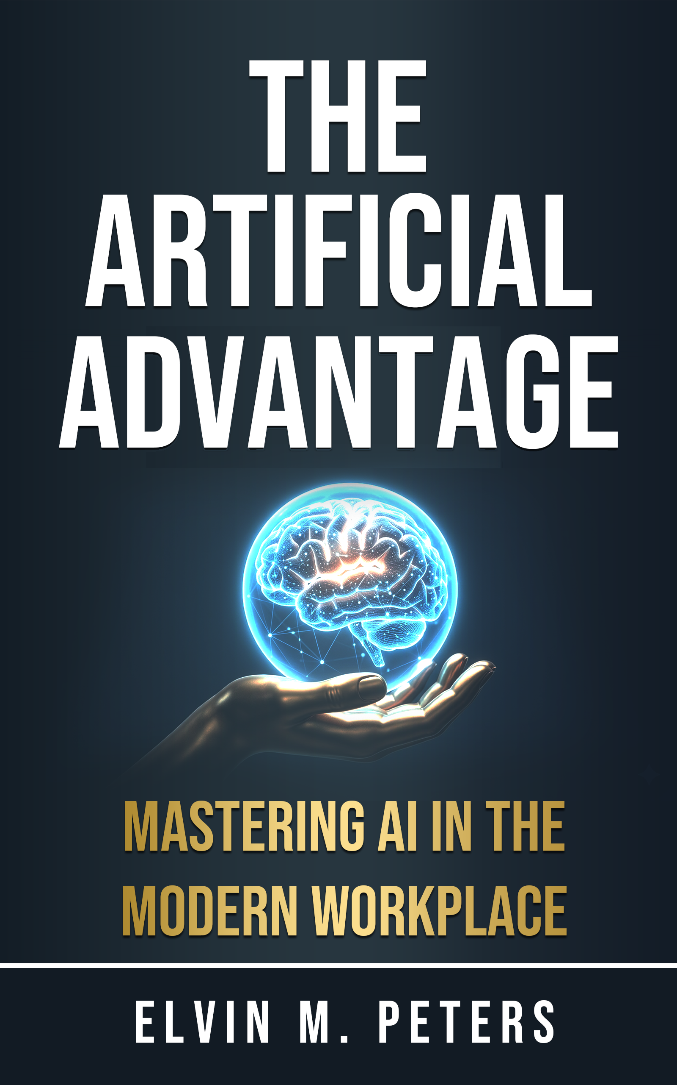
The Artificial Advantage
Mastering AI in the Modern Workplace
The AI Fluency Series · Volume 1
by Elvin M. Peters
Stop asking AI. Start directing it.
Press contact: elvin@elvinpeters.com · elvinpeters.com

ABOUT THE BOOK

The book that closes the AI gap
Most professionals have quietly written AI off, and for an understandable reason. They typed a question into a chatbot, got back a generic, hedge-everything answer, fixed it themselves, and decided the hype was overblown. The Artificial Advantage argues that the problem was never the tool. It was that nobody taught them how to direct it.
The people getting astonishing results are typing into the same box as everyone else. They have simply learned to brief the tool the way you would brief a sharp new hire, rather than asking it questions like a search engine. That single skill is the whole gap, and it has almost nothing to do with being technical. This book is the framework that teaches it, written for professionals and not programmers.
Across roughly 150 pages, three core frameworks and nine practical appendices, it takes a reader from someone who has heard of AI to someone who competently uses it to solve real work every day. There is no code anywhere in it.
THE BIG IDEA IN ONE LINE
AI literacy is becoming as basic as email. This is the book that gets a capable professional there in a weekend.

Key messages
The talking points behind the book, for interviews, articles and reviews:
- The gap is a skill, not the software. Two people using the identical tool get results a mile apart. The difference is that one asks it questions and the other gives it a brief.
- Stop asking AI, start directing it. A chat window looks like a search bar, so people use it like one, and the shortest instruction is the worst one you can give.
- Treat it like a brilliant new hire. Read everything, knows nothing about you. Hand it an empty brief and you get an average answer, because average is the correct response to an empty brief.
- Written for professionals, not programmers. Zero technical background required. If you can send an email, you can master this.
- It teaches how to think, not acronyms. Understanding the fundamentals of how these systems work keeps paying off on every new model and task, including the ones that do not exist yet.
- Earned at scale, not in theory. The author spent years directing AI-powered advertising across tens of millions of dollars in ad spend, watching exactly who pulled ahead with these tools and who did not.

ABOUT THE AUTHOR

Elvin M. Peters
Short bio. Elvin M. Peters is a Toronto-based AI consultant, author and builder, best described as a marketer who taught himself to build with AI. He spent his career in performance marketing, directing AI-powered advertising at scale for some of the largest financial brands in Canada, and now writes and builds full-time. The Artificial Advantage is his first book and the opening volume of the AI Fluency Series.
Long bio. Elvin M. Peters built a decade-long career in performance and paid-media marketing before turning it into a business of his own. At Google, he managed advertiser relationships representing more than sixty million dollars in annual ad investment across major Canadian financial institutions. Before that, at the consumer-finance company goeasy, he ran more than a million dollars a month in paid media across regulated brands, where directing AI-powered bidding and creative was part of the daily job long before AI reached the headlines.
That vantage point, watching highly capable professionals use AI every day and consistently pull a fraction of what it could deliver, is where the book began. The people getting exceptional results were not more technical. They were more deliberate. Now self-employed, Elvin consults on AI for teams and founders, runs workshops, and builds a portfolio of his own AI products. He is currently writing the next two volumes of the series, The Systematic Advantage and The Agentic Advantage.

Fact sheet
Title | The Artificial Advantage
Subtitle | Mastering AI in the Modern Workplace
Series | The AI Fluency Series, Volume 1
Author | Elvin M. Peters
Category | Business & Technology · Artificial Intelligence · Professional Development
Formats | Amazon Kindle, paperback, and hardcover
Length | Approximately 150 pages · 3 core frameworks · 9 appendices
ISBN (paperback) | 9798254324782
Published | 2026
Where to buy | amazon.com · amazon.ca
Free chapter | elvinpeters.com

FOR PRODUCERS & HOSTS

Suggested interview questions
- Everyone is talking about AI. So why do so many smart professionals still come away underwhelmed by it?
- You say the problem is never the tool. What is it, then?
- What do you mean by “stop asking AI, start directing it”? Can you show it with an everyday example?
- You spent years directing AI-powered advertising across tens of millions in ad spend. What did that teach you that most people miss?
- Is AI going to take our jobs?
- What is the single change someone could make today to get noticeably better results?
- Who is this book for, and who is it not for?
- People worry they are too late, too old, or too non-technical for AI. What do you tell them?

Soundbites
Pull quotes, ready to lift:
“The people getting astonishing results are typing into the same box you are. They have just learned to direct it.”
“An average answer is the correct response to an empty brief.”
“You do not need to be technical. You need a system and a weekend.”
“A chat window looks like a search bar, so people use it like one. And with AI, the shortest instruction is the worst one you can give.”
“AI literacy is becoming as basic as email. I would rather help you cross that line early than watch you cross it late.”

Interviews, review copies & contact
Review copies, interviews and excerpts are available on request. The author is based in Toronto and available for podcasts, print, and virtual events.
Press & interviews: elvin@elvinpeters.com
Website: elvinpeters.com
LinkedIn: linkedin.com/in/elvinmpeters
Book a time: meet.elvinpeters.com
The Artificial Advantage by Elvin M. Peters · The AI Fluency Series · Media kit 2026

