Create database called «lab7»

Copy content and run using DataGrip/PGadmin query tool (check if tables created correctly).

create table table_c (ID int primary key, NAME varchar (100));

create table table_d (ID int primary key, NAME varchar (100));

insert into table_c values (1,'Apple');

insert into table_c values (2,'Orange');

insert into table_c values (3,'Banana');

insert into table_c values (4,'Cucumber');

insert into table_c values (5,'Onion');

insert into table_c values (6,'Broccoli');

insert into table_c values (7,'Mushroom');

insert into table_d values (1,'Orange');

insert into table_d values (2,'Apple');

insert into table_d values (3,'Watermelon');

insert into table_d values (4,'Pear');

insert into table_d values (5,'Onion');

insert into table_d values (7,'Mushroom');

insert into table_d values (8,'Tomato');

**Use a recommendation from lexical structure and add comment for each query below.**

**Use both table and JOIN statement.**

1. Please write a SQL query that will return an output shown below. You have to use both tables and JOIN statement. *(11p)*

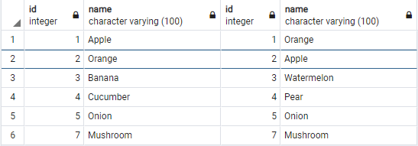

1. Please write a SQL query that will return an output shown below. You have to use both tables and JOIN statement. *(11p)*

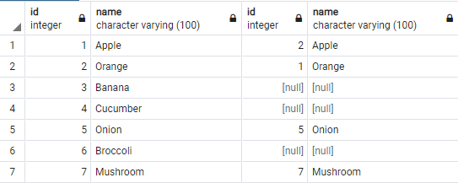

1. Please write a SQL query that will return an output shown below. You have to use both tables and JOIN statement. *(11p)*

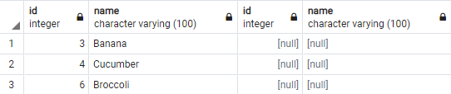

1. Please write a SQL query that will return an output shown below. You have to use both tables and JOIN statement. *(11p)*

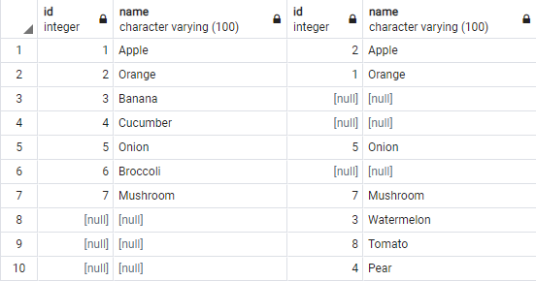

1. Please write a SQL query that will return an output shown below. You have to use both tables and JOIN statement. *(11p)*

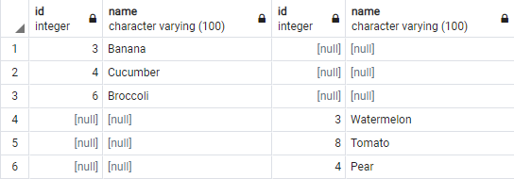

1. Please write a SQL query that will return an output shown below. You have to use both tables and JOIN statement. *(11p)*

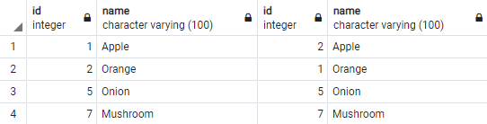

1. Please write a SQL query that will return an output shown below. You have to use both tables and JOIN statement. *(11p)*

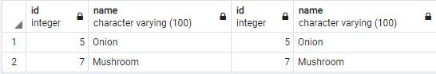

1. Please write a SQL query that will return an output shown below. You have to use both tables and JOIN statement. *(11p)*

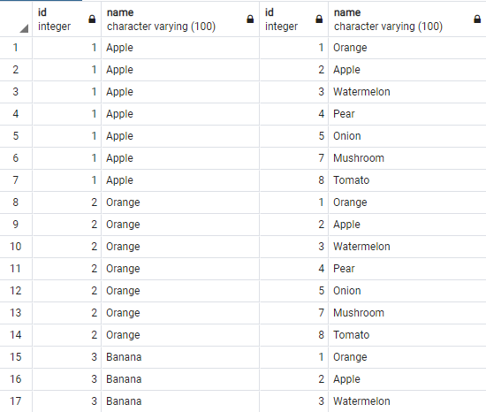

… … …

… … …

… … …

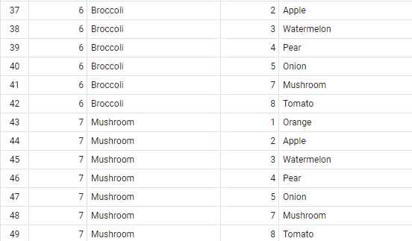

1. Please write a SQL query that will return an output shown below. You have to use both tables and JOIN statement. *(11p)*

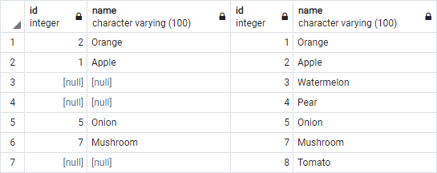

Save query file as ***Lab7_Lastname_Firstname.sql*** and sent to **a.zhumekenov@kbtu.kz**