# Company Context and Relevance to the Research

## Introduction to the Company

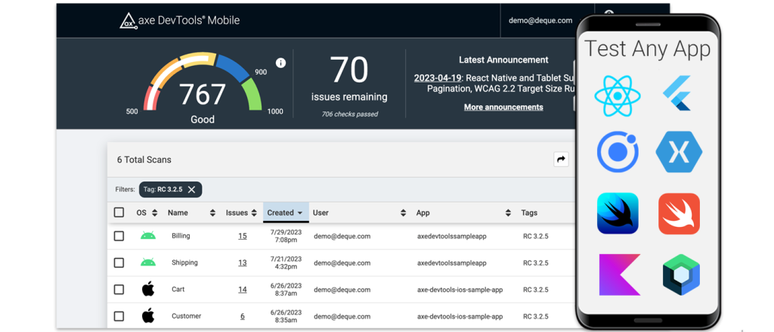

Figure . Deque Systems

Deque Systems, Inc. is one of the global leaders in digital accessibility and inclusion solutions. Founded in 1999 and headquartered in Herndon, Virginia (USA), the company provides a full suite of accessibility services and technologies designed to help organizations make their digital content accessible to all users, including those with disabilities. Deque is best known for developing the axe accessibility testing framework, which has become the industry standard for automated web accessibility evaluations and is widely integrated into browsers, development environments, and continuous integration pipelines worldwide.  
  
Deque’s mission statement, “Digital equality for all,” aligns closely with the objectives of this master’s thesis — ensuring that online platforms are perceivable, operable, understandable, and robust for every user, as described in the Web Content Accessibility Guidelines (WCAG). Their philosophy of combining automation, expert analysis, and user experience research to achieve full accessibility compliance represents an ideal industrial context for validating and applying the proposed solution developed within this research.

## 2. Relevance of Deque Systems to the Thesis Topic

The master’s thesis “Research on Website Accessibility Compliance” focuses on creating a comprehensive, multi-layered framework for assessing and improving the accessibility of websites. This framework combines three complementary evaluation layers:  
  
1. Automated evaluation – conducted using tools such as WAVE, SiteImprove, axe DevTools, and TAW.  
2. Expert manual evaluation – addressing complex or context-dependent issues that automated tools cannot detect.  
3. User-based evaluation – capturing the real-world experiences of people with disabilities through testing and feedback.  
  
Deque Systems provides a nearly identical structure in its professional accessibility assessment methodology. Its workflow includes automated testing using axe-core, expert-driven manual audits based on WCAG 2.1 and Section 508 criteria, and usability validation through engagement with people with disabilities. This overlap between the academic model proposed in the thesis and Deque’s industrial practice makes the company an ideal reference and benchmark for comparison, validation, and possible collaboration.

## 3. Similarities Between Deque’s Approach and the Proposed Thesis Solution

Both the Deque Systems methodology and the thesis’s proposed approach share several conceptual and methodological parallels:

|  |  |  |
| --- | --- | --- |
| Aspect | Deque Systems Approach | Thesis Proposed Approach |
| Automation Layer | axe-core automated scanning integrated into development pipelines | Automated evaluation using WAVE, SiteImprove, TAW, and axe DevTools |
| Expert Evaluation | Certified accessibility specialists manually verify compliance with WCAG and Section 508 | Expert reviewers validate automated findings and assess semantic, structural, and interactive elements |
| User-Centered Testing | Inclusion of people with disabilities in usability testing and feedback | Real user testing with diverse participants for authentic experience-based assessment |
| Data Integration | axe Monitor aggregates automated and manual results into unified dashboards | BPMN-based model integrates results from all layers into a consolidated accessibility report |
| Continuous Improvement | Accessibility embedded into CI/CD and governance frameworks | Iterative re-testing and feedback loops for continuous compliance improvement |

## 4. How the Thesis Enhances or Complements Deque’s Framework

While Deque Systems provides an advanced suite of accessibility assessment tools, the thesis contributes an academic dimension that strengthens their process from a research and innovation standpoint. The AI-based layer proposed in this study synthesizes data from automated, expert, and user evaluations to generate prioritized insights and explanations for developers.  
  
This automated interpretation mechanism can help reduce the manual workload of accessibility experts by clustering and prioritizing issues according to severity and user impact, provide actionable, human-readable recommendations derived directly from WCAG 2.1 mappings, and integrate seamlessly with existing tools like axe Monitor or axe DevTools, making accessibility compliance management more intelligent and adaptive.

## 5. Broader Industrial Impact and Collaboration Potential

Deque Systems operates globally, collaborating with organizations across finance, education, healthcare, government, and technology sectors — including major clients such as Google, Microsoft, and the U.S. Department of Veterans Affairs. These industries all share the same accessibility challenges investigated in this research: balancing compliance with real usability and ensuring sustainable monitoring over time.  
  
By aligning the thesis solution with Deque’s operational model, potential benefits include benchmarking the research outcomes against professional accessibility audits, testing real-world applicability of the proposed BPMN model and AI synthesis mechanism, and fostering collaborative research opportunities in AI-assisted accessibility analysis.

## 6. Conclusion

Deque Systems stands out as the most suitable company to represent the industrial application of this thesis. Both the company and the research share a common goal — improving the accessibility and inclusivity of the digital environment through structured, evidence-based evaluation methods. The company’s expertise in hybrid (automated + expert + user) auditing, its leadership in developing the axe accessibility toolset, and its global influence in shaping accessibility standards make it an ideal case study and benchmark for the proposed end-to-end evaluation framework

# DIAGRAMS ACCORDING TO MY THESIS TOPIC

1. Base Workflow

This figure presents the main evaluation process developed for this thesis. It demonstrates the complete end-to-end workflow beginning from data collection and automated testing, continuing with expert and user evaluations, and concluding with data synthesis, WCAG mapping, and compliance scoring. The model establishes a structured, repeatable approach for assessing website accessibility and includes a feedback loop for re-testing and continuous improvement.

1. AI-Enhanced Accessibility Evaluation

This figure illustrates the AI-enhanced version of the evaluation workflow. It integrates generative AI agents that automate data cleaning, analysis, and interpretation, while also supporting adaptive feedback through an interactive dashboard. The diagram highlights how AI improves consistency, reduces manual effort, and enables dynamic re-evaluation of accessibility results.

1. Sequence Diagram

This figure visualizes the sequential interaction between the main participants and system components in the accessibility assessment process. It shows the data flow from automated scanners, experts, and user testers through the GAI agents toward the reporting dashboard. The sequence also reflects the feedback mechanism that allows further analysis and targeted re-testing when compliance thresholds are not met.

1. GAI Workflow

This figure integrates the GAI agents into the overall accessibility evaluation framework. It shows how automated metrics analysis and expert/user assessments are supported by AI modules that interpret results, combine insights, and produce compliance reports. The workflow also includes a feedback loop that triggers refinement and new evaluations when accessibility gaps remain.

1. GAI Agents Overview

This figure defines the roles of the four GAI agents within the accessibility evaluation system. The Data Curator prepares and enriches input data, the Insight Summarizer converts metrics into textual insights, the Pattern Interpreter explains recurring accessibility issues, and the Compliance Advisor aggregates findings to generate reports and recommendations. Together, these agents form the intelligent core of the accessibility evaluation framework.

