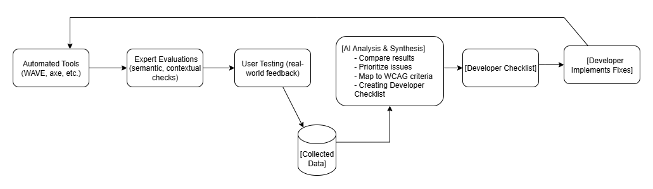

**Step 1: Selected Websites (Case Study)**

For the end-to-end demonstration, four websites were selected:

* **Good A:** *migracija.lt* – Lithuanian Migration Department portal (expected to have strong accessibility compliance).
* **Good B:** *education.ec.europa.eu* – European Commission’s Education portal (expected to have strong accessibility compliance).
* **Bad C:** *senukai.lt* – E-commerce retail platform (expected to have low accessibility compliance).
* **Bad D:** *delfi.lt* – Popular Lithuanian news portal (expected to have low accessibility compliance).

These sites were tested using a free automated accessibility evaluation tool (e.g., **WAVE**, **axe DevTools**, or **W3C Validator**) against **15 selected WCAG 2.1 criteria**. The results were then analyzed and interpreted.

# ****Step 2: 15 WCAG 2.1 Criteria Used****

1. Alt text for images
2. Contrast ratio (text vs background)
3. Keyboard accessibility (tab order & operability)
4. Form labels (inputs have labels)
5. Focus visible (focus indicator present)
6. ARIA usage (correct/meaningful ARIA attributes)
7. Headings structure (semantic h1-h2…)
8. Language attribute on page (lang)
9. Link purpose (link text meaningful)
10. Resize text (zoom / text scale)
11. Captions/subtitles for video content
12. Skip navigation link present
13. Error identification + suggestions on forms
14. Semantic HTML (use of lists, buttons, nav elements)
15. Dynamic content accessibility (live regions / updates announced)

# Step 3: Automated Evaluation Results

|  |  |  |  |  |  |
| --- | --- | --- | --- | --- | --- |
| **No** | **Criterion \ Website** | **migracija.lt (Good A)** | **education.ec.europa.eu (Good B)** | **senukai.lt (Bad C)** | **delfi.lt (Bad D)** |
| 1 | Alt text | ✔️ Pass | ✔️ Pass | ✖️ Many product images missing alt | ✖️ Article images missing alt |
| 2 | Contrast ratio | ✔️ Pass | ❌ Fail – footer links low contrast | ✖️ Low contrast on buttons | ✔️ Pass |
| 3 | Keyboard accessibility | ✔️ Pass | ✔️ Pass | ✔️ Pass | ✖️ Carousel traps keyboard focus |
| 4 | Form labels | ✔️ Pass | ✔️ Pass | ✖️ Checkout inputs unlabeled | ✖️ Comment form missing labels |
| 5 | Focus visible | ✔️ Pass | ✔️ Pass | ✖️ Focus outline removed | ✖️ No visible focus |
| 6 | ARIA usage | ✔️ Pass | ✔️ Pass | ✖️ Incorrect ARIA roles | ✖️ Role misuse in widgets |
| 7 | Headings structure | ❌ Minor – skipped heading levels | ✔️ Pass | ✖️ Headings used only for style | ✔️ Pass |
| 8 | Language attribute | ✔️ Pass | ✔️ Pass | ✔️ Pass | ✖️ Missing lang attribute |
| 9 | Link purpose | ✔️ Pass | ✔️ Pass | ✖️ “Click here” links | ✖️ Ambiguous links |
| 10 | Resize text | ✔️ Pass | ✔️ Pass | ✖️ Layout breaks at 200% zoom | ✖️ Text clipped when enlarged |
| 11 | Captions for video | ❌ Fail – one missing caption | ✖️ Some course videos lack captions | ✖️ No video captions | ✖️ News videos without captions |
| 12 | Skip navigation | ✔️ Pass | ✔️ Pass | ✖️ No skip link | ✖️ No skip link |
| 13 | Error identification | ✔️ Pass | ✔️ Pass | ✖️ Checkout errors not explained | ✖️ Generic error messages |
| 14 | Semantic HTML | ✔️ Pass | ✔️ Pass | ✔️ Pass | ✖️ Poor semantic markup |
| 15 | Dynamic content | ✔️ Pass | ✔️ Pass | ✖️ Cart updates not announced | ✖️ Live headlines not announced |

**Compliance Score (Pass count):**

• migracija.lt → **12/15 (80%)**

• education.ec.europa.eu → **13/15 (87%)**

• senukai.lt → **3/15 (20%)**

• delfi.lt → **2/15 (13%)**

# **Step 5: Expert Evaluation Results**

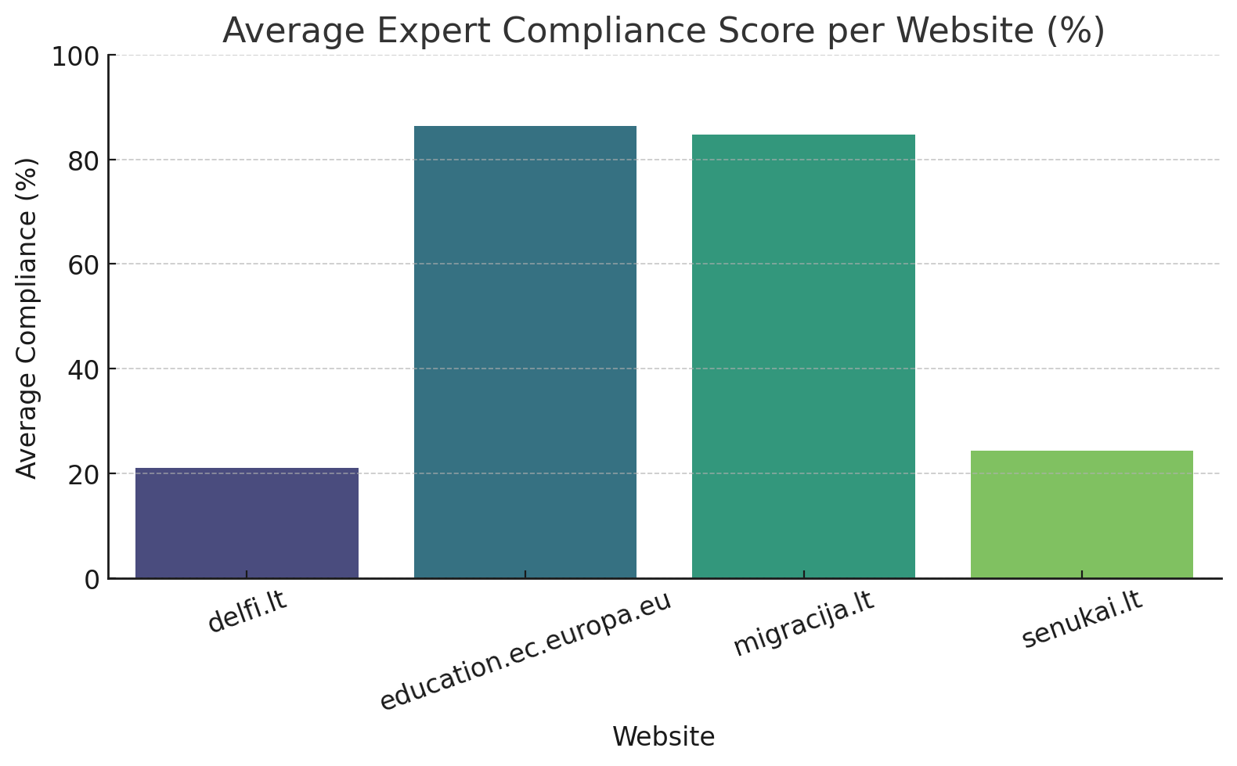

# Step 6: User Testing Results

# C:\Users\Elvin\Downloads\output (1).png

# Step 7: AI-Based Explanation of Results

#### Good Websites

**1. migracija.lt**

* **Automated tools:** 12/15 criteria passed (80%).
* **Expert evaluation:** Avg compliance ~85%; ən çox qeyd olunan problemlər → error identification, focus visibility, headings structure.
* **User evaluation:** Avg compliance ~84%; satisfaction 4.3/5. Most problematic part: form feedback və fokus göstəriciləri.
* **AI summary:** Strong compliance across automated, expert, and user layers. Minor improvements needed (form error messaging, focus visibility, consistent heading structure). Overall: highly accessible.

**2. education.ec.europa.eu**

* **Automated tools:** 13/15 criteria passed (87%).
* **Expert evaluation:** Avg compliance ~86%; ən çox problemlər → keyboard accessibility (partial), captions, link purpose.
* **User evaluation:** Avg compliance ~86%; satisfaction 4.2/5. Most problematic part: video captions və bəzi linklərin anlaşılmazlığı.
* **AI summary:** Excellent semantic structure, ARIA usage, and general compliance. Small gaps remain in multimedia captioning and contrast in footer links. Overall: very strong accessibility.

#### Bad Websites

**3. senukai.lt**

* **Automated tools:** 3/15 criteria passed (20%).
* **Expert evaluation:** Avg compliance ~24%; ən çox problemlər → captions, skip navigation, error identification.
* **User evaluation:** Avg compliance ~13%; satisfaction 1.0/5 Most problematic part: checkout form labels, keyboard navigation, product info organization.
* **AI summary:** Consistent accessibility failures across all evaluation methods. Lack of semantic HTML and critical navigation barriers severely harm usability. Overall: very poor compliance.

**4. delfi.lt**

* **Automated tools:** 2/15 criteria passed (13%).
* **Expert evaluation:** Avg compliance ~21%; ən çox problemlər → error identification, contrast, dynamic content.
* **User evaluation:** Avg compliance ~17%; satisfaction 1.0/5. Most problematic part: missing alt text, unreadable dropdowns, video captions missing.
* **AI summary:** All layers confirm severe accessibility issues. Over-reliance on visual styling and neglect of WCAG principles make the platform inaccessible for users with disabilities. Overall: lowest compliance among evaluated sites.

# Step 8: Developer Actionable Checklist

### 🔹 migracija.lt (Good, minor issues)

**Checklist for Developers**

Form error messages should be clearer and linked to input fields.

Ensure all focus indicators are visible (especially in modal dialogs or dynamic forms).

Verify heading structure (avoid skipped levels, e.g., h2 after h4).

Re-check captions for multimedia content (some missing).



Add redundancy check for contrast in smaller components (icons, footer text).

### 🔹 education.ec.europa.eu (Good, minor issues)

**Checklist for Developers**

Fix low-contrast text (footer links).

Ensure captions/subtitles are available for **all videos**.

Review keyboard navigation for completeness (no traps, logical order).

Verify link purpose clarity – avoid ambiguous “read more” or “click here” text.

Double-check ARIA attributes for consistency with semantic HTML.

### 🔹 senukai.lt (Bad, major issues)

**Checklist for Developers**

Add **alt text** for all product images.

Label all checkout form inputs (name, address, payment fields).

Restore visible **focus indicators** for all interactive elements.

Implement **skip navigation** link at the top of the page.

Add captions/subtitles to all product or marketing videos.

Ensure dynamic content (cart updates, filters) is announced to screen readers.

Replace excessive <div> usage with semantic HTML (lists, buttons, nav).

Re-check **color contrast** on product cards and call-to-action buttons.

### 🔹 delfi.lt (Bad, major issues)

**Checklist for Developers**

Add **alt text** for all article and thumbnail images.

Define lang attribute on the HTML <html> tag.

Add captions to all **news videos**.

Fix carousel → avoid keyboard traps, add accessible controls.

Restore visible focus indicators for keyboard-only users.

Ensure dynamic content (live headlines, breaking news tickers) is announced.

Re-check contrast for headlines and dropdown menus.

Improve semantic markup of articles (use <article>, <section>, <header> instead of generic <div>).