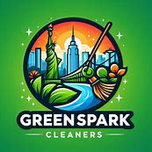

# **GreenSpark Cleaners**

### **Executive Summary**

**GreenSpark Cleaners** is a New York City-based cleaning company specializing in eco-friendly cleaning services for offices and commercial premises. Our mission is to provide high-quality, environmentally conscious cleaning solutions while supporting the local community by employing local contractors.

### **Market Overview**

* **Growing Demand**: Increasing preference for green cleaning products due to environmental and health benefits.
* **Market Size**: The global green cleaning products market was valued at USD 3.9 billion in 2019 and is projected to grow at a rate of 8.4% annually until 2027.
* **Community Impact**: Hiring local contractors, reducing transportation costs, and fostering customer loyalty.

### **Financial Projections**

* **Startup Costs**: $10,000 for equipment, materials, and marketing.
* **Revenue Streams**: Service fees from office and commercial cleaning contracts.
* **Profitability**: Expected to achieve break-even within the first year due to low operational costs and high demand for eco-friendly services.