Predictors of the macroinvertebrate fauna in semiarid aquatic systems
Prof. Elvio S. F. Medeiros (Autor)
Rafaela L. de Farias (Autor)
Laryssa K. de Carvalho (Doutoranda)
Affiliation:
Laboratório de Ecologia, Universidade Estadual da Paraíba, Campus V, João Pessoa, PB
2026-02-08
Abstract
…
Table of contents

1. Introduction

2. Material and Methods

2.1 Study Area and Sampling Design
The present study was performed at the easter limits of the semiarid region of Brazil (Figure 1). This area is characterized by low average precipitation, concentrated in a few months of the year, usually between January and July (Figure 2), and high average annual temperatures between 20 and 32 °C (Barbosa et al. 2025). The main hydrological feature in the study area is the intermittence of surface water flow of its streams and rivers and, as a consequence, many man-made reservoirs built from the damming of the intermittent streams (Maltchik and Medeiros 2006). These rivers flow through the “Caatinga”, a deciduous arboreal to shrubby open forest (Silva et al. 2017). The climate in the study area is semiarid (BS´h hot and dry) and equatorial (As, dry summer) (Peel et al. 2007). A diverse array of sampling sites was chosen to represent the most common aquatic environment types of semiarid Brazil, with different sets of specificities and across different catchment basins. We sampled six sites, three of which consisted of stream reaches with surface water flow (during the rainy season) or isolated temporary pools (during the dry season) and three sites in artificial reservoirs created from stream impoundment. Sampling was conducted during the year of 2006 on four occasions during the rainy (April and June) and dry seasons (September and December).

2.2 Data Collection
Environmental characteristics of each site were measured in four sets of variables: (a) site morphology, (b) water quality, (c) sediment composition, and (d) marginal habitat structure. Site morphology was assessed by their width (cm) and depth (cm) measured from three random transects. Catchment scale variables (such as elevation and river length) were measured using handheld GPS and satellite imagery. Water quality was evaluated as physical and chemical variables that were measured using portable equipment for temperature (°C) and dissolved oxygen (mg/L). Transparency (cm) was measured using a Secchi disk and water velocity (m/s) was estimated using the float method (Maitland 1990). Sediment composition and the habitat physical structure followed protocols from Pusey Pusey et al. (2004) and Mugodo et al. (2006), adapted by Medeiros et al. (2008), where they are estimated from 9 to 12 one meter quadrants along the margins (terrestrial-aquatic interface) and determined by visual estimation of sediment type percentage cover (mud, sand, cobbles, small gravel, large gravel, rocks and bedrock) and of littoral and sub-aquatic structures (macrophytes, littoral grass, leaf litter, attached algae, filamentous algae, overhanging vegetation, submerged vegetation, small woody debris, large woody debris and root masses). At each study site, three samples of benthic macroinvertebrates were collected in the margins using a D type net (40 cm wide and 250 μm) to represent different habitat types. Samples were fixed in situ with 4% formalin and subsequently preserved in 70% ethanol. Macroinvertebrate specimens were sorted and identified to the lowest possible taxonomic level, usually family (McCafferty and Provonsha (1983), Mugnai et al. (2010), Thorp and Covich (2010) and Merritt et al. (2019), among others).

2.3 Statistical Analyses
Prior to statistical analysis, environmental variables were checked for multivariate collinearity and square root transformed to enhance normality and homogeneity of variances (Sokal and Rohlf 1995).
These variables were then subject to a Principal Component Analysis (PCA) to have their multivariate correlations described across sites. The PCA was conducted on the square root transformed and scaled data using the R package FactoMineR (Lê et al. 2008).
For the macroinvertebrate community, all analyses were performed on density of individuals (ind/m²) calculated by the ratio between the number of individuals and the sampled area of the D-net in each sample. Macroinvertebrate fauna was described by means of average density and rarefied taxa richness, where richness was standardized by the average sample size across all samples. Life stages (larvae, pupae, nymph and adults) were treated as separate taxa, considering their ecological differences (Ross et al. 1987). Comparisons of density and richness among study sites were tested by one-way ANOVA followed by post hoc multiple comparisons using Tukey’s HSD test (α=0.05) (Zar 1999).
A Stepwise Multiple Regression (SMR) analysis using the Akaike Information (MASS R package, stepAIC function, Venables and Ripley (2002)) as the selection criterion was performed in both directions (forward and backward) to identify the best predictors across subsets of variables (site morphology, water quality, sediment composition and marginal habitat structures) for species richness and density (Vendramin et al. 2020).
Variation in species composition among sites were ordinated using Non-metric Multidimensional Scaling (NMDS) (Lanés et al. 2018). Data were arcsine square-root transformed after relativization and the Bray-Curtis distance was calculated. Significance of groups was tested using the Multi-Response Permutation Procedure (MRPP) (Biondini et al. (1985), McCune and Grace (2002)). For all MRPP analyses, the A value is presented as a measure of homogeneity degree in a cluster, as compared to random expectation.
Indicator Species Analysis (ISA) was performed to evaluate species–site associations (indicspecies R package, De Cáceres and Legendre (2009)) using the Indicator, or index, Value (IndVal) (De Cáceres et al. 2010). The Indicator Value was calculated according to the method proposed by Dufrene and Legendre (1997). This value was then tested for statistical significance by means of permutations (999 repetitions). Further explorations of species ecological preferences was performed using Multilevel Pattern Analysis with the multipatt fuction (De Cáceres et al. 2010), based on correlation indices and the Pearson’s phi coefficient of association (Chytrý et al. (2002), De Cáceres and Legendre (2009)). This coefficient is a measure of the correlation between two binary vectors. Phi was based on the presence–absence community matrix (De Cáceres et al. 2010) and corrected for unequal group sizes (Tichy and Chytry 2006).
To summarize the contribution of site environmental variables to species composition we performed distance-based Redundancy Analysis (dbRDA; Legendre and Anderson (1999)), implemented by the vegan R package (Oksanen et al. 2020), between each group of environmental variables (explanatory predictors) (site morphology, water quality, sediment composition and marginal habitat structure) and the community composition density matrix (response matrix) to see which environmental/habitat variables were the most important for determining each benthic community composition (Lanés et al. 2018). Model significance was evaluated using permutation-based Analysis of Variance (ANOVA), with 999 permutations) (Oksanen et al. 2020). To identify a parsimonious model, forward and backward stepwise model selection based on permutation tests was applied, retaining only predictors that significantly explained additional variation in community structure. The final RDA model was re-fitted using the selected variables and re-evaluated for collinearity and significance. Both sequential (Type I) and marginal (Type III) permutation tests were conducted, with marginal effects used to infer the independent contribution of each predictor.
RDA was applied to the density community matrix after being transformed by the Hellinger transformation (Legendre and Gallagher 2001). Site morphology and water quality variables were square root transformed, whereas sediment composition and the marginal habitat structure (which were measured as percentages) were arcsine square-root transformed after relativization by column total (McCune and Grace 2002). Only taxa with the highest absolute scores on the first canonical axis were labeled in the final ordination diagram. Multicollinearity across the explanatory (environmental) variables was assessed using Variance Inflation Factor (VIF) function (vif.cca). Highly collinear variables (VIF > 10) were excluded and the the final model was selected using stepwise permutation tests (999 permutations). All statistical analyses were performed in the statistical environment of R v.2.9.0 (Team 2017).

3. Results

3.1 Environmental variables
The study sites showed a wide array of environmental features, as expected from their different types (Figure 9). Water flow was present only in smaller streams in lower altitudes (sites 4-6) and during the rainy season (0.10-0.17 m/s). Stream sites tended to be narrower with widths ranging from 5.4 to 29.6 m, compared with 72.2 to 330 m for reservoirs. Littoral depths varied widely from 4.7 to 81.3 cm across all sites. Dissolved oxygen (DO) ranged from 1.8 to 9.4 mg/L and temperatures from 24.0 and 35.2 °C. Turbidity was low with Secchi depths reaching 90 cm, even though some sites had depths as low as 16 cm of the Secchi disk. Mud and sand were the main substrates across all sampled sites (with average covers of 54.4 and 37.9%, respectively). The habitat elements that gave greater overall contributions were attached and filamentous algae (12% on average), littoral grass (9.0%) and aquatic macrophytes (8.4%), but these contributions varied widely across sites and season (Figure 9) (detailed information on the study sites has been published elsewhere by Medeiros et al. (2008) and Medeiros et al. (2024).
Principal Component Analysis described the overall structure of the study sites and the most important features in separating them in terms of their physical and chemical variables, site morphometry, sediment composition, and marginal habitat structure (Figure 1). PCA explained 41.9% of the variance in the environmental variables, with the first axis (27.6%) showing a gradient from large reservoirs to smaller streams sites. Large scale morphology variables such as altitude, river length and site width were important to describe most reservoirs, whereas river sites were better described by local physical, chemical and habitat variables, such as water velocity, dissolved oxygen, temperature and overhanging vegetation. Larger reservoirs were mostly associated with a muddy substrate whereas river sites included a more diverse array of substrates including sand, rocks and gravel and cobbles. Other variables such as submerged vegetation and leaf litter (habitat structure), and slope (morphology) were important in explaining specific sites at given sampling occasions.

3.2 Benthic macroinvertebrates
A total amount of 28155 individuals was collected, divided into 32 taxonomic groups. Out of these, Thiaridae (1340.15 ind./m² ± 3068.95), larvae of Chironomidae (629.07 ind./m² ± 1424.72), and Oligochaeta (380.49 ind./m² ± 856.62) were the most the representative (Figure 10).
Sampling sites were different in macroinvertebrate rarefied richness (ANOVA d.f.= 5, 16; F_{richness} = 6.9; p=0.001) but not in density of individuals (ANOVA d.f.= 5, 16; F_{density} = 2.06; p = 0.124). According to post hoc Turkey tests, Cipó stream and the Recando reservoir had significantly higher rarefied richness when compared to the other study sites (p < 0.05) (Figure 2).
The Stepwise Multiple Regression Model (SMRM) was applied separately for each of the four sets of environmental variables (morphology, water quality, sediment composition and marginal habitat structures). Site morphology variables retained only stream width, with the final model explaining 15.4% of the variation (Adjusted R² = 0.111; d.f. = 1,20; F = 3.63, p = 0.071). Site width β = -0.36 (± 0.19), indicates that wider sites tend to have fewer species, although this effect was marginally significant (p = 0.071). River length had a strong negative effect on species richness (β = -1.96 ± 0.34), explaining 63.1% of its variation (Adjusted R² = 0.612; d.f. = 1, 20; F = 34.15, p < 0.001). The SMRM that best explained the water quality variables (42.3% of the variation in rarefied species richness) included water velocity and water temperature as significant predictors (Adjusted R² = 0.288; d.f. = 4,17; F = 3.12, p = 0.043). Water velocity (β = -19.97 ± 9.04) had a significant negative effect on species richness (p = 0.041) and water temperature (β = 16.11 ± 4.97) had a significant positive effect (p = 0.005). Dissolved oxygen and turbidity were not significant predictors (p > 0.05). Among the substrate composition variables, gravel was the only significant predictor, explaining 32.8% of the variation in rarefied species richness (Adjusted R² = 0.294; d.f. = 1,20; F = 9.76, p = 0.005, β = 1.85 ± 0.59). The SMRM for the habitat variables explained 58.6% of the variation in rarefied species richness (Adjusted R² = 0.379; d.f. = 7,14; F = 2.83, p = 0.046), with leaf litter (β = 6.24 ± 2.33, p = 0.018) and algal cover (β = 0.92 ± 0.41, p = 0.039) having significant positive effects on species richness. Other predictors such as roots (β = 4.71, p = 0.058) and littoral grass (β = -1.01, p = 0.052) may have been important showing marginal effects. Stepwise Multiple Regression was not performed between the environmental variables and species densities because the latter did not vary significantly across sites and sampling occasions.
Ordination analysis revealed a wide variation in community composition across sampling occasions with some degree of similarity within sites. The NMDS resulted in a non-metric fit (R²) of 0.97, with a stress of 0.173 (Figure 3).
Spatial segregation in macroinvertebrate composition was confirmed by MRPP, which shows significant differences between sites (A = 0.14, p = 0.001), but not for sampling months (A=-0.01, p=0.815) or seasons (wet/dry) (A < 0.01, p = 0.413). Differences between reservoir and stream sites were also significant (A = 0.03, p = 0.004).
Indicator Species Analysis identified ten taxa with significant indicator values (p < 0.05), partially overlapping with the multilevel pattern results. Several taxa were confirmed as indicators of RE, these being Oligochaeta, Conchostraca, Physidae and Coenagrionidae, all showing high indicator values (IndVal = 0.82–0.98, p < 0.03). Corixidae remained the solely indicator of CI (IndVal = 0.86, p = 0.013). Further exploration using Multilevel Pattern Analysis incorporated additional as indicators of specific site combinations, which were Ceratopogonidae and Libellulidae, for CI and RE (IndVal = 0.87-0.94, p < 0.007), Thiaridae and Atyidae, both associated with EP and SE (IndVal = 0.76-0.99, p < 0.048) and Planorbidae, associated with CI, RE, and SE (IndVal = 0.91, p = 0.048) (Figure 8).
Redundancy analysis (Figure 4) revealed a significant relationship between macroinvertebrate community composition and the site morphology variables, river length, maximum site depth, and site width (Permutation test, F~3,18 = 4.71, p = 0.001). The constrained model explained 43.99% of the total community variation (adjusted R² = 0.35), with the remaining 56.01% attributable to unconstrained variation. The first RDA axis was highly significant (F~1,18 = 11.33, p = 0.001) and accounted for 80.2% of the constrained inertia, whereas the second and third axes were not significant (p > 0.20). Sequential permutation tests indicated that channel width (F = 8.59, p = 0.001) and river length (F = 3.70, p = 0.013) contributed significantly to explaining community structure, while maximum depth had a weaker, non-significant effect (p = 0.10). Marginal tests confirmed that width and river length remained significant predictors when evaluated independently (p = 0.001). Species scores along RDA1 indicated strong associations of Oligochaeta and larvae of Chironomidae (≈ 40%) with wider sites (indicative of artificial reservoirs), whereas Thiaridae showed a pronounced negative association with RDA1 (90%), corresponding to narrower and shorter river reaches.
Among the water quality variables, the model including only turbidity showed significant relationship with macroinvertebrate community composition (F_{1,20} = 3.37, p = 0.013). The constrained model explained 14.42% of the total variation in community composition (adjusted R² = 0.10). The first RDA axis was significant (F_{1,20} = 3.37, p = 0.01) and accounted for 100% of the constrained inertia, reflecting the presence of a single explanatory variable. Both sequential and marginal permutation tests confirmed that turbidity independently explained a significant proportion of variation in community structure (p = 0.015 and p = 0.008, respectively). Species scores along RDA1 showed strong positive associations of Thiaridae (56%) with higher turbidity values, whereas Oligochaeta (37%) and Notonectidae (18%) were negatively associated with this axis.
Substrate composition revealed a weak overall relationship between macroinvertebrate community composition and the sediment variables. The final reduced model included only mud and sand (permutation test, F_{2,19} = 1.70, p = 0.089). The constrained model explained 15.21% of the total community variation (adjusted R² = 0.06). The first RDA axis was marginally significant (F_{1,19} = 2.70, p = 0.097) and accounted for 79.2% of the constrained inertia, whereas the second axis was not significant (p = 0.60). Sequential permutation tests indicated that sand contributed significantly to explaining community structure (F = 2.69, p = 0.035), while mud did not show a significant sequential effect (p = 0.59). Nonetheless, marginal tests showed that both sand (F = 2.69, p = 0.038) and mud (F = 2.44, p = 0.043) independently explained significant portions of community variation when evaluated while controlling for the other variable. Species scores along first RDA axis indicated a positive association of Chironomidae larvae (50%) and Notonectidae(13%) with sandy substrates, whereas Thiaridae (29%) and Oligochaeta (16%) showed strong negative associations with this axis, corresponding to sites with higher mud content.
Relationship between macroinvertebrate community composition and habitat structure variables was significant, with the final reduced model including macrophytes, submerged vegetation, litter, roots, and algae (F_{5,16} = 2.89, p = 0.001). The constrained model explained 47.43% of the total variation (adjusted R² = 0.31). The first two RDA axes were significant, with RDA1 (F_{1,16} = 8.03, p = 0.003) and RDA2 (F_{1,16} = 4.00, p = 0.041), together accounting for 83.3% of the constrained inertia. The sequential permutation tests indicated that macrophyte cover (F = 4.34, p = 0.003), leaf litter (F = 2.61, p = 0.038), roots (F = 2.58, p = 0.024), and algae (F = 3.12, p = 0.014) contributed significantly to explaining community structure. Marginal tests confirmed that macrophytes (p = 0.002), roots (p = 0.003), and algae (p = 0.019) remained significant predictors when evaluated independently, while submerged vegetation and leaf litter showed weaker, non-significant marginal effects (p > 0.06). Species scores along RDA1 indicated strong positive associations of larvae of Chironomidae (36%) and Oligochaeta (35%) with sites characterized by higher macrophyte and leaf litter cover, whereas Thiaridae showed a pronounced negative association with this axis (79%), corresponding to habitats with lower structural complexity. Along RDA2, larvae of Chironomidae was positively associated (49%) with increased root and algal presence, whereas Oligochaeta was negatively associated, reflecting an important association with aquatic macrophytes.

4. Discussion
Spatial segregation in macroinvertebrate composition was confirmed by MRPP, which shows significant differences between sites (A = 0.14, p = 0.001), but not for sampling months (A = -0.01, p = 0.815) or seasons (wet/dry) (A < 0.01, p = 0.413). Differences between reservoir and stream sites were also significant (A = 0.03, p = 0.004). CITE paper about time from (Rocha et al. 2012) and explain that variations in time in this study were too wide to pick up variations in macroinvertebrate composition. Also mention that our results are expected given that the sampling design span different basins and regions in the northeast of Brazil.
Overall, both approaches consistently identified RE as the habitat with the highest number of indicator taxa, while CI also supported distinct specialist species. Multilevel pattern analysis emphasized taxa with shared habitat affinities, whereas IndVal highlighted taxa with high fidelity to specific habitat combinations.
Site scores displayed a gradual separation along RDA1 consistent with a gradient from sand-dominated to mud-dominated substrates.

5. References
Barbosa, J. E. de L., J. dos S. Severiano, S. Y. L. Costa, B. de F. Terra, E. S. F. Medeiros, and R. F. Menezes. 2025. Rivers of the northeast. Pages 437–465 in M. A. S. Graça, M. Callisto, F. T. de Mello, and D. Rodríguez-Olarte, editors. Rivers of south america. Book Section, Elsevier.
Biondini, M. E., C. D. Bonham, and E. F. Redente. 1985. Secondary successional patterns in a sagebrush (artemisia tridentata) community as they relate to soil disturbance and soil biological activity. Vegetatio 60:25–36.
Chytrý, M., L. Tichý, J. Holt, and Z. Botta-Dukát. 2002. Determination of diagnostic species with statistical fidelity measures. Journal of Vegetation Science 13:79–90.
De Cáceres, M., and P. Legendre. 2009. Associations between species and groups of sites: Indices and statistical inference. Ecology 90:3566–3574.
De Cáceres, M., P. Legendre, and M. Moretti. 2010. Improving indicator species analysis by combining groups of sites. Oikos 119:1674–1684.
Dufrene, M., and P. Legendre. 1997. Species assemblages and indicator species: The need for a flexible asymmetrical approach. Ecological Monographs 67:345–366.
Lanés, L. E. K., M. Reichard, R. G. de Moura, R. S. Godoy, and L. Maltchik. 2018. Environmental predictors for annual fish assemblages in subtropical grasslands of south america: The role of landscape and habitat characteristics. Environmental Biology of Fishes 101:963–977.
Lê, S., J. Josse, and F. Husson. 2008. FactoMineR: An r package for multivariate analysis. Journal of Statistical Software 25:1–18.
Legendre, P., and M. J. Anderson. 1999. Distance-based redundancy analysis: Testing multispecies responses in multifactorial ecological experiments. Ecological Monographs 69:1–24.
Legendre, P., and E. D. Gallagher. 2001. Ecologically meaningful transformations for ordination of species data. Oecologia 129:271–280.
Maitland, P. S. 1990. Field studies: Sampling in freshwaters. Pages 123–148 Biology of fresh waters. Second edition. Book Section, Springer, Dordrecht, The Netherlands.
Maltchik, L., and E. S. F. Medeiros. 2006. Conservation importance of semi-arid streams in north-eastern brazil: Implications of hydrological disturbance and species diversity. Aquatic Conservation: Marine and Freshwater Ecosystems 16:665–677.
McCafferty, W. P., and A. V. Provonsha. 1983. Aquatic entomology: The fisherman’s and ecologist’s illustrated guide to insects and their relatives. Page 448. Book, Jones; Bartlett Publishers, Inc.
McCune, B., and J. B. Grace. 2002. Analysis of ecological communities. Page 300. Book, MjM Software Design, Gleneden Beach, Oregon, U.S.A.
Medeiros, E. S. F., M. J. da Silva, T. P. A. Ramos, and R. T. C. Ramos. 2024. Environmental variables as predictors of fish community composition in semiarid aquatic systems. Acta Limnologica Brasiliensia 36:1–13.
Medeiros, E. S. F., M. J. Silva, and R. T. C. Ramos. 2008. Application of catchment- and local-scale variables for aquatic habitat characterization and assessment in the brazilian semi-arid region. Neotropical Biology and Conservation 3:13–20.
Merritt, R. W., K. W. Cummins, and M. B. Berg. 2019. An introduction to the aquatic insects of north america. Page 1480. Fifth edition. Book, Kendall Hunt Publishing Company, Dubuque, IA.
Mugnai, R., J. L. Nessimian, and D. F. Baptista. 2010. Manual de identificação de macroinvertebrados aquáticos do estado do rio de janeiro. Page 176. Book, Technical Books Editora, Rio de Janeiro, RJ.
Mugodo, J., M. J. Kennard, P. Liston, S. Nichols, S. Linke, R. H. Norris, and M. Lintermans. 2006. Local stream habitat variables predicted from catchment scale characteristics are useful for predicting fish distribution. Hydrobiologia 572:59–70.
Oksanen, J., F. G. Blanchet, M. Friendly, R. Kindt, P. Legendre, D. McGlinn, P. R. Minchin, R. B. O’Hara, G. L. Simpson, P. Solymos, M. H. H. Stevens, E. Szoecs, and H. Wagner. 2020. Vegan: Community ecology package. R package version 2.5-7. Report, The Comprehensive R Archive Network Archive.
Peel, M. C., B. L. Finlayson, and T. A. McMahon. 2007. Updated world map of the köppen-geiger climate classification. Hydrology and Earth System Sciences 11:1633–1644.
Pusey, B., M. J. Kennard, and A. Arthington. 2004. Study area, data collection, analysis and presentation. Pages 26–48 in B. Pusey, M. J. Kennard, and A. Arthington, editors. Freshwater fishes of north-eastern australia. Book Section, CSIRO Publishing, Melbourne, Australia. 682 pp.
Rocha, L. G., E. S. F. Medeiros, and H. T. A. Andrade. 2012. Influence of flow variability on macroinvertebrate assemblages in an intermittent stream of semi-arid brazil. Journal of Arid Environments 85:33–40.
Ross, S. T., Jr. McMichael Robert H., and D. L. Ruple. 1987. Seasonal and diel variation in the standing crop of fishes and macroinvertebrates from gulf of mexico surf zone. Estuarine, Coastal and Shelf Science 25:391–412.
Silva, J. M. C., I. R. Leal, and M. Tabarelli. 2017. Caatinga: The largest tropical dry forest region in south america. Edited Book, Springer.
Sokal, R. R., and F. J. Rohlf. 1995. Biometry: The principles and practice of statistics in biological research. Page 776. Third edition. Book, W.H. Freeman; Company, New York.
Team, R. D. C. 2017. R: A language and environment for statistical computing. Book, R Foundation for Statistical Computing, Austria.
Thorp, J. H., and A. P. Covich. 2010. Ecology and classification of north american freshwater invertebrates. 3rd edition. Edited Book, Academic Press.
Tichy, L., and M. Chytry. 2006. Statistical determination of diagnostic species for site groups of unequal size. Journal of Vegetation Science 17:809–818.
Venables, W. N., and B. D. Ripley. 2002. Modern applied statistics with s. Fourth edition. Book, Springer, New York, NY.
Vendramin, D., C. S. Klagenberg, M. R. Provensi, C. Stenert, M. M. Pires, E. S. F. Medeiros, M. Reichard, and L. Maltchik. 2020. Effects of the presence of annual killifish on the assemblage structure of resting stages of aquatic invertebrates in temporary ponds. Limnetica 39:1–16.
Zar, J. H. 1999. Biostatistical analysis. Page 663. 4th edition. Book, Prentice Hall, Upper Saddle River, New Jersey, USA.

Figures and Tables
Figure 1. Study sites across the Seridó/Borborema (RN/PB) and Buíque/Ipojuca (PE), areas in northeastern Brazil. MU, Mulungú reservoir, Salobro reservoir, EP, Escama-peixe stream, RE, Recanto reservoir, CI, Cipó stream, SE, Seridó river. (Seridó river, Site 2: Cipó river, Site 3: Recanto reservoir, Site 4: Escama-Peixe stream, Site 5: Mulungú reservoir and Site 6: Gurjão reservoir.)
Figure 2. Historical averages (2009-2020) of precipitation in the study area (SUDENE 2025).
Figure 1: Principal component analysis of the environmental variables measured during the 2006 hydrological cycle for each group of variables.
Figure 2: …
Figure 3: NMDS Bi-dimensional solution (stress= 14.09) to macroinvertebrate composition in the studied áreas (Seridó and Buíque), Brazilian semi-arid. Vectors indicate direction and strength of correlation between macroinvertebrate taxa and NMDS axes (r² > 0.3). Codes indicate sites (S1-S6) and sampling occasions (1-4).
Figure 4. Triplot of the final RDA model showing sites, species, and significant environmental variables. Arrows indicate the direction of increasing environmental gradients. Biplot CCA graphic showing benthic macroinvertebrate composition and predictive environmental variables as defined by analysis. Codes indicate sites (S1-S6) and sampling occasions (1-4).
Table 1: Environmental variables measured during the 2006 hydrological cycle averaged (min-max) per site.
Figure 10: Abundance, percentage and frequency of occurrence (F.O.) of taxa. Seridó stream (SE), Cipó stream (CI) and Recanto reservoir (RE), Escama-Peixe stream (EP), Mulungu reservoir (MU) and Salobro reservoir (SA).
Table I. Density (ind/m²) and frequency of occurence (FO%) of benthic macroinvertebrates collected during 2006 hydrological cycle in Brazilian semi-arid.
Table II. Summary of CCA axes of environmental variables and benthic macroinvertebrates collected from aquatic ecosystems in Brazilian semi-arid during 2006 hydrological cycle.

Figures
Fig.: Environment data PCA - fviz
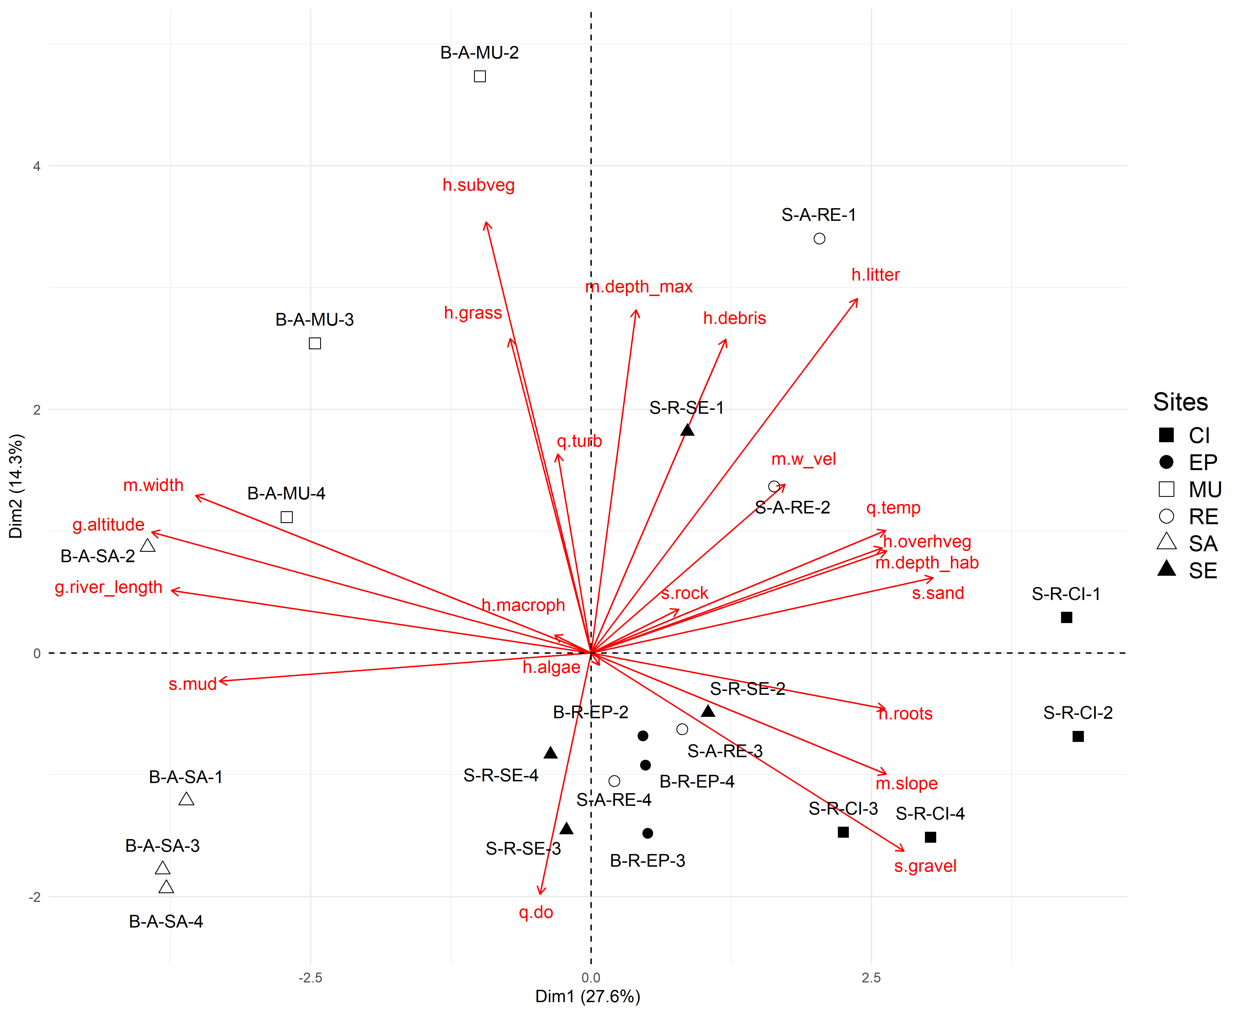
Figure 1: Environment data Principal Component Analysis using the fviz function.
Fig.: Variation in rarefied richness
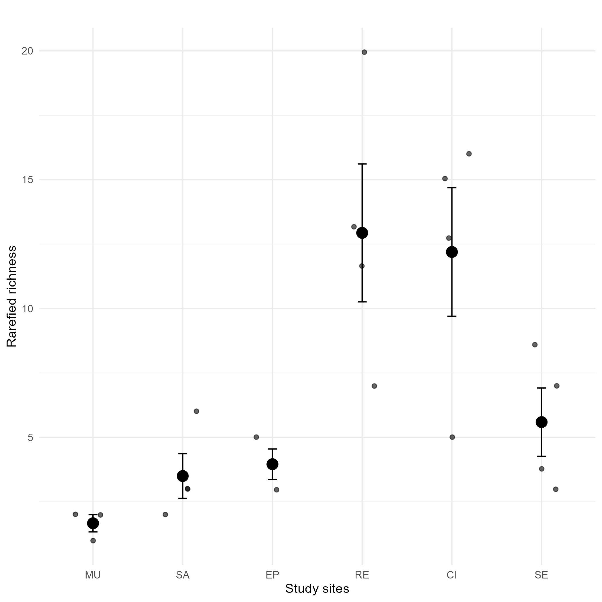
Figure 2: Variation in rarefied richness across study sites.
Fig.: NMDS of community data
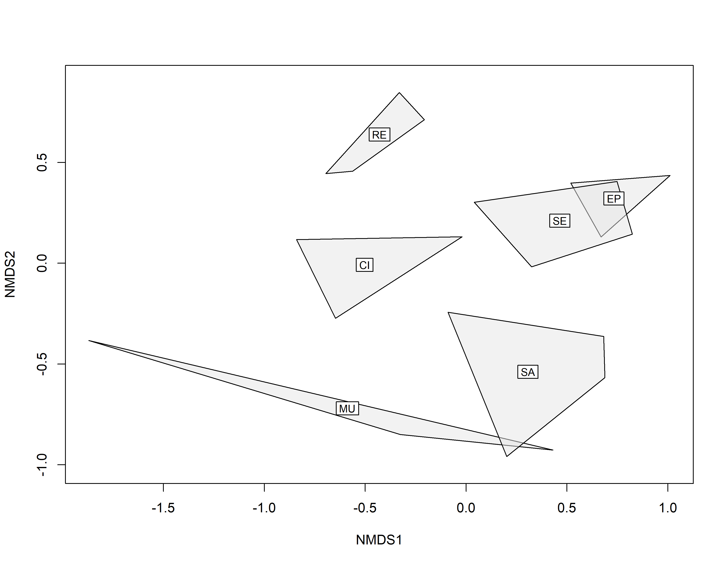
Figure 3: Community data NMDS.
Fig.: Redundace Analisys
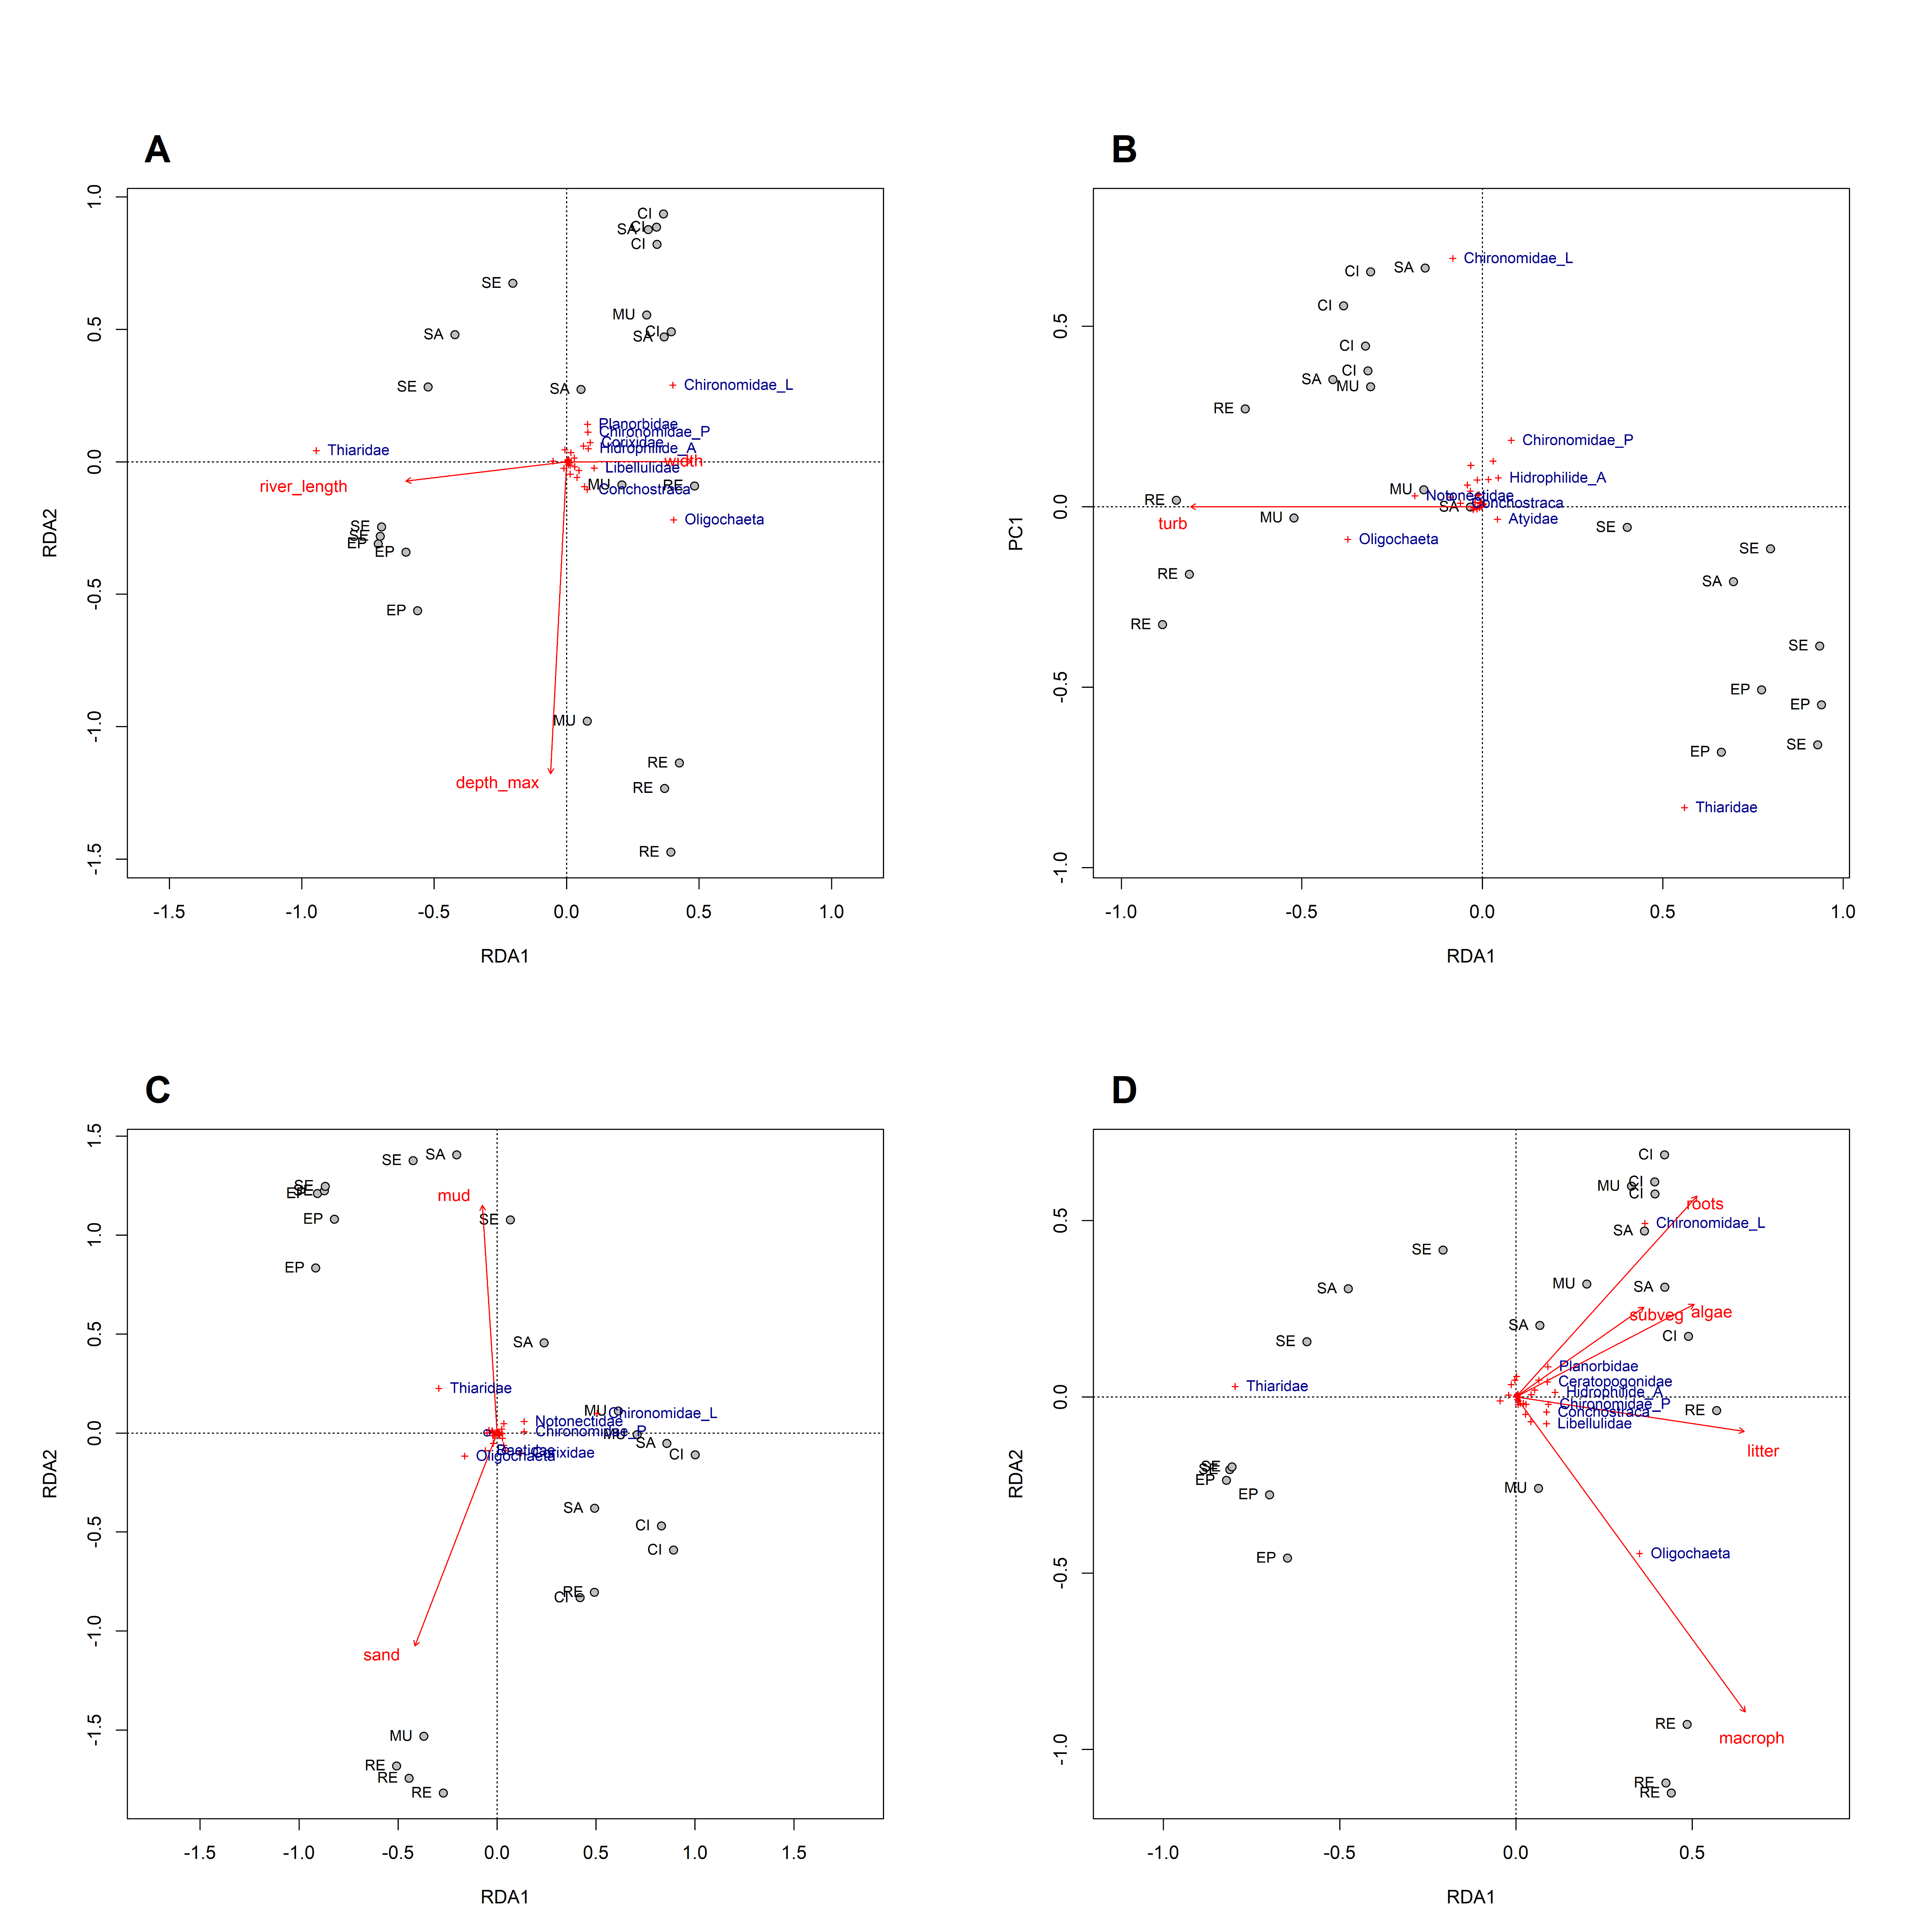
Figure 4: Redundace Analisys.

Tables
Tab.: Environment data GT table
Table 1: Environment data GT table.
 | BuiqueAcudeMU | BuiqueAcudeSA | BuiqueRioEP | SeridoAcudeRE | SeridoRioCI | SeridoRioSE
g.river.length | 214(214-214) | 212.7(212.7-212.7) | 196.8(196.8-196.8) | 110.2(110.2-110.2) | 83(83-83) | 163.2(163.2-163.2)
g.altitude | 725(725-725) | 713(713-713) | 402(402-402) | 270(270-270) | 169(169-169) | 226(226-226)
m.depth.hab | 29.7(22-41.3) | 6.7(4.7-8.2) | 50.7(49.3-52.8) | 36.2(22.3-54.7) | 33.3(22.7-45.3) | 53.2(32.3-81.3)
m.depth.max | 114.7(112-117) | 65(60-69) | 95(80-110) | 117(87-154) | 67.8(60-79) | 98.8(74-110)
m.slope | 30(30-30) | 30(30-30) | 90(90-90) | 60(60-60) | 60(60-60) | 30(30-30)
m.width | 240.4(234.5-247.6) | 313.7(289.5-330) | 25.6(20-29.6) | 90.6(72.2-102) | 15.4(10.7-18.5) | 11.8(5.4-19.6)
q.w.vel | 0(0-0) | 0(0-0) | 0(0-0) | 0.025(0-0.1) | 0.04(0-0.159) | 0.073(0-0.167)
q.temp | 27(26-29) | 26.7(24-29.2) | 29(28.9-29) | 31.6(29-34) | 30.4(27.6-35.2) | 31.4(28.3-32.9)
q.do | 4.9(1.8-7.3) | 6.1(1.9-8.8) | 5.2(5-5.6) | 7.1(4.8-9.4) | 4.9(3-6.9) | 6(5.4-6.5)
q.turb | 65(43-89) | 42.1(25.7-55) | 37.4(30-50) | 67.4(51.7-90) | 42.3(26-60) | 30.8(16-46)
s.mud | 59.1(20.6-91.8) | 94.4(87.8-98) | 40.5(33.7-48.9) | 48.1(5-81.7) | 17.8(0.7-48.8) | 66.4(40-95)
s.sand | 38.4(3.2-77) | 3.9(2-6.7) | 55.6(47.9-63) | 45.5(8.3-95) | 60(22.5-87.7) | 23.7(1.8-40)
h.macroph | 0(0-0) | 12.8(0-46.7) | 0(0-0) | 35.7(5.8-54.8) | 0(0-0) | 2.1(0-8.3)
h.grass | 29.3(5.6-54) | 5.2(0-13.3) | 0.7(0-2) | 2.1(0-8.1) | 5.8(0-23.3) | 11.1(0.1-20)
h.subveg | 15(0-36.6) | 7.3(0-26) | 0(0-0) | 4.2(0-16.7) | 0.8(0-3) | 2.5(0-10)
h.overhveg | 0(0-0) | 0.9(0-3.3) | 0(0-0) | 10.4(0-33.3) | 17.1(0-33.3) | 0(0-0)
h.litter | 2.1(0.4-5) | 0(0-0) | 0.4(0.3-0.5) | 1.5(0.6-3.7) | 1.5(1-2.3) | 0.4(0-0.8)
h.roots | 0(0-0) | 0(0-0) | 0(0-0) | 0(0-0) | 2.3(0-5) | 0(0-0)
s.gravel | 0.8(0-2.4) | 1.7(0-5.6) | 3.1(2-4) | 4.3(0-13.3) | 19.7(11.7-28.8) | 6.3(0.3-20)
s.rock | 1.7(0-5) | 0(0-0) | 0.8(0-1.2) | 2.1(0-8.3) | 2.5(0-10) | 3.6(0-8.3)
h.algae | 10.1(0-30) | 17.3(0-43.3) | 0.1(0-0.4) | 17.7(0-33.3) | 21.4(0-75) | 5.1(0-12)
h.debris | 10.7(10-11.7) | 0.9(0-3.8) | 1.1(0.4-2.5) | 7.2(1.7-13.7) | 4.7(1-10.3) | 2.6(0-5)
Tab.: List of taxa GT table
Table 2: List of taxa GT table.
Taxa | MU | SA | EP | RE | CI | SE | F.O. (%)
INSECTA
Hemiptera
Belastomatidae | 0 | 0 | 0 | 1(2.1) | 0 | 0 | 4.545455
Corixidae | 0 | 0 | 0 | 10.9(21.9) | 447.4(693.4) | 0 | 18.181818
Naucoridae | 0 | 0 | 0 | 6.3(11.2) | 0 | 0.5(1.0) | 13.636364
Notonectidae | 6.2(10.8) | 0 | 0 | 5.7(11.5) | 22.4(15.5) | 1.6(3.1) | 27.272727
Veliidae | 0 | 0 | 0 | 0 | 1.6(3.1) | 0 | 4.545455
Coleoptera
Curculionidae | 0 | 0 | 0 | 2.6(5.2) | 0.5(1.0) | 0 | 9.090909
Dytiscidae (larvae) | 0 | 0 | 0 | 1(1.2) | 2.1(2.9) | 0 | 18.181818
Dytiscidae (adult) | 0.7(1.2) | 0 | 0 | 3.6(7.3) | 4.2(5.1) | 9.4(18.8) | 22.727273
Gerridae | 0 | 0 | 0 | 0 | 1(2.1) | 0 | 4.545455
Hidrophilidae (larvae) | 0 | 0 | 0 | 5.7(5.7) | 115.1(179.0) | 0.5(1.0) | 27.272727
Hidrophilide (adult) | 0 | 0 | 0 | 38(47.2) | 5.2(6.5) | 7.8(15.6) | 31.818182
Diptera
Ceratopogonidae | 0 | 0 | 0.7(1.2) | 9.4(12.0) | 25.5(38.7) | 3.6(7.3) | 45.454545
Chaoboridae | 0 | 0 | 0 | 0 | 1(2.1) | 0 | 4.545455
Chironomidae (larvae) | 4.2(3.6) | 15.1(6.4) | 7.6(6.7) | 509.9(926.2) | 2483.9(2583.7) | 442.2(862.2) | 90.909091
Chironomidae (pupae) | 0 | 1(2.1) | 0 | 12.5(25.0) | 57.3(82.5) | 1.6(3.1) | 22.727273
Ephemeroptera
Baetidae | 2.1(3.6) | 0.5(1.0) | 0 | 9.4(16.1) | 46.9(86.9) | 0 | 31.818182
Caenidae | 0 | 0 | 0 | 14.1(28.1) | 65.1(130.2) | 0.5(1.0) | 13.636364
Leptohyphidae | 0 | 0 | 0 | 0 | 18.2(36.5) | 0 | 4.545455
Odonata
Coenagrionidae | 0 | 0 | 0 | 8.3(12.6.0) | 0 | 1(2.1) | 18.181818
Gomphidae | 0 | 0.5(1.0) | 0.7(1.2) | 1(2.1) | 13(14.5) | 5.7(7.5) | 40.909091
Libellulidae | 0 | 0 | 0 | 77.1(39.5) | 47.4(80.2) | 0 | 27.272727
Trichoptera
Glossosomatidae | 0 | 0 | 0 | 0 | 3.1(3.6) | 0 | 9.090909
Leptoceridae | 0 | 0 | 0 | 0 | 1.6(3.1) | 0 | 4.545455
GASTROPODA
Ampularidae | 0 | 0.5(1.0) | 0 | 0 | 1.6(2.0) | 0 | 13.636364
Lymnaeidae | 0 | 0 | 0 | 1.6(3.1) | 0 | 0 | 4.545455
Planorbidae | 0 | 3.1(4.0) | 0.7(1.2) | 98.4(145.3) | 139.1(218.3) | 132.3(238.6) | 59.090909
Physidae | 0 | 0 | 0 | 15.6(18.0) | 0 | 0 | 13.636364
Thiaridae | 0 | 16.1(28.3) | 2090.3(1051.4) | 0 | 1(1.2) | 5785.9(5418.1) | 50.000000
CRUSTACEA
Atyidae | 0 | 0 | 9(10.7) | 0 | 0 | 24(28.5) | 18.181818
Conchostraca | 0 | 0 | 0 | 93.8(146.0) | 0 | 0 | 13.636364
Ostracoda | 0 | 0 | 0 | 67.7(131.3) | 0 | 0 | 9.090909
ANNELIDA
Hirudinea | 0 | 0 | 0 | 4.2(5.1) | 0 | 0 | 9.090909
Oligochaeta | 0 | 1.6(2.0) | 95.8(143.2) | 2016.1(869.3) | 3.1(2.7) | 0 | 50.000000
BIVALVIA
Sphaeridae | 0 | 0 | 0 | 0 | 0.5(1.0) | 0 | 4.545455
TROMBIDIFORMES
Hydrachnidia | 0 | 0 | 0 | 0 | 23.4(46.9) | 0 | 4.545455

Apêndices
 Non-used figures ana tables
Fig.: Environment variables pairs
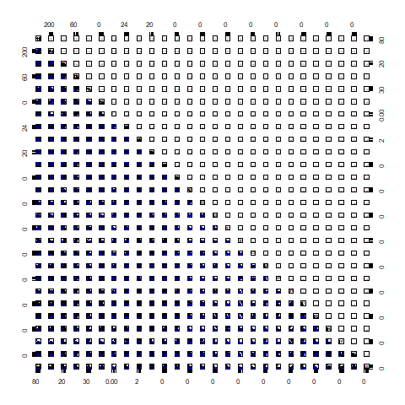
Figure 5: Environment variables correlations pairs.
Fig.: Habitat variables correlations plot
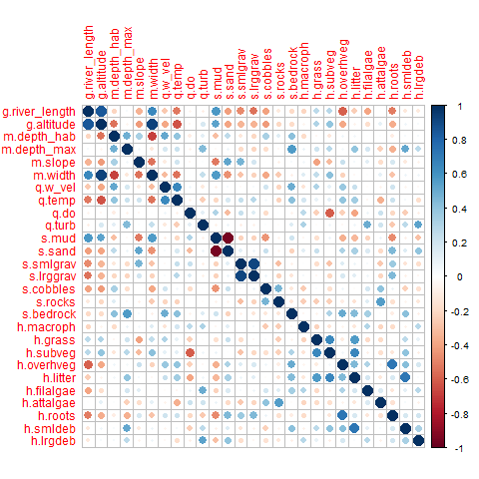
Figure 6: Habitat variables correlations correlogram.
Fig.: Environment data PCA - R Base
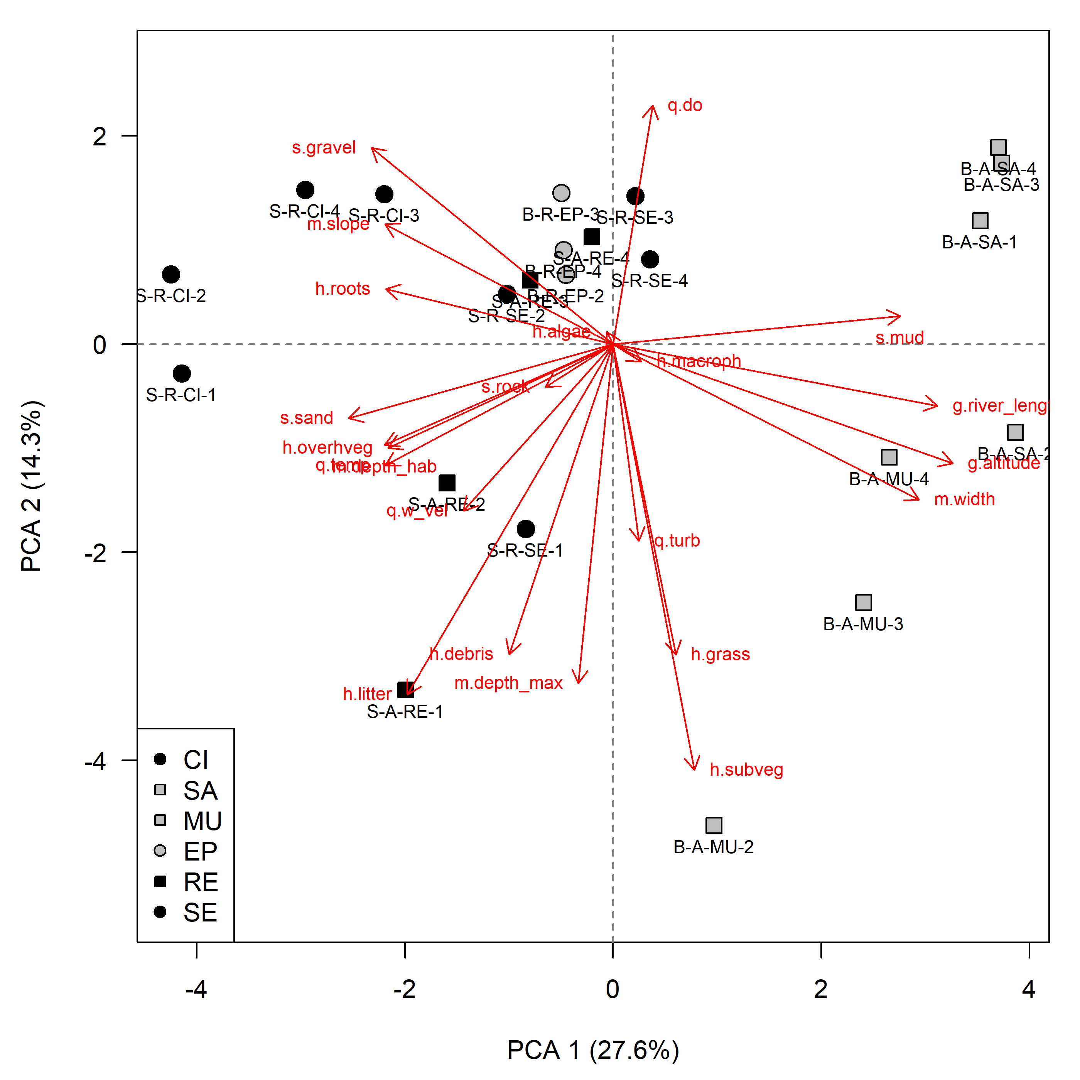
Figure 7: Environment data Principal Component Analysis using the prcomp and plot functions.
Fig.: Multilevel Pattern Analysis of indicator species
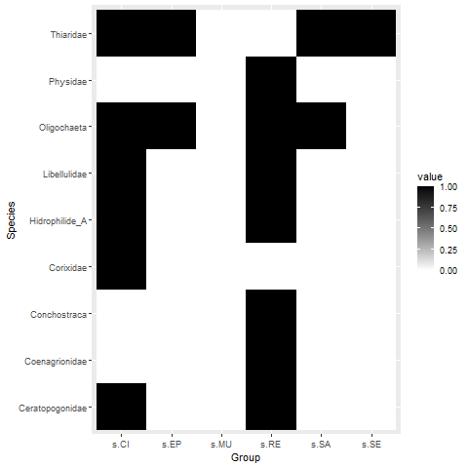
Figure 8: Multilevel Pattern Analysis of indicator species.
Tab.: Environment data GT table
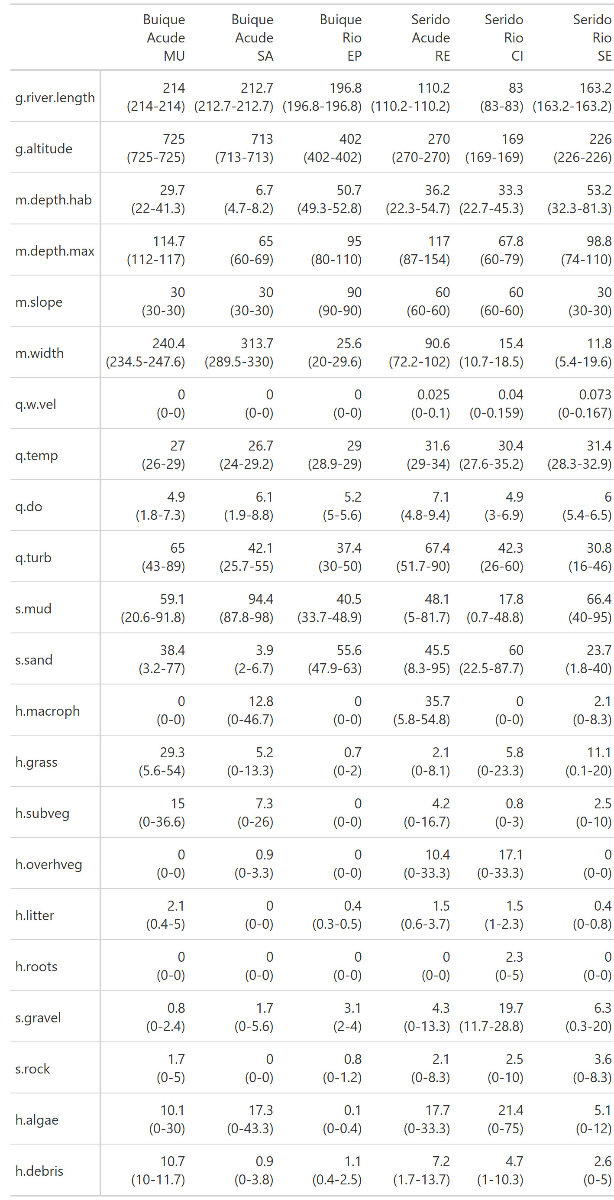
Figure 9: Environment data GT table
Tab.: Density data table
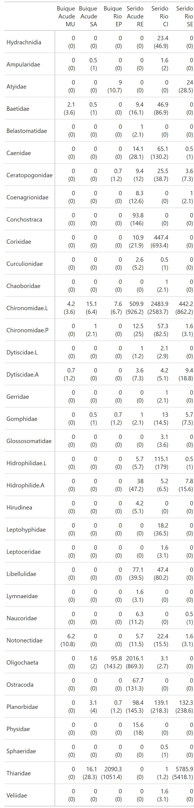
Figure 10: Density of species data table.
Tab.: Diversity descriptors data table
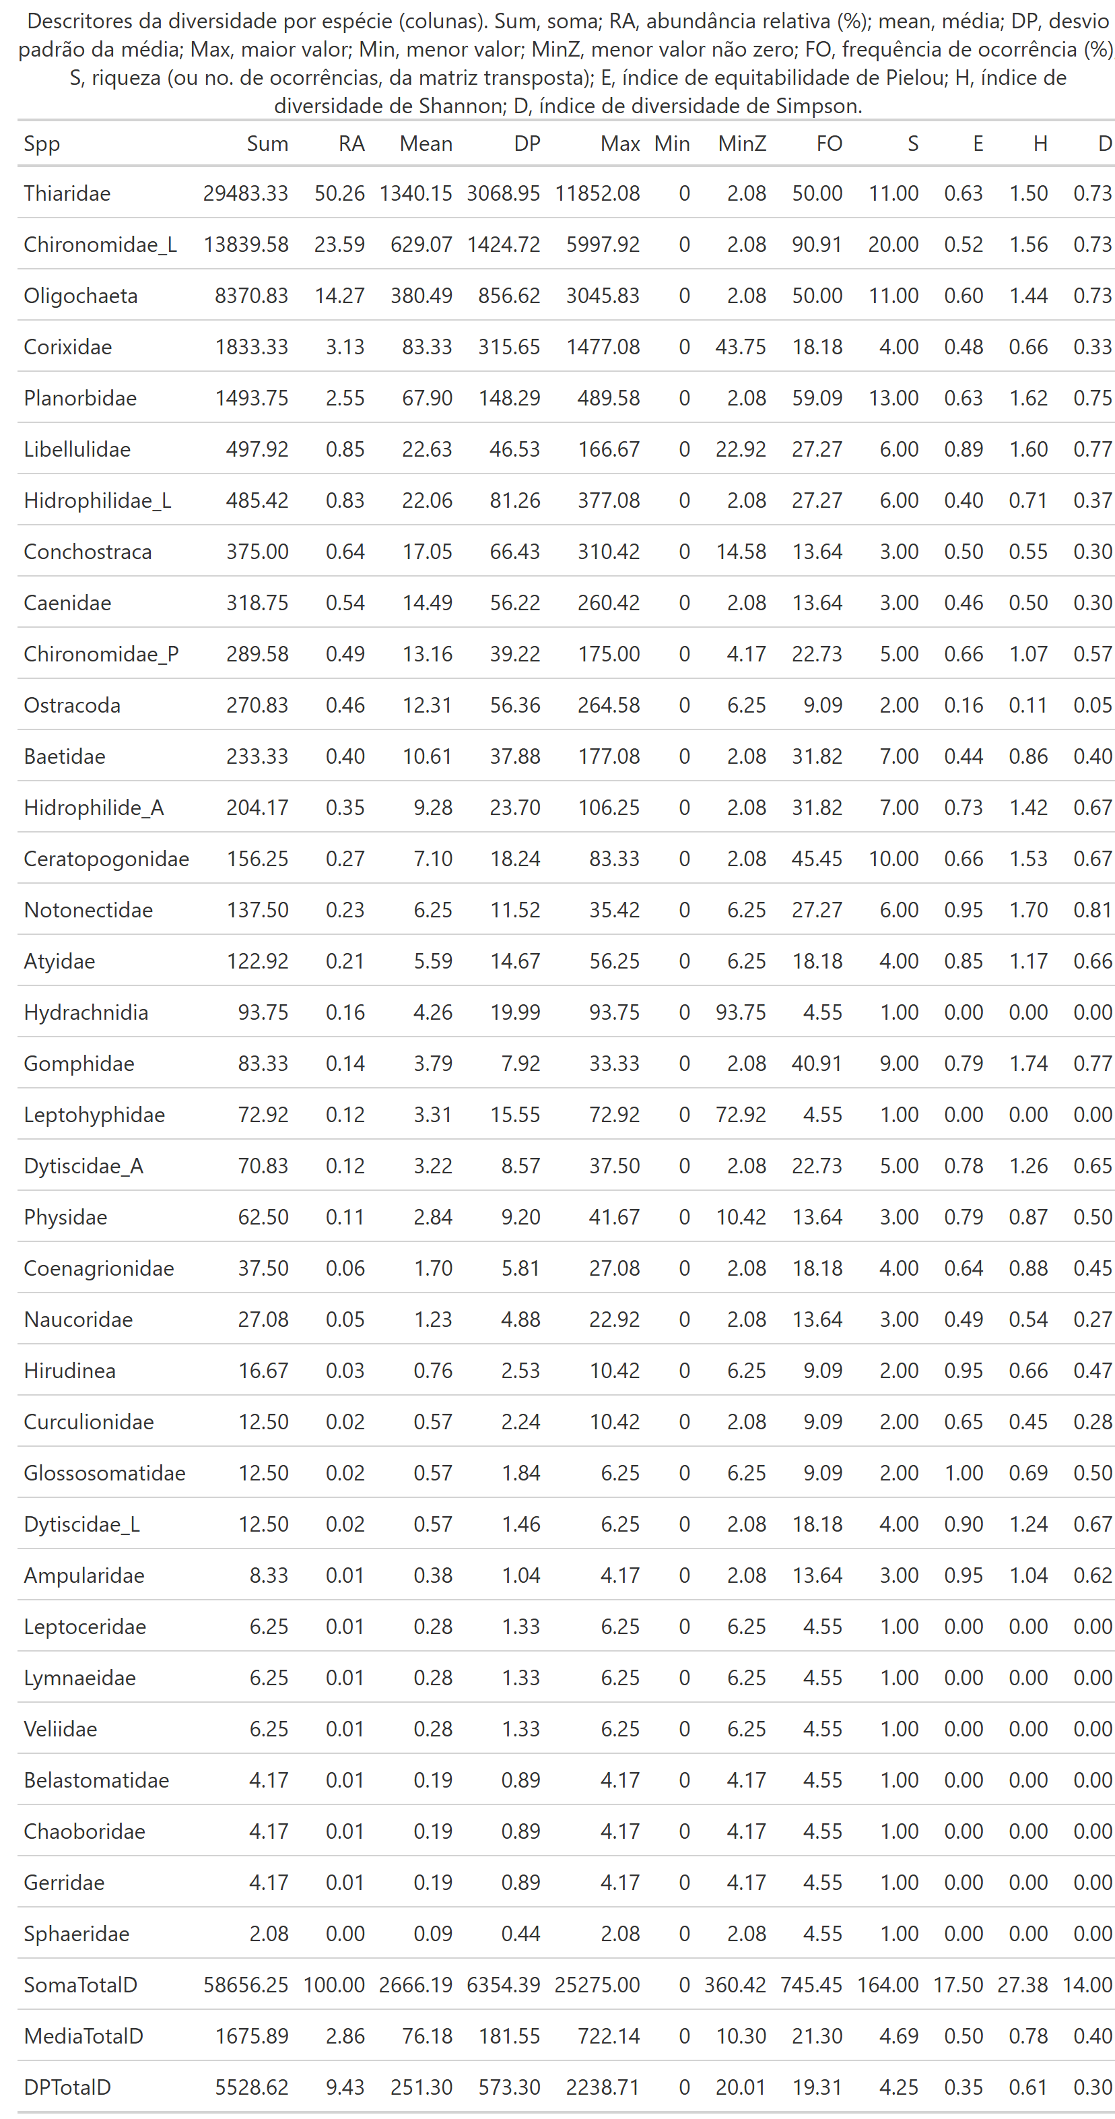
Figure 11: Diversity descriptors of the community structure data table.

 Non-used codes

Neotropical Entomology

