Untitled
Steven V. Miller

Seciton

Subsection

dsfsfs
Lorem ipsum dolor sit amet, consectetur adipiscing elit. Sed commodo consequat mi in fermentum. Phasellus id nisi at nibh sollicitudin volutpat non et massa. Nam nec sapien porttitor, sollicitudin erat vitae, auctor mauris. Nam nisl enim, sagittis vitae semper vitae, suscipit id turpis. Aliquam vel lacinia libero, sit amet dapibus nunc. Nullam vitae bibendum orci. Vestibulum hendrerit maximus volutpat. Nulla a placerat sapien. Integer ullamcorper dapibus magna, eget scelerisque orci consequat quis. Fusce suscipit mi tortor, ultricies faucibus arcu finibus at. Quisque blandit velit in hendrerit pulvinar.
Integer vitae consequat mi, sit amet pulvinar massa. Quisque at dui lectus. Mauris malesuada mattis arcu nec ultricies. Integer quis condimentum nulla. Nullam lacinia vel diam condimentum hendrerit. Quisque sed rhoncus dolor. Vivamus at sem vitae nisi imperdiet hendrerit a sed felis. Quisque sollicitudin ex nec enim malesuada iaculis. Nam in interdum sapien. Fusce pellentesque volutpat metus faucibus vulputate. In turpis odio, ornare tempus facilisis vel, malesuada sed est.

R Markdown
This is an R Markdown document. Markdown is a simple formatting syntax for authoring HTML, PDF, and MS Word documents. For more details on using R Markdown see http://rmarkdown.rstudio.com.
When you click the Knit button a document will be generated that includes both content as well as the output of any embedded R code chunks within the document. You can embed an R code chunk like this:
summary(cars)
## speed dist
## Min. : 4.0 Min. : 2.00
## 1st Qu.:12.0 1st Qu.: 26.00
## Median :15.0 Median : 36.00
## Mean :15.4 Mean : 42.98
## 3rd Qu.:19.0 3rd Qu.: 56.00
## Max. :25.0 Max. :120.00

Including Plots
You can also embed plots, for example:
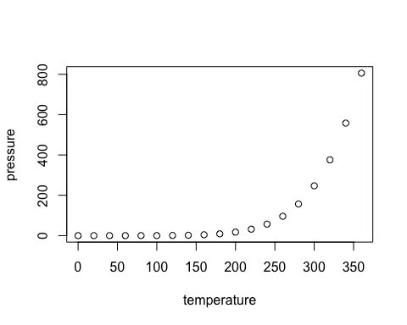
Note that the echo = FALSE parameter was added to the code chunk to prevent printing of the R code that generated the plot.

