Title
  - Subtitle 1 Subtitle 2
Steve Purves
Rowan Cockett
2026-03-04
Abstract
Abstract
Table of contents

1. Introduction
The scientific research follows the model shown in the figured cross-referenced here (Figure 1).

2. Material and Methods
Data and methods are discussed in Section 2.2. This citation will appear in the bibliography section (Gouveia et al. (2017); Medeiros et al. (2008)).

2.1 Study Area and Sampling Design
See publications by Gouveia et al. (2017).

2.2 Data Collection
See publications by Macêdo et al. (2019).

2.3 Statistical Analyses
Here you can add your statistical analyses and follow the text with the RStudio code. Following the model in https://elviomedeiros.github.io/Bentos2006_Q/.
plot(1:10)

3. Results
The results section should follow the model in https://elviomedeiros.github.io/Bentos2006_Q/.

3.1 Environmental variables

3.2 Community structure

4. Discussion

Conclusions

Acknowledgements

Authorship contribution statement
Authorship of this paper is based on CRediT (2026).
Author1: Writing – review & editing, Writing – original draft, Formal analysis, Data curation, Conceptualization. Author2: Writing – review & editing, Data curation, Conceptualization. Author3: Writing – review & editing, Formal analysis, Data curation, Conceptualization.

Ethical approval
This study did not require ethical approval as it did not involve human participants or sensitive data. Field surveys were conducted based on collection permit number (IEF-10327-6 and SISBIO-10.635-7).

References
CRediT. (2026). CRediT - contributor role taxonomy. NISO/CRediT Standing Committee. https://credit.niso.org/
Gouveia, R. S. D., Lira, G. L. D. A., Anselmo Ramos, T. P., & Medeiros, E. S. F. (2017). Ichthyofauna of the Reserva Biológica Guaribas and surrounding areas, state of Paraíba, Brazil. Check List, 13(5), 581–590. https://doi.org/10.15560/13.5.581
Macêdo, A. K. S., Da Silva, J. R. P., Dos Santos, H. B., Thomé, R. G., Vendel, A. L., & Amado, E. M. (2019). Estuarine fish assemblages present a species-specific difference in the multixenobiotics resistance activity. Journal of Experimental Zoology Part A: Ecological and Integrative Physiology, 331(10), 530–539. https://doi.org/10.1002/jez.2320
Medeiros, E. S. F., Silva, M. J., & Ramos, R. T. C. (2008). Application of catchment- and local-scale variables for aquatic habitat characterization and assessment in the brazilian semi-arid region. Neotropical Biology and Conservation, 3(1), 13–20.

Figures and Tables

Figures
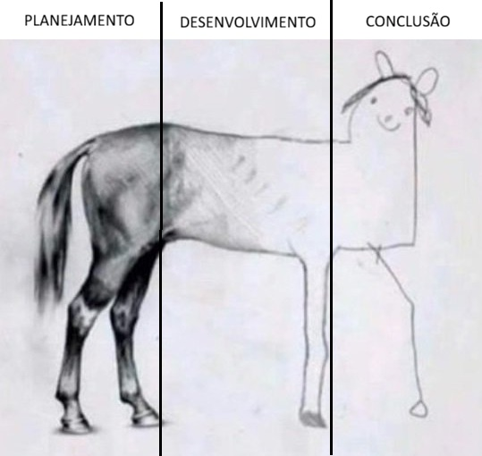
Figure 1: Etapas do desenvolvimento da pesquisa científica.

Tables

Apendices

Non-used figures and tables
 Non-used codes

