Contrasting conservation conditions shape the spatial partitioning of zooplankton diversity in Atlantic Forest streams
Contrasting conservation conditions shape the spatial partitioning of zooplankton diversity in Atlantic Forest streams ON Acta Limnologica Brasiliensia
Ellen Gomes da Silva
Mayara Mirelly da Silva Monteiro
Marcela Vitória Bernardo da Silva
Ludmilla Cavalcanti Antunes Lucena
Thais Xavier de Melo
Elvio Sergio Figueredo Medeiros
2026-09-30
Abstract
Abstract

Table of contents

List of Figures

List of Tables

1. Introduction
Essas abordagens são baseadas nos conceitos de turnover and nestedness. Species turnover and nestedness are two distinct components used to break down and understand beta diversity—which measures how much species composition changes between different communities or sites (Baselga, 2010), where, turnover is the replacement of some species by different species from one site to another, while nestedness is the loss or gain of species where poorer sites contain a strict subset of the species found at richer sites.
CITAR: (Ávila et al., 2011; Baselga, 2010, 2012; Crist et al., 2003; Ligeiro et al., 2010; Shell & Collier, 2018)

1.1 Objectives
This study describes the richness and density of zooplankton, comparatively between two small head water streams subject to different levels of environmental pressures. One originates withing a protected area - Biological Reserve, or REBIO, according to Brasil (2000) - and its course extends beyond its administrative boundaries (MMA, 2003), and a second one that flows entirely outside of the protected area. Within this framework, we use hierarchical additive partitioning to evaluate the relative contribution of different spatial and temporal scales to the diversity of zooplankton assemblages. Given the importance of the Atlantic Forest to the biodiversity (Pereira et al., 2026) and its fragmented stated north of the São Francisco river basin (Silva & Casteleti, 2003), we aim with this study, (1) to infer environmental degradation from species turnover (Baselga, 2010) and (2) to associate beta-diversity to the ecological health of sites inside and surrounding a protected area of Atlantic Forest. Given the expected different levels of environmental pressures in the area (Gouveia et al., 2017), we hypothesize that the diversity is not be homogeneously distributed among the different spatial scales but concentrated at the finer levels and seasonal variation will be limited to species composition, but no spacial variation is expected between dry and wet seasons. Some environmental features (reach morphology, habitat structure, and water quality) are also described to explore possible explaining factors for the observed patterns.

2. Material and methods

2.1 Study area and sampling design
This study was conducted in the Guaribas Biological Reserve (REBIO Guaribas), a protected area of Atlantic Forest in northeastern Brazil. This protected area is located in a transitional zone between the Caatinga and Atlantic Forest ecoregions. The land use of the study area is based on the occupation of traditional human populations and an increasing use of land for large scale monocultures, mostly sugar cane (Heinrichs et al., 2017). Other than these, small scale agricultural activities, fishing, and the modification of the natural vegetation for livestock are important anthropogenic pressures that affect the buffer zone of the REBIO (Arruda et al., 2013; MMA, 2026). Other common uses of the soil in the area are, coconut plantations, orchards and subsistence agriculture. These land uses represent important sources of pollution, either through agrochemicals runoff or direct and indirect domestic effluents (such as septic tanks). These nonpoint source pollutants contaminate underground water and create a spatial gradient of environmental disturbance (Mehla et al., 2026). Therefore, the mainly rural nature of the land use associated with the management of vegetation, will cause direct impact to aquatic systems, by the siltation of streams and contamination of groundwater. The hydrographic network of the study region is composed predominantly of small catchments containing first- and second-order streams (Strahler, 1957 classification) (Figure 1). These watercourses are tributaries of the Camaratuba River and are sustained by numerous springs distributed throughout the region. The two main stream systems in the study area are the Barro Branco and Caiana catchemnts. The Barro Branco stream is approximately 8.8 km long and originates within the protected area. Its upper section remains within the boundaries of the REBIO, whereas its middle and lower sections extend into the surrounding landscape. Despite this transition, riparian vegetation is preserved along most of the stream. The Caiana stream is approximately 9.8 km long and also originates within the REBIO, although most of its course lies outside the protection area.
The climate in the region is classified as As’ (Peel et al., 2007), characterized by a mean annual temperature of approximately 25 °C, with maximum temperatures occurring mainly between February and March, during the dry period, as well as by low annual thermal amplitude. Annual precipitation ranges from 1,400 to 1,800 mm, concentrated between March and July, whereas the lowest rainfall levels occur between September and December. In the study area, rainfall is concentrated between March and July, beginning in autumn and extending into winter. This pattern is attributed to the influence of cold air masses from the South Atlantic ocean that affect the region. The hydrographic network is composed of small headwater streams fed by rain (Gouveia et al., 2017).
Sampling was conducted during the dry (January-February) and rainy (June-July) periods of 2024 in two Atlantic Forest streams. A total of 15 sampling sites were distributed longitudinally across the two streams to capture spatial variation in environmental conditions and habitat characteristics. The Barro Branco stream included sampling sites located within the protected area and sites located outside its boundaries, whereas all sampling sites in the Caiana stream were located outside the protected area. This sampling design allowed the assessment of zooplankton diversity across nested spatial scales and contrasting conditions of environmental protection and human influence (Figure 1).
{#SITE TYPES .html} <!--# For comparative purposes, sampling sites were assigned a priori to one of four environmental categories based on their location relative to the protected area and their expected environmental conditions (@fig-refsites). Type I sites, considered reference sites for this study, were located within the protected area and were expected to represent the best-preserved conditions. These sites were characterized by well-preserved riparian vegetation and the absence of agricultural fields within a 1-km radius. They were also expected to meet the following environmental criteria: mean water temperature ≤ 28 °C, mean dissolved oxygen concentration ≥ 6 mg/L, mean water velocity ≥ 0.025 m/s, and mean turbidity ≤ 15 NTU. Type II sites were also located within the protected area but were expected to show some degree of environmental alteration. This category included sites located close to agricultural areas or sites that failed to meet one or more of the environmental or hydrological criteria established for Type I sites. Type III sites were located outside the protected area but were expected to maintain relatively favorable water-quality conditions, broadly comparable to those observed at reference sites. However, because these sites were situated outside the REBIO, they were not expected to satisfy the criteria related to intact riparian vegetation or a minimum distance of 1 km from agricultural fields. Finally, Type IV sites were located outside the protected area and were characterized by evidence of environmental disturbance. These sites did not meet at least one of the water-quality criteria established for reference sites and showed alterations in habitat characteristics relative to Type I sites. As with Type III sites, the criteria concerning riparian forest integrity and distance from agricultural fields were not met for this category because these sites were intentionally selected outside the REBIO. The classification was subsequently evaluated and confirmed using environmental measurements collected in situ. -->

2.2 Environmental data collection
To evaluate whether the a priori classification of sampling sites into Types I–IV was supported by quantitative environmental information, environmental conditions were characterized using four groups of variables: site morphology, water quality, substrate composition, and marginal habitat structure. Morphological characteristics were assessed from three randomly selected transects at each site, where stream width (cm) and water depth (cm) were measured. Bank slope was classified into four categories according to its inclination: 1, ≤ 20°; 2, > 20–30°; 3, > 30–50°; and 4, > 50°. Broader-scale landscape characteristics, including elevation and stream length, were obtained from handheld GPS records and satellite imagery. Water quality was characterized using physical and chemical measurements obtained with portable instruments, including water temperature (°C) and dissolved oxygen concentration (mg/L). Turbidity was subsequently measured in the laboratory with a turbidimeter using water samples collected at each sampling site. Current velocity (m/s) was estimated using the float method, as described by Maitland (1990). Substrate composition and the physical structure of marginal habitats were evaluated following procedures adapted by Medeiros et al. (2008) from the protocols proposed by Pusey et al. (2004) and Mugodo et al. (2006). Between 9 and 12 quadrats (1 m²) were distributed along the terrestrial–aquatic interface at each sampling site. Within each quadrat, the proportional cover of different substrate categories was visually estimated, including mud, sand, cobbles, small and large gravel and rocks. The same quadrats were used to characterize littoral and submerged habitat features. Recorded habitat components included macrophytes, marginal grasses, leaf litter, attached and filamentous algae, overhanging and submerged vegetation, small and large woody debris, and root masses. For subsequent analyses and presentation, environmental measurements were summarized as mean values for each sampling site.
Three 250 mL replicate samples of water from each site were taken and refrigerated for concentration analysis (μg L⁻¹) of ammonia, nitrite, nitrate, orthophosphate (soluble reactive phosphorus) and total phosphorus. Nutrient concentrations were obtained based on Standard Methods for the Examination of Water (1998) and Mackereth et al. (1978).
The ecophysiological evaluation of human impact on the forest, was mainly guided by the fish species inventory for the REBIO made by Gouveia et al. (2017). This study lists 18 species from five different orders: Characiformes (12 species), Perciformes (3 species), Synbranchiformes (1 species), Siluriformes (1 species) e Cyprinodontiformes (1 species). From those, two are exotic - Oreochromis niloticus, second most farmed fish species in the world and tolerant to osmotic variation, and Poecilia reticulata, largely used in mosquito control and resistant to stressful environments (Miranda, 2012). The predominance of small fish inhabiting small basins is thought to lead to low dispersion and consequent isolation of populations (Gouveia et al., 2017), associated with the fact that most species in the study area are phylogenetic close (with the predominance of Characidae) and are widely distributed, offers an appropriate design to access the entire local ichthyofauna using a few species, namely the genuses Hemigrammus and Astyanax.

2.3 Zooplankton sampling
Zooplankton was sampled at habitats within each sampling site, hereafter referred to as habitat samples. Collections were performed in the main channel of the streams at the surface water. At each sampling habitat, a plankton net (30 cm mouth diameter, 70 cm length, and 60 μm mesh size) was used to filter 50 L of water. The net was rinsed between successive samples to prevent clogging and carryover of organisms. Each sample was concentrated to a final volume of 80 mL for laboratory analyses. Following collection, zooplankton samples were anesthetized with commercial sparkling water and subsequently preserved in 4% formalin. Sucrose was added to the preserved material to reduce the loss of eggs by female cladocerans and minimize deformation of zooplankton carapaces (Haney & Hall, 1973). In the laboratory, samples had their zooplankton identified and counted using a Sedgewick–Rafter counting chamber. The analyses focused on representatives of Rotifera, Cladocera, and Copepoda. Taxonomic identification was based on specialized literature and confirmed by specialists. To evaluate whether the sampling effort adequately represented the zooplankton assemblage, species accumulation curves were calculated
Zooplankton was collected using a plankton net (opening diameter 30 cm, 70 cm long, pore size 60 µm and sample cup of 80 mL). At three different locations, at each site, one sample of fifty liters of water was filtered through the net. Commercial sparkling water was added to the sample to narcotize the zooplankters, which were the preserved in 4% formalin (EPA 2013). Sucrose was added to the preserved sample to prevent female cladocerans from losing eggs and to minimize carapace distortion (Haney e Hall 1973). In the laboratory, three subsample aliquots of 1 mL were taken from each sample and all individuals were identified and counted in a Sedgewick-Rafter counting cell (Koste 1978, Elmoor-Loureiro 1997, Elmoor-Loureiro e Sousa 2021, GBIF.org 2023, NIES 2023, Haney J. F. et al 2024). Only rotifers, cladocerans and copepods were considered in the present study.

2.4 Statistical analyses
Environmental variables were screened for multicollinearity and to identify redundant descriptors. Variables representing similar environmental information were also combined when appropriate, thereby reducing redundancy in the dataset (Legendre & Legendre, 1998).
These data were then analyzed using Principal Component Analysis (PCA) to summarize multivariate patterns of environmental variation among sampling sites. Prior to PCA, site morphology and water-quality variables were square-root transformed (Sokal & Rohlf, 1995). Variables describing sediment composition and marginal habitat structure, expressed as percentages, were relativized by their column totals and subsequently subjected to the arcsine square-root transformation (McCune & Grace, 2002). PCA was conducted in R using the FactoMineR package (Lê et al., 2008), with all variables centered and standardized to unit variance before analysis. The water quality parameters temperature and dissolved oxygen, and all nutrients were used to characterize differences between streams but were not used in the PCA because they were not measured for both seasons.
Zooplankton diversity was characterized using species richness (R) and Shannon’s density (D) (Magurran, 2013). Species richness was calculated as the number of species recorded in each sample, whereas density was expressed as the number of individuals per liter (ind./L) (Bowen, 2017; Silva et al., 2017). Variation in richness and density was evaluated using factorial analysis of variance (ANOVA) followed by post hoc multiple comparisons using Tukey’s HSD test (α=0.05) (Zar, 2010). Density was square root transformed to enhance normality and homogeneity of variances (Sokal & Rohlf, 1995) and species richness was corrected based on rarefied analyses for the average number of individuals from all sites (Chao et al., 2014; Oksanen et al., n.d.).
Each observation was classified according to three factors: river reach (three levels), habitat (three levels), and hydrological season (wet and dry). The analysis initially considered the full factorial model. When significant interactions were detected, higher-order interactions were examined first, followed by the corresponding two-way interactions (reach × season, reach × habitat, and season × habitat) and, subsequently, the main effects. Response variables were transformed using log₁₀(x + 1) to improve compliance with assumptions of normality and homogeneity of variances [39]. Differences among factor levels were subsequently investigated using Tukey’s HSD test at α = 0.05. –>
Differences in assemblage composition across the spatial hierarchy were explored using hierarchical agglomerative clustering. Bray–Curtis dissimilarities were calculated from the density matrix, and clusters were formed using the flexible beta linkage method (β = −0.25) (Ávila et al., 2011). Prior to the analyses, density data were relativized and square-root transformed to reduce the influence of highly abundant taxa and improve the distributional properties of the dataset (Rocha et al., 2012). The resulting dendrogram was interpreted visually, and the number of groups retained was determined using a cut-off corresponding to 25% or less of the remaining information (Quinn & Keough, 2023). The statistical significance of compositional differences among groups and spatial levels was evaluated using the Multi-Response Permutation Procedure (MRPP) (Biondini et al., 1985; McCune & Grace, 2002). In addition to the probability associated with the test, the MRPP agreement statistic (A) was used to describe within-group homogeneity relative to that expected under random grouping. Both the hierarchical clustering and MRPP analyses were conducted in PC-ORD version 7.07.
Additive diversity partitioning was used to quantify the contribution of within- and between-unit diversity to total zooplankton diversity. In this framework, alpha diversity (α) represents diversity occurring within sampling units, whereas beta diversity (β) represents the contribution of differences among units at successive levels of the spatial hierarchy. The hierarchical structure included three spatial scales. The finest scale consisted of habitat samples within each site (n = 3), the intermediate scale corresponded to each site (n = 18, for the Barro Branco stream, and n = 27, for the Caiana stream), whereas the broadest scale represented differences among the upper and lower river sections (n = 36, for the Barro Branco stream, and n = 54, for the Caiana stream). Accordingly, total diversity (γ) was decomposed into within-habitat diversity (α₁) and the successive beta components associated with differences among habitats (β₁), among sites withing river reaches (β₂), and among river reaches (β₃). The contribution of each component was expressed as a percentage of total diversity. To investigate seasonal variation in the hierarchical structure of diversity, additive partitioning was performed independently for the wet and dry seasons and for each stream.
Additive diversity partitioning was conducted in R using the adipart function implemented in the Vegan package (Oksanen et al., n.d.; R Core Team, 2017). Significance was evaluated using individual-based randomizations under a Type I null model (Crist et al., 2003). For each hierarchical level, 10,000 randomized communities were generated to produce null distributions for the corresponding α- and β-diversity components. The observed diversity components were then compared with their respective null distributions. The probabilities generated by the randomization procedure were interpreted as measures of departure from random expectations, Values below 0.05 indicated that the observed component was significantly greater than expected under the null model, whereas values above 0.95 indicated that the observed value was significantly lower than expected (Gering et al., 2003; Veech et al., 2003).

3. Results

3.1 Environmental variables and nutrient concentration
<!--#
É importante destacar que as unidades amostrais (UAs) P05 a P10 correspondem ao riacho Barro Branco, sendo as UAs P5, P6 e P7 localizadas no interior da reserva, enquanto que os pontos P08, P09 e P10 estão situados fora da área de preservação. O riacho Caiana, por sua vez, é representado pelas UAs P12 a P20, todas localizadas fora da reserva (ver @fig-mapa). Os resultados da Análise de Componentes Principais (PCA) evidenciaram uma clara diferenciação das unidades amostrais com base nas características físicas e estruturais do habitat. Ao longo dos riachos e períodos amostrais analisados. No período seco, observou-se que as UAs P05, P07 e P08, pertencentes ao riacho Barro Branco, apresentaram maior associação a liteira, algas filamentosas e aderidas.
Em contraste, a UA P06 do Barro Branco, juntamente com as UAs P16, P17 e P20, do Caiana, esteve associada principalmente às variáveis estruturais, como a presença de pedras, profundidade máxima, mínima e marginal, largura e vegetação submersa. Além disso, P10 do Barro Branco e P18 do Caiana apresentaram associação evidente ao pH, cujos valores variaram de ácido a levemente neutro. No período chuvoso, a distribuição das unidades amostrais no espaço da biplot indicou alterações nos padrões de associação observados no período seco. As UAs P05 e P06 do Barro Branco, assim como a UA P18 do Caiana, estiveram associadas principalmente à presença de lama, macrófitas, vegetação submersa, folhiço e detritos. Por outro lado, as P08, P10 e P16 apresentaram maior associação com algas filamentosas e aderidas, vegetação marginal e largura média do canal. De modo geral, os resultados indicaram que ambos os períodos contribuíram de formas distintas para a estruturação do habitat, evidenciando variações espaciais e sazonais nas características físicas e estruturais dos riachos estudados.
-->
Water velocity ranged from 0.022 to 0.293 m/s, with the highest values recorded at site 5. Width varied from 1.2 to 7.2 m, while depth ranged from 13.7 to 44.2 cm. Waters were, on average, well oxygenated (from 5.4 to 8.1 mg/L), and cool, with average temperatures from 25.2 to 27.8 °C. Conductivity was high, between 129.0 and 163.3 μS/cm, and pH, neutral to slightly acidic (from 5.5 to 7.0). Turbidity was generally low, although higher values were observed at sites 5 and 6, reaching 17.5 and 29.6 NTU, respectively. Elevation ranged from 41.5 to 112.8 m a.s.l., while the slope reached 50° for some sites. Mud and sand were the main substrate components across all sampled sites, with average cover ranging from 30 to 100% and from 0 to 70%, respectively. Habitat structure varied along the stream course. The reference site (site 1) was characterized by high contributions of overhanging vegetation (90%) and exclusively muddy substrates. Site 2 exhibited similar characteristics, whereas site 3 showed a more reduced habitat complexity. Sites 4–6 displayed greater variation in habitat composition. Overall, the habitat structures contributing most were overhanging vegetation, debris, and root masses, although these contributions varied among sites. Aquatic macrophytes and littoral grass were particularly abundant at site 4, contributing on average 35.8% and 39.2%, respectively, whereas root masses represented the dominant habitat structure at site 5 (76.7%). Sand cover increased downstream, reaching 70% at site 6, where overhanging vegetation was markedly reduced (Table 1).
Principal Component Analysis (PCA) was used to summarize environmental variation among sampling sites and to identify variables contributing to their differences (Figure 2 and Figure 3). The first two principal components explained 37% of the total variance, with the first axis accounting for 21.1%. PCA confirmed the expected quality of sites, separating site types (Figure 2), where site types I and II where associated with higher elevation, the presence of algae and leaf litter, and where dominated by muddy substrate. Sites type III, tended to have higher water velocity and the presence of gravel and sand as substrate. The presence of root masses and greater inclination on the margins were also important features of these sites. Sites type IV showed a wide range of environmental characteristics, certainly due to their greater number. Nonetheless, these sites may be associated with greater depths, the presence of rocks in the substrate, and higher pH and turbidity. Comparison of the two study streams showed that, the Barro Branco stream tended to have a greater presence of algae, macrophytes, leaf litter and submerged vegetation as major habitat structures, a muddy substrate and an overall higher elevation. The Caiana stream was characterized by sandy substrate, with occasionally gravel and rocks, higher depths, and higher pH, turbidity, and water velocity. Dry and rainy seasons did not show clear segregation in the PCA.
Among the averaged nutrient concentrations (Table 2), ammonia ranged from 49.2 to 243.7 µg L⁻¹. The Caiana stream tended to have greater values, overall no clear trend can be observed when comparing both streams. Nitrite and nitrate, on the other hand, show greater concentrations at the Caiana stream, the latter varying from 166.4 to 2003.0 µg L⁻¹, compared with the maximum of 18.8 µg L⁻¹ at the Barro Branco stream. Nitrite was too low to be detectable at the Barro Branco stream. The same pattern was observed for orthophosphate concentrations, being barely detectable at Barro Branco stream, and varying from 4.0 to 13.0 µg L⁻¹ at the Caiana stream. Total phosphorus, however, tended to have higher concentrations at Barro Branco stream, reaching 50.1 µg L⁻¹ at Site 3, but with highly variable values (from non detectable to 38.7 µg L⁻¹, as the second highest value).

3.2 Community structure
<!--#
Foram registrados táxons pertencentes aos grupos Rotifera, Cladocera e Copepoda, distribuídos entre os riachos Barro Branco e Caiana, durante os períodos seco e chuvoso (Tabela 1). No total, foram contabilizadas 15 espécies de Rotifera, 12 de Cladocera e 6 de Copepoda, incluindo estágios juvenis, como náuplios e copepoditos.
A comunidade zooplanctônica esteve distribuída em 15 famílias, sendo Lecanidae a mais representativa em ambos os períodos amostrais, com 15 espécies registradas, seguida por Lepadellidae (4 espécies) e Brachionidae (3 espécies).
No período seco, foram registrados 58 táxons, com predominância de Rotifera, seguidos por Cladocera e Copepoda. No período chuvoso, observou-se o mesmo padrão de composição, contudo, com redução no número total de táxons, sendo registrados 40 táxons.
Entre os Rotifera, a família Lecanidae foi a mais representativa em ambos os períodos, com espécies do gênero Lecane ocorrendo de forma recorrente nos dois riachos. Espécies como *Lecane bulla* (Gosse, 1851), *L. cornuta* (Müller, 1786), *L. crepida* (Harring, 1914), *L. curvicornis* (Murray, 1913), *L. leontina* (Turner, 1892), *L. lunaris* (Ehrenberg, 1832) e *L. luna* (Müller, 1776) ocorreram em ambos os períodos e foram compartilhadas entre os riachos Barro Branco e Caiana.
O Caiana apresentou maior número de táxons exclusivos, especialmente entre Rotifera e Cladocera, tanto no período seco quanto no chuvoso, enquanto no Barro Branco apresentou composição mais reduzida.
Quando se discute sobre espécies exclusivas, se refere a espécies que ocorrem unicamente no riacho amostrado, logo:
No período seco foram registradas 12 espécies de Rotifera exclusivas no riacho Caiana, incluindo *Dicranophoroides* sp., *Dissotrocha aculeata* (Ehrenberg, 1832), *Testudinella mucronata* (Gosse, 1886), *Lepadella patella* (Müller, 1773), *Lepadella* sp.1, *Lepadella* sp.2, *Euchlanis dilatata* (Ehrenberg, 1832), *Polyarthra bicerca* (Wulfert, 1956), *P. dolichoptera* (Idelson, 1925), *Mytilina crassipes* (Lucks, 1912), *M. bisulcata* (Lucks, 1912) e *Trichotria tetractis* (Ehrenberg, 1830). Ainda neste período, no Barro Branco foram registradas 9 espécies de Rotifera exclusivas, sendo elas *Lecane aculeata* (Jakubski, 1912), *L. furcata* (Murray, 1913), *L. quadridentata* (Ehrenberg, 1830), *Lecane* sp.3, *Brachionus patulus* (Müller, 1786), *Polyarthra dolichoptera* (Idelson, 1925), *Polyarthra* sp., *Mytilina bisulcata* (Lucks, 1912) e *Trichocerca* sp.
No período chuvoso, o riacho Caiana manteve o maior número de espécies exclusivas (5 espécies), sendo elas *Testudinella mucronata* (Gosse, 1886), *Filinia longiseta* (Ehrenberg, 1834), *Lecane aculeata* (Jakubski, 1912), *L. papuana* (Murray, 1913) e *Colurella* sp. No riacho Barro Branco, foram registradas 4 espécies exclusivas: *Cephalodella* sp., *Macrochaetus* sp., *Lepadella* *ovalis* (Müller, 1786) e *L. patella* (Müller, 1773).
Entre os Cladocera, foram registradas 5 famílias e 12 espécies. A família Chydoridae apresentou ampla distribuição, com *Alonella dadayi* (Birge, 1910) ocorrendo em ambos os riachos e períodos. No período seco, foram registradas sete espécies exclusivas no riacho Caiana, enquanto no riacho Barro Branco foi registrada apenas *Chydorus* sp. No período chuvoso, o número de espécies exclusivas reduziu-se para uma em cada riacho, sendo *Leydigia* sp. no Caiana e *Macrothrix* sp. no Barro Branco.
Os Copepoda estiveram representados pelas famílias Cyclopidae (*Macrocyclops* sp., *Mesocyclops* sp. e *Paracyclops* sp., com exceção da ocorrência da primeira espécie no Caiana durante o período chuvoso) e Diaptomidae (*Notodiaptomus* sp., ocorrendo apenas no Caiana no período seco e chuvoso). Estágios juvenis de náuplios e copepoditos ocorreram em ambos os riachos durante os dois períodos.
-->

3.3 Diversity Partitioning
<!--#
A análise dos dados, conduzida por meio de diagramas de Venn, revelou a distribuição da riqueza de espécies nos riachos Barro Branco e Caiana durante os períodos seco e chuvoso, destacando como diferentes espécies são compartilhadas e exclusivas entre estes ambientes.
No período seco, foram registradas 27 espécies compartilhadas entre os riachos. O Caiana apresentou alfa (α) diversidade de 46 espécies, destas, 19 eram espécies exclusivas, enquanto o Barro Branco apresentou α-diversidade de 39 espécies, com 12 espécies exclusivas. Considerando ambos os riachos, o patrimônio regional (γ) foi de 58 espécies.
No período chuvoso, o número de espécies compartilhadas permaneceu inalterado, com 27 espécies. Entretanto, observou-se uma redução na α-diversidade e no número de espécies exclusivas, bem como na diversidade gama. No Caiana, a α-diversidade foi de 34 espécies, com 7 espécies ocorrendo apenas neste riacho. No Barro Branco, registrou-se α-diversidade de 33 espécies, com 6 espécies exclusivas. A γ-diversidade total foi de 40 espécies.
De modo geral, os resultados indicam que o número de espécies exclusivas variou entre os períodos hidrológicos, embora grande parte da riqueza tenha sido compartilhada entre os riachos.
## Additive partition
Os valores observados representam a proporção percentual da diversidade zooplanctônica registrada no presente estudo, enquanto os valores esperados correspondem à proporção estimada a partir de amostras aleatórias contendo maior riqueza de espécies do que a amostra observada. Utilizou-se o método de partição aditiva, com base nas médias do componente alfa (α), para realização das comparações entre habitats, pontos de amostragem e riachos (Tabela 2 e Figura 5 e 6). Assim, a variação total da diversidade zooplanctônica (diversidade gama) foi decomposta em diversidade alfa (α) e beta (β). A diversidade total (γ) foi assumida como constante e igual a 1,00 em todas as comparações.
A tabela e figuras (Figuras 5A,5B e 5C e Figuras 6A, 6B e 6C) abordam duas escalas espaciais: uma maior, englobando ambos os riachos Caiana e Barro Branco, e uma menor, que se refere a apenas um dos riachos, seja Barro Branco ou Caiana separadamente.
**Período seco**
Em uma escala mais ampla, considerando ambos os riachos, a diversidade alfa (α) observada entre os riachos Barro Branco e Caiana foi significativamente menor e diferente (0,12%) do que o esperado (0,19%; P\<0,999).
A diversidade observada entre os habitats (β1) foi de 0,10%, tendo um valor menor do que o esperado (0,15%; P\<0,999). Contudo, a respeito da diversidade entre todos os pontos (β2), a riqueza observada (0,51%) é ligeiramente similar à esperada (0,50%), com um valor de significância P=0,477. Entre os riachos Barro Branco e Caiana (β3), o valor observado (0,27%) foi maior do que o esperado (0,16%), com valor de significância P=0,001.
A α-diversidade observada no riacho Barro Branco foi significativamente menor e diferente (0,20%) do esperado (0,27%; P\<0,999). O mesmo acontece na diversidade entre os habitats (β1), com 0,15% de diversidade observada (P\<0,999). Entretanto, a diversidade entre os pontos (β2) foi significativamente maior (0,65%) que o esperado (0,53%; P=0,001).
No Caiana, a diversidade estimada no componente alfa foi menor do que o esperado (0,22%), com apenas 0,15% observada (P\<0,999). Em β1, foi observado 0,12%, sendo significativamente inferior ao esperado (0,16%; P\<0,999), tendo em vista que o valor esperado era de 0,16% (P\<0,999). Em β2, o observado foi de 0,73%, maior do que o valor esperado de 0,61% (P=0,001).
**Período chuvoso**
No período chuvoso, considerando ambos os riachos, a diversidade α apresentou valor observado de 0,24%, inferior ao esperado (0,52%; P\<0,999). A diversidade β1 apresentou valor observado de 0,12%, inferior ao valor esperado (0,18%; P\<0,999).
A diversidade β2 observada (0,48%) foi superior ao esperado (0,27%), com nível de significância P=0,001. Foi observada em β3 uma diversidade acima (0,16%) do esperado (0,04%; P=0,001).
No Barro Branco, a α-diversidade observada foi de 0,24%, abaixo do esperado (0,44%; P\<0,999). Sua diversidade entre habitats apresentou valor observado de 0,13%, inferior ao esperado (0,18%; P=0,003). Entre os pontos, o valor observado (0,63%) foi superior ao esperado (0,38%; P=0,001).
O Caiana também demonstrou α-diversidade observada (0,31%) abaixo do esperado (0,62%; P\<0,999). Entre habitats, a diversidade observada era de 0,15%, quando o esperado era de 0,18% (P=0,007). Contudo, seu β2 foi acima do esperado (P=0,001), com valor observado (0,55%) superior ao esperado (0,21%).
Diversidades com significância P menor que 0,999 indicam que a diversidade observada é relativamente comum ou não é rara se comparada ao que seria esperado. Vale ressaltar que em todas as comparações, o valor da diversidade gama (γ) não muda, sendo assim, é assumido o valor de 1,00.
## Multiplicative partition
Assim como na aplicação da partição aditiva, os valores obtidos representam a proporção percentual da diversidade zooplanctônica registrada no presente estudo, enquanto os valores esperados correspondem à proporção estimada a partir de amostras aleatórias contendo maior riqueza de espécies do que a amostra observada.
A tabela 3 aborda duas escalas espaciais: uma maior, englobando ambos os riachos Caiana e Barro Branco, e uma menor, que se refere a apenas um dos riachos separadamente, seja Barro Branco ou Caiana.
**Período seco**
Considerando ambos os riachos (Tabela 3) a unidade de amostragem, apresentou valor observado (2,94%) inferior ao esperado (4,84%; P≤0,999). Em contraste, os componentes β-diversidade apresentaram valores observados superiores ao esperado (P=0,001). A diversidade entre habitats (β~1~) foi de 2,05%, quando o esperado era de 1,24%. Entre pontos (β~2~), a diversidade observada foi de 1,92%, quando o esperado era de 1,11%, entre riachos (β~3~), foi observado 1,18%, superior ao esperado (1,00%). A contribuição para a diversidade total (γ) foi de 6,04%
Em relação ao riacho Barro Branco (Tabela 3), o alfa observado (2,75%) foi inferior ao que era esperado (3,56%; P\<0,999). Seus betas observados foram maiores que o esperado (P=0,001), em que o componente β~1~ obteve o valor de 1,50% e o componente β~2~ atingiu 1,39%. Sua diversidade gama foi de 4,13%.
A α-diversidade observada no Caiana (Tabela 3) foi de 3,08%, quando o esperado era que fosse 4,89% (P\<0,999). Assim como no Barro Branco, as β-diversidades observadas foram maiores que o esperado (P=0,001), tendo em vista que β~1~ foi de 1,97% e β~2~ apresentou valores de 1,85%. O patrimônio regional de espécies atingiu o valor de 6,08%.
**Período chuvoso**
A α-diversidade observada em ambos os riachos (Tabela 3) foi de 3,56%, sendo inferior significativamente ao esperado (9,29%; P\<0,999). Mesmo no período chuvoso, suas β-diversidades atingiram valores acima do esperado. β~1~ apresentou 2,96% do esperado (1,13%; P=0,001), β~2~ obteve um valor observado de 2,52%, acima do esperado (1,04%; P=0,001), já em β~3~, foi observada uma diversidade de 1,11% acima do esperado (1,00%; P=0,001). A γ-diversidade total foi de 10,55.
No Barro Branco (Tabela 3), a α-diversidade observada (2,64%) foi inferior ao esperado (6,65%; P\<0,999). β~1~ obteve diversidade observada de 2,68% (P=0,001). A diversidade observada em β~2~ foi de 2,18% (P=0,001). γ-diversidade obteve valor de 7,23%.
O Caiana (Tabela 3) apresentou α-diversidade observada (4,14%) superior ao esperado (10,25%; P\<0,999). A diversidade observada em β~1~ foi de 2,80%, valor superior ao esperado (1,13%; P=0,001). β~2~ apresentou 2,44% superior ao esperado (1,04%; P=0,001). A contribuição de γ-diversidade foi de 11,62%.
-->

4. Discussion
<!--#
Os habitats de ambientes de água doce estão entre os ecossistemas mais modificados do planeta, seja em função de atividades antrópicas, como o despejo inadequado de efluentes, a destruição e a degradação de habitat, ou pela introdução de espécies exóticas [@altindag2025; @marcelino2025; @pinto2006; @silva2020]. Neste contexto, torna-se essencial compreender e avaliar como a estrutura do habitat influencia a diversidade e composição da fauna de organismos aquáticos, como o zooplâncton, grupo conhecido como bioindicador de processos de poluição e eutrofização, uma vez que são essenciais para os serviços ecossistêmicos de ambientes de água doce [@marcelino2025; @santos2025].
Segundo @cottenie2005 e @gomes2020, fatores ambientais e espaciais desempenham um papel central na estruturação das comunidades biológicas, especialmente em ecossistemas aquáticos. Em sistemas hidrológicos abertos, como riachos, córregos e grandes rios, o fluxo contínuo de água, desde a nascente até a foz, provoca turbulência e movimentação de partículas em suspensão [@schäfer1985; @wetzel2000], influenciando na composição e distribuição das comunidades biológicas. Variáveis como temperatura da água, oxigênio dissolvido, pH, transparência, condutividade, profundidade e largura, além de outras características associadas à complexidade do habitat, são apontadas como de grande importância para a estrutura da comunidade zooplanctônica [@silva2009; @sousa2008; @vieira2009; @wetzel2001].
Os resultados obtidos através da PCA evidenciaram uma clara diferenciação entre as UAs. O padrão apresentado pelo Barro Branco no período seco, especialmente aqueles localizados no interior da reserva (P05 e P07), apresentou maior associação com estruturas como liteira e algas filamentosas e aderidas. Este padrão pode estar relacionado à menor variabilidade hidrológica característica desse período, favorecendo a estabilidade de estruturas [@allan2007; @allan2021]. Além disso, a baixa vazão permite que estruturas subaquáticas e marginais favorecem tanto a captura de alimentos quanto o fornecimento de refúgio para os organismos, auxiliando na permanência em determinadas áreas da coluna d’água [@esteves2011]. A vegetação ciliar adiciona diversidade de estruturas subaquáticas e marginais, criando micro-habitats que podem ser colonizados por diversas espécies de zooplâncton [@cyr1988; @margalef1983; @medeiros2008].
Ainda no período seco, algumas unidades, tanto do Barro Branco quanto do Caiana, estiveram associadas a variáveis como profundidade e largura, presença de pedras e vegetação submersa. Estas características, além do fluxo da água, são fatores determinantes para a caracterização de ambientes lóticos [@allan2007; @bonecker1998; @fulone2008]. Observou-se que os dados de profundidade e largura de ambos os riachos apresentaram variações reduzidas, como o esperado para riachos de primeira ordem, de acordo com a classificação de @strahler1952.
A associação de algumas UAs ao pH, que variou entre ácido à levemente neutro, também merece destaque. Segundo [@duré2021], o pH é um fator que pode influenciar a comunidade zooplanctônica, uma vez que algumas espécies são mais sensíveis às suas variações, impactando a composição e o funcionamento da comunidade.
No período chuvoso, a PCA revelou o rearranjo das UAs, o que evidenciou a influência da precipitação sobre a estrutura do habitat. Unidades do Barro Branco e do Caiana apresentaram associação à presença de lama, macrófitas, vegetação submersa, folhiço e detritos, indicando um aumento na entrada e no transporte de material alóctone. A precipitação pode influenciar diretamente o transporte e a introdução de materiais alóctones em ecossistemas aquáticos [@granjeiro2024], promovendo a heterogeneidade ambiental e criando condições favoráveis à ocorrência de organismos como o zooplâncton.
A influência da vegetação ripária foi evidente no Barro Branco, especialmente nas UAs localizadas no interior da reserva. @beltrão2009 e @medeiros2008 apontam que elementos relacionados à vegetação ripária podem influenciar na estrutura do habitat, visto que favorece as comunidades aquáticas presentes nesses ecossistemas. É a vegetação ripária a responsável por adicionar diversidade de estruturas subaquáticas e marginais, criando micro-habitats que podem ser colonizados por diversas espécies de zooplâncton [@cyr1988; @margalef1983; @medeiros2008]. Sua remoção pode intensificar a erosão e a sedimentação, além de reduzir a disponibilidade de sombra ao longo do curso d’água.
As estruturas submersas e marginais desempenham papel fundamental na captura de alimento e no fornecimento de refúgio, auxiliando na permanência dos organismos em áreas específicas da coluna d’água [@esteves2011]. Dessa forma, é visto que as variações hidrológicas influenciaram a estrutura do habitat e disponibilidade de recursos.
O grupo de maior representatividade taxonômica em todas as unidades amostrais foi Rotifera, o que está de acordo com estudos realizados em ambientes de água doce, nos quais este grupo se destaca por sua abundância e diversidade [@almeida2009; @barbosa2018; @cabral2020; @larson2007; @majeed2023]. Os Rotifera são frequentemente associados à alta fecundidade, reprodução partenogênica e rápidas taxas de crescimento, aspectos que contribuem para seu caráter cosmopolitas [@pourriot1997]. A alimentação desses organismos é baseada em pequenas partículas, como detritos orgânicos, algas e bactérias. Estas características os tornam organismos r-estrategistas (oportunistas), com capacidade de sobreviverem a ambientes instáveis [@allan1976; @araújo2017; @dantas-silva2013; @fernández2024].
Neste estudo, a família de maior representatividade em relação ao número total de espécies foi Lecanidae, corroborando com diversos estudos sobre a composição da comunidade zooplanctônica em ambientes de água doce [@fernández2024; @joko2008]. Além disso, diversas pesquisas apontam essa família como a mais representativa em ambientes lóticos e lênticos [@aggio2015; @melo2011; @oliveira2009; @vieira2009]. De acordo com @almeida2006, os representantes dessa família estão associados principalmente ao bento e perifíton, especialmente em locais ricos em vegetação, ocorrendo no plâncton apenas como migrantes ocasionais.
A ocorrência de Bdelloidea em todas as UAs é consistente com a literatura, que destaca a adaptabilidade desses organismos a diferentes condições ambientais, bem como ao seu hábito bentônico [@esteves1998; @ricci2001]. A ampla ocorrência da espécie Lecane bulla também está de acordo com os estudos de @davidson2012, que destacam sua capacidade de se adaptar a variações na qualidade da água e na estrutura do habitat.
Em relação aos Cladocera, a família Chydoridae apresentou a maior riqueza de espécies, padrão observado em trabalhos realizados por @costa2018; @miranda2018 e @santos-wisniewski2002. Este táxon é composto por organismos associados à vegetação ciliar e a regiões mais profundas de corpos d'água. Sua alimentação ocorre por meio da raspagem ou filtração de partículas de alimentos [@fryer1968; @fryer1974; @santos-wisniewski2002; @smirnov1998]. Segundo @soares2011, sua presença está frequentemente associada a bancos de macrófitas.
Entre os Copepoda, a única espécie de Calanoida detectada neste estudo foi *Notodiaptomus* sp., presente exclusivamente no Caiana. Estudos realizados por @costa2018; @lima2022 e @melo2011 corroboram com este padrão, uma vez que encontraram apenas um exemplar da família Diaptomidae. Estágios juvenis de náuplios e copepoditos estiveram presentes em ambos os riachos. Segundo @czerniawski2013; @czerniawski2010 e @lair2005, estágios juvenis são frequentemente encontrados em rios e riachos.
Em resumo, os resultados sobre ausência e presença deixam claro como o fator de seca e chuva corroboram para a composição e manutenção de espécies da comunidade zooplanctônica, uma vez que ocorre a substituição das mesmas ao longo das unidades amostrais de ambos os riachos.
A utilização da partição da diversidade é uma ferramenta fundamental para compreender como a diversidade se distribui em diferentes escalas espaciais, permitindo avaliar a variabilidade de espécies [@magurran2021]. De acordo com @crist2003, os padrões de diversidade de espécies podem variar em escalas espaciais e temporais, refletindo os processos ecológicos que atuam sobre as comunidades. Nesse sentido, a sazonalidade hidrológica atua como um dos principais fatores temporais capazes de influenciar a estrutura das comunidades aquáticas de ecossistemas lóticos.
A partição da diversidade está diretamente associada à β-diversidade, que expressa o grau de similaridade entre comunidades e permite estimar a diversidade total de espécies em uma região maior através de amostras menores [@lande1996; @oksanen2020]. A diversidade beta pode refletir dois fenômenos: aninhamento (*nestedness*) e a substituição de espécies (*turnover*) [@baselga2010; @freiry2019]. O aninhamento ocorre quando a composição de espécies em locais com menor riqueza tende a ser um subconjunto de locais mais ricos, resultando na perda de espécies não aleatórias. Por outro lado, o turnover consiste na troca da composição de espécies por outras ao longo de gradientes espaciais e temporais [@baselga2010; @baselga2012; @fleishman2017]. É importante ressaltar que uma comunidade pode ser estruturada por ambos os processos, que variam entre diferentes grupos taxonômicos [@baselga2012]. Contudo, tais fenômenos não foram estimados através de estatísticas específicas no presente estudo.
Os padrões espaciais e temporais influenciam a diversidade de espécies e têm sido classificados como capazes de atuar em escalas locais ou regionais [@lopes2008]. Logo, os diagramas de Venn permitiram avaliar indiretamente a influência da sazonalidade sobre a distribuição de espécies nos riachos Barro Branco e Caiana. No período seco, registrou-se maior riqueza total, com 58 espécies, além de um número elevado de espécies exclusivas, especialmente no Caiana. Em contrapartida, no período chuvoso houve uma redução na γ-diversidade e no número de espécies exclusivas, embora o número de espécies compartilhadas tenha se mantido constante.
A redução na α-diversidade e γ-diversidade no período chuvoso pode estar atrelada às alterações na sazonalidade climática, como o aumento da vazão, maior instabilidade no habitat e transporte de organismo ao longo dos riachos.
De acordo com @lande1996, a partição aditiva da diversidade propõe uma medida natural de similaridade entre várias comunidades, ou seja, a proporção da diversidade total encontrada dentro das comunidades. Em uma escala espacial mais ampla, considerando os riachos como um conjunto, a diversidade alfa (α) observada variou significativamente, sendo visivelmente inferior à diversidade esperada nos períodos seco e chuvoso. Embora o Caiana tenha apresentado maior riqueza local de espécies quando se comparado ao Barro Branco, a partição aditiva revelou que a proporção local foi menor do que o esperado. Logo, valores reduzidos de α indicam menor contribuição para a diversidade regional do que seria o esperado. Segundo @heino2011, em ambientes de água doce, a diversidade local é frequentemente limitada por fatores regionais, como dispersão e conectividade entre habitats, que podem reduzir o peso do componente α.
A diversidade beta entre habitats (β~1~) também apresentou valores observados inferiores aos esperados em ambos os períodos, indicando que os habitats compartilham uma parte significativa da sua composição zooplanctônica. Isto pode estar ligado à homogeneidade estrutural dos habitats ou à capacidade de dispersão do zooplâncton [@grönroos2013].
Em contrapartida, a diversidade entre os pontos de amostragem (β~2~) apresentou valores observados semelhantes ou superiores aos esperados, especialmente no período chuvoso. Este resultado indica que, em uma escala local, há contribuição significativa entre os pontos para a diversidade total. @melo2009 e @fleishman2017 citam que a β-diversidade em escalas locais tem associação à heterogeneidade ambiental, à variação de micro-habitats e às diferenças nas condições físico e químicas da água.
Já a diversidade entre os riachos (β~3~) apresentou valores observados significativamente acima do esperado nos períodos seco e chuvoso. Este padrão sugere que processos regionais, como limitações de dispersão, diferenças ambientais e perturbação, possuem um importante papel na estruturação das comunidades [@poorter2023].
Quando os riachos foram analisados separadamente, tanto o Barro Branco quanto o Caiana obtiveram baixa α-diversidade observada. Entretanto, a diversidade entre pontos (β~2~) no Barro Branco foi superior à esperada. Este padrão pode estar associado à heterogeneidade ambiental ao longo do riacho, dispersão, escala espacial e características que os organismos apresentam ao ambiente em que estão inseridos, fatores reconhecidos como determinantes da β-diversidade em ambientes lóticos [@heino2015; @heino2013]. O Caiana apresentou alta contribuição de β~2~ nos dois períodos, contudo, β~3~ no período chuvoso também apresentou alto valor observado, sugerindo que a γ-diversidade é sustentada, em especial, pela substituição de espécies. Logo, mesmo em riachos que tenham alta riqueza, sua diversidade pode estar associada a processos espaciais e variação ambiental local [@súarez2009].
A utilização da partição aditiva permitiu diferenciar a influência causada pelos períodos seco e chuvoso sobre a comunidade zooplanctônica. Sendo assim, é possível afirmar que o período chuvoso intensifica a heterogeneidade ambiental espacial e promove diferenciação entre os pontos amostrais e riachos devido ao aumento do nível da água, levando à velocidade da corrente, alterando as características físicas e químicas da água e facilitando o transporte de organismos ao longo dos corpos d’água [@boyero2009; @heino2011].
Em riachos tropicais, a variabilidade hidrológica é reconhecida como um dos fatores capazes de atuar sobre a estrutura das comunidades aquáticas, pois ela influencia a disponibilidade de recursos e os processos ecológicos [@boyero2009; @golec-fialek2021; @picapedra2021].
A partição multiplicativa carece de estudos mais aprofundados, tornando-a pouco utilizada devido a sua complexidade de interpretação e, por isto, a partição aditiva se torna mais usual em estudos sobre a influência de processos locais e regionais em comunidades. Ainda assim, esta abordagem permite avaliar os padrões de diversidade no que se refere à contribuição dos componentes alfa e beta para a diversidade regional, tornando-se útil para analisar a estrutura de comunidades em múltiplas escalas espaciais [@jost2007; @tuomisto2010].
De acordo com @shurin2000, a diversidade de zooplâncton é influenciada por processos locais e regionais, com a limitação pela dispersão sendo mais evidente em escalas geográficas maiores. Neste contexto, os resultados obtidos através da aplicação da partição multiplicativa indicaram que em ambos os períodos, a α-diversidade observada foi consistentemente inferior à esperada em ambas as áreas de estudo, sejam elas em conjunto ou separadamente. Em contraste, todos os componentes β-diversidade (β~1~, β~2~ e β~3~) entre os riachos e somente no Caiana e Barro Branco apresentaram valores superiores ao esperado nos períodos seco e chuvoso, indicando que há uma significativa variação na composição de espécies entre habitats (β~1~), pontos (β~2~) e, em uma escala maior, entre riachos (β~3~).
Tendo em vista que α-diversidade (diversidade local ou dentro de um habitat) e β-diversidade (diversidade entre habitats ou comunidades) devem ser livres para variar independentemente, um valor alto do componente alfa não deve, por si só, tornar o valor do componente beta alto (ou baixo) e vice-versa. Sendo assim, uma alta diversidade beta pode ocorrer mesmo se cada habitat refletir uma baixa α-diversidade [@jost2007; @medeiros2021].
De modo geral, os resultados indicam que a diversidade zooplanctônica dos riachos Barro Branco e Caiana é influenciada por processos espaciais que atuam em escalas intermediárias e regionais, tendo sido evidenciado pelos valores elevados de β-diversidade. Esses padrões reforçam a importância de um ambiente heterogêneo e a influência da sazonalidade como fatores determinantes para a manutenção da diversidade regional.
-->

Conclusions
<!--#
O presente estudou revelou que a diversidade zooplanctônica nos riachos Barro Branco e Caiana é estruturada principalmente por processos locais e regionais, estes que variam de acordo com a escala espacial e sazonalidade climática. A aplicação conjunta dos métodos de partição aditiva e multiplicativa permitiu a compreensão da organização da diversidade, demonstrando que valores baixos de α-diversidade contribuem para as diversidades beta e gama.
De modo geral, mesmo sob a influência das condições ambientais e de conservação, os riachos sustentam um patrimônio regional de espécies, evidenciando a importância da heterogeneidade ambiental para a conservação de processos biológicos essenciais para a biodiversidade zooplanctônica. Estes resultados contribuem para o entendimento dos padrões de diversidade em riachos tropicais, evidenciando o zooplâncton como organismo sensível às variações espaciais e temporais e, ainda, a necessidade de conservação de riachos de Floresta Atlântica para a manutenção da biodiversidade.
-->

Acknowledgements
We are greatly indebted to the staff of the REBIO Guaribas for field work assistance. LCA is grateful to Programa de Pós-Graduação em Ecologia e Conservação (PPGEC-UEPB) and CAPES for scholarship granted. EGS, MMSM and MVBS are grateful to Programa de Iniciação Científica (PIBIC-UEPB) and CNPq for scholarship granted.

Authorship contribution statement
Authorship of this paper is based on CRediT (2026).
Ellen Gomes da Silva: Data curation, Formal analysis, Investigation, Software, Visualization, Writing – original draft.
Mayara Mirelly da Silva Monteiro: Data curation, Formal analysis, Investigation.
Ludmilla Cavalcanti Antunes Lucena: Supervision, Validation.
Thais Xavier de Melo: Supervision, Validation.
Elvio Sergio Figueredo Medeiros: Conceptualization, Data Curation, Formal Analysis, Funding Acquisition, Investigation, Methodology, Project Administration, Resources, Software, Supervision, Validation, Visualization, Writing – original draft, Writing – review & editing.

Ethical approval
Activities inside the REBIO Guaribas were authorized by the Instituto Chico Mendes de Conservação da Biodiversidade (license no. SISBIO-89415-1, SISBIO-89429-2 and SISBIO-89415-2).

Declaration of generative AI and AI-assisted technologies in the manuscript preparation process
During the preparation of this manuscript, the authors used ChatGPT (OpenAI) to assist with English language editing and improve the clarity and fluency of the writing. No AI was used for data analysis, interpretation, or generation of scientific conclusions. The authors carefully reviewed and revised all AI-generated suggestions and take full responsibility for the accuracy and content of the final manuscript (CNPq, 2026).

References
APHA. (1998). Standard methods for the examination of water and wastewater. https://www.standardmethods.org/
Arruda, D. B., Cunha, B. P., & Rêgo, K. M. C. (2013). Conflitos entre REBIO Guaribas e comunidades locais: (in)justiça ambiental e ecologia política. Revista Direitos Emergentes na Sociedade Global, 2(2), 280–304. https://doi.org/10.5902/2316305410852
Ávila, A. C., Stenert, C., & Maltchik, L. (2011). Partitioning macroinvertebrate diversity across different spatial scales in southern brazil coastal wetlands. Wetlands, 31(3), 459–469. https://doi.org/10.1007/s13157-011-0178-3
Baselga, A. (2010). Partitioning the turnover and nestedness components of beta diversity. Global Ecology and Biogeography, 19(1), 134–143. https://doi.org/10.1111/j.1466-8238.2009.00490.x
Baselga, A. (2012). The relationship between species replacement, dissimilarity derived from nestedness, and nestedness. Global Ecology and Biogeography, 21(12), 1223–1232. https://doi.org/10.1111/j.1466-8238.2011.00756.x
Biondini, M. E., Bonham, C. D., & Redente, E. F. (1985). Secondary successional patterns in a sagebrush (artemisia tridentata) community as they relate to soil disturbance and soil biological activity. Vegetatio, 60(1), 25–36. https://doi.org/10.1007/BF00053909
Bowen, K. L. (2017). Methods for the determination of zooplankton density, biomass and secondary production (p. 50). https://publications.gc.ca/site/eng/9.836661/publication.html
Brasil. (2000). Lei no 9.985, de 18 de julho de 2000. Regulamenta o art. 225, § 1o, incisos i, II, III e VII da constituição federal, institui o sistema nacional de unidades de conservação da natureza e dá outras providências. https://www.planalto.gov.br/ccivil_03/leis/l9985.htm
Chao, A., Gotelli, N. J., Hsieh, T. C., Sander, E. L., Ma, K. H., Colwell, R. K., & Ellison, A. M. (2014). Rarefaction and extrapolation with hill numbers: A framework for sampling and estimation in species diversity studies. Ecological Monographs, 84(1), 45–67. https://doi.org/10.1890/13-0133.1
CNPq. (2026). Portaria 2664/2026 de 6 de março de 2026 - política de integridade na atividade científica do CNPq. http://memoria2.cnpq.br/web/guest/view/-/journal_content/56_INSTANCE_0oED/10157/23142775
CRediT. (2026). CRediT - contributor role taxonomy. https://credit.niso.org/
Crist, T. O., Veech, J. A., Gering, J. C., & Summerville, K. S. (2003). Partitioning species diversity across landscapes and regions: A hierarchical analysis of α, β, and γ diversity. The American Naturalist, 162(6), 734–743. https://doi.org/10.1086/378901
Gering, J. C., Crist, T. O., & Veech, J. A. (2003). Additive partitioning of species diversity across multiple spatial scales: Implications for regional conservation of biodiversity. Conservation Biology, 17(2), 488–499. https://doi.org/10.1046/j.1523-1739.2003.01465.x
Gouveia, R. S. D., Lira, G. L. D. A., Ramos, T. P. A., & Medeiros, E. S. F. (2017). Ichthyofauna of the reserva biológica guaribas and surrounding areas, state of paraíba, brazil. Check List, 13(5), 581–590. https://doi.org/10.15560/13.5.581
Haney, J. F., & Hall, D. J. (1973). Sugar-coated Daphnia : A preservation technique for Cladocera1. Limnology and Oceanography, 18(2), 331–333. https://doi.org/10.4319/lo.1973.18.2.0331
Heinrichs, R., Otto, R., Magalhães, A., & Meirelles, G. C. (2017). Importance of sugarcane in brazilian and world bioeconomy (S. Dabbert, I. Lewandowski, J. Weiss, & A. Pyka, Eds.; pp. 205–217). Springer International Publishing. https://doi.org/10.1007/978-3-319-58374-7_11
Lê, S., Josse, J., & Husson, F. (2008). FactoMineR: An r package for multivariate analysis. Journal of Statistical Software, 25(1), 1–18.
Legendre, P., & Legendre, L. (1998). Numerical ecology (2nd English ed).
Ligeiro, R., Melo, A. S., & Callisto, M. (2010). Spatial scale and the diversity of macroinvertebrates in a neotropical catchment. Freshwater Biology, 2010(55), 424–435. https://doi.org/10.1111/j.1365-2427.2009.02291.x
Mackereth, F. J. H., Heron, J., & Talling, J. F. (1978). Water analysis: Some revised methods for limnologists.(scientific publication n. 36) freshwater biological association. Cumbria and Dorset, England.
Magurran, A. E. (2013). Measuring biological diversity. Wiley-Blackwell.
Maitland, P. S. (1990). Biology of fresh waters (1st ed.). Springer Netherlands. https://doi.org/10.1007/978-94-011-7852-5
McCune, B., & Grace, J. B. (2002). Analysis of ecological communities. MjM Software Design.
Medeiros, E. S. F., Silva, M. J., & Ramos, R. T. C. (2008). Application of catchment- and local-scale variables for aquatic habitat characterization and assessment in the Brazilian semi-arid region. Neotropical Biology and Conservation, 3, 13–20. https://doi.org/10.4013/5440
Mehla, M. K., Jeong, J., Cho, G., Wolfe, J. E., & Kan, E. (2026). How agricultural field management modulates downstream transport of antibiotics, bacteria and nutrients in runoff water using edge-of-field monitoring. Water Research, 307, 126704. https://doi.org/10.1016/j.watres.2026.126704
Miranda, J. (2012). Ameaças aos peixes de riachos da mata atlântica. Natureza On Line, 10, 136–139.
MMA. (2003). Plano de Manejo da Reserva Biológica Guaribas.
MMA. (2026). Plano de manejo integrado do fogo 2026-2030. Reserva biológica guaribas (p. 56). https://www.gov.br/icmbio/pt-br/centrais-de-conteudo/publicacoes/planos-de-manejo-integrado-do-fogo/Plano_de_Manejo_Integrado_do_Fogo_da_Reserva_Biologica_Guaribas.pdf
Mugodo, J., Kennard, M. J., Liston, P., Nichols, S., Linke, S., Norris, R. H., & Lintermans, M. (2006). Local stream habitat variables predicted from catchment scale characteristics are useful for predicting fish distribution. Hydrobiologia, 572(1), 59–70. https://doi.org/10.1007/s10750-006-0252-7
Oksanen, J., Simpson, G. L., Blanchet, F. G., Kindt, R., Legendre, P., Minchin, P. R., O’Hara, R. B., Solymos, P., Stevens, M. H. H., Szoecs, E., Wagner, H., Barbour, M., Bedward, M., Bolker, B., Borcard, D., Borman, T., Carvalho, G., Chirico, M., Caceres, M., … Weedon, J. (n.d.). Vegan: Community ecology package. https://doi.org/10.32614/CRAN.package.vegan
Peel, M. C., Finlayson, B. L., & McMahon, T. A. (2007). Updated world map of the köppen-geiger climate classification. Hydrology and Earth System Sciences, 11(5), 1633–1644. https://doi.org/10.5194/hess-11-1633-2007
Pereira, K. M. G., Cordeiro, N. G., Suzuki, L. P. Z. L., & Berg, E. van den. (2026). How important are small fragments for restoration in the central portion of the atlantic forest? Biological Conservation, 321, Article 111958. https://doi.org/https://doi.org/10.1016/j.biocon.2026.111958
Pusey, B., Kennard, M. J., & Arthington, A. (2004). Study area, data collection, analysis and presentation (B. Pusey, M. J. Kennard, & A. Arthington, Eds.; pp. 26–48). CSIRO Publishing.
Quinn, G. P., & Keough, M. J. (2023). Experimental design and data analysis for biologists (2nd ed.). Cambridge University Press. https://doi.org/10.1017/9781139568173
R Core Team. (2017). R: A language and environment for statistical computing. https://www.R-project.org/
Rocha, L. G., Medeiros, E. S. F., & Andrade, H. T. A. (2012). Influence of flow variability on macroinvertebrate assemblages in an intermittent stream of semi-arid brazil. Journal of Arid Environments, 85, 33–40. https://doi.org/10.1016/j.jaridenv.2012.04.001
Shell, T. M., & Collier, K. J. (2018). Partitioning of macroinvertebrate communities in a large new zealand river highlights the role of multiple shore-zone habitat types. River Research and Applications, 34(8), 993–1002. https://doi.org/10.1002/rra.3344
Silva, J. M. C., & Casteleti, C. H. M. (2003). Status of the biodiversity of the atlantic forest of brazil (C. Galindo-Leal & I. G. Câmara, Eds.; pp. 43–59). CABS; Island Press.
Silva, J. M. C., Barbosa, L. C. F., Leal, I. R., & Tabarelli, M. (2017). The caatinga: Understanding the challenges (J. M. Da Silva, I. Leal, & M. Tabarelli, Eds.; pp. 3–19). Springer.
Sokal, R. R., & Rohlf, F. J. (1995). Biometry: The principles and practice of statistics in biological research (3rd ed.). W.H. Freeman; Company.
Strahler, A. N. (1957). Quantitative analysis of watershed geomorphology. Eos, Transactions American Geophysical Union, 38(6), 913–920. https://doi.org/10.1029/TR038i006p00913
Veech, J. A., Crist, T. O., & Summerville, K. S. (2003). Intraspecific aggregation decreases local species diversity of arthropods. Ecology, 84(12), 3376–3383. https://doi.org/10.1890/02-3127
Zar, J. H. (2010). Biostatistical analysis (5th ed.). Prentice Hall.

Figures and Tables
Figure 1: Location of sampling sites along the Barro Branco Stream (Mamanguape, PB) (Site 1 06°43’06”S and 35°10’54”W; Site 2 06°42’38”S and 35°10’38”W; Site 3 06°43’06”S and 35°10’54”W; Site 4 06°41’46”S and 35°10’36”W; Site 5 06°40’56”S and 35°10’27”; Site 6 06°40’18”S and 35°10’34”W).
Figure 2: Principal Component Analysis (PCA) biplot of the sampling units (SUs) and environmental variables in the Barro Branco and Caiana streams during the study period, categorized by site type. Points represent the SUs, whereas vectors represent the environmental variables associated with habitat structure. Ellipses represent 95% confidence regions for the distribution of the groups of points, calculated based on the t-distribution.
Figure 3: Principal Component Analysis (PCA) biplot of the sampling units (SUs) and environmental variables in the Barro Branco and Caiana streams during the study period, categorized by stream. Points represent the SUs, whereas vectors represent the environmental variables associated with habitat structure. Ellipses represent 95% confidence regions for the distribution of the groups of points, calculated based on the t-distribution.
Figure 4: Principal Component Analysis (PCA) biplot of the sampling units (SUs) and environmental variables in the Barro Branco and Caiana streams during the study period, categorized by season. Points represent the SUs, whereas vectors represent the environmental variables associated with habitat structure. Ellipses represent 95% confidence regions for the distribution of the groups of points, calculated based on the t-distribution.
Figure 5: Individual-based extrapolation and rarefaction curves for the richness of resting stages of zooplanktonic taxa in each study stream. Shaded areas indicate 95% confidence intervals.
Figure 6: Classification analysis (UPGMA using Bray-Curtis dissimilarity) of wetland macroinvertebrate samples obtained in a. permanent and b. intermitent wetlands. The first number of the sample label indicates the wetland. The second number indicates the habitat type (1=hydrophytes; 2=reed-like emergent plants; and 3=leafy emergent plants). The third number indicates the individual sweeps realized in each habitat (1–3)UPGMA Hierarchical flexible beta clustering (β = −0.25) based on Bray-Curtis distance of (a) macroinvertebrates and (b) Chironomidae in the Paraíba River during the 2015 wet season. Tag codes indicate different sections of the river: U = upper segment, M = middle segment, and T = Taperoá River segment. R = reaches (1–3), S = sites (1–3), and Hab = habitat types (1–3). Percent chaining <4%.
Figure 7: Observed and expected diversity, partitioned into one alpha and three beta components, expressed as percent of total species richness. Numbers indicate the proportion of randomized samples containing more species than the observed sample for each partition. α1: subsample species richness, β1: beta diversity among sub-samples; β2: beta diversity among pools or habitats within pool, and β3: beta diversity among river reaches.
Table 1: Environmental variables averaged for sampling sites (minimum-maximum) for the Barro Branco stream (Mamanguape, PB).
Table 2: Nutrient concentration (μg L⁻¹) averaged for sampling sites (minimum-maximum) for the Barro Branco stream (Mamanguape, PB).
Table 3: Density (ind/m2) and frequency of occurrence (FO%) of zooplankton collected during the 2024 hydrological cycle.
Table 4: Contribution (expressed in percentage values) of each spatial scale assessed to the total diversity (richness) of the dormant stages of the zooplankton. Numbers in ‘P value’ column indicate the proportion of randomized samples containing more species than the observed sample for each partition.

Figures
Figure 1
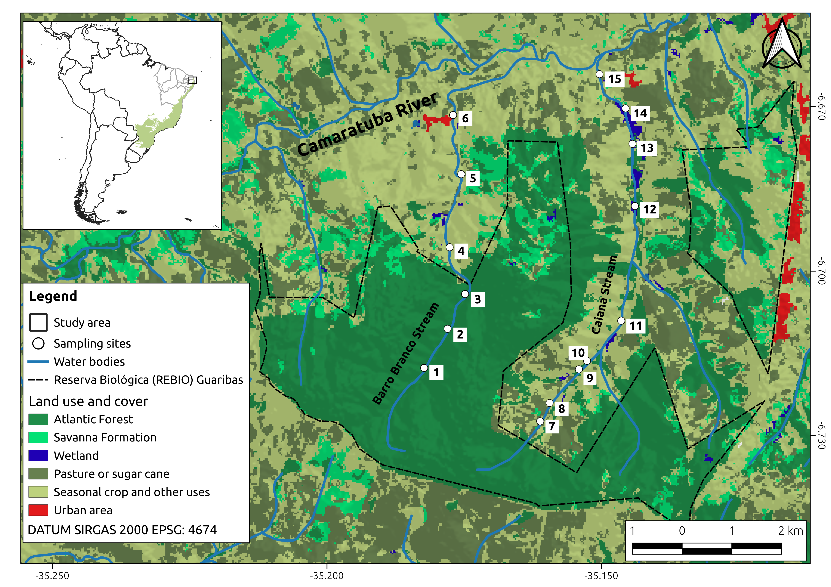
Figure 1
Figure 2
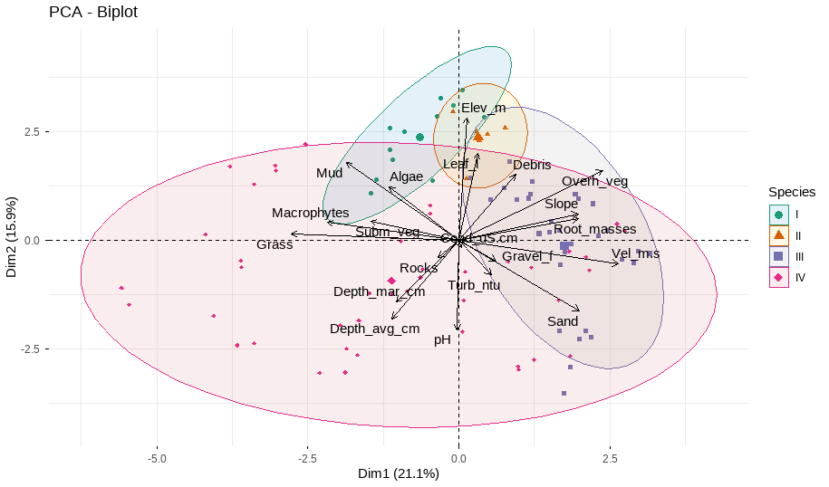
Figure 2
Figure 3
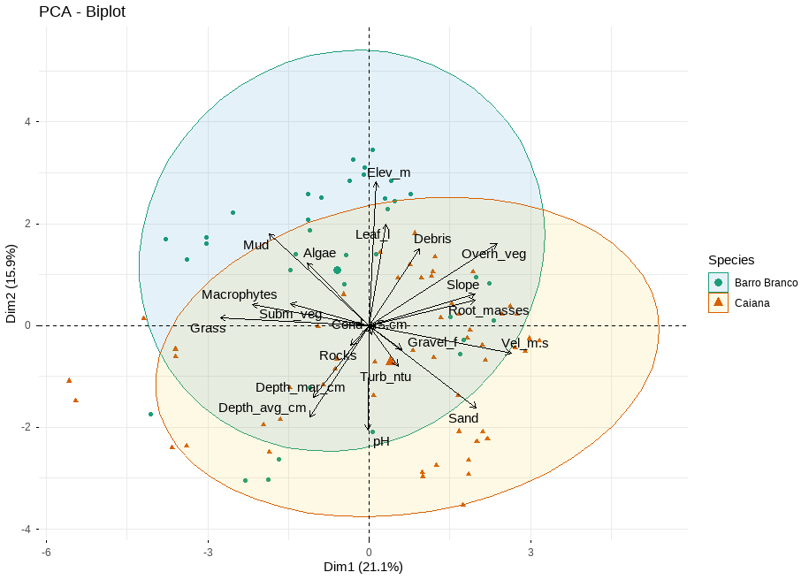
Figure 3
Figure 4
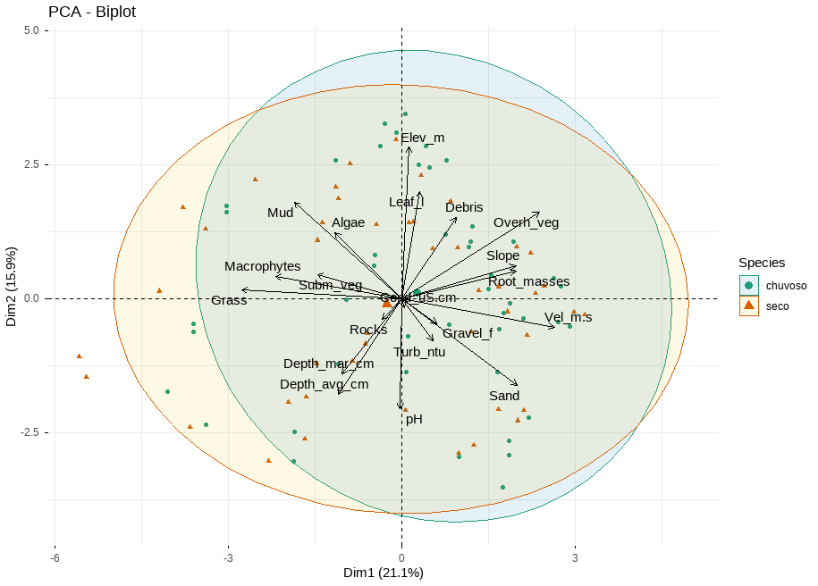
Figure 4
Figure 5
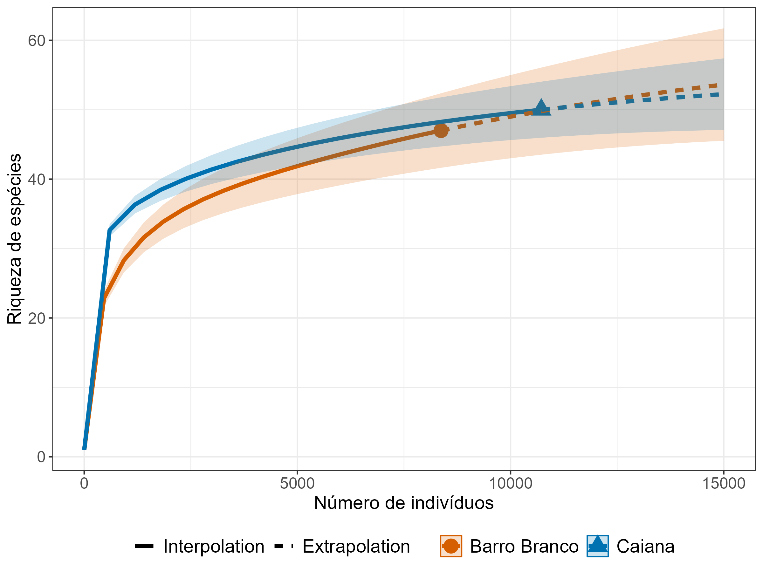
Figure 5
Figure 6
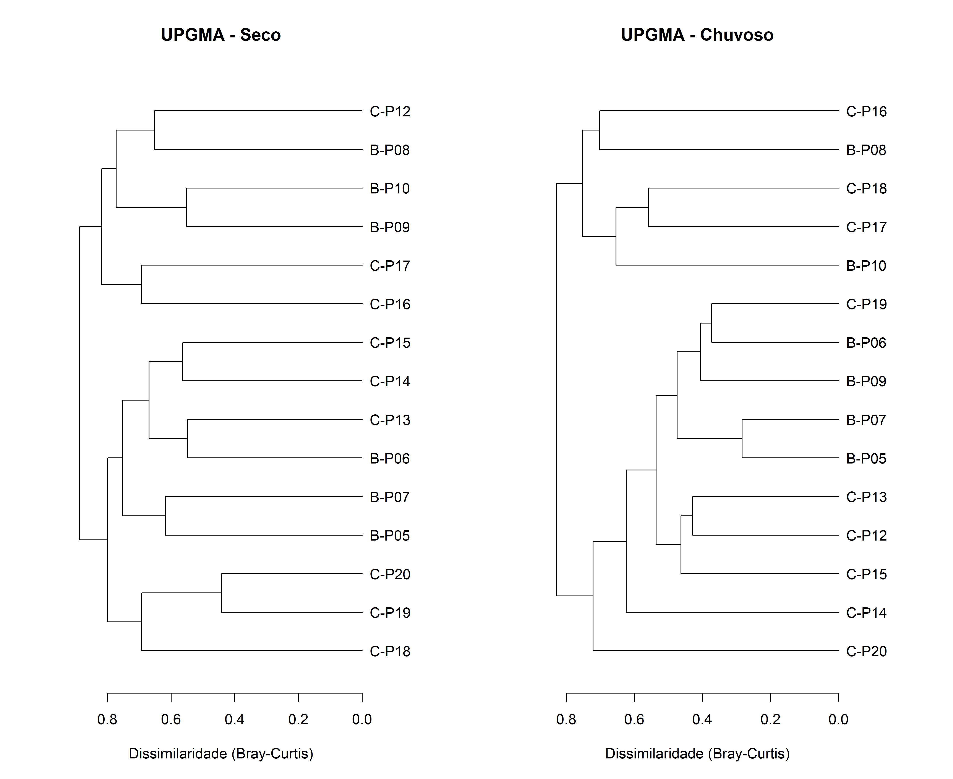
Figure 6
Figure 7
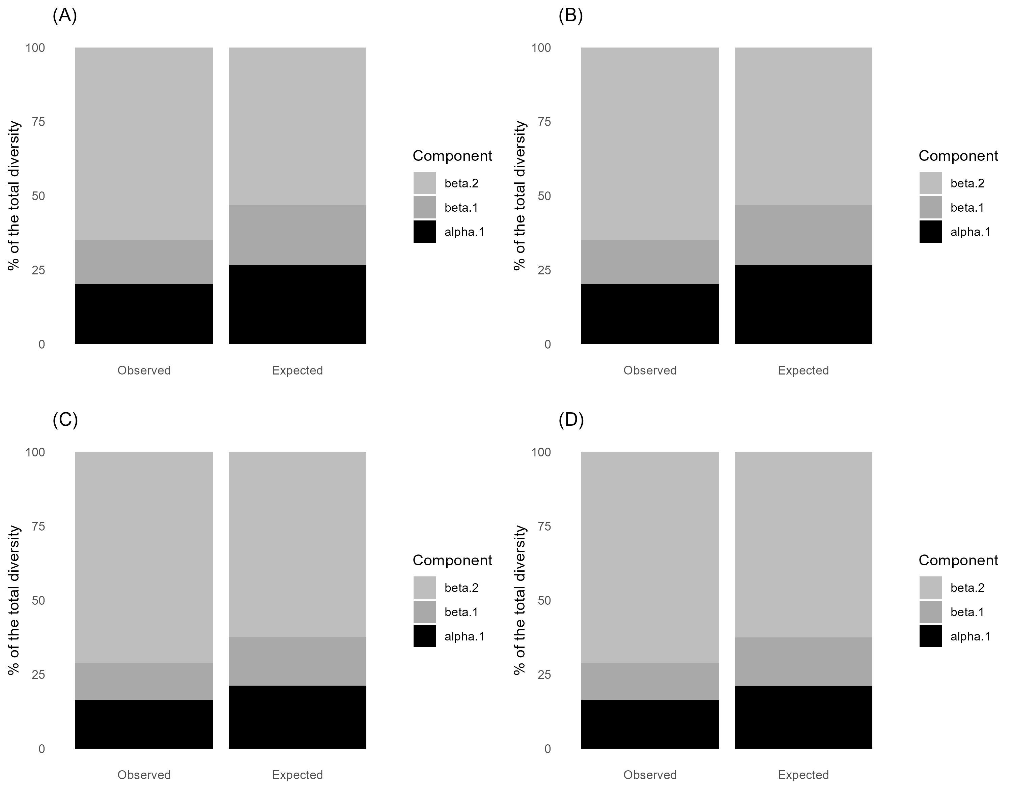
Figure 7

Tables
Table 1
Table 1: Environment data GT table.
Variable | Ponto5 | Ponto6 | Ponto7 | Ponto8 | Ponto9 | Ponto10 | Ponto12 | Ponto13 | Ponto14 | Ponto15 | Ponto16 | Ponto17 | Ponto18 | Ponto19 | Ponto20
w.Cond.uS.cm | 137.5 (119.2-164.4) | 148 (134.1-156.8) | 137.5 (98.3-160.2) | 154.2 (141.6-161.8) | 148.2 (120.8-165.5) | 140.7 (105-157.9) | 111.7 (85.2-129.8) | 98.8 (78.3-122.4) | 139.4 (92.2-184.2) | 223 (172.5-250.8) | 153.5 (109.3-212.5) | 123.4 (110.9-130.6) | 121.1 (100.8-136.6) | 130.9 (123.7-139.7) | 134.2 (125.6-139.6)
w.Turb.ntu | 5 (2-10.7) | 4.9 (2.1-14.1) | 4.9 (1.5-9.2) | 5.7 (4-6.8) | 15.1 (11-17.7) | 21.5 (10-34.8) | 79.2 (2-346) | 11.7 (2-21) | 27.8 (7-44) | 11.7 (6-21) | 11.3 (5-20) | 32 (11.9-61) | 30.1 (9.3-64) | 10.2 (4.3-14) | 11.2 (8-14.2)
w.pH | 5.9 (4.7-7.5) | 5.7 (4.6-7.7) | 5.1 (4.5-6) | 5.5 (5-6) | 6 (5.3-6.6) | 6.1 (5.3-7.3) | 5.8 (5.3-6.4) | 5.9 (5.5-6.2) | 6.1 (6-6.5) | 6.3 (6-6.6) | 6.5 (6.2-6.9) | 6.4 (6.3-6.6) | 6.5 (6-6.8) | 6.7 (6.4-7) | 6.9 (6.7-7.4)
m.Elev.m | 107.1 (107.1-107.1) | 112.8 (112.8-112.8) | 89 (89-89) | 89.1 (89.1-89.1) | 71 (71-71) | 41.5 (41.5-41.5) | 80 (80-80) | 87 (87-87) | 76 (76-76) | 86 (86-86) | 76 (76-76) | 49 (49-49) | 47 (47-47) | 54 (54-54) | 49 (49-49)
m.Vel.m.s | 0.073 (0.025-0.161) | 0.086 (0.035-0.24) | 0.135 (0.022-0.207) | 0.036 (0-0.115) | 0.261 (0.172-0.348) | 0.04 (0-0.119) | 0.271 (0.055-0.588) | 0.254 (0.021-0.423) | 0.296 (0.047-0.461) | 0.195 (0.09-0.302) | 0 (0-0) | 0.272 (0.084-0.508) | 0.118 (0.054-0.182) | 0.41 (0.33-0.557) | 0.22 (0.115-0.37)
m.Slope | 1.4 (1-2) | 2.7 (2.5-3) | 2.4 (1.5-3) | 1.5 (1-2) | 2.1 (1.5-3) | 1.2 (1-2) | 1.3 (1-2) | 1.8 (1-2) | 3.2 (2.5-3.5) | 2.3 (1.5-2.5) | 1 (1-1) | 2.1 (1-3.5) | 1 (1-1) | 2.4 (2-3.5) | 1.9 (1.5-3)
m.Depth.avg.cm | 12.8 (9-14) | 23.7 (16.3-31.7) | 23.8 (16-41) | 43.3 (28.3-51.3) | 22.1 (15-29) | 35.2 (25.3-40.7) | 13.2 (5.3-22.7) | 22.6 (10.3-36.3) | 19.8 (10.7-40.7) | 17.2 (10.7-26) | 33 (14-42) | 54.4 (15.7-98.7) | 49.9 (18-65) | 46.2 (34.7-64) | 72.4 (43-110)
m.Depth.mar.cm | 11.8 (3-16) | 21.7 (8-30) | 18.8 (7-42) | 48.3 (16-87) | 18.8 (11-30) | 33.5 (17-52) | 10.7 (6-15) | 19.5 (11-38) | 12.7 (10-15) | 13.7 (8-23) | 20.3 (12-33) | 38.3 (5-100) | 28.8 (9-50) | 41.5 (28-57) | 49 (20-94)
s.Mud | 100 (100-100) | 100 (100-100) | 95 (90-100) | 74.2 (5-100) | 38.3 (5-80) | 36.7 (10-100) | 90 (90-90) | 61.7 (10-90) | 7.5 (0-30) | 7.5 (0-10) | 83.3 (0-100) | 97.5 (90-100) | 68.3 (5-100) | 1.7 (0-5) | 66.7 (5-100)
s.Sand | 0 (0-0) | 0 (0-0) | 5 (0-10) | 25.8 (0-95) | 61.7 (20-95) | 63.3 (0-90) | 10 (10-10) | 38.3 (10-90) | 91.7 (70-100) | 90.8 (80-100) | 16.7 (0-100) | 0.8 (0-5) | 30 (0-95) | 98.3 (95-100) | 33.3 (0-95)
s.Gravel.f | 0 (0-0) | 0 (0-0) | 0 (0-0) | 0 (0-0) | 0 (0-0) | 0 (0-0) | 0 (0-0) | 0 (0-0) | 0.8 (0-5) | 1.7 (0-10) | 0 (0-0) | 0 (0-0) | 1.7 (0-10) | 0 (0-0) | 0 (0-0)
s.Rocks | 0 (0-0) | 0 (0-0) | 0 (0-0) | 0 (0-0) | 0 (0-0) | 0 (0-0) | 0 (0-0) | 0 (0-0) | 0 (0-0) | 0 (0-0) | 0 (0-0) | 1.7 (0-10) | 0 (0-0) | 0 (0-0) | 0 (0-0)
h.Macrophytes | 5.8 (5-10) | 10 (0-30) | 0 (0-0) | 17.9 (0-60) | 0 (0-0) | 1.7 (0-5) | 0 (0-0) | 0.8 (0-5) | 0 (0-0) | 0 (0-0) | 20.8 (0-50) | 0 (0-0) | 4.2 (0-15) | 0 (0-0) | 0 (0-0)
h.Grass | 3.3 (0-10) | 8.3 (5-15) | 6 (0-15) | 27.1 (15-50) | 0 (0-0) | 21.8 (1-50) | 0 (0-0) | 0 (0-0) | 0 (0-0) | 0.8 (0-5) | 39.2 (15-50) | 5.8 (5-10) | 4.2 (0-10) | 0 (0-0) | 0 (0-0)
h.Subm.veg | 7.5 (5-15) | 8.3 (5-15) | 5.8 (0-10) | 5.8 (0-10) | 10.8 (0-20) | 5 (0-10) | 1.7 (0-5) | 6.7 (0-15) | 5 (0-15) | 0 (0-0) | 16.7 (5-20) | 10 (5-15) | 10 (0-20) | 0.8 (0-5) | 8.3 (0-25)
h.Overh.veg | 68.3 (40-90) | 70.8 (50-85) | 76.7 (60-90) | 31.7 (25-50) | 70 (60-80) | 5 (0-20) | 83.3 (75-90) | 63.3 (30-80) | 65.8 (50-85) | 50 (40-70) | 0.8 (0-5) | 20.8 (10-30) | 33.3 (0-70) | 61.7 (50-70) | 61.7 (40-80)
h.Leaf.l | 7.5 (5-10) | 11 (1-25) | 15.8 (5-30) | 18.3 (10-30) | 10.2 (1-30) | 3.5 (0-10) | 7.5 (5-15) | 6.7 (5-10) | 5 (5-5) | 7.5 (5-10) | 1.7 (0-5) | 2.5 (0-5) | 5 (0-10) | 4.2 (0-5) | 8.3 (0-15)
h.Root.masses | 5 (0-15) | 10.8 (5-15) | 12.5 (5-20) | 4.2 (0-10) | 42.5 (5-90) | 3.3 (0-10) | 5.8 (0-10) | 10 (5-15) | 11.7 (5-20) | 9.2 (0-25) | 0.8 (0-5) | 10.8 (5-15) | 5.8 (0-15) | 7.5 (5-15) | 11.7 (10-15)
h.Algae | 2.5 (0-5) | 0.2 (0-1) | 5.5 (0-21) | 19.2 (15-25) | 0 (0-0) | 0.8 (0-5) | 0.8 (0-5) | 0 (0-0) | 0 (0-0) | 0 (0-0) | 0 (0-0) | 0 (0-0) | 0 (0-0) | 0 (0-0) | 0 (0-0)
h.Debris | 30.8 (20-45) | 12.7 (5-20) | 17.7 (5-30) | 21.7 (5-35) | 16.8 (1-40) | 8.3 (0-20) | 22.2 (8-40) | 25.8 (10-40) | 23.3 (10-30) | 18.3 (10-40) | 4.2 (0-10) | 25.8 (0-45) | 20 (0-35) | 4.2 (0-15) | 17.5 (5-25)
Table 2
Table 2: Nutrient concentrations at the sampling sites.
Variable | Ponto5 | Ponto6 | Ponto7 | Ponto8 | Ponto9 | Ponto10 | Ponto12 | Ponto13 | Ponto14 | Ponto15 | Ponto16 | Ponto17 | Ponto18 | Ponto19 | Ponto20
n.Ammonia.NH3.ug.L | 54.8 (39.3-64.3) | 58.9 (47.5-77) | 72 (33.4-115.7) | 81.6 (68.9-93) | 80.8 (65.2-99.3) | 243.7 (203.9-277.5) | 82.8 (64.3-101.6) | 60.5 (53-73.4) | 94.2 (53.4-125.7) | 168.9 (141.1-191.6) | 67.8 (61.6-73.9) | 82.2 (79.3-87) | 49.2 (43.9-54.8) | 50.2 (46.1-54.3) | 109.8 (53.4-194.8)
n.Nitrite.NO2.ug.L | 0 (0-0) | 0 (0-0) | 0 (0-0) | 0 (0-0) | 0 (0-0) | 0 (0-0) | 1.9 (1.5-2.4) | 14.9 (1.2-23.3) | 5 (4.1-6.2) | 2.2 (1.2-2.7) | 6.7 (4.7-10.3) | 3.6 (2.7-4.1) | 3.5 (3.3-3.9) | 3.1 (2.7-3.9) | 34.2 (3-96.8)
n.Nitrate.NO3.ug.L | 6 (0-9.7) | 8.8 (6.9-12.6) | 5.5 (0-12.6) | 18.8 (11.1-31.1) | 18.3 (16.9-19.7) | 10.2 (5.4-16.9) | 798.8 (94-1379.7) | 166.4 (144-189.7) | 2003 (1652.6-2309.7) | 768.3 (352.6-1044) | 1624 (322.6-4106.9) | 677.3 (461.1-1004) | 622.6 (486.9-754) | 644 (581.1-695.4) | 728.8 (594-889.7)
n.Orthophosphate.SRP.ug.L | 0 (0-0) | 0 (0-0) | 1 (0-3) | 0 (0-0) | 0 (0-0) | 0 (0-0) | 7.8 (7.3-8.7) | 4 (0.1-5.9) | 5.9 (4.4-7.3) | 7.3 (5.9-8.7) | 32 (7.3-75.9) | 8.7 (7.3-10.1) | 8.7 (7.3-10.1) | 11.6 (10.1-13) | 13 (7.3-23)
n.Phosphorus.TP.ug.L | 0 (0-0) | 4.6 (0.3-10.3) | 50.1 (0-150.3) | 9 (0-27) | 19.2 (15.3-22) | 38.7 (13.7-55.3) | 9.8 (8.7-12) | 4.8 (0.3-7) | 8.1 (5.3-12) | 18.7 (7-33.7) | 65.3 (10.3-170.3) | 19.8 (12-25.3) | 12.6 (8.7-17) | 14.8 (12-18.7) | 16.4 (8.7-30.3)
Table 3
Table 3: Density (ind/m²) taxa GT table.
Stream | Barro Branco Stream | ...3 | ...4 | ...5 | ...6 | ...7 | ...8 | ...9 | ...10 | ...11 | ...12 | ...13 | Caiana Stream | ...15 | ...16 | ...17 | ...18 | ...19 | ...20 | ...21 | ...22 | ...23 | ...24 | ...25 | ...26 | ...27 | ...28 | ...29 | ...30 | ...31
Season | Wet |  |  |  |  |  | Dry |  |  |  |  |  | Wet |  |  |  |  |  |  |  |  | Dry
Site | Ponto5 | Ponto6 | Ponto7 | Ponto8 | Ponto9 | Ponto10 | Ponto5 | Ponto6 | Ponto7 | Ponto8 | Ponto9 | Ponto10 | Ponto12 | Ponto13 | Ponto14 | Ponto15 | Ponto16 | Ponto17 | Ponto18 | Ponto19 | Ponto20 | Ponto12 | Ponto13 | Ponto14 | Ponto15 | Ponto16 | Ponto17 | Ponto18 | Ponto19 | Ponto20
Alo.dadayi | 0 (0) | 0 (0) | 0 (0) | 5.3 (6.6) | 0 (0) | 0.4 (0.3) | 0 (0) | 0 (0) | 0 (0) | 0.1 (0.1) | 0 (0) | 0 (0) | 0.1 (0) | 0.1 (0) | 0.1 (0.1) | 0 (0) | 0.6 (0.5) | 0.1 (0.2) | 0.1 (0) | 0 (0) | 0 (0) | 0 (0) | 0 (0) | 0 (0) | 0 (0) | 0 (0) | 0 (0) | 0 (0) | 0 (0) | 0 (0)
Alo.hamulata | 0 (0) | 0 (0) | 0 (0) | 1.1 (1.3) | 0 (0) | 0.1 (0.1) | 0 (0) | 0 (0) | 0 (0) | 0 (0) | 0 (0) | 0 (0) | 0 (0) | 0 (0) | 0 (0) | 0 (0) | 0.2 (0.2) | 0 (0) | 0 (0) | 0.1 (0) | 0 (0) | 0 (0) | 0 (0) | 0 (0) | 0 (0) | 0 (0) | 0 (0) | 0 (0) | 0 (0) | 0 (0)
Alonella.sp | 0 (0) | 0 (0) | 0 (0) | 0.4 (0.5) | 0 (0) | 0 (0.1) | 0 (0) | 0 (0) | 0 (0) | 0 (0) | 0 (0) | 0 (0) | 0 (0) | 0 (0) | 0 (0) | 0 (0) | 0.2 (0.3) | 0 (0) | 0 (0) | 0 (0) | 0 (0) | 0 (0) | 0 (0) | 0 (0) | 0 (0) | 0 (0) | 0 (0) | 0 (0) | 0 (0) | 0 (0)
Bdelloidea | 1.7 (0.5) | 1.3 (0) | 1.5 (0.5) | 3.4 (0.8) | 2 (0.8) | 2.9 (1.3) | 0.6 (0.1) | 1.2 (0.5) | 1 (0.2) | 1.1 (0.2) | 1.5 (0.7) | 1.3 (0.8) | 3.3 (0.8) | 2.5 (0.6) | 1.7 (0.3) | 1.9 (0.7) | 1.9 (1.3) | 1.5 (0.4) | 1.4 (0.7) | 1.2 (0.8) | 0.8 (0.2) | 0.4 (0.1) | 0.4 (0.3) | 0.6 (0.4) | 0.4 (0.1) | 0.5 (0.5) | 0.8 (0.2) | 0.3 (0.1) | 1 (0.6) | 1.2 (0.8)
Bra.patulus | 0 (0) | 0 (0) | 0 (0) | 0 (0) | 0 (0) | 0 (0) | 0 (0) | 0 (0) | 0 (0) | 0 (0) | 0 (0) | 0 (0) | 0 (0) | 0 (0) | 0 (0) | 0 (0) | 1.2 (0.5) | 0.1 (0.1) | 0 (0) | 0 (0) | 0 (0) | 0 (0) | 0 (0) | 0 (0) | 0 (0) | 0 (0) | 0 (0) | 0 (0) | 0 (0) | 0 (0)
Cephalodella.sp | 0 (0) | 0 (0) | 0 (0) | 0 (0) | 0 (0) | 0.1 (0.1) | 0 (0) | 0 (0) | 0 (0) | 0 (0) | 0 (0) | 0 (0) | 0 (0) | 0 (0) | 0 (0) | 0 (0) | 0 (0) | 0 (0) | 0 (0) | 0 (0) | 0 (0) | 0 (0) | 0 (0) | 0 (0) | 0 (0) | 0 (0) | 0 (0) | 0 (0) | 0 (0) | 0 (0)
Colurella.sp | 0 (0) | 0 (0) | 0 (0) | 0 (0) | 0 (0) | 0 (0) | 0 (0) | 0 (0) | 0 (0) | 0 (0) | 0 (0) | 0 (0) | 0 (0) | 0 (0) | 0 (0) | 0 (0) | 0.1 (0.1) | 0 (0) | 0 (0) | 0 (0) | 0 (0) | 0 (0) | 0 (0) | 0 (0) | 0 (0) | 0 (0) | 0 (0) | 0 (0) | 0 (0) | 0 (0)
Copepodite | 0.5 (0.4) | 0.1 (0) | 0.1 (0) | 12.1 (14.5) | 0 (0) | 0.5 (0.8) | 0 (0) | 0 (0) | 0 (0) | 1 (0.8) | 0 (0) | 0 (0) | 0.1 (0.1) | 0.3 (0) | 0.1 (0.1) | 0 (0) | 7.9 (0.9) | 0.4 (0.3) | 0.9 (0.8) | 0 (0) | 0 (0) | 0.1 (0.1) | 0 (0) | 0 (0) | 0.1 (0.2) | 1.1 (1.3) | 1.3 (0.2) | 0.2 (0.1) | 0 (0) | 0 (0.1)
Chydorus.sp | 0 (0) | 0 (0) | 0 (0) | 3.2 (3.5) | 0 (0) | 0.2 (0.1) | 0 (0) | 0 (0) | 0 (0) | 0 (0) | 0 (0) | 0 (0) | 0 (0) | 0 (0) | 0 (0) | 0 (0) | 1.9 (0.9) | 0.2 (0.2) | 0.1 (0.1) | 0 (0) | 0 (0) | 0 (0) | 0 (0) | 0 (0) | 0 (0) | 0 (0) | 0 (0) | 0 (0) | 0 (0) | 0 (0)
Dicranophoroides.sp | 0 (0) | 0 (0) | 0 (0) | 0 (0) | 0 (0) | 0 (0) | 0 (0) | 0 (0) | 0 (0) | 0 (0) | 0 (0) | 0 (0) | 0 (0) | 0 (0) | 0 (0) | 0 (0) | 0 (0) | 0 (0) | 0 (0) | 0 (0) | 0 (0) | 0 (0) | 0 (0) | 0 (0) | 0 (0) | 0 (0) | 0 (0) | 0 (0) | 0 (0) | 0 (0)
Dia.birgei | 0 (0) | 0 (0) | 0 (0) | 0.1 (0.1) | 0 (0) | 0.1 (0.1) | 0 (0) | 0 (0) | 0 (0) | 0 (0) | 0 (0) | 0 (0) | 0 (0) | 0 (0) | 0 (0.1) | 0 (0) | 1.9 (0.9) | 0.1 (0.1) | 0.2 (0.2) | 0 (0) | 0 (0) | 0 (0) | 0 (0) | 0 (0) | 0 (0) | 0.2 (0.4) | 0 (0) | 0 (0) | 0 (0) | 0 (0)
Dia.spinulosum | 0 (0) | 0 (0) | 0 (0) | 0 (0) | 0 (0) | 0 (0) | 0 (0) | 0 (0) | 0 (0) | 0 (0) | 0 (0) | 0 (0) | 0 (0) | 0 (0) | 0 (0) | 0 (0) | 0 (0) | 0 (0) | 0 (0) | 0 (0) | 0 (0) | 0 (0) | 0 (0) | 0 (0) | 0 (0) | 0.1 (0.2) | 0 (0) | 0 (0) | 0 (0) | 0 (0)
Dis.aculeata | 0 (0) | 0 (0) | 0 (0) | 0 (0) | 0 (0) | 0 (0) | 0 (0) | 0 (0) | 0 (0) | 0 (0) | 0 (0) | 0 (0) | 0 (0) | 0 (0) | 0 (0) | 0 (0) | 0 (0) | 0 (0) | 0 (0) | 0 (0) | 0 (0) | 0 (0) | 0 (0) | 0 (0) | 0 (0) | 0 (0) | 0 (0) | 0 (0) | 0 (0) | 0 (0)
Euc.dilatata | 0 (0) | 0 (0) | 0 (0) | 0 (0) | 0 (0) | 0 (0) | 0 (0) | 0 (0) | 0 (0) | 0 (0) | 0 (0) | 0 (0) | 0 (0) | 0 (0) | 0 (0) | 0 (0) | 0 (0) | 0 (0) | 0 (0) | 0 (0) | 0 (0) | 0 (0) | 0 (0) | 0 (0) | 0 (0) | 0 (0) | 0 (0) | 0 (0) | 0 (0) | 0 (0)
Fil.longiseta | 0 (0) | 0 (0) | 0 (0) | 0 (0) | 0 (0) | 0 (0) | 0 (0) | 0 (0) | 0 (0) | 0 (0) | 0 (0) | 0 (0) | 0 (0) | 0 (0) | 0 (0) | 0 (0) | 0 (0) | 0 (0) | 0 (0) | 0 (0) | 0 (0) | 0 (0) | 0 (0) | 0 (0) | 0 (0) | 0 (0) | 0 (0) | 0 (0) | 0 (0) | 0 (0)
Ily.spinifer | 0 (0) | 0 (0) | 0 (0) | 0 (0) | 0 (0) | 0.1 (0.1) | 0 (0) | 0 (0) | 0 (0) | 0 (0) | 0 (0) | 0 (0) | 0 (0) | 0 (0) | 0 (0) | 0 (0) | 1.3 (0.3) | 0 (0) | 0 (0) | 0 (0) | 0 (0) | 0 (0) | 0 (0) | 0 (0) | 0 (0) | 0 (0) | 0 (0) | 0 (0) | 0 (0) | 0 (0)
Lec.aculeata | 0 (0) | 0 (0) | 0 (0) | 0 (0) | 0 (0) | 0 (0) | 0 (0) | 0 (0) | 0 (0) | 0 (0) | 0 (0) | 0 (0) | 0 (0) | 0 (0) | 0 (0) | 0 (0) | 0.3 (0.3) | 0.1 (0.1) | 0 (0) | 0 (0) | 0 (0) | 0 (0) | 0 (0) | 0 (0) | 0 (0) | 0 (0) | 0 (0) | 0 (0) | 0 (0) | 0 (0)
Lec.bulla | 0 (0) | 0 (0) | 0 (0) | 0 (0.1) | 0 (0) | 0 (0) | 0 (0) | 0 (0) | 0 (0) | 0.1 (0.1) | 0 (0) | 0.3 (0.1) | 0 (0) | 0 (0) | 0 (0) | 0 (0) | 0.1 (0.2) | 0 (0) | 0 (0) | 0 (0) | 0 (0) | 0.1 (0) | 0 (0) | 0 (0) | 0 (0) | 0.1 (0.1) | 0 (0) | 0 (0) | 0 (0) | 0 (0)
Lec.cornuta | 0 (0) | 0 (0) | 0 (0) | 0 (0) | 0 (0) | 0 (0) | 0 (0) | 0 (0) | 0 (0) | 0 (0) | 0 (0) | 0 (0) | 0 (0) | 0 (0) | 0 (0) | 0 (0) | 0.7 (0.1) | 0.1 (0.1) | 0 (0) | 0 (0) | 0 (0) | 0 (0) | 0 (0) | 0 (0) | 0 (0) | 0 (0) | 0 (0) | 0 (0) | 0 (0) | 0 (0)
Lec.crepida | 0 (0) | 0 (0) | 0 (0) | 0 (0) | 0 (0) | 0 (0) | 0 (0) | 0 (0) | 0 (0) | 0 (0) | 0 (0) | 0 (0.1) | 0 (0) | 0 (0) | 0 (0) | 0 (0) | 0.1 (0.1) | 0 (0) | 0 (0) | 0 (0) | 0 (0) | 0 (0) | 0 (0) | 0 (0) | 0 (0) | 0 (0) | 0 (0) | 0 (0) | 0 (0) | 0 (0)
Lec.curvicornis | 0 (0) | 0 (0) | 0 (0) | 0 (0) | 0 (0) | 0 (0) | 0 (0) | 0 (0) | 0 (0) | 0 (0) | 0 (0) | 0 (0) | 0 (0) | 0 (0) | 0 (0) | 0 (0) | 4 (3.9) | 0.1 (0.1) | 0 (0) | 0 (0) | 0 (0) | 0 (0) | 0 (0) | 0 (0) | 0 (0) | 0 (0) | 0 (0) | 0 (0) | 0 (0) | 0 (0)
Lec.furcata | 0 (0) | 0 (0) | 0 (0) | 0 (0) | 0 (0) | 0 (0) | 0 (0) | 0 (0) | 0 (0) | 0 (0) | 0 (0) | 0 (0) | 0 (0) | 0 (0) | 0 (0) | 0 (0) | 0 (0) | 0 (0) | 0 (0) | 0 (0) | 0 (0) | 0 (0) | 0 (0) | 0 (0) | 0 (0) | 0 (0) | 0 (0) | 0 (0) | 0 (0) | 0 (0)
Lecane.sp1 | 0 (0) | 0 (0) | 0 (0) | 0 (0) | 0 (0) | 0 (0) | 0 (0) | 0 (0) | 0 (0) | 0 (0) | 0 (0) | 0 (0) | 0 (0) | 0 (0) | 0 (0) | 0 (0) | 0 (0) | 0 (0) | 0 (0) | 0 (0) | 0 (0) | 0 (0) | 0 (0) | 0 (0) | 0 (0) | 0 (0) | 0 (0) | 0 (0) | 0 (0) | 0 (0)
Lec.leontina | 0 (0) | 0 (0) | 0 (0) | 0.5 (0.5) | 0 (0) | 0 (0.1) | 0 (0) | 0 (0) | 0 (0) | 0 (0) | 0 (0) | 0 (0) | 0 (0) | 0 (0) | 0 (0) | 0 (0) | 0.1 (0.1) | 0 (0) | 0 (0) | 0 (0) | 0 (0) | 0 (0) | 0 (0) | 0 (0) | 0 (0) | 0 (0) | 0 (0) | 0 (0) | 0 (0) | 0 (0)
Lec.lunaris | 0 (0) | 0 (0) | 0 (0) | 0 (0) | 0 (0) | 0 (0) | 0 (0) | 0 (0) | 0 (0) | 0 (0) | 0 (0) | 0 (0) | 0 (0) | 0 (0) | 0 (0.1) | 0 (0) | 0.4 (0.4) | 0.1 (0.1) | 0 (0) | 0 (0) | 0 (0) | 0 (0) | 0 (0) | 0 (0) | 0 (0) | 0 (0) | 0 (0) | 0 (0) | 0 (0) | 0 (0)
Lec.luna | 0 (0) | 0 (0) | 0 (0) | 0 (0) | 0 (0) | 0 (0) | 0 (0) | 0 (0) | 0 (0) | 0.1 (0) | 0 (0) | 0 (0) | 0 (0) | 0 (0) | 0 (0) | 0 (0) | 0.9 (0.4) | 0.2 (0.3) | 0 (0) | 0 (0) | 0 (0) | 0 (0) | 0 (0) | 0 (0) | 0 (0) | 0 (0) | 0 (0) | 0 (0) | 0 (0) | 0 (0)
Lec.monostyla | 0 (0) | 0 (0) | 0 (0) | 0 (0) | 0 (0) | 0 (0) | 0 (0) | 0 (0) | 0 (0) | 0 (0) | 0 (0) | 0 (0) | 0 (0) | 0 (0) | 0 (0) | 0 (0) | 0 (0) | 0 (0) | 0 (0) | 0 (0) | 0 (0) | 0 (0) | 0 (0) | 0 (0) | 0 (0) | 0 (0) | 0 (0) | 0 (0) | 0 (0) | 0 (0)
Lecane.sp2 | 0 (0) | 0 (0) | 0 (0) | 0 (0) | 0 (0) | 0 (0) | 0 (0) | 0 (0) | 0 (0) | 0 (0) | 0 (0) | 0 (0) | 0 (0) | 0 (0) | 0 (0) | 0 (0) | 0 (0) | 0 (0) | 0 (0) | 0 (0) | 0 (0) | 0 (0) | 0 (0) | 0 (0) | 0 (0) | 0 (0) | 0 (0) | 0 (0) | 0 (0) | 0 (0)
Lec.papuana | 0 (0) | 0 (0) | 0 (0) | 0 (0) | 0 (0) | 0 (0) | 0 (0) | 0 (0) | 0 (0) | 0 (0) | 0 (0) | 0 (0) | 0 (0) | 0 (0) | 0 (0) | 0 (0) | 0.2 (0.2) | 0 (0) | 0 (0) | 0 (0) | 0 (0) | 0 (0) | 0 (0) | 0 (0) | 0 (0) | 0 (0) | 0 (0) | 0 (0) | 0 (0) | 0 (0)
Lec.quadridentata | 0 (0) | 0 (0) | 0 (0) | 0 (0) | 0 (0) | 0 (0) | 0 (0) | 0 (0) | 0 (0) | 0 (0) | 0 (0) | 0 (0) | 0 (0) | 0 (0) | 0 (0) | 0 (0) | 0 (0) | 0 (0) | 0 (0) | 0 (0) | 0 (0) | 0 (0) | 0 (0) | 0 (0) | 0 (0) | 0 (0) | 0 (0) | 0 (0) | 0 (0) | 0 (0)
Lecane.sp3 | 0 (0) | 0 (0) | 0 (0) | 0 (0) | 0 (0) | 0 (0) | 0 (0) | 0 (0) | 0 (0) | 0 (0) | 0 (0) | 0 (0) | 0 (0) | 0 (0) | 0 (0) | 0 (0) | 0 (0) | 0 (0) | 0 (0) | 0 (0) | 0 (0) | 0 (0) | 0 (0) | 0 (0) | 0 (0) | 0 (0) | 0 (0) | 0 (0) | 0 (0) | 0 (0)
Leydigia.sp | 0 (0) | 0 (0) | 0 (0) | 0 (0) | 0 (0) | 0 (0) | 0 (0) | 0 (0) | 0 (0) | 0 (0) | 0 (0) | 0 (0) | 0 (0) | 0 (0) | 0 (0) | 0 (0) | 0.2 (0.1) | 0 (0) | 0 (0) | 0 (0) | 0 (0) | 0 (0) | 0 (0) | 0 (0) | 0 (0) | 0 (0) | 0 (0) | 0 (0) | 0 (0) | 0 (0)
Lepadella.sp1 | 0 (0) | 0 (0) | 0 (0) | 0 (0) | 0 (0) | 0 (0) | 0 (0) | 0 (0) | 0 (0) | 0 (0) | 0 (0) | 0 (0) | 0 (0) | 0 (0) | 0 (0) | 0 (0) | 0 (0) | 0 (0) | 0 (0) | 0 (0) | 0 (0) | 0 (0) | 0 (0) | 0 (0) | 0 (0) | 0 (0) | 0 (0) | 0 (0) | 0 (0) | 0 (0)
Lepadella.sp2 | 0 (0) | 0 (0) | 0 (0) | 0 (0) | 0 (0) | 0 (0) | 0 (0) | 0 (0) | 0 (0) | 0 (0) | 0 (0) | 0 (0) | 0 (0) | 0 (0) | 0 (0) | 0 (0) | 0 (0) | 0 (0) | 0 (0) | 0 (0) | 0 (0) | 0 (0) | 0 (0) | 0 (0) | 0 (0) | 0 (0) | 0 (0) | 0 (0) | 0 (0) | 0 (0)
Lep.ovalis | 0 (0) | 0 (0) | 0 (0) | 0 (0) | 0 (0) | 0 (0) | 0 (0) | 0 (0) | 0 (0) | 0 (0) | 0 (0) | 0.1 (0.1) | 0 (0) | 0 (0) | 0 (0) | 0 (0) | 0 (0) | 0 (0) | 0 (0) | 0 (0) | 0 (0) | 0 (0) | 0 (0) | 0 (0) | 0 (0) | 0 (0) | 0 (0) | 0 (0) | 0 (0) | 0 (0)
Lep.patella | 0 (0) | 0 (0) | 0 (0) | 0 (0) | 0 (0) | 0 (0) | 0 (0) | 0 (0) | 0 (0) | 0 (0) | 0 (0) | 0 (0) | 0 (0) | 0 (0) | 0 (0) | 0 (0) | 0 (0) | 0 (0) | 0 (0) | 0 (0) | 0 (0) | 0 (0) | 0 (0) | 0 (0) | 0 (0) | 0 (0) | 0 (0) | 0 (0) | 0 (0) | 0 (0)
Mesocyclops.sp | 0 (0) | 0 (0) | 0 (0) | 0.6 (0.6) | 0 (0) | 0 (0) | 0 (0) | 0 (0) | 0 (0) | 0 (0) | 0 (0) | 0 (0) | 0 (0) | 0 (0) | 0 (0) | 0 (0) | 0.2 (0.1) | 0 (0) | 0 (0) | 0 (0) | 0 (0) | 0 (0) | 0 (0) | 0 (0) | 0 (0) | 0 (0) | 0 (0) | 0 (0) | 0 (0) | 0 (0)
Macrocyclops.sp | 0 (0) | 0 (0) | 0 (0) | 0.2 (0.2) | 0 (0) | 0 (0) | 0 (0) | 0 (0) | 0 (0) | 0 (0) | 0 (0) | 0 (0) | 0 (0) | 0 (0) | 0 (0) | 0 (0) | 0 (0) | 0 (0) | 0 (0) | 0 (0) | 0 (0) | 0 (0) | 0 (0) | 0 (0) | 0 (0) | 0 (0) | 0 (0) | 0 (0) | 0 (0) | 0 (0)
Macrochaetus.sp | 0 (0) | 0 (0) | 0 (0) | 0.2 (0.3) | 0 (0) | 0 (0) | 0 (0) | 0 (0) | 0 (0) | 0 (0) | 0 (0) | 0 (0) | 0 (0) | 0 (0) | 0 (0) | 0 (0) | 0 (0) | 0 (0) | 0 (0) | 0 (0) | 0 (0) | 0 (0) | 0 (0) | 0 (0) | 0 (0) | 0 (0) | 0 (0) | 0 (0) | 0 (0) | 0 (0)
Macrothrix.sp | 0 (0) | 0 (0) | 0 (0) | 0 (0) | 0 (0) | 0 (0) | 0 (0) | 0 (0) | 0 (0) | 0 (0) | 0 (0) | 0 (0) | 0 (0) | 0 (0) | 0 (0) | 0 (0) | 0 (0) | 0 (0) | 0 (0) | 0 (0) | 0 (0) | 0 (0) | 0 (0) | 0 (0) | 0 (0) | 0 (0) | 0 (0) | 0 (0) | 0 (0) | 0 (0)
Mac.mira | 0 (0) | 0 (0) | 0 (0) | 0.2 (0.3) | 0 (0) | 0 (0) | 0 (0) | 0 (0) | 0 (0) | 0 (0) | 0 (0) | 0 (0) | 0 (0) | 0 (0) | 0 (0) | 0 (0) | 1.2 (0.4) | 0 (0) | 0 (0) | 0 (0) | 0 (0) | 0 (0) | 0 (0) | 0 (0) | 0 (0) | 0 (0) | 0 (0) | 0 (0) | 0 (0) | 0 (0)
Mac.laticornis | 0 (0) | 0 (0) | 0 (0) | 0.1 (0.1) | 0 (0) | 0 (0) | 0 (0) | 0 (0) | 0 (0) | 0 (0) | 0 (0) | 0 (0) | 0 (0) | 0 (0) | 0 (0) | 0 (0) | 1.4 (0.8) | 0.1 (0.2) | 0 (0) | 0 (0) | 0 (0) | 0 (0) | 0 (0) | 0 (0) | 0 (0) | 0 (0) | 0 (0) | 0 (0) | 0 (0) | 0 (0)
Moi.minuta | 0 (0) | 0 (0) | 0 (0) | 0 (0) | 0 (0) | 0 (0) | 0 (0) | 0 (0) | 0 (0) | 0 (0) | 0 (0) | 0 (0) | 0 (0) | 0 (0) | 0 (0) | 0 (0) | 0.3 (0.4) | 0 (0) | 0 (0) | 0 (0) | 0 (0) | 0 (0) | 0 (0) | 0 (0) | 0 (0) | 0 (0) | 0 (0) | 0 (0) | 0 (0) | 0 (0)
Myt.crassipes | 0 (0) | 0 (0) | 0 (0) | 0 (0) | 0 (0) | 0 (0) | 0 (0) | 0 (0) | 0 (0) | 0 (0) | 0 (0) | 0 (0) | 0 (0) | 0 (0) | 0 (0) | 0 (0) | 0 (0) | 0 (0) | 0 (0) | 0 (0) | 0 (0) | 0 (0) | 0 (0) | 0 (0) | 0 (0) | 0 (0) | 0 (0) | 0 (0) | 0 (0) | 0 (0)
Mytilina.sp | 0 (0) | 0 (0) | 0 (0) | 0 (0) | 0 (0) | 0 (0) | 0 (0) | 0 (0) | 0 (0) | 0 (0) | 0 (0) | 0 (0) | 0 (0) | 0 (0) | 0 (0) | 0 (0) | 0 (0) | 0 (0) | 0 (0) | 0 (0) | 0 (0) | 0 (0) | 0 (0) | 0 (0) | 0 (0) | 0 (0) | 0 (0) | 0 (0) | 0 (0) | 0 (0)
Myt.bisulcata | 0 (0) | 0 (0) | 0 (0) | 0 (0) | 0 (0) | 0 (0) | 0 (0) | 0 (0) | 0 (0) | 0 (0) | 0 (0) | 0 (0) | 0 (0) | 0 (0) | 0 (0) | 0 (0) | 0 (0) | 0 (0) | 0 (0) | 0 (0) | 0 (0) | 0 (0) | 0 (0) | 0 (0) | 0 (0) | 0 (0) | 0 (0) | 0 (0) | 0 (0) | 0 (0)
Nauplii | 0.2 (0.2) | 0.1 (0.1) | 0.1 (0) | 3.2 (2.6) | 0 (0.1) | 0.8 (1.2) | 0.1 (0.1) | 0 (0) | 0 (0) | 0.6 (0.5) | 0.1 (0) | 0.2 (0.2) | 0.2 (0.1) | 0.1 (0.2) | 0.1 (0) | 0.1 (0) | 2.4 (0.9) | 0.1 (0.1) | 0.4 (0.4) | 0 (0) | 0 (0) | 0.1 (0.1) | 0 (0) | 0.1 (0.1) | 0.1 (0.1) | 6.4 (8.7) | 0.6 (0.3) | 0.1 (0) | 0 (0) | 0 (0)
Notodiaptomus.sp | 0 (0) | 0 (0) | 0 (0) | 0 (0) | 0 (0) | 0 (0) | 0 (0) | 0 (0) | 0 (0) | 0 (0) | 0 (0) | 0 (0) | 0 (0) | 0 (0) | 0 (0) | 0 (0) | 0.1 (0.2) | 0 (0) | 0.1 (0.2) | 0 (0) | 0 (0) | 0 (0) | 0 (0) | 0 (0) | 0 (0) | 0.3 (0.2) | 0.2 (0.2) | 0 (0) | 0 (0) | 0 (0)
Paracyclops.sp | 0 (0) | 0 (0) | 0 (0) | 0.7 (1.3) | 0 (0) | 0 (0) | 0 (0) | 0 (0) | 0 (0) | 0.1 (0.1) | 0 (0) | 0 (0) | 0 (0) | 0 (0) | 0 (0) | 0 (0) | 0.2 (0.1) | 0 (0) | 0.1 (0.1) | 0 (0) | 0 (0) | 0 (0) | 0 (0) | 0 (0) | 0 (0) | 0.1 (0.1) | 0.2 (0.3) | 0 (0) | 0 (0) | 0 (0)
Pla.quadricornis | 0 (0) | 0 (0) | 0 (0) | 0 (0) | 0 (0) | 1.2 (1.3) | 0 (0) | 0 (0) | 0 (0) | 0 (0) | 0 (0) | 0 (0) | 0 (0) | 0 (0) | 0 (0) | 0 (0) | 1.2 (1.2) | 0 (0.1) | 0.1 (0) | 0 (0) | 0 (0) | 0 (0) | 0 (0) | 0 (0) | 0 (0) | 0 (0) | 0 (0) | 0 (0) | 0 (0) | 0 (0)
Polyarthra.sp | 0 (0) | 0 (0) | 0 (0) | 0 (0) | 0 (0) | 0 (0) | 0 (0) | 0 (0) | 0 (0) | 0 (0) | 0 (0.1) | 0 (0) | 0 (0) | 0 (0) | 0 (0) | 0 (0) | 0 (0) | 0 (0) | 0 (0) | 0 (0) | 0 (0) | 0 (0) | 0 (0) | 0 (0) | 0 (0) | 0 (0) | 0 (0) | 0 (0) | 0 (0) | 0 (0)
Pol.bicerca | 0 (0) | 0 (0) | 0 (0) | 0 (0) | 0 (0) | 0 (0) | 0 (0) | 0 (0) | 0 (0) | 0 (0) | 0 (0) | 0 (0) | 0 (0) | 0 (0) | 0 (0) | 0 (0) | 0 (0) | 0 (0) | 0 (0) | 0 (0) | 0 (0) | 0 (0) | 0 (0) | 0 (0) | 0 (0) | 0.2 (0.4) | 0 (0) | 0 (0) | 0 (0) | 0 (0)
Pol.dolichoptera | 0 (0) | 0 (0) | 0 (0) | 0 (0) | 0 (0) | 0 (0) | 0 (0) | 0 (0) | 0 (0) | 0 (0) | 0 (0) | 0 (0) | 0 (0) | 0 (0) | 0 (0) | 0 (0) | 0 (0) | 0 (0) | 0 (0) | 0 (0) | 0 (0) | 0 (0) | 0 (0) | 0 (0) | 0 (0) | 0 (0) | 0 (0) | 0 (0) | 0 (0) | 0 (0)
Pol.vulgaris | 0 (0) | 0 (0) | 0 (0) | 0 (0) | 0 (0) | 0 (0) | 0 (0) | 0 (0) | 0 (0) | 0 (0) | 0 (0) | 0 (0) | 0 (0) | 0 (0) | 0 (0) | 0 (0) | 0 (0) | 0 (0) | 0 (0) | 0 (0) | 0 (0) | 0 (0) | 0 (0) | 0 (0) | 0 (0) | 1 (1.6) | 0 (0) | 0 (0) | 0 (0) | 0 (0)
Tes.patina | 0 (0) | 0 (0) | 0 (0) | 0 (0) | 0 (0) | 0 (0) | 0 (0) | 0 (0) | 0 (0) | 0 (0) | 0 (0) | 0 (0) | 0 (0) | 0 (0) | 0 (0) | 0 (0) | 0.2 (0.1) | 0.1 (0.2) | 0 (0) | 0 (0) | 0 (0) | 0 (0) | 0 (0) | 0 (0) | 0 (0) | 0.1 (0.1) | 0 (0) | 0 (0) | 0 (0) | 0 (0)
Tes.mucronata | 0 (0) | 0 (0) | 0 (0) | 0 (0) | 0 (0) | 0 (0) | 0 (0) | 0 (0) | 0 (0) | 0 (0) | 0 (0) | 0 (0) | 0 (0) | 0 (0) | 0 (0) | 0 (0) | 0.2 (0) | 0 (0) | 0 (0) | 0 (0) | 0 (0) | 0 (0) | 0 (0) | 0 (0) | 0 (0) | 0 (0) | 0 (0) | 0 (0) | 0 (0) | 0 (0)
Trichocerca.sp | 0 (0) | 0 (0) | 0 (0) | 0 (0) | 0 (0) | 0 (0) | 0 (0) | 0 (0) | 0 (0) | 0 (0) | 0 (0) | 0 (0) | 0 (0) | 0 (0) | 0 (0) | 0 (0) | 0 (0) | 0 (0) | 0 (0) | 0 (0) | 0 (0) | 0 (0) | 0 (0) | 0 (0) | 0 (0) | 0 (0) | 0 (0) | 0 (0) | 0 (0) | 0 (0)
Tri.tetractis | 0 (0) | 0 (0) | 0 (0) | 0 (0) | 0 (0) | 0 (0) | 0 (0) | 0 (0) | 0 (0) | 0 (0) | 0 (0) | 0 (0) | 0 (0) | 0 (0) | 0 (0) | 0 (0) | 0 (0) | 0 (0) | 0 (0) | 0 (0) | 0 (0) | 0 (0) | 0 (0) | 0 (0) | 0 (0) | 0 (0) | 0 (0) | 0 (0) | 0 (0) | 0 (0)
Table 4
Table 4: Partition data GT table.
Sistema | Período | Componente | Obs (%) | Esp (%) | SES | p-valor
Riacho Caiana (CA) | Seco | α1 (micro-habitat) | 16.40% | 21.17% | -12.27 | < 0.001*
Riacho Caiana (CA) | Seco | α2 (ponto) | 28.84% | 37.52% | -9.32 | < 0.001*
Riacho Caiana (CA) | Seco | γ (Riqueza total) | 100.00% | 100.00% | 0.00 | 1.000
Riacho Caiana (CA) | Seco | β1 (entre micro-habitats) | 12.43% | 16.35% | -4.84 | < 0.001*
Riacho Caiana (CA) | Seco | β2 (entre pontos) | 71.16% | 62.48% | 9.32 | < 0.001*
Riacho Caiana (CA) | Chuvoso | α1 (micro-habitat) | 16.40% | 21.18% | -12.12 | < 0.001*
Riacho Caiana (CA) | Chuvoso | α2 (ponto) | 28.84% | 37.52% | -9.29 | < 0.001*
Riacho Caiana (CA) | Chuvoso | γ (Riqueza total) | 100.00% | 100.00% | 0.00 | 1.000
Riacho Caiana (CA) | Chuvoso | β1 (entre micro-habitats) | 12.43% | 16.33% | -4.70 | < 0.001*
Riacho Caiana (CA) | Chuvoso | β2 (entre pontos) | 71.16% | 62.48% | 9.29 | < 0.001*
Riacho Barro Branco (BB) | Seco | α1 (micro-habitat) | 20.23% | 26.63% | -11.64 | < 0.001*
Riacho Barro Branco (BB) | Seco | α2 (ponto) | 35.04% | 46.86% | -9.03 | < 0.001*
Riacho Barro Branco (BB) | Seco | γ (Riqueza total) | 100.00% | 100.00% | 0.00 | 1.000
Riacho Barro Branco (BB) | Seco | β1 (entre micro-habitats) | 14.81% | 20.23% | -4.66 | < 0.001*
Riacho Barro Branco (BB) | Seco | β2 (entre pontos) | 64.96% | 53.14% | 9.03 | < 0.001*
Riacho Barro Branco (BB) | Chuvoso | α1 (micro-habitat) | 20.23% | 26.64% | -11.86 | < 0.001*
Riacho Barro Branco (BB) | Chuvoso | α2 (ponto) | 35.04% | 46.88% | -9.39 | < 0.001*
Riacho Barro Branco (BB) | Chuvoso | γ (Riqueza total) | 100.00% | 100.00% | 0.00 | 1.000
Riacho Barro Branco (BB) | Chuvoso | β1 (entre micro-habitats) | 14.81% | 20.24% | -4.88 | < 0.001*
Riacho Barro Branco (BB) | Chuvoso | β2 (entre pontos) | 64.96% | 53.12% | 9.39 | < 0.001*
Partição Total (PT) | Seco | α1 (micro-habitat) | 12.45% | 19.41% | -21.58 | < 0.001*
Partição Total (PT) | Seco | α2 (ponto) | 22.18% | 34.41% | -16.50 | < 0.001*
Partição Total (PT) | Seco | α3 (riacho) | 73.28% | 84.12% | -5.60 | < 0.001*
Partição Total (PT) | Seco | γ (Riqueza total) | 100.00% | 100.00% | 0.00 | 1.000
Partição Total (PT) | Seco | β1 (entre micro-habitats) | 9.73% | 15.00% | -8.68 | < 0.001*
Partição Total (PT) | Seco | β2 (entre pontos) | 51.09% | 49.72% | 0.69 | 0.499
Partição Total (PT) | Seco | β3 (entre riachos) | 26.72% | 15.88% | 5.60 | < 0.001*
Partição Total (PT) | Chuvoso | α1 (micro-habitat) | 23.72% | 51.72% | -45.73 | < 0.001*
Partição Total (PT) | Chuvoso | α2 (ponto) | 35.50% | 69.45% | -35.41 | < 0.001*
Partição Total (PT) | Chuvoso | α3 (riacho) | 83.75% | 96.48% | -9.42 | < 0.001*
Partição Total (PT) | Chuvoso | γ (Riqueza total) | 100.00% | 100.00% | 0.00 | 1.000
Partição Total (PT) | Chuvoso | β1 (entre micro-habitats) | 11.78% | 17.73% | -7.46 | < 0.001*
Partição Total (PT) | Chuvoso | β2 (entre pontos) | 48.25% | 27.04% | 13.64 | < 0.001*
Partição Total (PT) | Chuvoso | β3 (entre riachos) | 16.25% | 3.52% | 9.42 | < 0.001*

Apendices

Non-used figures and tables
 Non-used codes

