DE Computational Practicum
Report
Student’s name: Salikhova Elvira
Group: BS17-08
Variant: 19
Innopolis University, 2018
Click here to see code on GitHub

Solution:

1. Solving equation:

Bernoulli's equation
ODE classification: first - order non-linear ordinary differential equation
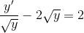

Substitution:

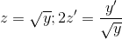

Substitution:
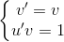

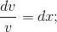
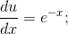

Integrating: Integrating:

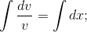
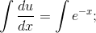

- general solution.

- also solution.

2. IVP:

- particular solution

Code:

In main class, starting GUI class you can change values of step,x,y,and Xfinal.
There are 4 classes for each method :
Euler, Improved Euler Runge-Kutta and exact solution which are inherit abstract class and implements funct. In GUI class we solve numerical methods with given values, adding to chart.
When program will calculate all values it shoes window with two chart - methods and errors of methods.

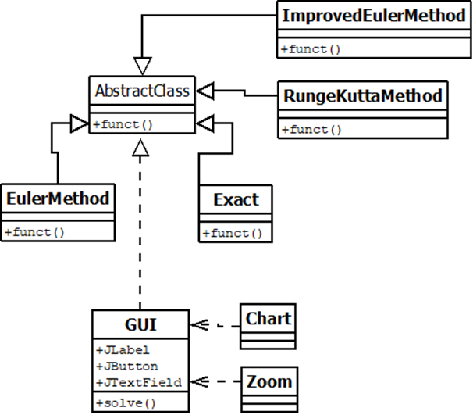

The UML diagram

Methods implementation:

1. Exact method

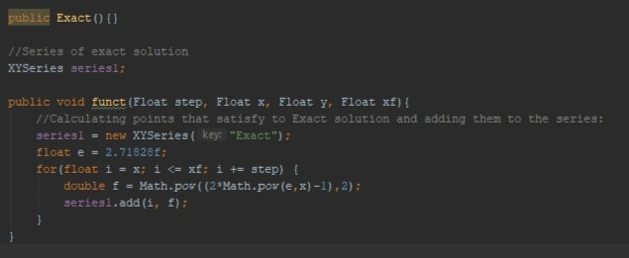

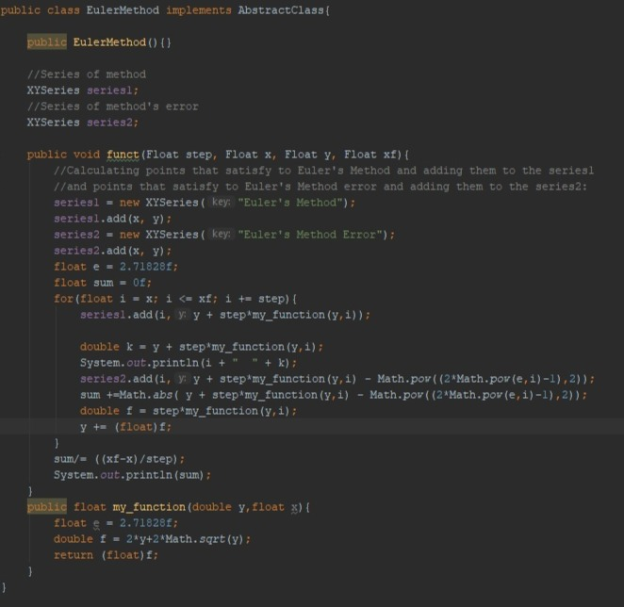

2. Euler method

3. Improved Euler
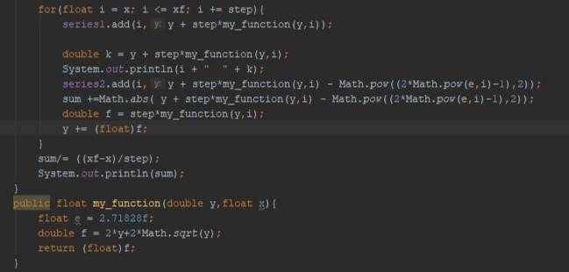

4. Runge-Kutta method

