PRACTICAL LOGBOOK
BIT4139: Ethical Hacking and Countermeasures
Student Details
Student Name | Elvis wambugu
Admission Number | BSCCS/2024/54678
Course / Class | Comp sci
Unit Code | BIT4139
Unit Name | ETHICAL HACKING AND COUNTERMEASURES
Lecturer Name | Michael Nyoro
Semester / Year | Semester 2 Year 3

Table of Contents
(Right-click → Update Field to refresh page numbers)
Table of Contents 2
Week 1: Introduction to Ethical Hacking 3
Week 2: Penetration Testing Basics 4
Week 3: Footprinting & Reconnaissance 6
Week 4: Scanning Networks 10
Week 5: Enumeration 12

Week 1: Introduction to Ethical Hacking
Setting Up the Lab Environment
Required Evidence

Fig 1: Kali Linux Installed and Running
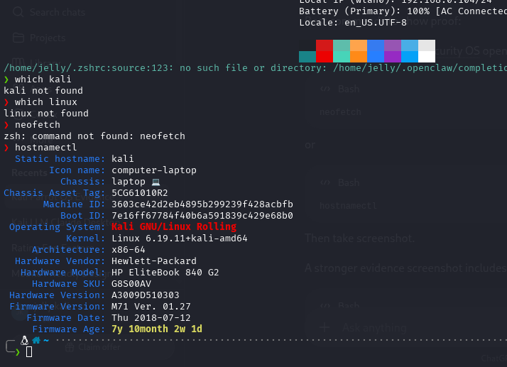
Fig 1: Kali Linux Installed and Running

Week 2: Penetration Testing Basics
Security Audits, Vulnerability Assessment and Testing Phases
Required Evidence
Fig 1: Penetration Testing Phases Diagram
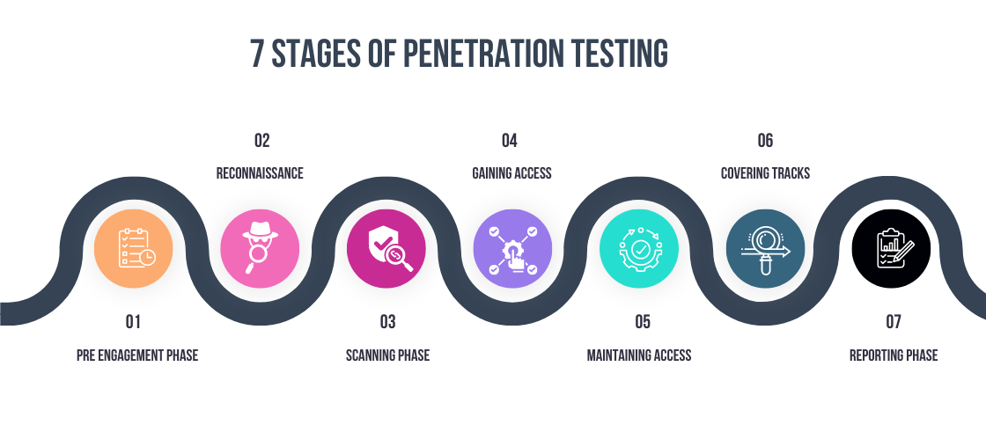
Fig 1: Penetration Testing Phases Diagram

Fig 2: Nmap Installation / Version Check
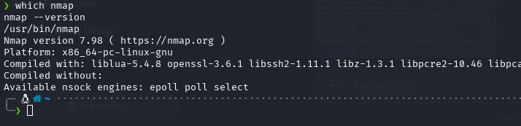
Fig 2: Nmap Installation / Version Check

Fig 4: First Vulnerability Scan Result
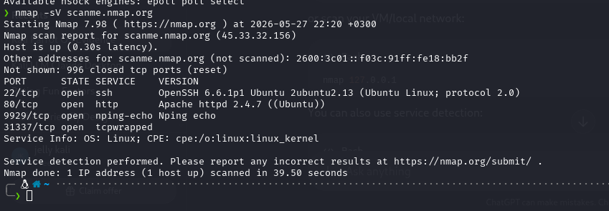
Fig 4: First Vulnerability Scan Result

Fig 5: Scan Summary Report
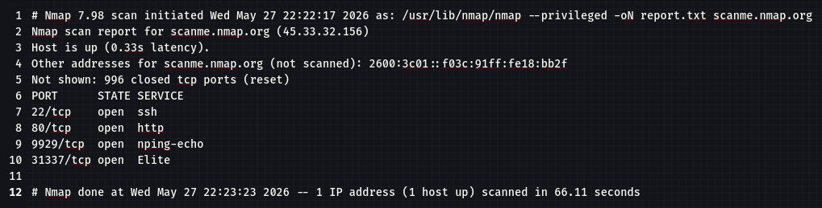
Fig 5: Scan Summary Report

My reflection
I explored the phases of penetration testing and ran my first vulnerability scan using Nmap and Nessus. Understanding the structured approach to security audits helped me appreciate how ethical hackers systematically identify and document system weaknesses.

Week 3: Footprinting & Reconnaissance
DNS, WHOIS, Social Engineering and Web Footprinting
Required Evidence
Fig 1: WHOIS Lookup Result
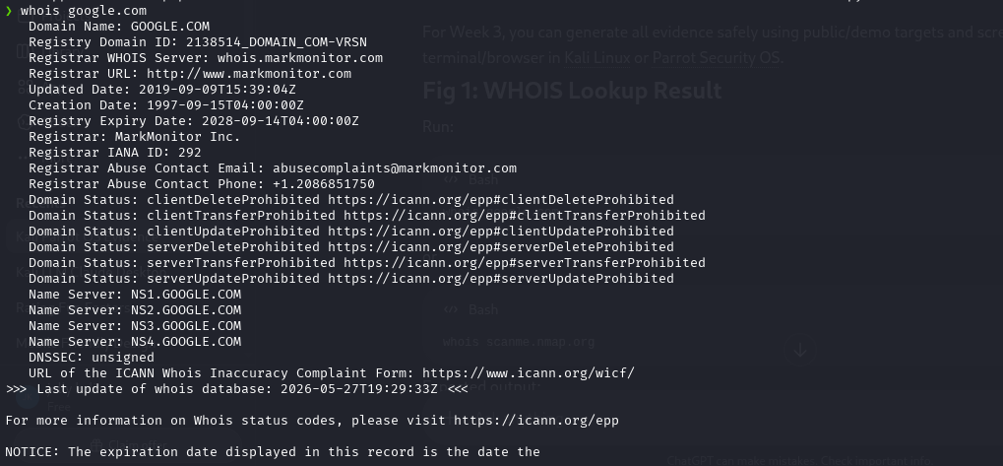
Fig 1: WHOIS Lookup Result

Fig 2: DNS Footprinting Output (nslookup / dig)
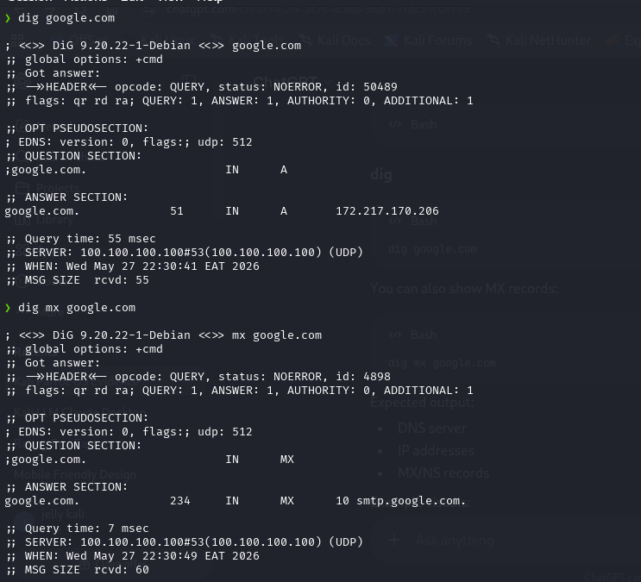
Fig 2: DNS Footprinting Output (nslookup / dig)

Fig 3: Recon-ng Module Output
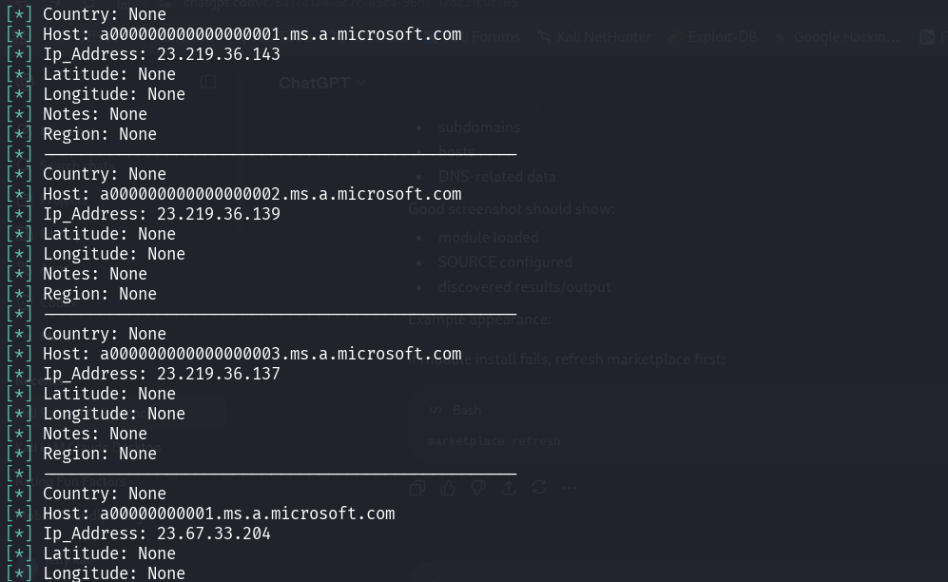
Fig 4: Recon-ng Module Output

Fig 5: Harvester foot print results
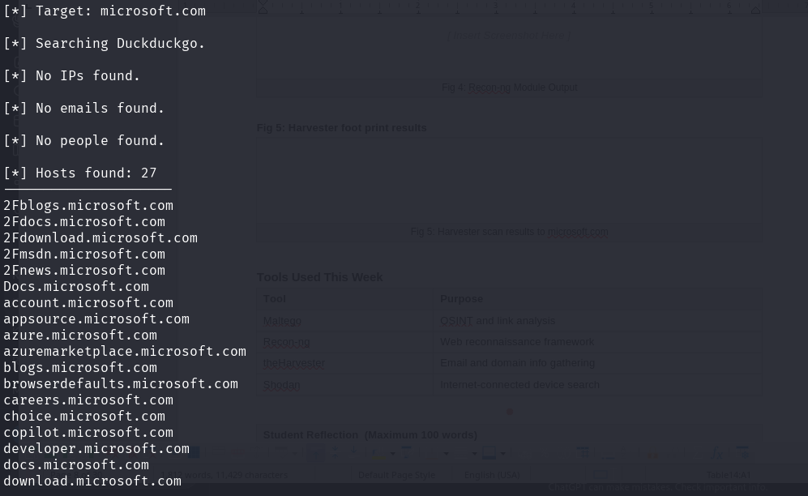
Fig 5: Harvester scan results to microsoft.com

My Reflection
Using tools like theHarvester and Recon-ng against microsoft.com revealed how much public information is exposed online. This week reinforced that reconnaissance is the most critical phase — the more information gathered, the more targeted and effective a penetration test becomes.

Week 4: Scanning Networks
Port Scanning, Banner Grabbing and Network Mapping
Required Evidence
Fig 1: Nmap SYN Scan Output
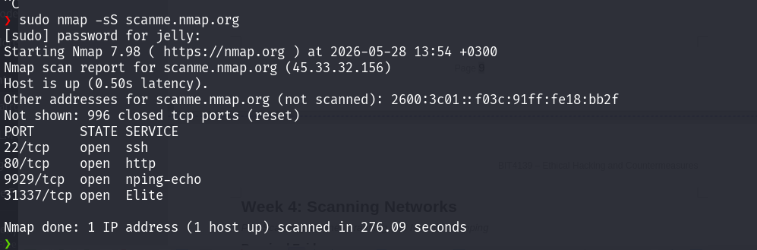
Fig 1: Nmap SYN Scan Output

Fig 2: OS Detection Scan Result
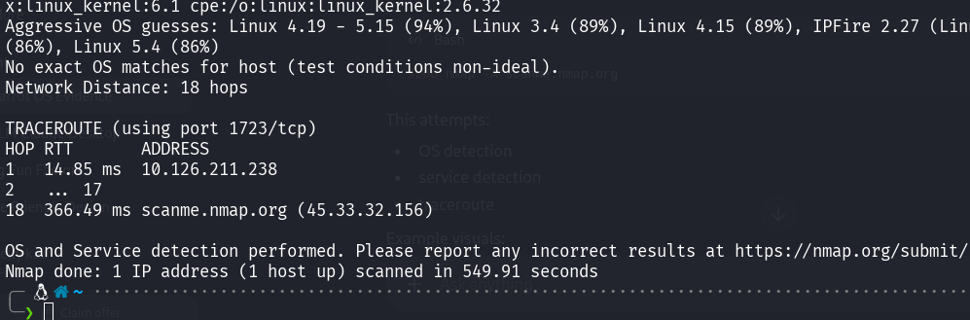
Fig 2: OS Detection Scan Result

Fig 3: Banner Grabbing with Netcat / Nmap
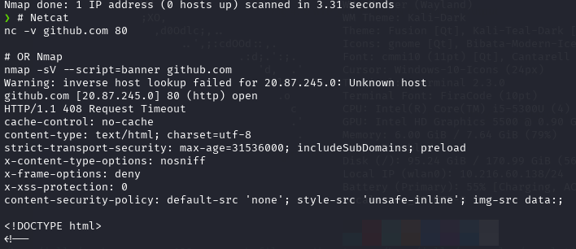

MY REFLECTION
I performed SYN scans, OS detection and banner grabbing against GitHub using Nmap and Netcat, while capturing traffic in Wireshark. This week showed me how attackers map live systems and open ports before launching any targeted exploitation attempt

Week 5: Enumeration
NetBIOS, SNMP, LDAP, SMTP and DNS Enumeration
Required Evidence
Fig 1: NetBIOS Enumeration Output (nbtstat)
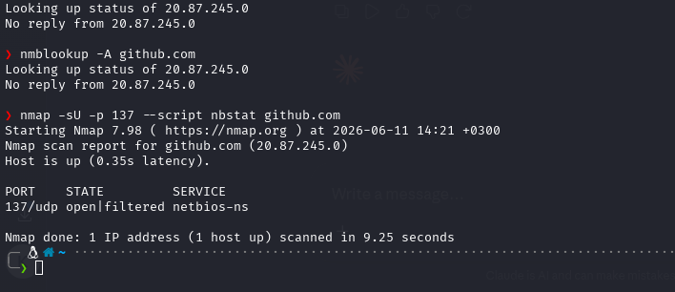
Fig 1: NetBIOS Enumeration Output (nbtstat)

Fig 2: SNMP Walk Result
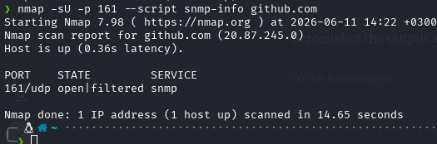

Fig 2: SNMP Walk Result

Fig 3: LDAP Enumeration Output
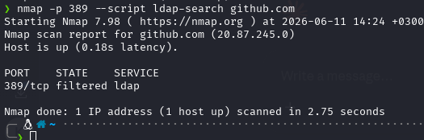

Fig 3: LDAP Enumeration Output

Fig 4: SMTP VRFY / EXPN Command Output
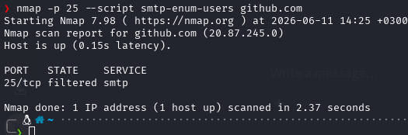

Fig 4: SMTP VRFY / EXPN Command Output

MY Reflection
Enumeration allowed me to extract detailed service information from GitHub using DNS, SNMP and SMTP probing techniques. Although most services were hardened and returned limited results, I understood how attackers use enumeration to identify exploitable entry points in real

