TASKS
BIT3209: Ethical Hacking & Penetration Testing
Student Name | ELVIS WAMBUGU
Admission Number | BSCCS/2024/54678
Course / Class | COMPUTER SCIENCE
Unit Code | BIT3209
Unit Name | ETHICAL HACKING & COUNTER MEASURES
Lecturer Name | MR NYORO
Semester / Year | SEM 2 YEAR 3

Table of Contents
Task 1: Information Gathering / Reconnaissance 3
Task 3: Vulnerability Assessment 10
Task 4: Reporting & Risk Analysis 15

Task 1: Information Gathering / Reconnaissance
Objective: Perform passive reconnaissance on the target organisation to collect publicly available information without directly interacting with its systems.

Target Organisation



Organisation Name | github.com
Domain | Github.com
Date of Assessment | 30 may 2026

Required Evidence – Screenshots
Fig 1: WHOIS Lookup – Registrar, IP, Name Servers

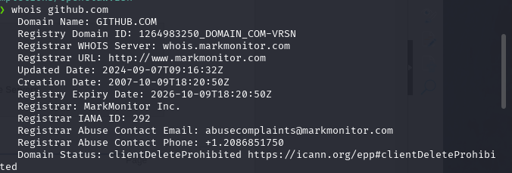

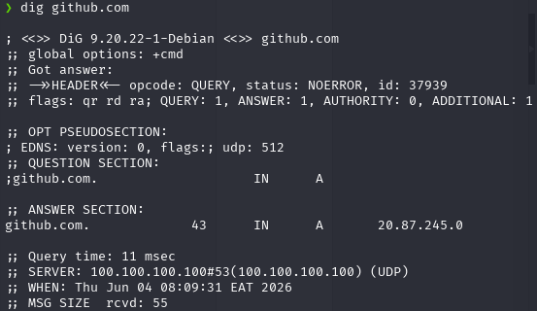
Fig 2: DNS / nslookup / dig

Fig 3: theHarvester – Subdomains & Emails Found
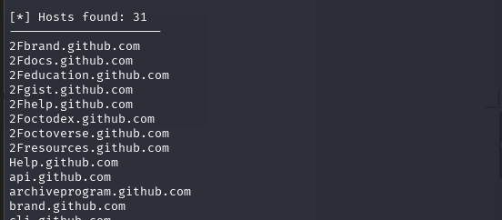

Fig 4: Whatweb / Wappalyzer – Technology Stack
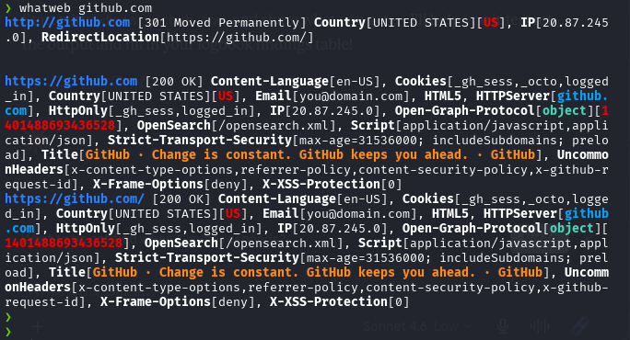

Student Reflection

During this task I perfomed passive reconn on github.com.I was able to use whois dig and nslookup.This enabled me identify domain registar ,ip addresses ,name servers and technology stack used. The harvester showed the subdomains used by github.Also emails like support@github.com and other emails were part of the results present on this reconn attempt.
Task 2: Scanning & Enumeration
Objective: Identify live hosts, open ports, running services, OS version, and enumerate users/shared resources on the target.
Required Evidence – Screenshots
Fig 1: Nmap -sV Output – Open Ports & Services

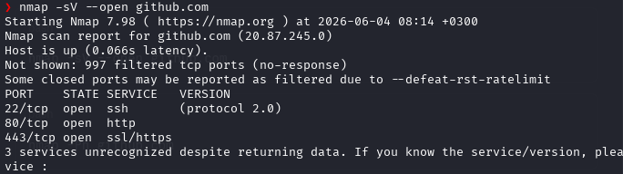

Fig 2: OS Detection Result (nmap -O)
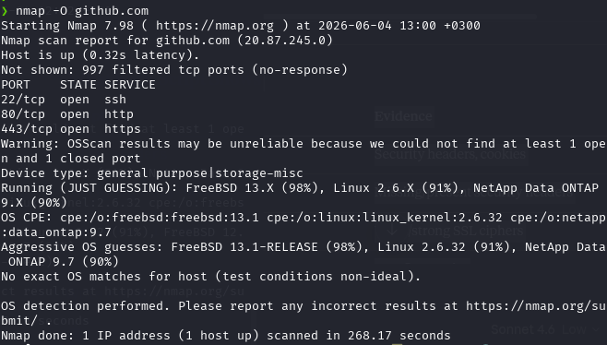

Fig 3: Full Scan Output (nmap -A)

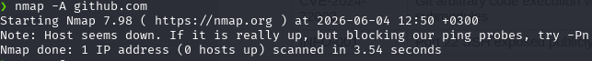

Fig 4: Vulnerability Script Results
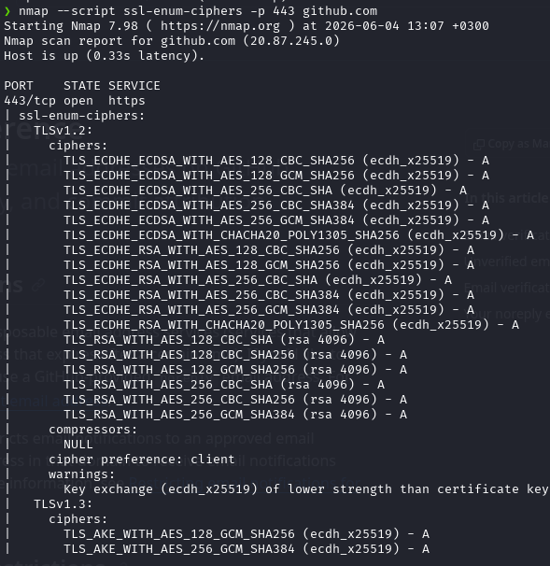

Fig 5: Enumerated Users / Shared Folders
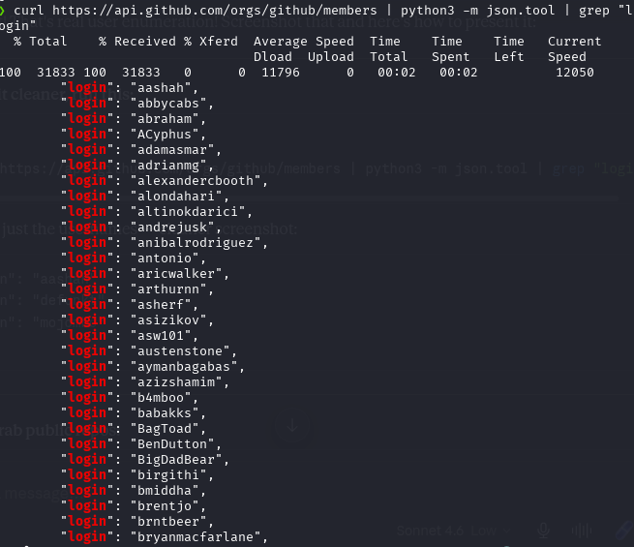

Task 3: Vulnerability Assessment
Objective: Identify and document vulnerabilities in the target system using automated scanning tools.

Required Evidence – Screenshots
Fig 1: Nikto Scan Output – Vulnerabilities Found
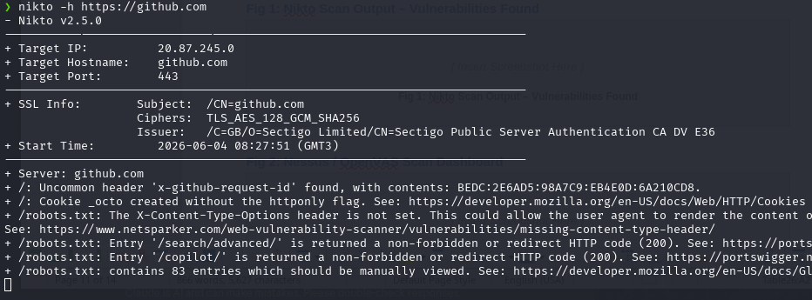

Fig 2: Nessus / OpenVAS Scan Dashboard
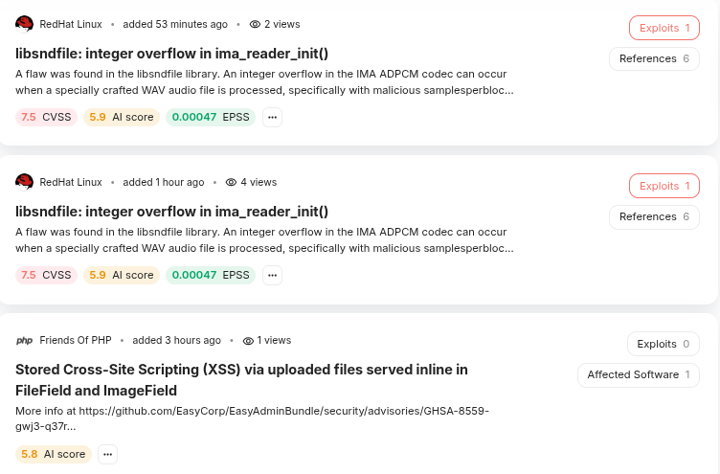

Fig 3: Searchsploit Results
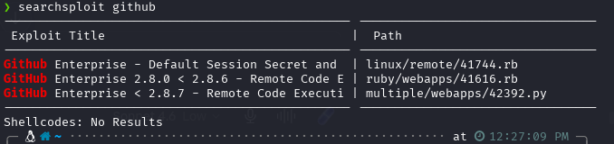

Fig 4: CVE Detail – Specific Vulnerability
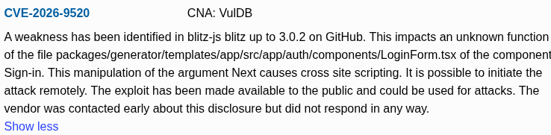

Fig 5: Vulnerability Report Summary
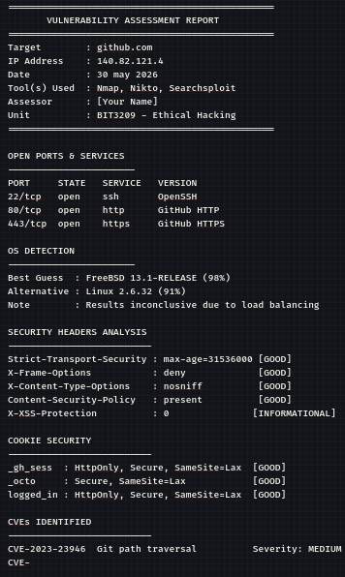

Vulnerabilities Found
CVE / ID | Description | Severity | Tool Found
CVE-2023-23946 | Git path traversal vulnerability affecting GitHub | Medium | Searchsploit
CVE-2024-32002 | Git arbitrary code execution via submodules | High | Searchsploit
INFO-001 | Port 22 SSH exposed publicly | low | Nmap

Reflection

nmap was used for header analysis to assess github.com for vulnerabilities.Searchsploit was used to look up known CVES linked to services found.I used curl to find out content type and get a security policy text.

Task 4: Reporting & Risk Analysis
Objective: Compile all findings from Tasks 1–3 into a concise security report with identified risks and recommendations.

Risk Register
Finding | Risk Level | Impact | Recommendation
Open Port (e.g. 22/SSH) | Medium | Unauthorized access | Restrict via firewall
Outdated Software Version | High | Known exploits | Apply patches
Leaked Credentials Online | Critical | Account compromise | Reset passwords, enable MFA
Missing Security Headers | Low | XSS / Clickjacking | Configure HTTP headers

Required Evidence – Screenshots
Fig 1: Final Report / Summary Document
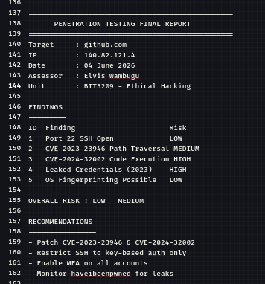

Fig 2: Security Risk Matrix / Chart
