APE/DOGE Spread Trade
Run 2026-09-10 · OKX 30m perpetual futures, last bar 2026-09-10 20:00 UTC
Universe 22,366 USDT-perp pairs · 30-day Engle–Granger scan → OU entry model
Long APE / Short DOGE
β 0.363 · entry z −1.47σ · target +1.85% gross (APE leg, pre-cost) · time cap 24h

Summary
APE/DOGE screens as a cointegrated pair over a trailing 30-day window. After a sharp down-move the spread now sits 1.5 stationary σ below its long-run mean. The OU fit gives a 9-hour half-life and a 0.66 model probability of reverting to the mean within the horizon; all five entry gates pass.
The trade is long the spread — long APE, short DOGE at a 0.363 hedge ratio — targeting an 80% retrace to the mean, about +1.85% gross on the APE leg before costs, worked against a 24-hour time cap. Levels, construction, and risks below.

Method
Stage 1 | Engle–Granger p-value scan, all 22,366 valid pairs, trailing 30 days (1,441 × 30m bars)
Stage 2 | Full diagnostics on 3,000 candidates — half-life, Hurst, rolling coint_stability, β stability
Tradeable filter | half-life 1–120h · Hurst < 0.5 · coint_stability ≥ 0.5 · β_cv < 0.6 · both legs ≥ $450k ADV · last two weekly windows cointegrated
Entry model | 5-gate OU check (generate_entry_signal) on a 45-day EWMA fit, 30m bars
Stability cross-check | survival curves from coint_survival.py (events file rebuilt 2026-09-09)

Screen output
22,366 pairs → 3,000 diagnosed → 13 tradeable → 1 entry signal
13 pairs cleared the tradeable filter. Twelve then failed at least one entry gate — eight on insufficient current dislocation (deviation < 1σ), three on the recent-window cointegration gate, one on volatility regime. One pair passed all five: APE/DOGE. LUNA appears in 6 of the 13 tradeable pairs, consistent with a single trending asset cointegrating broadly.

The trade — APE/DOGE

Structure
Direction | LONG spread — long APE, short DOGE
Hedge ratio β | 0.363 (spread = ln(APE) − 0.363·ln(DOGE) − α, α = −1.073)
Notional | short 0.363 units DOGE per 1 unit APE; size to the APE leg
Reference px | APE $0.13551 · DOGE $0.08427
Liquidity | APE ≈ $1.4M ADV · DOGE ≈ $300M ADV (APE is the constraining leg)

Entry gates
Gate | Test | Value | Pass if | Result
1 · Cointegration | Engle–Granger p, trailing 7d | 0.0567 | ≤ 0.10 | pass
2 · OU fit | EWMA θ > 0 (half-life 9.2h) | 0.0755/h | > 0 | pass
3 · Dislocation | |S₀ − μ| in stationary σ | 1.47σ | ≥ 1.0σ | pass
4 · θ significance | static full-window θ p-value | 0.0000 | ≤ 0.05 | pass
5 · Volatility regime | log(σ_recent / σ) | 0.786 | ≤ 1.1 | pass

OU parameters & targets
Entry spread S₀ | −0.02889
Long-run mean μ | −0.00569
σ · σ_stationary | 0.00614 · 0.01580
Entry z | −1.47 σ_stationary
θ (EWMA) · half-life | 0.0755 /h · 9.2 h
Reversion probability | 0.66 (Monte Carlo, residual bootstrap; gate ≥ 0.60)
Take-profit | −0.01033 (80% capture of S₀→μ ≈ +1.85% gross on the APE leg, pre-cost)
Expected reversion | 32.0 h (1.5× ln(1/f)/θ, f = 0.20)
Hard time cap | 24 h (MAX_TIME_STOP_HOURS)

Spread path — trailing five days
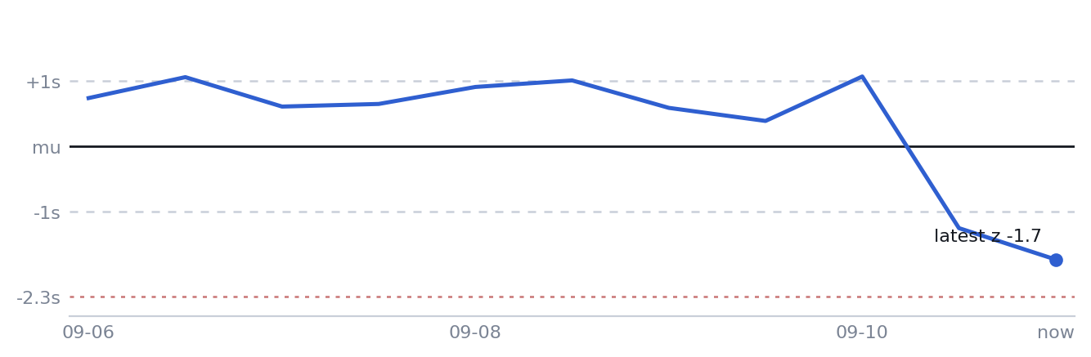
APE/DOGE spread in units of stationary σ, 12-hour samples. Roughly four days between +0.4σ and +1.4σ, then a single 12-hour move from +0.5σ to −1.7σ through the mean — the dislocation this trade enters against. Dashed lines: the ±1σ entry threshold and the −2.3σ abort level.

Execution
- Long APE / short DOGE at β = 0.363; size to the APE leg (≈ $1.4M ADV, the constraining side).
- Entry spread −0.0289, mean −0.0057, take-profit −0.0103 — about +1.85% gross on the APE leg before ≈ 0.2% round-trip fees across two legs, plus funding on both.
- Work against the 24-hour time cap; the model's own 32-hour reversion estimate sits past the cap, so the position closes on time before reaching its target if it has not reverted.
- Abort if the spread extends past ≈ −0.042 (−2.3σ) rather than reverting.
- Re-run the screen on fresh data immediately before execution — this signal is one day old and has changed sign once already (see Risks).

Risks
- Cointegration has weakened. The strict rolling test (Engle–Granger p < 0.01, three-consecutive-day failure rule) has flagged the APE/DOGE relationship as broken since about 2026-08-28 — it survived nine days past its 2026-08-19 detection. The 7-day entry-gate p-value rose from 0.010 to 0.057 over the last 24 hours and now clears only the looser 0.10 gate, not the strict screen threshold. The strong 30-day p-value (≈ 0.000) reflects older data.
- The entry side reversed in 24 hours. Yesterday's run gave short-spread at z ≈ +1.28; today is long-spread at z ≈ −1.47. The spread covered roughly 2.75σ in a day, most of it in one 12-hour bar. Realized spread volatility is currently high relative to the fitted OU σ.
- Reversion probability near the gate. Monte Carlo P(revert within τ) = 0.66 against a 0.60 minimum, down from 0.75 the prior day.
- Gate 4 tests a different θ. The significance check runs on the static full-window OLS θ, not the EWMA θ used for sizing and targets. Known gap, flagged in the code since 2026-08-20.
- Reversion-time multiplier is stale. The 1.5× correction on ln(1/f)/θ is a global constant; internal analysis puts the realized ratio nearer 0.5× on take-profit exits, so the 32-hour estimate is more likely long than short.
- No validated track record. The backtest record for this exact configuration is weak. Treat this as a research candidate, not established alpha.

Appendix — 13 tradeable pairs
Entry-gate trace, 45-day EWMA fit, data through 2026-09-10 20:00 UTC. First failing gate shown.
Pair | G1 coint p | Half-life (h) | Dislocation (σ) | G5 regime | Outcome
APE/DOGE | 0.0567 | 9.2 | 1.468 | 0.786 | signal
DOGE/TRB | 0.0628 | 4.1 | 0.662 | 0.490 | G3 dislocation
LUNA/SUI | 0.0000 | 1.7 | 0.499 | 0.333 | G3 dislocation
LUNA/ONDO | 0.0022 | 12.4 | 0.805 | 0.995 | G3 dislocation
LUNA/TRB | 0.0024 | 6.0 | 0.999 | 0.744 | G3 dislocation
MANA/SHIB | 0.0886 | 3.6 | 0.460 | 0.289 | G3 dislocation
LUNA/ORDI | 0.0009 | 4.6 | 0.670 | 0.580 | G3 dislocation
ASTER/BNB | 0.0399 | 12.0 | 0.968 | 1.172 | G3 dislocation
FLOKI/LUNA | 0.3332 | 3.3 | 0.530 | 0.785 | G1 cointegration
LUNA/STRK | 0.2444 | 7.1 | 1.288 | 0.861 | G1 cointegration
FLOKI/MEME | 0.0062 | 17.5 | 1.049 | 1.179 | G5 vol regime
AXS/DYDX | 0.2172 | 13.8 | 0.546 | 0.759 | G1 cointegration
RENDER/TRB | 0.0442 | 10.4 | 1.234 | 1.120 | G5 vol regime

Data — OKX 30-minute perpetual futures via freqtrade; last bar 2026-09-10 20:00 UTC; 212 instruments. Screen — research/pair_analysis.py (analyze_top_pairs, get_tradeable_pairs) · research/signal_generator.py (generate_entry_signal) · research/coint_survival.py (stability cross-check). Internal research note. Not investment advice. Figures are model output on a configuration with no validated live track record.

