**A RESEARCH PROPOSAL OF:**

**PLACEMENT NOTIFICATION PORTAL SYSTEM**

**By**

**ELVIS SAUTET MERITEI**

**DSE-01-0086/2019**

**DIPLOMA IN SOFTWARE ENGENEERING**

**ZETECH UNIVERSITY**

**2020**

# DECLARATION

I therefore declare this project proposal is my original work and has not been submitted to any institution of higher learning for the award of diploma.

# ACKNOWLEGMENT

I express my thanks and full hearted gratitude to my respected to my Lecturers, supervisor and guide of my project Mr. Titus of department of ICT **Zetech University**, for his guidance and entire support in writing this project successfully. I am very much thankful to him for the constant encouragement and continuous inspiration that he has given to me during all times.

I convey my real sense of gratitude and thankfulness to my family members and all friends for their unconditional support and encouragement during my project work without which I would hardly be capable of producing this huge work.

Finally, I express my gratitude to the almighty God the most beneficent and the most merciful, for granting me the opportunity to write this project proposal.

ABSTRACT.

Finding jobs that best suits the interests and skill set is quite a challenging task for the job seekers. The difficulties arise from not having proper knowledge on the institutions’ objective, their work culture and current job openings. In addition, finding the right candidate with desired qualifications to fill their current job openings is an important task for the recruiters of any institution. Online Job Search Portals have certainly made job seeking convenient on both sides. Job Portal is the solution where recruiter as well as the job seeker meets aiming at fulfilling their individual requirement. They are the cheapest as well as the fastest source of communication reaching wide range of audience on just a single click irrespective of their geographical distance. The web application “**PLACEMENT NOTIFICATION PORTAL SYSTEM OF JOBS & INTERNSHIPS**” provides an easy and convenient search application for the job seekers to find their desired jobs and for the recruiters (**zetech-university**) to find the right candidate. Job seekers from any background can search for the current job openings. Job seekers can register with the application and update their details and skill set. They can search for available jobs and apply to their desired positions. The website is able to let the university post jobs, which the students will apply and be placed on regard to the different positions they had applied and if qualified the university places them to their positions. If it’s on different companies they will too be placed there.

DECLARATION ii

ACKNOWLEGMENT iii

ABSTRACT iv

CHAPTER ONE 3

INTRODUCTION 3

PROBLEM STATEMENT 4

GOALS & OBJECTIVES OF THE STUDY 4

SIGNIFICANCE OF THE STUDY. 4

LIMITATIONS OF THE STUDY 5

SCOPE OF THE STUDY 5

LITERATURE REVIEW 6

Introduction 6

GLOBAL LITERATURE REVIEW 6

Local literature review with an advantage 7

CHAPTER THREE 9

METHODOLOGY 9

INTRODUCTION 9

Feasibility study 9

Requirement analysis and specification 9

Technical feasibility 9

Economic feasibility 10

Legal feasibility 10

Operational feasibility 10

Schedule feasibility 10

TOOLS 11

Web browsers 11

Mozilla Firefox 11

Google chrome 11

SYSTEM DEVELOPMENT TECHNIQUES 12

The water fall model 12

System requirement analysis 14

Functional requirements 14

NON-FUNCTIONAL REQUIREMENTS. 15

TESTING PLAN FOR THE SYSTEM 16

Testing Methodologies: 16

CHAPTER 4: SYSTEM ANALYSIS AND DESIGN. 17

System Design 17

TABLES 17

Architectural Design 20

CHAPTER 5: WORKPLAN AND BUDGET. 26

RECOMMENDATION 26

REFERENCES AND LIST OF BIBLIOGRAPHIES 26

Development costs: 27

System analyst 27

1 27

KSH = 100,000 27

Programmer 27

1 27

KSH = 600,000 27

Software cost 27

KSH = 0 27

Operating cost 27

KSH = 400,000 27

Hardware cost 27

# CHAPTER ONE

## INTRODUCTION

A job portal is a modern name for an online job board that helps the employers to find their candidates and also helps the job seekers to find the jobs which are suitable for them. This online job portals offer a wide range of in different areas e.g. government agencies, on profit organizations, universities and private businesses have created the online job portals to enable the job seekers access the organizations website.

The Placement Notification Portal system is a web application which aims at providing an easy and automated system for conducting placements during Campus internships and also jobs which are posted in the web page for the students to apply for different positions either (jobs, internships).The only way to select the candidate eligible for the jobs and the internships’ is by posting the interest career opportunities to the sites available in the market. Placement Notification Portal system best suits this field’s purpose. A lot of traditional methods like: university career employment services, employee referrals, advertising in newspapers, televisions and many more others were in place but by the advancement in technology worldwide with the growth of the internet, the online requirements and placements have made it possible and easier for institutions to employ and accommodate internships.

With this online job/advertisement system the work flow to employ and process interns’ will be speed up and work distribution will be reduced at a large rate since processing of the data will be at a faster rate. The cost for job searching/posting will be at a low price since the system will be managed by the institution compared to the traditional ways like the advertisements etc.

Using the portal job seekers can extensively search for jobs from the institution’s posted jobs which vary and match their skills and many more by which they will apply and send their resumes, and more which will help in the jobs and internships allocation in the institution. In addition, candidates/Employers can write a review about an organization, which might help them to change.

## PROBLEM STATEMENT

In **Zetech University** job applications and internships have been made manual in the past many years up-to this current situation where everything has totally changed due to technological changes. The traditional mode of employment takes a lot of steps therefore consuming a lot of time. It is also clear that Zetech University has a career site portal but it’s too complex to understand and also some problems defined in the section below fit.

Our existing system will work fully automatically since all job searches won’t be done manually because the institution is connected with the system to the internet and hence be easy to manage.

## GOALS & OBJECTIVES OF THE STUDY

The main objective of this project is to change manual way of operation of the job application to an automatic system. This system will help to reduce the time required during the job search process.it will help the institution and the employees to reduce the human resources needed in a company. The job portal also provides flexibility to the job seekers.

* To develop a user friendly job portal application interface where users can interact with the system without problems.
* To create a System that allows a user to input files on application forms and even more captures for the validation of jobs.
* To create a system that enables users to save their information they had given to the system for later reviews.
* To create a system that captures real world entity data for the system.

## SIGNIFICANCE OF THE STUDY.

This study will contribute to the improvement of job application in the universities. I hope that this research will encourage the faculty administration to this new method of job application, and to adapt it to the applicants as an effective strategy of the institutions’ portal for the application that will benefit them all of them in general.

## LIMITATIONS OF THE STUDY

The system may not be able to edit words or texts the user’s hands in e.g. a like “i” instead of “1” while for example submitting an identification. number.

## SCOPE OF THE STUDY

In this online portal, the zetech university students are able to log in the system either with their students id number where after logging in the system, they can navigate on the jobs posted by the admin or the internship positions and apply regarding their career choice. their details are then send to a database regarding them as students not new applicants like the job seekers, they will also hand in their resumes and also some details in the system for the admin either to contact them if they have gotten the positions they applied for.

# LITERATURE REVIEW

## Introduction

It is concerned with the critical review of the related systems and the technologies required on the implementation. it is focused on the justification and evaluation of the recruitment process and technology selection. There are several systems which are related to the online job portal. Some of the systems are operated manually. The systems are as follows, the job search engines/job websites, social media, newspapers and advertisement, local employment agencies and the social websites and advertisements. This systems show the job vacancies available, the qualifications which a candidate needs to apply for the jobs and also how to apply for the jobs. Like the local employment agencies shows the jobs which are available local. People who are not able to access the social media and other job websites can access their local employment agencies easily and at any time. Most of these systems are traditional systems.

(Weddle) According to online recruiting commentator Peter Weddle, nearly two-thirds of all companies under-utilize their corporate web sites for recruiting. Weddle suggests the following recruiting website improvements: take full advantage of virtually unlimited web space, communicate your company's image as an employer, attract both active and passive job seekers, and provide a high-quality web experience.

## GLOBAL LITERATURE REVIEW

Internet has begun to become a popular advantage to most organizations and companies. Many companies have designed websites to be used to advertise their jobs. It came to my realization that a portal can be far better to use in job advertisement than websites because a portal can be a gateway to access website information whereas a website just displays online content.

A portal enhances functionality and flexibility to cater for various classes of users. Many companies have realized the need to change employment or recruitment process in order to cope up with the increasingly changing technology and the large number of job seekers. (Midiwo, 2015)

A well-developed web-based portal is a top cost reducing strategy to be applied or used by organizations because efficiency is improved within the organization (Kemei,2016).With cloud computing, it is easy to maintain data and applications using remote servers and the internet (Anitha and Aruna,2013).

New technology is currently changing the way we carry out business everyday i.e., the way we isolate, recruit and hire or employ the best candidates/applicants. Traditionally it was all about paper resumes, newspaper advertisement, television or radio advertisement and traditional sit-down interviews.

Galanaki [5] lists the following methods to be the traditional (old) ways for recruitment:

a. Employment recruitment agencies

b. Job fairs

c. Advertising in the mass media such as newspapers

d. Advertisement in television and radio

e. Management Consultants

f. Existing employee contacts

## Local literature review with an advantage

Companies in Kenya must realize the efficiency and competitive nature of the global economy with relation to online recruitment. (Kumar, 2012) argues that an organization that does not use any system consumes a lot of time to update and retrieve employee information. A web based portal can be used easily in updating and retrieving employee data and information. Posting a job on the portal costs nothing as compared with the traditional methods.

Some traditional methods like the following below:

* Putting up vacancies at the gates of the factory. (Called gate hiring).
* Asking existing to refer suitable candidates for existing vacancies.
* Campus hiring by visiting campuses for filling,

The above will cost a lot of time and waste a lot of money but an online portal like this will just be implemented in the internet whereby institution will not spend money since it’s their portal, so they just post and wait for applicants and they choose their best persons who fit the job so they will save a lot and even time will be used well.

# CHAPTER THREE

## METHODOLOGY

## INTRODUCTION

There are the methods that are used in the system development process, to analyze the cost estimates time and other resources required. There is the feasibility study and requirement analysis.

## Feasibility study

The aim of the feasibility study is to identify the weaknesses and the strengths the existing system and the threats and opportunities that are presented in the environment, if the resources are available to carry out the project and the chances of success.it helps in the cost estimation and the value attained if the project is undergone.

## Requirement analysis and specification

It is a phase where the developer tries to understand the customer’s requirement and to systematically organize the specifications into a specification document. Requirement gathering and analysis requirement specification is one of the activity that is carried out during the requirement analysis and specification the activity analysis the data which is gathered get a clear understanding of the system which is to be developed requirement analysis and specification also identifies the problem of inconsistency, ambiguity and incompleteness.

### Technical feasibility

Technical feasibility on this system on the required technology is available since I the programmer will develop the system using the latest technological tools such as a text editor VS code and programming languages like the HTML, CSS and the php with the MySQL database connections which are very secure on regard with the latest technology.

Data is also available to the system since some methods of data collections I have implemented from obtaining from the recent jobs posted by the institution. Testing will also be done for the system to check full functionality.

Software’s will also implemented when developing this system, like the PHP 7.3, XaMP and other like vs. Code editor hence they need to be downloaded.

### Economic feasibility

This is also known has the cost/ benefits analysis. It aids in evaluating the effectiveness of a new system. The cost of the new system should not outweigh the benefits. If the benefit outweighs the cost a decision is made to design and implement the new system.

Portal placement system will therefore contain a development cost and maintenance cost. The development costs are one time investment whereas maintenance costs are recurring. The development cost of the system will just incur software’s/equipment and some reference personnel who will help in some issues in the coding and a lot of research which will be an amount of wage

Operating costs:

Operating costs are the expenses required for the day to day running of this system. This includes the maintenance of the system. That can be in the form of maintaining the application programs and maintaining this system in the university

The system will not cost much maybe some advancements of it by the institution to make it more perfect as per their regards

### Legal feasibility

This system will not conflict with the patents law, copyrights, trade-marks of different institutions.it will be an own project system which is a new project with different features with a lot of research in it.

### Operational feasibility

The system will be simple, easy and user friendly to use and manage. It will also satisfy the needs of the institution and other users.

The portal system will really benefit the institution In such a way that data will be stored and secured, also thought the jobs posted with no cost to the website the institution may also be able to get qualified personnel without using extra costs,

### Schedule feasibility

Most projects fail because they take a long time to be completed. Time should be estimated for which the system will take to be developed.

Hence this portal system will be according to schedule and follow the proposed time and maybe also completed before the proposed time.

## TOOLS

These tools can be accessed with different operating systems and function as per properly with the software designed.

Some of the tools are as follows:

### Web browsers

Web browsers are software applications which allow users to access information on the World Wide Web. The URL distinct to enable the browsers to retrieve the webpages, images and videos on the users’ device. A web browser is different from the search engines.

### Mozilla Firefox

Mozilla Firefox (or simply Firefox) is a free and open-source web browser developed by Mozilla Foundation and its subsidiary, Mozilla Corporation. Firefox is available for Windows, mac OS, Linux, BSD, illumes and Solaris operating systems. Its sibling, Firefox for Android, is available for Android. Firefox uses the Gecko layout engine to render web pages, which implements current and anticipated web standards. In 2016, Firefox began incorporating new technology under the code name Quantum to promote parallelism and a more intuitive user interface. An additional version, Firefox for IOS, was released on November 12, 2015. Due to platform restrictions, it uses the Weskit layout engine instead of Gecko, as with all other IOS web browsers.

### Google chrome

Google Chrome browser is an open source program for accessing the World Wide Web and running Web-based applications. The Google Chrome Web browser is based on the open source Chromium project. Google released Chrome in 2008 and issues several updates a year. It is available for Windows, Mac OS X, Linux, Android and IOS operating systems. The Google Chrome browser takes a sandboxing-based approach to Web security. Each open website runs as its own process, which helps prevent malicious code on one page from affecting others (or the computer operating system at large). The browser also supports Web standards such as HTML5 and cascading style sheets (CSS).

## SYSTEM DEVELOPMENT TECHNIQUES

### The water fall model

This was the earliest of all the process to be introduced. This model is also known as the linear sequential life cycle model. It was user friendly and easy to understand. The waterfall model uses phases and each phase must be completed before the next phase. During the process there is no over lapping when the process starts. The waterfall model uses linear sequential to illustrate the software development process.

This process of software development has separate phases which are divided. The output from the first phase is used as the input in the next phases sequentially.

The figure below represents its stages and how our system will be developed:

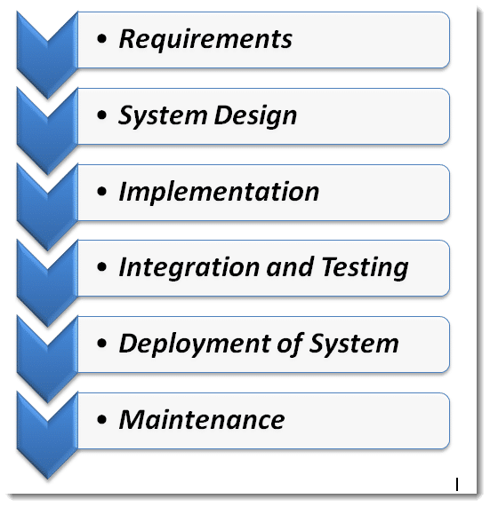

Figure 1.waterfall model

The steps of the waterfall model are explained below:

Requirements analysis: The first phase involves understanding what needs to design and what is its function, purpose, etc. Here, the specifications of the input and output or the final product are studied and marked.

System Design: The requirement specifications from the first phase are studied in this phase and system design is prepared. System Design helps in specifying hardware and system requirements and also helps in defining overall system architecture. The software code to be written in the next stage is created now.

Implementation: With inputs from system design, the system is first developed in small programs called units, which are integrated into the next phase. Each unit is developed and tested for its functionality which is referred to as Unit Testing.

Integration and Testing: All the units developed in the implementation phase are integrated into a system after testing of each unit. The software designed, needs to go through constant software testing to find out if there are any flaws or errors. Testing is done so that the client does not face any problem during the installation of the software.

Deployment of System: Once the functional and non-functional testing is done, the product is deployed in the customer environment or released into the market.

Maintenance: This step occurs after installation, and involves making modifications to the system or an individual component to alter attributes or improve performance. These modifications arise either due to change requests initiated by the customer, or defects uncovered during live use of the system. The client is provided with regular maintenance and support for the developed software.

Advantages of waterfall methodology

1. The advantage of waterfall development is that it allows for departmentalization and control. A schedule can be set with deadlines for each stage of development and a product can proceed through the development process model phases one by one.
2. The waterfall model progresses through easily understandable and explainable phases and thus it is easy to use.
3. It is easy to manage due to the rigidity of the model – each phase has specific deliverables and a review process.
4. In this model, phases are processed and completed one at a time and they do not overlap. The waterfall model works well for smaller projects where requirements are very well understood.

### System requirement analysis

Upon the completion of the **PLACEMENT NOTIFICATION PORTAL SYSTEM OF JOBS & INTERNSHIPS**, there are a number of things that will be expected of it not only by the prospected users but also for the administrator of the system. These will therefore form the requirements of the Job portal and will be broadly classified in to the system requirements, functional requirements and the Non-functional requirements.

### Functional requirements

Functional requirements entail what the system should able to do, some of which include the following;

User registration/login

Job vacancies advertisement

User dashboard

Contact us functionality

Privacy and security

Terms of use of the system

Database holding all data

Login functionality for admins

### NON-FUNCTIONAL REQUIREMENTS.

The non-functional requirements of the system are how our system should be like and respond and operate. The system must perform accurately towards the administrator request. For example, when the administrator saves the edited details of the user, after he reviews the details later, they must be changed according to the latest details that was updated. Moreover, the client is not allowed to view the details that the administrator has. Besides that, the login form will have validity check to ensure that only the authorized users gain access to the system

**Software requirement Specification**

A set of programs associated with the operation of a computer is called software. Software is the part of the computer system, which enables the user to interact with several physical hardware devices.

The minimum software requirement specifications for developing this project are as follows:

Operating System: Window 8, windows 10 pro,

Presentation layer: JavaScript, html, CSS,

Database: My SQL, php

Documentation Tool: Microsoft Office

The collection of internal electronic circuits and external physical devices used in building a computer is called the Hardware. The minimum hardware requirement specifications for developing this project are as follows:

Processor: Standard processor with a speed of 1.6 GHz or more

RAM: 256 MB RAM or more

Hard Disk: 20 GB or more

Monitor: Standard color monitor

Keyboard: Standard keyboard

Mouse: Standard mouse

## TESTING PLAN FOR THE SYSTEM

TESTING

This is process of executing a system with the intent of finding an error.

Testing is defined as the process in which defects are identified, isolated, subjected for rectification and ensured that product is defect free in order to produce the quality product and hence customer satisfaction.

### Testing Methodologies:

***Black box Testing***: is the testing process in which tester can perform testing on an application without having any internal structural knowledge of application.

Usually Test Engineers are involved in the black box testing.

In this testing method the system is fed with certain values to tests its functionality if certain functions are working properly, it can be done with different personnel who have no knowledge of programing, so even the users can be brought so test the system functionalities

***White box Testing***: is the testing process in which tester can perform testing on an application with having internal structural knowledge.

Usually The Developers are involved in white box testing.in this system it requires some programmers with a lot of knowledge of programming to test this portal system.

The programmers here will test the algorithms I have implemented in my system. Whereby the system will be checked also by inputs to check and verify loops.

# CHAPTER 4: SYSTEM ANALYSIS AND DESIGN.

## System Design

Systems design is the process of defining the architecture, components, modules, interfaces, and data for a system to satisfy specified requirements [6]. System designs are modeled using UML which is a standard object-oriented analysis and design language. The UML is a collection of diagrams and standard set of notations for specifying and visualizing various aspects such as requirements and design of software systems.

### TABLES

|  |  |
| --- | --- |
| Job type | Varchar |
| Job id | number |
| Job description | Varchar |
| Created date | date |
| Closing date | date |
| Job skill | number |

Table 1 job table

|  |  |
| --- | --- |
| Internship type | varchar |
| Internship id | number |
| internship description | Varchar |
| Created date | date |
| Closing date | date |
| Internship skill set | varchar |

Table 2 internship

|  |  |
| --- | --- |
| First name | varchar |
| last name | varchar |
| Id number(country) | number |
| School id | varBinary(max) |
| Email | varBinary |
| Cv attachment file | varBinary(max) |
| Certificate attachment | varBinary(max) |
| description | varchar |

Table 3 students

|  |  |
| --- | --- |
| First name | varchar |
| last name | varchar |
| Id number(country) | number |
| Email | varBinary |
| Cv attatchment file | varBinary(max) |
| Certificate attatchment | varBinary(max) |
| description | varchar |

Table 4 new (applicant)

|  |  |
| --- | --- |
| username | varchar |
| password | varchar |

Table 5 job-seeker login

|  |  |
| --- | --- |
| Admin id | varchar |
| password | varchar |

Table 6 admin login

#### A sketch of the system

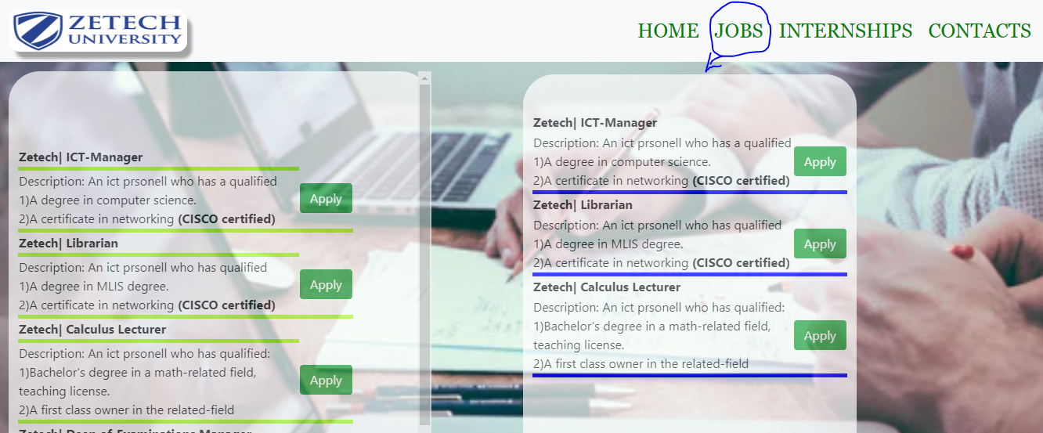

Figure 8 jobs (sketch)

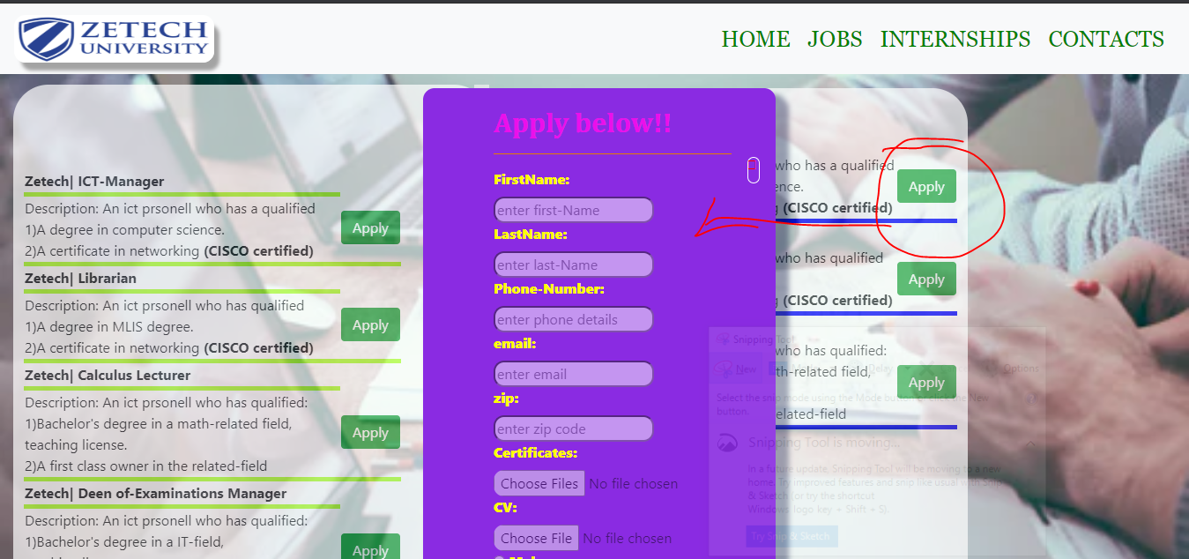

Figure 9 on click (apply button)

The same applies to the internship part.

The home part on the navigation part describes the portal and some navigation to be implemented.

The contacts part describes the contact information of the system and how to contact the admins.

### Architectural Design

A Placement Notification Portal system uses the three tier architecture. The Three tier architecture is a client-server architecture in which the functional process logic, data access, computer data storage and user interface are developed and maintained as independent modules on separate platforms. Three-tier architecture is a software design pattern and well-established software architecture.

The three tiers in three-tier architecture are:

i. Presentation Tier: Occupies the top level and displays information related to services available on a website. This tier communicates with other tiers by sending results to the browser and other tiers in the network.

ii. Application Tier: Also called the middle tier, logic tier, business logic or logic tier, this tier is pulled from the presentation tier. It controls application functionality by performing detailed processing.

iii. Data Tier: Houses database servers where information is stored and retrieved. Data in this tier is kept independent of application servers or business logic.

In this system we will use HTML, CSS, PHP, JAVASCRIPT and MySQL.

Html

In this part html is user part the programming on the front end

Example of a html code:

<! DOCTYPE html>

<html Lang="en">

<head>

    <meta charset="UTF-8">

    <meta name="viewport" content="width=device-width, initial-scale=1.0">

    <title>Document</title>

</head>

<body>

</body>

</html>

Figure 10. html type

CSS

This language is used to me make a page of describing the presentation of Web pages, including colors, layout, and fonts. It allows one to adapt the presentation to different types of devices, such as large screens, small screens, or printers. It is also dependent to html.

So it requires a html to be linked to css example:

    <link rel="style sheet" href="index.css">

Figure 11 CSS (linked) HTML

The example above represents a index.css style sheet linked to the html page.

A code for css

  <style>

 Align-content: center;

     Overflow: auto;

     Margin-left: 15px;

     Margin-right: auto;

     Opacity: 0.7;

     Background-color: white;

     Box-sizing: border-box;

     Max-width: 40%;

     Margin-top: 12px;

     Border-radius: 40px;

     Height: 36em;

     Padding: 0px 12px;

</style>

Figure 12 CSS style sheet

JAVASCRIPT

This language is used to make the page more interactive.

E.g. when a button is clicked something can happen etc.

An example of a JavaScript code is as follows:

<script>

         function myfunction(){

             document.getElementById ('application').style. Display="block";

         }

         Function myfunction1 () {

             document.getElementById ('application').style. Display="none"

         }

     </script>

Figure 13 Java script code

The CSS, HTML and JavaScript for the presentation layer

The logic part language

PHP is a server side scripting language. That is used to develop Static websites or Dynamic websites or Web applications. PHP handles the way your website works

Example of a php code.

The <?php

// PHP code goes here

?>syntax of a php program looks like:

An example of a code from the syntax looks like:

Echo 'This is a <strong>test</strong>!';

This is used to print out.

The data tier uses MySQL.

MySQL open source relational database management system. It runs as a server and allows multiple users to manage and create numerous databases.

Example of a table created:

CREATE TABLE IF NOT EXISTS tasks (

Task_id INT AUTO_INCREMENT PRIMARY KEY,

Title VARCHAR (255) NOT NULL,

Start date date

Due date DATE,

Status TINYINT NOT NULL,

Priority TINYINT NOT NULL,

Description TEXT,

Created_at TIMESTAMP DEFAULT CURRENT_TIMESTAMP

)

**Logical Design**

In this system I have illustrated a context Level DFD which acts as a sample of the system and how it will work and function in major parts of the implementation.

The figure below illustrates:

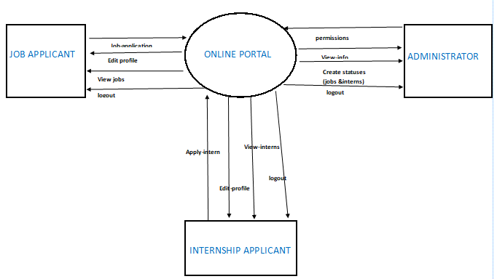

**Use-case Documentation**

A use case diagram is a diagram that shows a set of use cases and actors and relationships.

Use case commonly contains:

1. Use cases
2. Actors
3. Dependency, generalization and association relationships.

The figure below shows Placement Notification Portal system Overall Use Case:

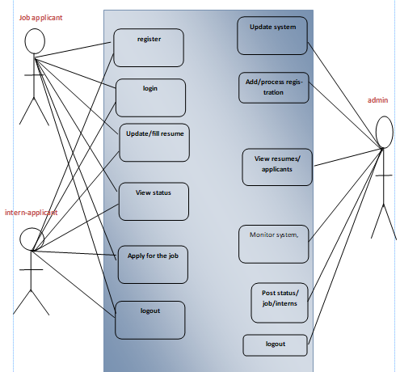

# CHAPTER 5: WORKPLAN AND BUDGET.

Job Search Portals stands as a revolutionizing element in the sphere of recruitment. They act as a communication bridge between applicants and recruiters facilitating their requirements. This website application helps the institution to have a greater exposure to the candidate pool and also job seekers facilitating wide search of jobs matching their interests which are posted to the system by the administrator. The PLACEMENT NOTIFICATION PORTAL SYSTEM OF JOBS & INTERNSHIPS provides flexibility to the jobseekers and internship finders to view the openings and applied jobs and interns using the internet since it’s a website which can be accessible over the internet.

The advantages of the new portal are as follows:

i. Achieve the main targets of the Project

ii. Standard content services and display

iii. High level management and flexibility

## RECOMMENDATION

The placement notification portal system provides a platform where the institution can advertise their Job vacancies and the internships available.

Encrypting user data and ensuring multiple layers of security to avoid phishing hence helps to maintain Confidentiality, Integrity and Availability

## REFERENCES AND LIST OF BIBLIOGRAPHIES

1. Seddon, P. (1997) "A Re-specification and Extension of the DeLone and McLean Model of IS Success", Information Systems Research, Vol. 8, No. 3.
2. Petter, S., and McLean, E. (2009) " A meta-analytic assessment of the DeLone and McLean IS success model: An examination of IS success at the individual level", Information & Management, Vol. 46, pp.159–166.
3. Research proposal budget. <https://orsp.umich.edu/research-proposals-budget>
4. System design model <https://www.tutorialspoint.com/sdlc/sdlc_waterfall_model.htm>
5. System design modeling <https://www.toolsqa.com/software-testing/waterfall-model/>
6. Anitha, J, &#038; Aruna, M. &#8221; Adoption of Human Resource Information System in Organizations. SDMIMD journal of management, 2013.
7. E Kemei. &#8221; THE INFLUENCE OF HUMAN RESOURCE. Nairobi, 2016. Holm, AB. German
8. Journal of Human Resource, 2012.
9. Kumar, R. &#8221; Human Resource Management System: An innovative Strategy for Human Resource Management. 2012.

**APPENDIX**

**BUDGET**.

|  |  |  |
| --- | --- | --- |
| Development/item | unit | Total cost |
| Development costs:System analyst | 1 | KSH = 100,000 |
| Programmer | 1 | KSH = 600,000 |
| Software cost Software licensee |  | KSH = 0 |
| Operating cost Stationary & maintenance |  | KSH = 400,000 |
| Hardware cost Personal computer | 1 | KSH = 30,000 |

**workplan**

