**A RESEARCH PROPOSAL OF:**

**PLACEMENT NOTIFICATION PORTAL SYSTEM**

**By**

**ELVIS SAUTET MERITEI**

**DSE-01-0086/2019**

**DIPLOMA IN SOFTWARE ENGENEERING**

**ZETECH UNIVERSITY**

**2020**

## DECLARATION.

This project proposal is my original work and has not been submitted to any institution of higher learning for the award of diploma.

ACKNOWLEDGMENT.

I express my thanks and full hearted gratitude to my respected to my Lecturers, supervisor and guide of my project Mr. Titus of department of ICT **Zetech University**, for his guidance and entire support in writing this project successfully. I am very much thankful to him for the constant encouragement and continuous inspiration that he has given to me during all times.

I convey my real sense of gratitude and thankfulness to my family members and all friends for their unconditional support and encouragement during my project work without which I would hardly be capable of producing this huge work.

Finally, I express my gratitude to the almighty God the most beneficent and the most merciful, for granting me the opportunity to write this project proposal.

ABSTRACT.

Finding jobs that best suits the interests and skill set is quite a challenging task for the job seekers. The difficulties arise from not having proper knowledge on the institutions’ objective, their work culture and current job openings. In addition, finding the right candidate with desired qualifications to fill their current job openings is an important task for the recruiters of any institution. Online Job Search Portals have certainly made job seeking convenient on both sides. Job Portal is the solution where recruiter as well as the job seeker meets aiming at fulfilling their individual requirement. They are the cheapest as well as the fastest source of communication reaching wide range of audience on just a single click irrespective of their geographical distance. The web application “**PLACEMENT NOTIFICATION PORTAL SYSTEM OF JOBS & INTERNSHIPS**” provides an easy and convenient search application for the job seekers to find their desired jobs and for the recruiters (**zetech-university**) to find the right candidate. Job seekers from any background can search for the current job openings. Job seekers can register with the application and update their details and skill set. They can search for available jobs and apply to their desired positions. The institution cans posts their current openings also can view the Job applicants and can screen them according to the best fit. The applicants can also share their resumes, which will be used as only a direct communication with the institution.

TABLE OF CONTENT:

DECLARATION. 2

ACKNOWLEDGMENT 2

ABSTRACT 2

CHAPTER ONE 6

INTRODUCTION. 6

1.2 PROBLEM STATEMENT. 7

1.3 GOALS AND OBJECTIVES OF THE STUDY. 7

1.3.1: General Objective. 7

1.3.2: Specific objectives. 8

WHY PLACEMENT NOTIFICATION PORTAL SYSTEM OF JOBS & INTERNSHIPS? 8

1.4 SIGNIFICANCE OF THE STUDY. 8

1.5 LIMITATIONS OF THE STUDY. 8

1.6 SCOPE OF THE STUDY. 9

CHAPTER 2: LITERATURE REVIEW. 9

1.0: Introduction. 9

2.1: GLOBAL LITERATURE REVIEW 9

Local literature review with an advantage. 11

CHAPTER THREE 11

METHODOLOGY 11

3.1: INTRODUCTION. 11

Feasibility study 11

Requirement analysis and specification 12

Technical feasibility 12

Economic feasibility. 12

Legal feasibility 12

Operational feasibility 12

Schedule feasibility 12

3.2 TOOLS. 12

3.3: SYSTEM DEVELOPMENT TECHNIQUES. 14

The water fall model 14

System requirement analysis. 17

Specification requirements. 17

Software requirement Specification 17

3.4 TESTING PLAN FOR THE SYSTEM 18

Testing 18

CHAPTER 4: SYSTEM ANALYSIS AND DESIGN. 19

System Design 19

Architectural Design 19

Logical Design 19

Use-case Documentation. 20

CHAPTER 5: WORKPLAN AND BUDGET. 22

CONCLUSION 22

RECOMMENDATION. 22

REFERENCES AND LIST OF BIBLIOGRAPHIES. 22

APPENDIX 23

Budget 23

# CHAPTER ONE

## INTRODUCTION.

A job portal is a modern name for an online job board that helps the employers to find their candidates and also helps the job seekers to find the jobs which are suitable for them. This online job portals offer a wide range of in different areas e.g. government agencies, on profit organizations, universities and private businesses have created the online job portals to enable the job seekers access the organizations website.

The Placement Notification Portal system is a web application which aims at providing an easy and automated system for conducting placements during Campus internships and also jobs which are posted in the web page for the students to apply for different positions either (jobs, internships).The only way to select the candidate eligible for the jobs and the internships’ is by posting the interest career opportunities to the sites available in the market. Placement Notification Portal system best suits this field’s purpose. A lot of traditional methods like: university career employment services, employee referrals, advertising in newspapers, televisions and many more others were in place but by the advancement in technology worldwide with the growth of the internet, the online requirements and placements have made it possible and easier for institutions to employ and accommodate internships.

With this online job/advertisement system the work flow to employ and process interns’ will be speed up and work distribution will be reduced at a large rate since processing of the data will be at a faster rate. The cost for job searching/posting will be at a low price since the system will be managed by the institution compared to the traditional ways like the advertisements etc.

Using the portal job seekers can extensively search for jobs from the institution’s posted jobs which vary and match their skills and many more by which they will apply and send their resumes, and more which will help in the jobs and internships allocation in the institution. In addition, candidates/Employers can write a review about an organization, which might help them to change.

## 1.2 PROBLEM STATEMENT.

In **Zetech University** job applications and internships have been made manual in the past many years up-to this current situation where everything has totally changed due to technological changes. The traditional mode of employment takes a lot of steps therefore consuming a lot of time. It is also clear that Zetech University has a career site portal but it’s too complex to understand and also some problems defined in the section below fit.

Our existing system will work fully automatically since all job searches won’t be done manually because the institution is connected with the system to the internet and hence be easy to manage.

## 1.3 GOALS AND OBJECTIVES OF THE STUDY.

### 1.3.1: General Objective.

The main objective of this project is to change manual way of operation of the job application to an automatic system. This system will help to reduce the time required during the job search process.it will help the institution and the employees to reduce the human resources needed in a company. The job portal also provides flexibility to the job seekers.

### 1.3.2: Specific objectives.

The following are the specific objectives of the system;

1. To analyze the system.
2. To design the system.
3. To develop system.
4. To evaluate the system.
5. To test and implement the system.

## WHY PLACEMENT NOTIFICATION PORTAL SYSTEM OF JOBS & INTERNSHIPS?

The Objective of this project is to develop an e-recruitment site, which is a modern way for the employers to advertise the latest job openings in their organization over the internet. This project also facilitates the jobseekers to apply for these jobs online. This project will provide the institution with low budget cost effective resume search and job posting options for the best fit their job requirements. This job portal is able to capture job requirements based on institution’s needs. Placement portal system also tends to offer career advice to internship-holdings by giving them opportunities.

## 1.4 SIGNIFICANCE OF THE STUDY.

This study will contribute to the improvement of job application in the universities. I hope that this research will encourage the faculty administration to this new method of job application, and to adapt it to the applicants as an effective strategy of the institutions’ portal for the application that will benefit them all of them in general.

## 1.5 LIMITATIONS OF THE STUDY.

The system will run as long as there is an internet connectivity since it is a web application.

## 1.6 SCOPE OF THE STUDY.

In this online portal, there is no payment therefore free registration. Banners for advertisement on this portal are not allowed. This system can run on windows and also can be accessed by use of mobile phones. It is supported in MYSQL database and data security is provided. It is operated in English language.

# CHAPTER 2: LITERATURE REVIEW.

## 1.0: Introduction.

It is concerned with the critical review of the related systems and the technologies required on the implementation.it are focused on the justification and evaluation of the recruitment process and technology selection. There are several systems which are related to the online job portal. Some of the systems are operated manually. The systems are as follows, the job search engines/job websites, social media, newspapers and advertisement, local employment agencies and the social websites and advertisements. This systems show the job vacancies available, the qualifications which a candidate needs to apply for the jobs and also how to apply for the jobs. Like the local employment agencies shows the jobs which are available local. People who are not able to access the social media and other job websites can access their local employment agencies easily and at any time. Most of these systems are traditional systems.

## 2.1: GLOBAL LITERATURE REVIEW

Internet has begun to become a popular advantage to most organizations and companies. Many companies have designed websites to be used to advertise their jobs. It came to my realization that a portal can be far better to use in job advertisement than websites because a portal can be a gateway to access website information whereas a website just displays online content.

A portal enhances functionality and flexibility to cater for various classes of users. Many companies have realized the need to change employment or recruitment process in order to cope up with the increasingly changing technology and the large number of job seekers. (Midiwo, 2015).

A well-developed web-based portal is a top cost reducing strategy to be applied or used by organizations because efficiency is improved within the organization (Kemei,2016).With cloud computing, it is easy to maintain data and applications using remote servers and the internet (Anitha and Aruna,2013).

New technology is currently changing the way we carry out business everyday i.e., the way we isolate, recruit and hire or employ the best candidates/applicants. Traditionally it was all about paper resumes, newspaper advertisement, television or radio advertisement and traditional sit-down interviews.

Galanaki [5] lists the following methods to be the traditional (old) ways for recruitment:

a. Employment recruitment agencies

b. Job fairs

c. Advertising in the mass media such as newspapers

d. Advertisement in television and radio

e. Management Consultants

f. Existing employee contacts

## Local literature review with an advantage.

Companies in Kenya must realize the efficiency and competitive nature of the global economy with relation to online recruitment. (Kumar, 2012) argues that an organization that does not use any system consumes a lot of time to update and retrieve employee information. A web based portal can be used easily in updating and retrieving employee data and information.

Posting a job on the online portal costs nothing as compared to advertising on print media therefore online recruitment is cost effective.

# CHAPTER THREE

METHODOLOGY.

## 3.1: INTRODUCTION.

There are the methods that are used in the system development process, to analyze the cost estimates time and other resources required. There is the feasibility study and requirement analysis.

### Feasibility study

The aim of the feasibility study is to identify the weaknesses and the strengths the existing system and the threats and opportunities that are presented in the environment, if the resources are available to carry out the project and the chances of success.it helps in the cost estimation and the value attained if the project is undergone.

### Requirement analysis and specification

It is a phase where the developer tries to understand the customer’s requirement and to systematically organize the specifications into a specification document. Requirement gathering and analysis requirement specification is one of the activity that is carried out during the requirement analysis and specification the activity analysis the data which is gathered get a clear understanding of the system which is to be developed requirement analysis and specification also identifies the problem of inconsistency, ambiguity and incompleteness.

### Technical feasibility

This feasibility is carried out to show if the company has got the required hardware, software, and if the expertise is available to handle the project up to its completion.

### Economic feasibility.

This is also known has the cost/ benefits analysis. It aids in evaluating the effectiveness of a new system. The cost of the new system should not outweigh the benefits. If the benefit outweighs the cost a decision is made to design and implement the new system.

### Legal feasibility

The system should not conflict with the legal requirements.

### Operational feasibility

The system should be development to fit with the skills avaible.it should be simple, easy and user friendly. It should also satisfy the needs of the company and other users.

### Schedule feasibility

Most projects fail because they take a long time to be completed. Time should be estimated for which the system will take to be developed.

## 3.2 TOOLS.

These tools can be accessed with different operating systems and function as per properly with the software designed.

Some of the tools are as follows:

#### Web browsers

Web browsers are software applications which allow users to access information on the World Wide Web. The URL distinct to enable the browsers to retrieve the webpages, images and videos on the users’ device. A web browser is different from the search engines.

#### Mozilla Firefox

Mozilla Firefox (or simply Firefox) is a free and open-source web browser developed by Mozilla Foundation and its subsidiary, Mozilla Corporation. Firefox is available for Windows, mac OS, Linux, BSD, illumes and Solaris operating systems. Its sibling, Firefox for Android, is available for Android. Firefox uses the Gecko layout engine to render web pages, which implements current and anticipated web standards. In 2016, Firefox began incorporating new technology under the code name Quantum to promote parallelism and a more intuitive user interface. An additional version, Firefox for IOS, was released on November 12, 2015. Due to platform restrictions, it uses the Weskit layout engine instead of Gecko, as with all other IOS web browsers.

#### Google chrome

Google Chrome browser is an open source program for accessing the World Wide Web and running Web-based applications. The Google Chrome Web browser is based on the open source Chromium project. Google released Chrome in 2008 and issues several updates a year. It is available for Windows, Mac OS X, Linux, Android and IOS operating systems. The Google Chrome browser takes a sandboxing-based approach to Web security. Each open website runs as its own process, which helps prevent malicious code on one page from affecting others (or the computer operating system at large). The browser also supports Web standards such as HTML5 and cascading style sheets (CSS).

## 3.3: SYSTEM DEVELOPMENT TECHNIQUES.

### The water fall model

This was the earliest of all the process to be introduced. This model is also known as the linear sequential life cycle model. It was user friendly and easy to understand. The waterfall model uses phases and each phase must be completed before the next phase. During the process there is no over lapping when the process starts. The waterfall model uses linear sequential to illustrate the software development process.

This process of software development has separate phases which are divided. The output from the first phase is used as the input in the next phases sequentially.

The figure below represents its stages and how our system will be developed:

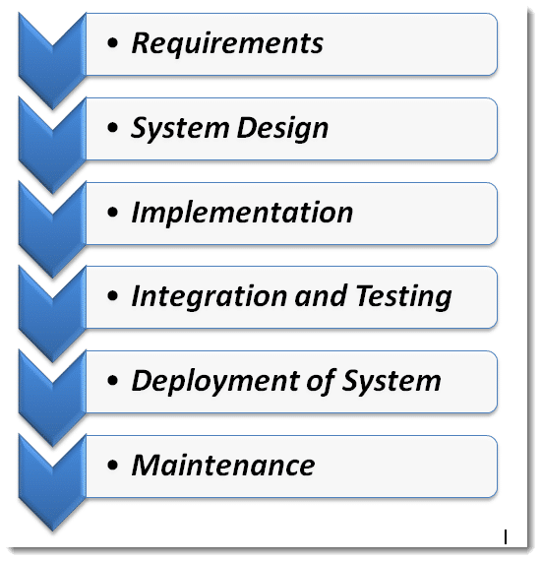

The steps of the waterfall model are explained below:

Requirements analysis: The first phase involves understanding what needs to design and what is its function, purpose, etc. Here, the specifications of the input and output or the final product are studied and marked.

System Design: The requirement specifications from the first phase are studied in this phase and system design is prepared. System Design helps in specifying hardware and system requirements and also helps in defining overall system architecture. The software code to be written in the next stage is created now.

Implementation: With inputs from system design, the system is first developed in small programs called units, which are integrated into the next phase. Each unit is developed and tested for its functionality which is referred to as Unit Testing.

Integration and Testing: All the units developed in the implementation phase are integrated into a system after testing of each unit. The software designed, needs to go through constant software testing to find out if there are any flaws or errors. Testing is done so that the client does not face any problem during the installation of the software.

Deployment of System: Once the functional and non-functional testing is done, the product is deployed in the customer environment or released into the market.

Maintenance: This step occurs after installation, and involves making modifications to the system or an individual component to alter attributes or improve performance. These modifications arise either due to change requests initiated by the customer, or defects uncovered during live use of the system. The client is provided with regular maintenance and support for the developed software.

Advantages of waterfall methodology.

1. The advantage of waterfall development is that it allows for departmentalization and control. A schedule can be set with deadlines for each stage of development and a product can proceed through the development process model phases one by one.
2. The waterfall model progresses through easily understandable and explainable phases and thus it is easy to use.
3. It is easy to manage due to the rigidity of the model – each phase has specific deliverables and a review process.
4. In this model, phases are processed and completed one at a time and they do not overlap. The waterfall model works well for smaller projects where requirements are very well understood.

## System requirement analysis.

Upon the completion of the **PLACEMENT NOTIFICATION PORTAL SYSTEM OF JOBS & INTERNSHIPS**, there are a number of things that will be expected of it not only by the prospected users but also for the administrator of the system. These will therefore form the requirements of the Job portal and will be broadly classified in to the system requirements, functional requirements and the Non-functional requirements.

### Specification requirements.

Requirement analysis for web applications encompasses three major tasks: formulation, requirements gathering and analysis modeling. During formulation, the basic motivation and goals for the web application are identified, and the categories of users are defined. In the requirements gathering phase, the content and functional requirements are listed and interaction scenarios written from end-user’s point-of-view are developed. This intent is to establish a basic understanding of why the web application is built, who will use it, and what problems it will solve for its users.

### Software requirement Specification

A set of programs associated with the operation of a computer is called software. Software is the part of the computer system, which enables the user to interact with several physical hardware devices.

The minimum software requirement specifications for developing this project are as follows:

Operating System: Window 8, windows 10 pro,

Presentation layer: JavaScript, html, CSS,

Database: My SQL

Documentation Tool: Microsoft Office

Hardware Requirement Specification

The collection of internal electronic circuits and external physical devices used in building a computer is called the Hardware. The minimum hardware requirement specifications for developing this project are as follows:

Processor: Standard processor with a speed of 1.6 GHz or more

RAM: 256 MB RAM or more

Hard Disk: 20 GB or more

Monitor: Standard color monitor

Keyboard: Standard keyboard

Mouse: Standard mouse

## 3.4 TESTING PLAN FOR THE SYSTEM

Testing**:**

This is process of executing a system with the intent of finding an error.

Testing is defined as the process in which defects are identified, isolated, subjected for rectification and ensured that product is defect free in order to produce the quality product and hence customer satisfaction.

#### Testing Methodologies:

***Black box Testing***: is the testing process in which tester can perform testing on an application without having any internal structural knowledge of application.

Usually Test Engineers are involved in the black box testing.

***White box Testing***: is the testing process in which tester can perform testing on an application with having internal structural knowledge.

Usually The Developers are involved in white box testing.

***Gray Box Testing***: is the process in which the combination of black box and white box techniques are used.

## CHAPTER 4: SYSTEM ANALYSIS AND DESIGN.

## System Design

Systems design is the process of defining the architecture, components, modules, interfaces, and data for a system to satisfy specified requirements [6]. System designs are modeled using UML which is a standard object-oriented analysis and design language. The UML is a collection of diagrams and standard set of notations for specifying and visualizing various aspects such as requirements and design of software systems.

## Architectural Design

A Placement Notification Portal system uses three tier architecture. Three tier architecture is a client-server architecture in which the functional process logic, data access, computer data storage and user interface are developed and maintained as independent modules on separate platforms. Three-tier architecture is a software design pattern and well-established software architecture.

The three tiers in three-tier architecture are:

i. Presentation Tier: Occupies the top level and displays information related to services available on a website. This tier communicates with other tiers by sending results to the browser and other tiers in the network.

ii. Application Tier: Also called the middle tier, logic tier, business logic or logic tier, this tier is pulled from the presentation tier. It controls application functionality by performing detailed processing.

iii. Data Tier: Houses database servers where information is stored and retrieved. Data in this tier is kept independent of application servers or business logic.

### Logical Design

In this system I have illustrated a context Level DFD which acts as a sample of the system and how it will work and function in major parts of the implementation.

The figure below illustrates:

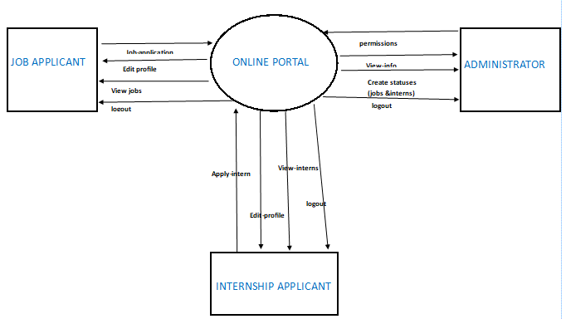

### Use-case Documentation.

A use case diagram is a diagram that shows a set of use cases and actors and relationships.

Use case commonly contains:

1. Use cases
2. Actors
3. Dependency, generalization and association relationships.

The figure below shows Placement Notification Portal system Overall Use Case:

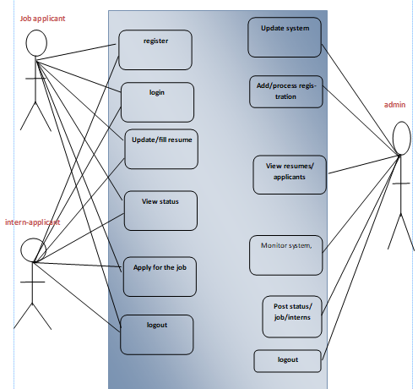

# CHAPTER 5: WORKPLAN AND BUDGET.

CONCLUSION**.**

Job Search Portals stands as a revolutionizing element in the sphere of recruitment. They act as a communication bridge between applicants and recruiters facilitating their requirements. This website application helps the institution to have a greater exposure to the candidate pool and also job seekers facilitating wide search of jobs matching their interests which are posted to the system by the administrator. The PLACEMENT NOTIFICATION PORTAL SYSTEM OF JOBS & INTERNSHIPS provides flexibility to the jobseekers and internship finders to view the openings and applied jobs and interns using the internet since it’s a website which can be accessible over the internet.

The advantages of the new portal are as follows:

i. Achieve the main targets of the Project

ii. Standard content services and display

iii. High level management and flexibility

## RECOMMENDATION.

The placement notification portal system provides a platform where the institution can advertise their Job vacancies and the internships available.

Encrypting user data and ensuring multiple layers of security to avoid phishing hence helps to maintain Confidentiality, Integrity and Availability

## REFERENCES AND LIST OF BIBLIOGRAPHIES.

1. Seddon, P. (1997) "A Re-specification and Extension of the DeLone and McLean Model of IS Success", Information Systems Research, Vol. 8, No. 3.
2. Petter, S., and McLean, E. (2009) " A meta-analytic assessment of the DeLone and McLean IS success model: An examination of IS success at the individual level", Information & Management, Vol. 46, pp.159–166.
3. Research proposal budget. <https://orsp.umich.edu/research-proposals-budget>
4. System design model <https://www.tutorialspoint.com/sdlc/sdlc_waterfall_model.htm>
5. System design modeling <https://www.toolsqa.com/software-testing/waterfall-model/>
6. Anitha, J, &#038; Aruna,M.&#8221;Adoption of Human Resource Information System in Organizations. SDMIMD journal of management, 2013.
7. E Kemei.&#8221;THE INFLUENCE OF HUMAN RESOURCE. Nairobi, 2016. Holm, AB. German
8. Journal of Human Resource, 2012.
9. Kumar, R. &#8221;Human Resource Management System: An innovative Strategy for Human Resource Management. 2012.

## APPENDIX

Budget.

|  |  |  |
| --- | --- | --- |
| Development/item | unit | Total cost |
| Development costs:System analyst | 1 | KSH = 100,000 |
| Programmer | 1 | KSH = 600,000 |
| Software cost Software licensee |  | KSH = 600,000 |
| Operating cost Stationary & maintenance |  | KSH = 400,000 |
| Hardware cost Personal computer | 1 | KSH = 600,000 |