When Does a Model Learn Portuguese?
  - SLT signals during cross-lingual adaptation - synthetic mock submission
TRACK  Latin America - Technical AI Safety | ARTIFACT  6-page research report | STATUS  Illustrative, fabricated data

READ THIS FIRST
Every numerical result, plot, confidence interval, model run, and causal intervention in this document is invented. The purpose is to show what a moderately successful submission could look like before any experiment is run.

Abstract
We study whether an SLT-derived geometric diagnostic identifies a developmental transition while a small English-only transformer acquires Portuguese. In this fabricated scenario, lexical knowledge improves smoothly during continued pretraining, but compositional grammar generalization rises abruptly after roughly 3.4 million Portuguese tokens. At the same interval, the normalized Local Learning Coefficient (LLC) peaks and falls by 11.1%, a pattern absent in matched-English and word-shuffled Portuguese controls. Across three seeds, the estimated LLC transition precedes the grammar transition by 33 +/- 54 steps. A Spanish replication transitions earlier, while freezing the model component with the largest localized susceptibility delays Portuguese grammar generalization by about 418 steps without preventing lexical learning. These synthetic results would support a limited claim: SLT measures may provide an early warning of structural reorganization during cross-lingual adaptation. They would not establish a universal language-learning phase transition.

Submission fit
The current event page asks for a PDF research report documenting approach, results, and implications. The official Bogotá hub specifies a 4-8 page PDF. This mock-up uses six pages and gives most of the space to methods, controls, quantitative results, limitations, and reproducibility.
Page | Purpose | What judges should learn
1 | Problem and contribution | One question, one headline result, regional relevance
2 | Experimental design | Model, data, controls, metrics, preregistered hypotheses
3 | Main trajectories | Behavioral change and LLC signal in the same training interval
4 | Controls and replication | Alternative explanations weakened; uncertainty made visible
5 | Localization and intervention | A cautious causal test rather than correlation alone
6 | Implications and limits | What follows, what does not, and how to reproduce the work

1. Experimental design
Research question
Does a change in loss-landscape geometry mark the shift from Portuguese lexical adaptation to compositional grammatical generalization?
Element | Synthetic protocol
Base model | 8M-parameter, 4-block decoder transformer pretrained only on English TinyStories-like data
Continued training | 2,500 optimizer steps; 4,096 target-language tokens per step; 10.24M tokens per run
Main condition | Matched stories translated into Brazilian Portuguese; original tokenizer retained
Controls | Matched English continuation and Portuguese tokens shuffled within each sequence
Replication | Matched Spanish translations under the same token and optimizer budget
Behavioral probes | Validation bits/byte, lexical recognition, and 1,200 grammatical minimal pairs
SLT probes | Normalized LLC at dense checkpoints; 4 localized SGLD chains; component susceptibilities
Uncertainty | Three training seeds; seed-level error bars; segmented-model delta-BIC and smoothed transition estimates

Preregistered synthetic hypotheses
- H1: Portuguese lexical accuracy improves before grammatical minimal-pair accuracy.
- H2: A supported LLC changepoint occurs within one checkpoint interval of the grammar changepoint.
- H3: The aligned transition is absent when Portuguese word order is destroyed and during matched English continuation.
- H4: Freezing the component with the largest transition-localized susceptibility delays grammar generalization more than freezing a matched control component.

Analysis rule
A transition is called only when (i) a two-segment fit improves over a linear trend, (ii) continuous grammar margins change in the same interval, (iii) the pattern repeats across seeds, and (iv) controls do not show the same combination. Binary accuracy alone is not treated as evidence because smooth logit movement can create an apparent threshold crossing.
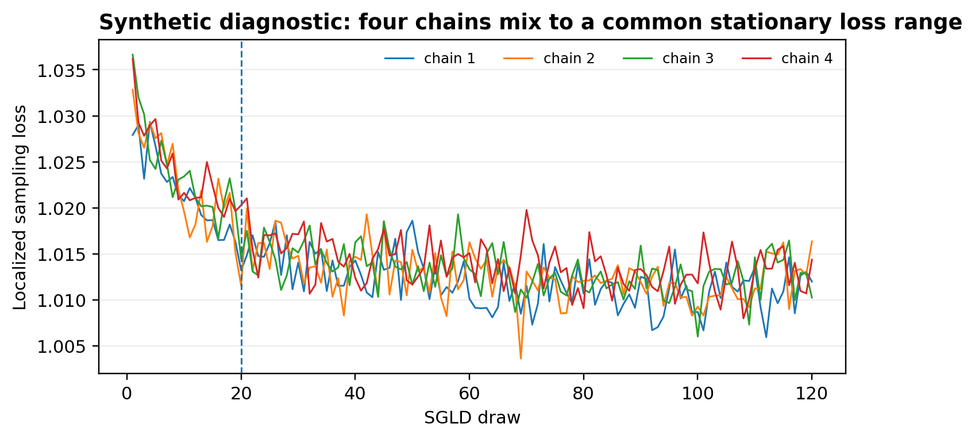
Supplementary diagnostic. Illustrative SGLD traces at the candidate transition. Four chains settle into a common loss range after the synthetic burn-in marker. A real report should include this diagnostic or an equivalent convergence check.

2. Results

2.1 Lexical adaptation preceded grammatical generalization
Portuguese validation loss fell rapidly during the first 2 million target-language tokens, tracking a rise in lexical-probe accuracy from 12.1% to 76.9%. The shuffled control improved almost as quickly at first, showing that early loss reduction was largely compatible with token-frequency and local-sequence learning. The structured condition then entered a second improvement regime near 3.3 million tokens and finished at 1.237 +/- 0.012 bits per byte, compared with 1.460 +/- 0.016 for shuffled Portuguese.
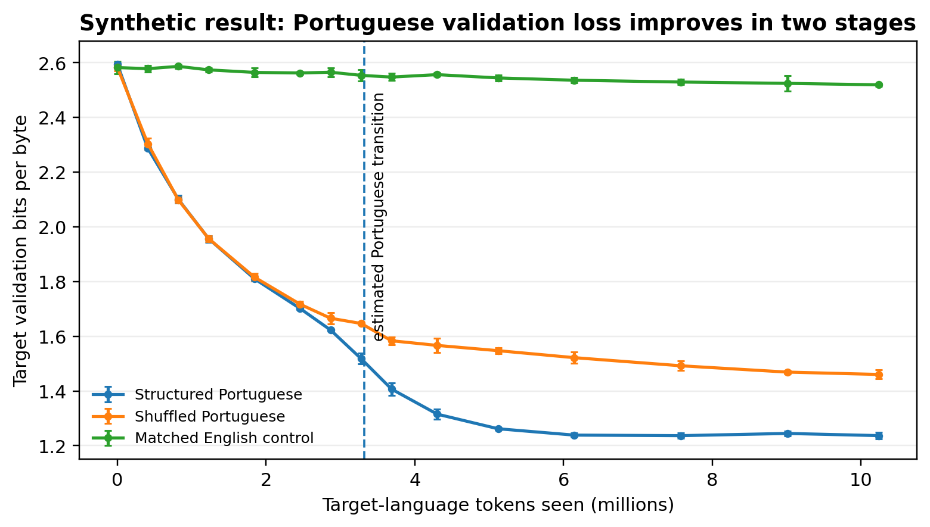
Figure 1a - synthetic. Mean target-language validation bits per byte across three seeds; error bars are illustrative 95% confidence intervals. The dashed line marks the mean estimated Portuguese LLC transition.
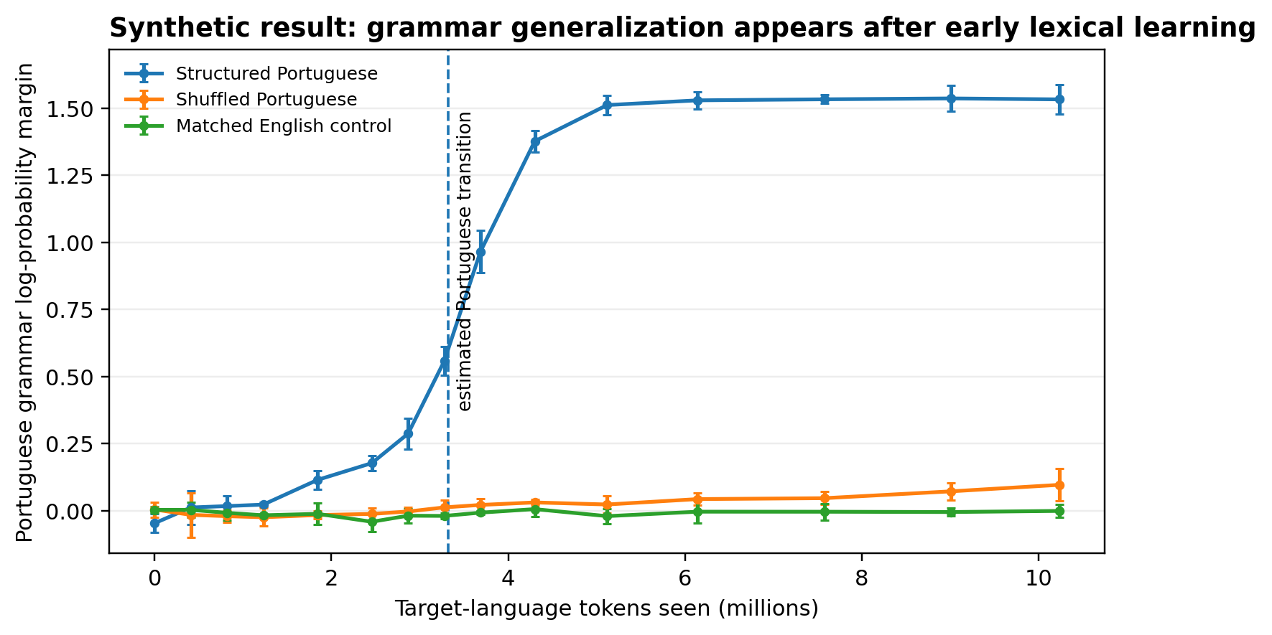
Figure 1b - synthetic. Continuous grammatical minimal-pair margin. Structured Portuguese rises sharply after early lexical learning; shuffled Portuguese and matched English remain near zero. A positive margin means the model assigns higher probability to the grammatical member of a pair.

2.2 The LLC trajectory changed in the same developmental interval
The normalized LLC initially rose to 1.24 times its starting value, then fell to 1.10 as grammar generalization emerged. In SLT terms, the fall is consistent with movement toward a more degenerate local geometry; it is not, by itself, proof that the model learned a discrete linguistic module. The mean segmented-fit evidence was strong for both LLC (delta-BIC 20.0) and grammar margin (delta-BIC 22.3).
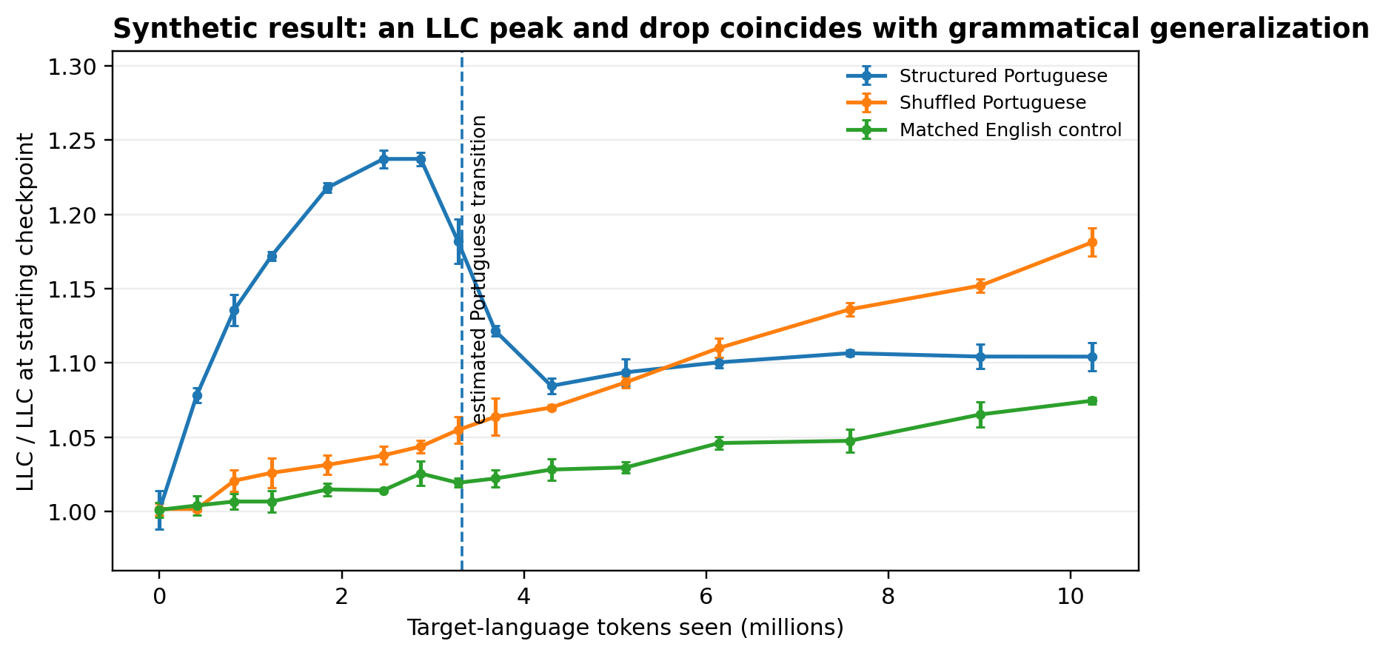
Figure 1c - synthetic. Normalized Local Learning Coefficient. Only structured Portuguese shows a peak-and-drop pattern aligned with the behavioral transition. Values are normalized within run because raw LLC scale depends on model and sampler choices.

2.3 Controls separated structured acquisition from token exposure
Condition | Target bpb | Lexical acc. | Grammar acc. | English bpb change | LLC delta-BIC
Structured Portuguese | 1.237 +/- .012 | 87.0 +/- 0.6% | 87.2 +/- 0.8% | +5.38 +/- .21% | 20.0
Shuffled Portuguese | 1.460 +/- .016 | 82.7 +/- 0.3% | 53.0 +/- 1.9% | +3.31 +/- .51% | 0.1
Matched English | 2.520 +/- .006 | 14.3 +/- 0.8% | 50.0 +/- 0.8% | -5.83 +/- .24% | 0.2
Table 1 - synthetic. Final-checkpoint outcomes across three seeds. The shuffled condition learns much of the Portuguese lexicon but remains near chance on compositional grammar, weakening a vocabulary-only explanation of the LLC transition.
The structured run also incurred a 5.38% increase in English validation bits per byte, indicating modest catastrophic forgetting. This is a meaningful trade-off: the candidate transition improves Portuguese structure while moving the model further from its original English optimum.

2.4 Transition estimates aligned across seeds and replicated in Spanish
For Portuguese, the maximum-rate LLC change occurred at step 791 +/- 52 and the grammar change at step 824 +/- 54. The estimated lag was 33 +/- 54 steps, so the data would be compatible with near-simultaneity or a small geometric lead. Spanish showed the same ordering but transitioned about 130 steps earlier. This comparison would be descriptive, not evidence that Spanish is intrinsically easier: tokenizer fertility and pretraining overlap remain plausible confounds.
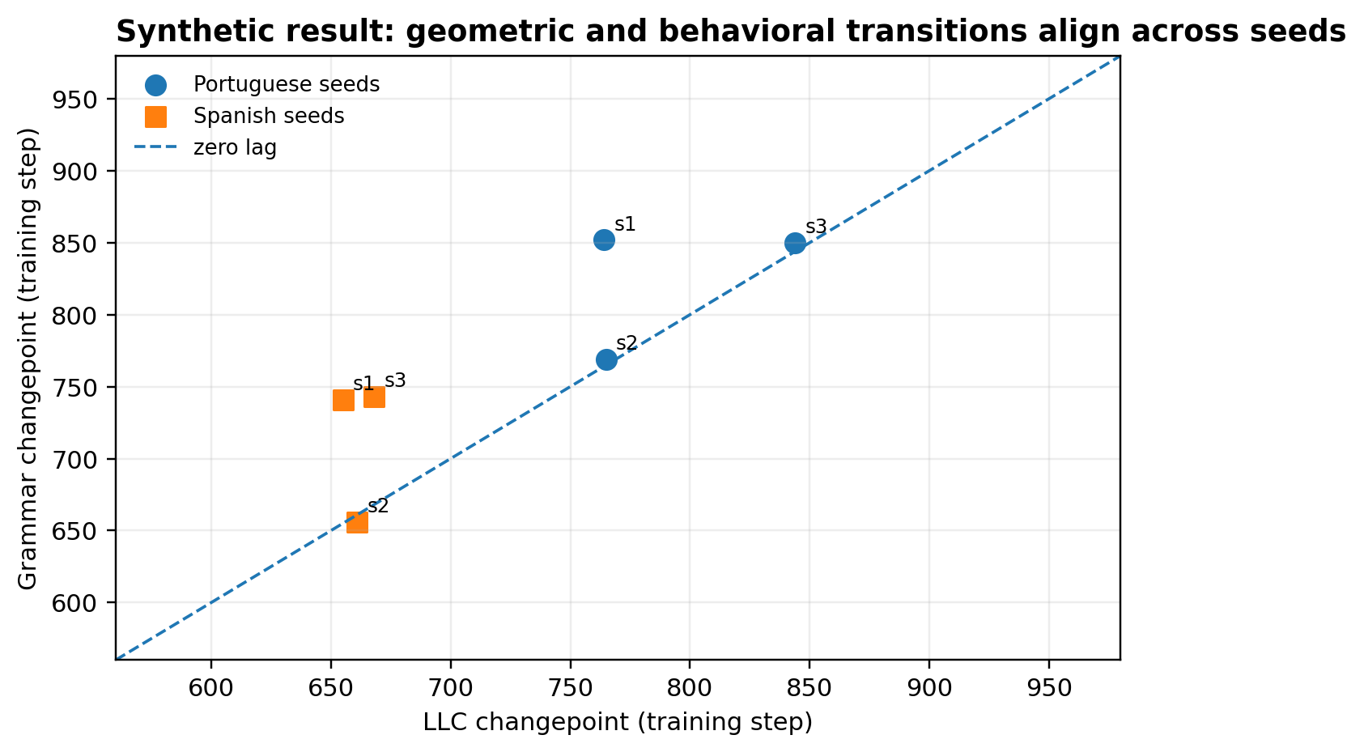
Figure 2 - synthetic. Seed-level LLC and grammar transition estimates for Portuguese and Spanish. Points near the diagonal indicate temporal alignment; the estimates are based on maximum-rate locations of shape-preserving smooth curves.
Run | LLC step | Grammar step | Lag | LLC delta-BIC | Grammar delta-BIC
Portuguese (3 seeds) | 791 +/- 52 | 824 +/- 54 | +33 +/- 54 | 20.0 | 22.3
Spanish (3 seeds) | 661 +/- 7 | 713 +/- 56 | +52 +/- 56 | 19.2 | 26.5
Shuffled Portuguese | No stable estimate | No transition | n/a | 0.1 | -0.8
Matched English | No stable estimate | No transition | n/a | 0.2 | 3.8*
Table 2 - synthetic. Means +/- illustrative 95% intervals across seeds. *The English grammar delta-BIC reflects low-amplitude noise around chance and is rejected by the preregistered joint criterion because no behavioral gain or reproducible LLC transition occurs.

2.5 Localization and intervention provided limited causal evidence
Component-restricted susceptibility peaked in the final MLP block at 4.08 times its pre-transition value. Freezing that block before the transition delayed grammar generalization by 418 steps and reduced final grammar accuracy to 79.0%, while Portuguese validation loss still reached 1.28 bits per byte. Freezing an earlier attention block delayed the transition by only 90 steps. This pattern is compatible with a causal contribution from the final MLP, but freezing also reduces trainable capacity and therefore does not isolate a specific circuit.

2.5 Localization and intervention (continued)
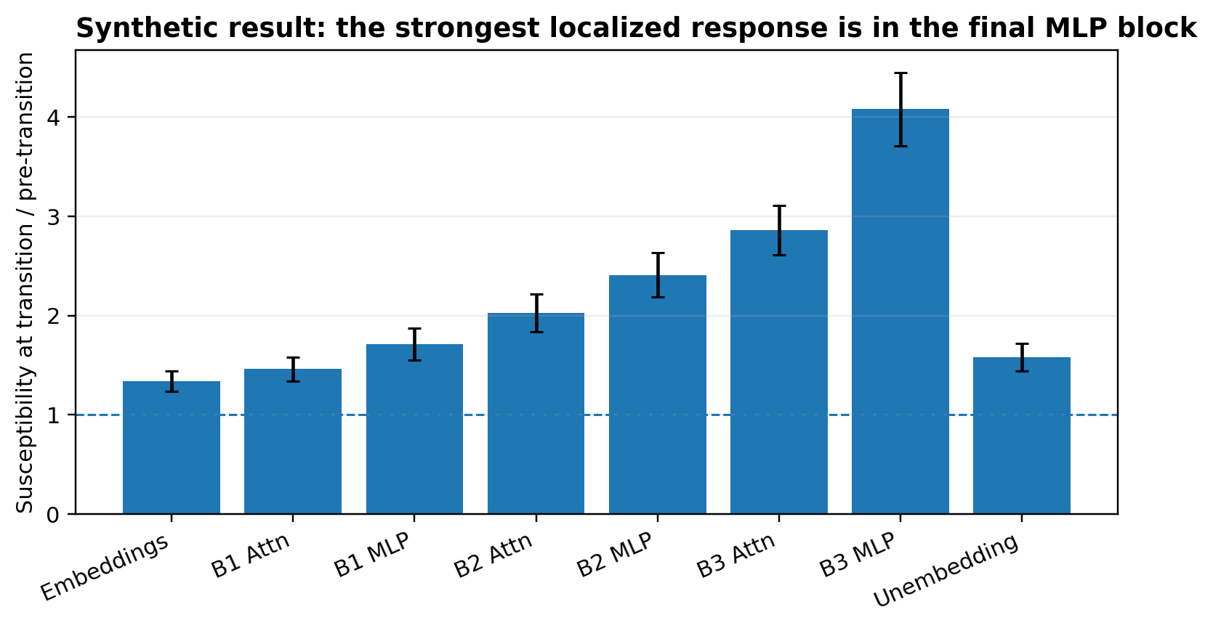
Figure 3 - synthetic. Transition-to-pre-transition susceptibility ratios by component. The final MLP block is the strongest candidate for intervention.
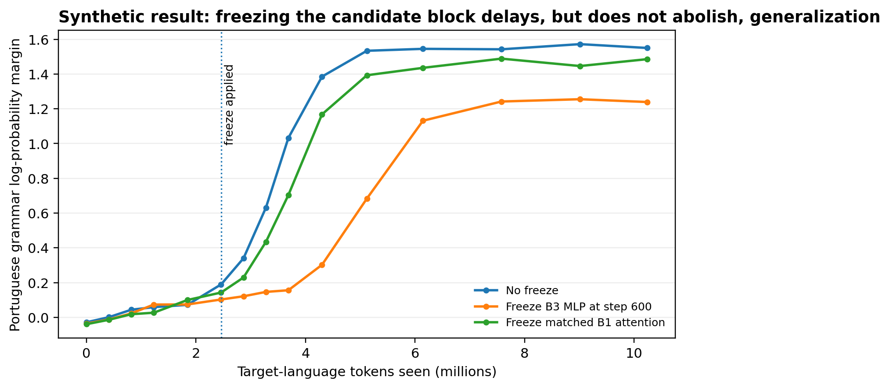
Figure 4 - synthetic. Grammar margin under two freeze interventions. The candidate-block freeze delays and weakens, but does not eliminate, grammatical generalization.
Intervention | Grammar transition | Final grammar acc. | Final PT bpb
No freeze | 824 | 87.2% | 1.24
Freeze final MLP at step 600 | 1,242 | 79.0% | 1.28
Freeze matched early attention | 914 | 85.1% | 1.25

3. Interpretation, safety relevance, and limitations
Synthetic conclusion. The strongest defensible claim would be that an LLC trajectory change is a useful candidate marker for the onset of compositional generalization during cross-lingual adaptation in this small-model regime. It would not show that all language acquisition is phase-like, that LLC causes the capability, or that the same transition occurs in frontier models.
- Safety relevance: a geometry-based developmental monitor could complement behavioral evaluations when adapting models to Portuguese and other under-evaluated languages.
- Primary risks to validity: tiny model and story domain; machine-translation artifacts; English-centric tokenizer; only three seeds; LLC sensitivity to localization and SGLD hyperparameters.
- Minimum reproducibility package: checkpoint hashes, exact datasets and splits, all seed-level curves, sampler traces, environment lockfile, evaluation sentences, changepoint code, and a one-command rerun.
- Most important follow-up: repeat with naturally authored Portuguese and a tokenizer-matched model, then test whether the same component-level transition appears.
Selected sources. Apart Research, Global South AI Safety Hackathon (2026); AI Safety Colombia, event deliverable guidance (2026); Hoogland et al., "Loss Landscape Degeneracy and Stagewise Development in Transformers," arXiv:2402.02364; Timaeus Research, devinterp v2 documentation and source repository.

