This is a technological invention on social media platform that result in making of an artificially intelligence guided application that is interactive ,reliable and powerful than any other social media application platform in the word ,I come up with this idea after I did some research by observing the dominant social media software's in the world , in references on what they contain and how they serve their customers, actually I found that they serve their customers in-complete and I fell like they left out some important modules that they could have included and easy visible to customers anywhere anytime , since they are more important in persons life , more personality things that someone expect to find them and can easily access them .

The users of this application will have to provide unique crystallographic key that is combined with special characters, numbers, and letters , so that they can access the more sensitive modules like banking statements, important documents and treasure he/she has ,since this will be concerned with someone personal life's .Where it carries all the module of life like family , finances, documents and secrets of someone , accessing this can only be acceded by using a private key that is encrypted, the key will have a span of 3 attempts if more it will log off the system of secretive automatically for 30mins, for security reasons. The properties of this key is that it cannot be known by a third party ..only involves the machine and the person ...The reason for a third party not getting involved in this is to achieve confidentiality,integrity and availability ,that are core security issues.

The persons in servers cannot access this unless they know the crypt key the user is using , and that is confidential.

The users will have to store their secretive personal life s in this application.

And at some extent this people will view public status of other people who have decided to put their status public,also they will have their profile picture online with setting of who to view who. They will be notified about who viewed their profile picture online and comments on it .C hating will be necessary so that users can chat with their friends within their contact and extend if user allow public chats.

User can add friends depending on his wish.
User can write short notes and store them also update his/CV..

More cooling and refreshing times will be included in the application where user will have to listen to music or watch video depending on his/her choice..

For user to access this application he/she will have to register.
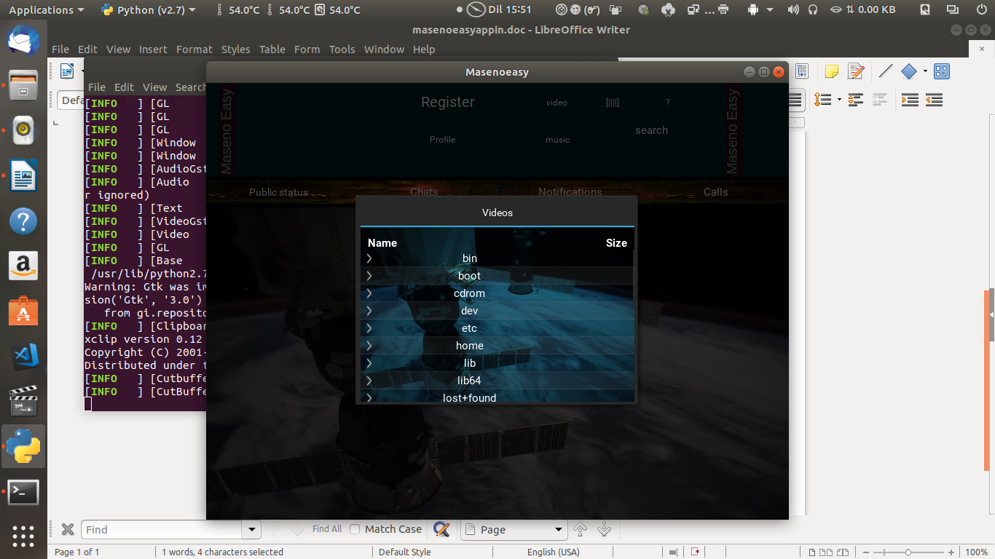
The prototype of the application
