ALU – 64 biți

-Proiect CN-

Hărdălău Elvis Costinel

Iorga Răzvan Vlad

An II – 2C.2.1

Unitatea aritmetică logică (ALU) este un circuit electronic digital complex care poate efectua operații aritmetice și logice. Constructiv, în calculator, ALU este un bloc fundamental al unității centrale de procesare (prelucrare) UCP (engleză CPU). Unitatea logică aritmetică este utilizată pentru a efectua transformări logice și aritmetice pe operanzii necesari, adesea comenzi sau coduri de numere. După finalizarea acțiunii, rezultatul este returnat dispozitivului de stocare pentru a fi utilizat în următoarele calcule.

Platformă hardware ALU:

* ***Logic Unit*** – Unitate specializată realizării operațiilor logice între cei 2 operanzi pe 64 de biți.
* AND
* OR
* XOR
* NOT A
* NOT B
* NAND
* NOR
* XNOR

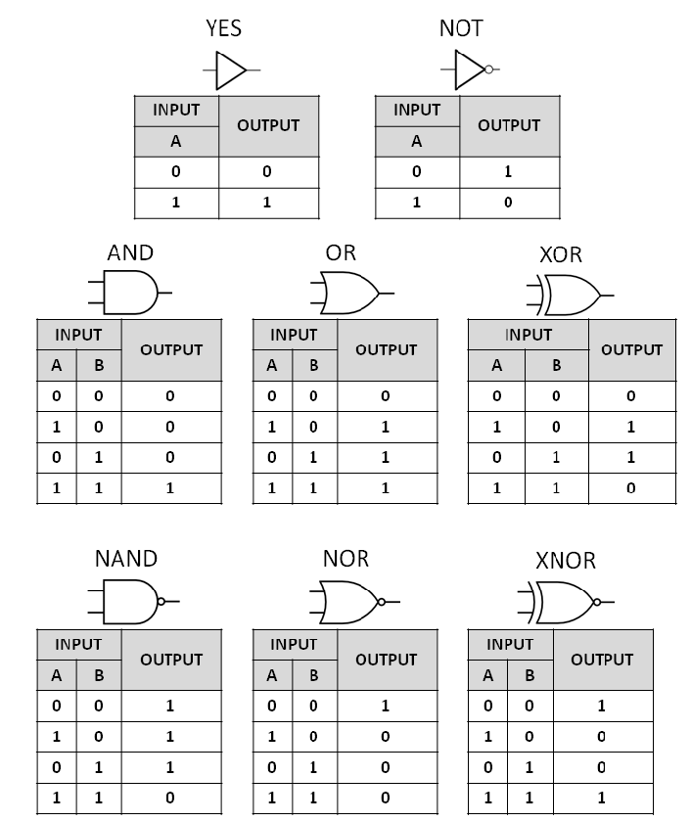

* AND

**module** bitwise_and (

**input** in_0,

**input** in_1,

**output** and_

);

**assign** and_ = in_0 & in_1;

**endmodule**

**module** and_wordgate #(**parameter** w = 64)(

**input** [w-1:0]in_0,

**input** [w-1:0]in_1,

**output** [w-1:0]AND

);

**generate**

**genvar** i;

**for**(i = 0 ; i < w ; i = i + 1) **begin**: and_gates

bitwise_and gate(.in_0(in_0[i]), .in_1(in_1[i]), .and_(AND[i]));

**end**

**endgenerate**

**endmodule**

* OR

module bitwise_or (

input in_0,

input in_1,

output or_

);

assign or_ = in_0 | in_1;

endmodule

**module** or_wordgate #(**parameter** w = 64)(

**input** [w-1:0]in_0,

**input** [w-1:0]in_1,

**output** [w-1:0]OR

);

**generate**

**genvar** i;

**for**(i = 0 ; i < w ; i = i + 1) **begin**: or_gates

bitwise_or gate(.in_0(in_0[i]), .in_1(in_1[i]), .or_(OR[i]));

**end**

**endgenerate**

**endmodule**

* XOR

**module** bitwise_xor (

**input** in_0,

**input** in_1,

**output** xor_

);

**assign** xor_ = in_0 ^ in_1;

**endmodule**

**module** xor_wordgate #(**parameter** w = 64)(

**input** [w-1:0]in_0,

**input** [w-1:0]in_1,

**output** [w-1:0]XOR

);

**generate**

**genvar** i;

**for**(i = 0 ; i < w ; i = i + 1) **begin**: xor_gates

bitwise_xor gate(.in_0(in_0[i]), .in_1(in_1[i]), .xor_(XOR[i]));

**end**

**endgenerate**

**endmodule**

* NOT A or NOT B

**module** bitwise_not (

**input** in,

**output** not_

);

**assign** not_ = ~in;

**endmodule**

**module** not_wordgate #(**parameter** w = 64)(

**input** [w-1:0]in,

**output** [w-1:0]NOT

);

**generate**

**genvar** i;

**for**(i = 0 ; i < w ; i = i + 1) **begin**: not_gates

bitwise_not gate(.in(in[i]), .not_(NOT[i]));

**end**

**endgenerate**

**endmodule**

* NAND

**module** bitwise_nand (

**input** in_0,

**input** in_1,

**output** nand_

);

**assign** nand_ = ~(in_0 & in_1);

**endmodule**

**module** nand_wordgate #(**parameter** w = 64)(

**input** [w-1:0]in_0,

**input** [w-1:0]in_1,

**output** [w-1:0]NAND

);

**generate**

**genvar** i;

**for**(i = 0 ; i < w ; i = i + 1) **begin**: nand_gates

bitwise_nand gate(.in_0(in_0[i]), .in_1(in_1[i]), .nand_(NAND[i]));

**end**

**endgenerate**

**endmodule**

* NOR

**module** bitwise_nor (

**input** in_0,

**input** in_1,

**output** nor_

);

**assign** nor_ = ~(in_0 | in_1);

**endmodule**

**module** nor_wordgate #(**parameter** w = 64)(

**input** [w-1:0]in_0,

**input** [w-1:0]in_1,

**output** [w-1:0]NOR

);

**generate**

**genvar** i;

**for**(i = 0 ; i < w ; i = i + 1) **begin**: nor_gates

bitwise_nor gate(.in_0(in_0[i]), .in_1(in_1[i]), .nor_(NOR[i]));

**end**

**endgenerate**

**endmodule**

* XNOR

**module** bitwise_xnor (

**input** in_0,

**input** in_1,

**output** xnor_

);

**assign** xnor_ = ~(in_0 ^ in_1);

**endmodule**

**module** xnor_wordgate #(**parameter** w = 64)(

**input** [w-1:0]in_0,

**input** [w-1:0]in_1,

**output** [w-1:0]XNOR

);

**generate**

**genvar** i;

**for**(i = 0 ; i < w ; i = i + 1) **begin**: xnor_gates

bitwise_xnor gate(.in_0(in_0[i]), .in_1(in_1[i]), .xnor_(XNOR[i]));

**end**

**endgenerate**

**endmodule**

* ***Shift/Rotate Unit*** – Unitate specializată realizării operațiilor de shiftare.
* Logic Left Shift
* Logic Right Shift
* Arithmetic Left Shift
* Arithmetic Right Shift
* Left Rotate
* Right Rotate

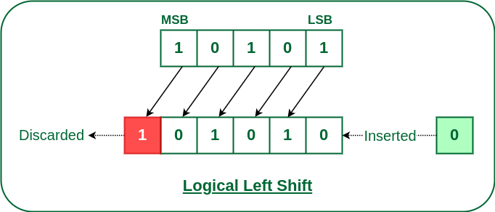

module sll (

input [127:0]in,

output [127:0]out

);

assign out = {in[126:0], 1'b0};

endmodule

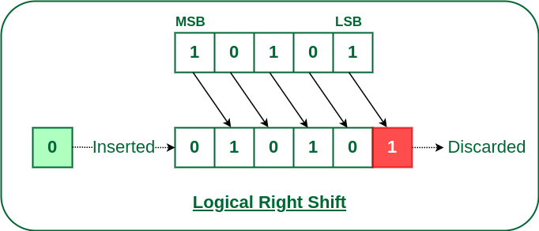

module srl (

input [127:0]in,

output [127:0]out

);

assign out = {1'b0, in[127:1]};

endmodule

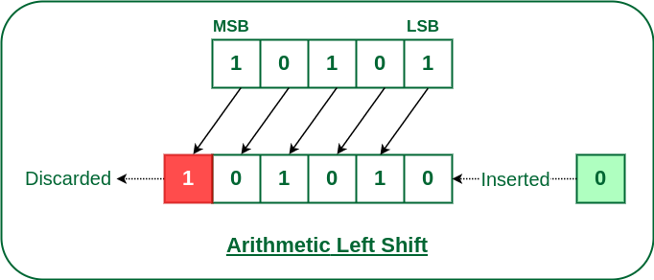

**module** sla (

**input** [127:0]in,

**output** [127:0]out

);

**assign** out = {in[126:0], 1'b0};

**endmodule**

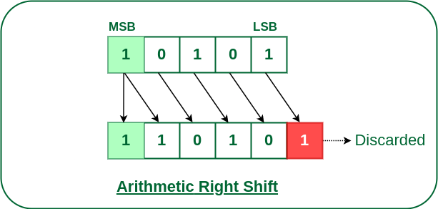

**module** sra (

**input** [127:0]in,

**output** [127:0]out

);

**assign** out = {in[127], in[127:1]};

**endmodule**

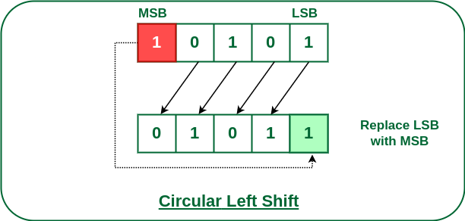

**module** rotl (

**input** [127:0]in,

**output** [127:0]out

);

**assign** out = {in[126:0], in[127]};

**endmodule**

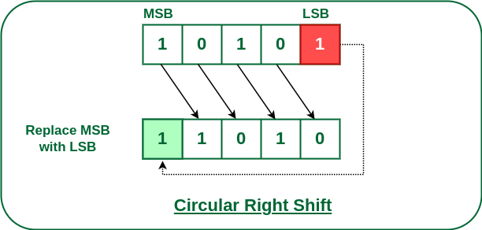

**module** rotr (

**input** [127:0]in,

**output** [127:0]out

);

**assign** out = {in[0], in[127:1]};

**endmodule**

* Shift/Rotate Unit implementat printr-un registru secvențial parametrizat prin lațime și prin numărul de biți shiftați:

**module** sh_reg #(**parameter** w = 64, **parameter** d = 1)(

**input** clk,

**input** rst_b,

**input** load,

**input** sh,

**input** [2:0]sh_mode,

**input** [d-1:0]sh_in,

**input** [w-1:0]in,

**output** **reg** [w-1:0]q

);

**reg** [w-1:0]qq;

**initial** **begin**

qq = 0;

**end**

**always** @(**posedge** clk) **begin**

**if**(load)

qq = in;

**if**(sh)

**case**(sh_mode)

3'b000: qq = {qq[w-1-d:0], {d{1'b0}}}; // logic left shift

3'b001: qq = {{d{1'b0}}, qq[w-1:d]}; // logic right shift

3'b010: qq = {qq[w-1-d:0], {d{1'b0}}}; // arithmetic left shift

3'b011: qq = {{d{qq[w-1]}}, qq[w-1:d]}; // arithmetic right shift

3'b100: qq = {qq[w-1-d:0], qq[w-1:w-d]}; // left rotate

3'b101: qq = {qq[d-1:0], qq[w-1:d]}; // right rotate

3'b110: qq = {qq[w-1-d:0], sh_in}; // left shift sh_in

3'b111: qq = {sh_in, qq[w-1:d]}; // right shift sh_in

**endcase**

**end**

**always** @(**posedge** clk **or** **negedge** rst_b) **begin**

**if**(!rst_b)

q <= {w{1'b0}};

**else**

q <= qq;

**end**

**endmodule**

* ***Arithmetic Unit*** – Unitate specializată realizării operațiilor aritmetice (+, -, *, /) între cei 2 operanzi pe 64 de biți.

**module** arithmetic_unit (

**input** clk,

**input** bgn,

**input** rst_b,

**input** [1:0]opcode, //00 - addition, 01 - substraction, 10 - multiplication, 11 - division

**input** [63:0]inbus,

**output** stop,

**output** [63:0]outbus

);

**wire** c0;

**wire** c1;

**wire** c2;

**wire** c3;

**wire** c4;

**wire** c5;

**wire** c6;

**wire** c7;

**wire** c8;

**wire** c9;

**wire** Q_lsb;

**wire** Q_msb;

**wire** q_1;

**wire** count63;

**wire** A_lsb;

**wire** A_msb;

**wire** [63:0]M;

**wire** [63:0]A;

**wire** [63:0]out_parallel;

**wire** [63:0]out_xor;

reg_M uut_M (

.clk(clk),

.rst_b(rst_b),

.c0(c0),

.inbus(inbus),

.q(M)

);

reg_A uut_A (

.clk(clk),

.rst_b(rst_b),

.c0(c0),

.c2(c2),

.c4(c4),

.c5(c5),

.c8(c8),

.sum(out_parallel),

.A_lsb(A_lsb),

.A_msb(A_msb),

.Q_msb(Q_msb),

.q(A),

.outbus(outbus)

);

reg_Q uut_Q (

.clk(clk),

.rst_b(rst_b),

.c1(c1),

.c4(c4),

.c6(c6),

.c8(c8),

.c9(c9),

.A_lsb(A_lsb),

.Q_lsb(Q_lsb),

.Q_msb(Q_msb),

.inbus(inbus),

.outbus(outbus)

);

reg_Q_1 uut_Q_1 (

.clk(clk),

.rst_b(rst_b),

.c0(c0),

.c4(c4),

.Q_lsb(Q_lsb),

.q(q_1)

);

counter uut_counter (

.clk(clk),

.rst_b(rst_b),

.c0(c0),

.c4(c4),

.count63(count63)

);

control_unit uut_control_unit (

.clk(clk),

.rst_b(rst_b),

.bgn(bgn),

.opcode(opcode),

.q_1(q_1),

.q0(Q_lsb),

.count63(count63),

.a63(A_msb),

.c0(c0),

.c1(c1),

.c2(c2),

.c3(c3),

.c4(c4),

.c5(c5),

.c6(c6),

.c7(c7),

.c8(c8),

.c9(c9),

.stop(stop)

);

xor_wordgate uut_xor (

.in_0({64{c3}}),

.in_1(M),

.XOR(out_xor)

);

ml_csea_8 uut_adder (

.x(out_xor),

.y(c7 ? inbus : A),

.c_in(c3),

.z(out_parallel)

);

**endmodule**

Modul ALU – 64 biți:

**module** ALU_64 (

**input** clk,

**input** rst_b,

**input** bgn,

**input** [63:0]in_0,

**input** [63:0]in_1,

**input** [4:0]sel,

**output** stop,

**output** [63:0]out

);

**wire** [63:0]out_arithmetic;

**wire** [63:0]out_logic;

**wire** [127:0]out_shift;

arithmetic_unit uut_arithmetic (

.clk(clk),

.bgn(bgn),

.rst_b(rst_b),

.opcode(sel[1:0]),

.inbus(in_0),

.stop(stop),

.outbus(out_arithmetic)

);

logic_unit uut_logic (

.in_0(in_0),

.in_1(in_1),

.sel(sel[2:0]),

.out(out_logic)

);

shift_rotate_unit uut_shift (

.in({in_1, in_0}),

.sel(sel[2:0]),

.out(out_shift)

);

mux4to1 uut_mux (

.in_0(out_arithmetic),

.in_1(out_logic),

.in_2(out_shift[63:0]),

.in_3({64{1'bz}}),

.sel(sel[4:3]),

.out(out)

);

**endmodule**