MyGym Fitness Membership Analytics
Project Documentation
Retention, Revenue & Engagement Analysis — Power BI Dashboard
Table of Contents

1. Project Overview
2. Business Problem & Objectives
3. Stakeholders
4. Data Sources
5. Data Dictionary
6. Data Quality Checks
7. Power Query Transformations
8. Data Model / Relationships
9. DAX Measures
10. Analysis & Business Questions
11. Dashboard Pages & Visuals
12. Key Findings
13. Recommendations
14. Limitations & Assumptions
15. Executive Summary
16. Change Log / Version History

1. Executive Summary
MyGym's 1,998 members generate $68.87K in tracked revenue with an overall 49.15% churn rate. The data points to a few clear, actionable patterns:
- Value is concentrated unevenly: Premium brings the volume, Elite brings the highest per-member value, and Basic retains members without monetizing them — each tier needs a different lever, not a single approach.
- Commitment length matters for retention: Quarterly plans churn noticeably less (44.4%) than Monthly or Annual plans (49-50%).
- Structured engagement pays off: members using personal training and/or group classes spend more and stay longer than those using neither.
- The 25-39 age group is the engagement engine of the business and should anchor staffing and promotional timing decisions.
- Before this analysis drives location-specific investment, the conflicting engagement-rate figures between the exploratory charts and the dashboard (Section 10.3) need to be reconciled against the live Power BI file.

2. Project Overview

MyGym is a rapidly growing fitness-center chain operating multiple locations across California, offering diverse membership tiers (Basic, Standard, Premium, Elite), subscription models (Monthly, Quarterly, Early Bird/Annual), and services such as group classes, personal training, and multi-location access.
This project analyzes membership, visit, transaction, and engagement data to identify which member segments create the most value, where revenue and retention leakage occurs, and which interventions would most efficiently raise retention and revenue. The output is a two-page Power BI dashboard (Revenue and Engagement) supported by this documentation.2. Business Problem & Objectives
3. Problem Statement
MyGym lacks a clear, data-driven picture of which member segments generate the most lifetime value, how services (group classes vs. personal training) influence retention and spend, and whether pricing or resource allocation is optimized across locations.
Key Analytical Questions
- Which membership types are linked to the highest retention or revenue?
- Do pricing models (e.g., Monthly vs. Early Bird annual) affect churn or satisfaction?
- Are some locations performing better than others in terms of engagement or profitability?
- How does personal training usage or group class participation influence value?
- What effect do discount types (promo, student, loyalty) have on final revenue?
- Is there a relationship between tenure and service usage or upgrade behavior?
- Do certain access types (off-peak, all hours, priority) impact visit frequency?
- What geographic patterns emerge from multi-location access behavior?
- How do different customer segments use the gym throughout the week?

Objectives
- Understand which member segments bring the most value.
- Identify areas for pricing, subscription, or service optimization.
- Improve customer experience through data-driven insights.
- Optimize staffing and facility allocation across locations.
- Explore trends in retention, usage, and upgrade behavior.

Stakeholders
- Executive Leadership / Founders — Overall strategic direction; approves major pricing or tier changes.
- Operations / Regional Facility Managers — Staffing schedules and facility allocation across locations.
- Marketing Team — Pricing, discount strategy, and targeted campaigns.
- Membership & Retention Team — Churn-reduction initiatives and member experience.
- Finance — Revenue modeling and pricing-model decisions.

4. Data Sources
The data used for the analysis was downloaded from: https://datadna.onyxdata.co.uk/challenges/august-2025-datadna-fitness-membership-analytics-challenge
- File type: CSV, later imported into Power BI
- Dataset: Fitness_Membership_Dataset
- Size: 1,000 rows × 27 columns Granularity: One row per member
5. Data Dictionary
Source columns as itemized in the original documentation:
Column | Data Type | Description
id | Text | Unique member identifier (e.g., MG-1)
age | Whole number | Member's age in years
membership_type | Text (category) | Basic / Standard / Premium / Elite
visit_per_week | Whole number | Number of visits recorded per week
days_per_week | Whole number | Number of distinct days per week the member attends
attend_group_lesson | True/False | Whether the member attends group classes
avg_time_check_in | Time | Average check-in time
avg_time_check_out | Time | Average check-out time
duration_in_gym_minutes | Decimal | Average session length in minutes
has_drink_subscription | True/False | Whether the member has an add-on drink subscription
personal_training | True/False | Whether the member uses personal training (PT)
uses_sauna | True/False | Whether the member uses the sauna
self_identified_gender | Text (category) | Member's self-identified gender
gym_house_location | Text (category) | City / branch location
subscription_price | Currency | Base list price of the subscription
subscription_model | Text (category) | Monthly / Quarterly / Early Bird (Annual)
adjusted_price | Currency | Price after any plan-level adjustment, before discount
discount_type | Text (category) | None / Loyalty / Promo / Student
discount_rate | Decimal / % | Discount percentage applied
final_price | Currency | Price actually charged after discount
access_hour | Text (category) | Weekdays only / Off-peak only / All hours / All hours + Priority access
latitude | Decimal | Branch latitude
longitude | Decimal | Branch longitude
join_date | Date | Date the member joined
personal_training_hour | Text / Time | Scheduled PT hour, where applicable
multi_location_access | True/False | Whether the member's plan allows multi-location access
last_visit_date | Date | Most recent recorded visit date

Calculated columns added in Power BI:
Four calculated columns were added to support the analysis:
Column | Type | Description
Age_Group | Calculated column | Buckets age into <25, 25-39, 40-54, 55+
Days_Since_Last_Visit | Calculated column | Days between a member's last_visit_date and the dataset's most recent date
Status | Calculated column | Active / Churned, based on a 30-day inactivity threshold
Engagement Segment | Calculated column | Both / PT Only / Group Only / Neither, based on personal_training and attend_group_lesson

Formula used in getting the calculated columns:
Age_Group
Groups member age into four buckets: <25, 25-39, 40-54, 55+.
Age_Group =
SWITCH(
TRUE(),
'Fitness_Membership_Analytics_Dataset'[age] < 25, "<25",
'Fitness_Membership_Analytics_Dataset'[age] >= 25 && 'Fitness_Membership_Analytics_Dataset'[age] < 40, "25-39",
'Fitness_Membership_Analytics_Dataset'[age] >= 40 && 'Fitness_Membership_Analytics_Dataset'[age] < 55, "40-54",
'Fitness_Membership_Analytics_Dataset'[age] >= 55, "55+",
"Unknown"
)

Days_Since_Last_Visit
Calculates how many days have passed between a member's last visit and the most recent date present anywhere in the dataset.

Days_Since Last_Visit =
VAR MaxDate =
CALCULATE(
MAX('Fitness_Membership_Analytics_Dataset'[last_visit_date]),
ALL('Fitness_Membership_Analytics_Dataset')
)
RETURN
DATEDIFF('Fitness_Membership_Analytics_Dataset'[last_visit_date], MaxDate, DAY)

Status
Flags a member as Churned once more than 30 days have passed since their last visit; otherwise Active.
Status =
IF(
Fitness_Membership_Analytics_Dataset[Days_Since Last_Visit] > 30,
"Churned",
"Active"
)
Engagement Segment
Classifies members by which of the two structured programs (personal training, group lessons) they use.
SWITCH(
TRUE(),
'Fitness_Membership_Analytics_Dataset'[personal_training] = TRUE() && 'Fitness_Membership_Analytics_Dataset'[attend_group_lesson] = TRUE(), "Both",
'Fitness_Membership_Analytics_Dataset'[personal_training] = TRUE() && 'Fitness_Membership_Analytics_Dataset'[attend_group_lesson] = FALSE(), "PT Only",
'Fitness_Membership_Analytics_Dataset'[personal_training] = FALSE() && 'Fitness_Membership_Analytics_Dataset'[attend_group_lesson] = TRUE(), "Group Only",
"Neither"
)

6. Data Quality Check
The dataset was reviewed in Excel prior to import. Per the original documentation, it was checked for errors, duplicate records, and missing values, and was found to be relatively clean.
7. Power Query Transformations
No Power Query (M) transformations were applied in this project. Cleaning (duplicate and missing-value checks) was performed in Excel before the file was imported directly into Power BI. Within Power BI, four additional columns were created using DAX calculated columns rather than Power Query steps — see Section 9.
8. Data Model / Relationships
The model consists of a single flat table (Fitness_Membership_Analytics_Dataset) with no related tables — there are no relationships to document, since every attribute (member profile, visit behavior, pricing, and location) lives on one row per member.
9. DAX Measures
Total members:
Total Members = COUNTROWS(Fitness_Membership_Analytics_Dataset)

Total revenue:
Total Revenue = SUM('Fitness_Membership_Analytics_Dataset'[final_price])

Average Subscription Price:
Avg Subscription Price = AVERAGE(Fitness_Membership_Analytics_Dataset[subscription_price])

Revenue Loss:
Revenue Loss =
SUMX(
'Fitness_Membership_Analytics_Dataset',
'Fitness_Membership_Analytics_Dataset'[subscription_price] - 'Fitness_Membership_Analytics_Dataset'[final_price]
)

Percentage of members active:
% Active = DIVIDE(
CALCULATE(
COUNTROWS('Fitness_Membership_Analytics_Dataset'),
'Fitness_Membership_Analytics_Dataset'[Status] = "Active"
),
[Total Members],
0
)

Churned rate:
Churn Rate = DIVIDE(
CALCULATE(
COUNTROWS('Fitness_Membership_Analytics_Dataset'),
'Fitness_Membership_Analytics_Dataset'[Status] = "Churned"
),
[Total Members],
0
)

Total visit:
Total Visits = SUM('Fitness_Membership_Analytics_Dataset'[visit_per_week])

10. Analysis & Business Questions
10.1 Which membership types are linked to the highest retention or revenue?
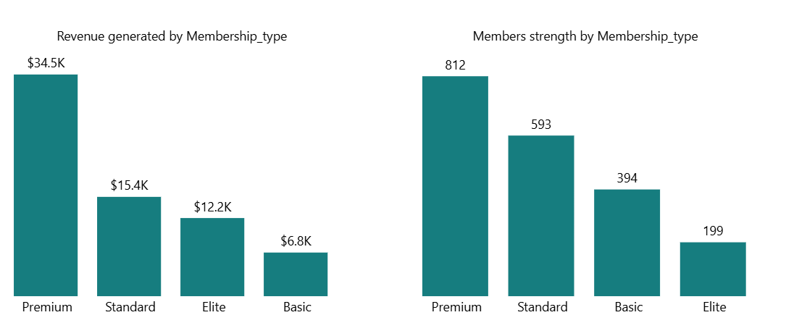
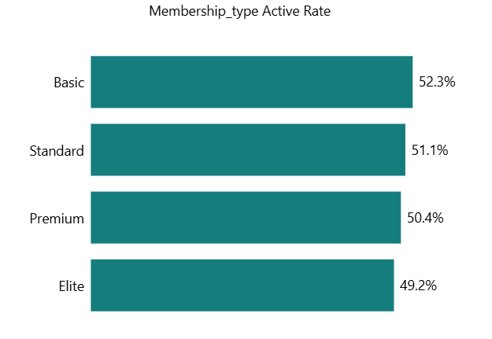
- Premium has the largest member base (812) and the highest total revenue ($34.5K), but its active rate (50.4%) is the second-lowest of the four tiers — strong acquisition, with room to deepen engagement.
- Basic actually has the highest active rate of any tier (52.3%), despite generating the lowest revenue ($6.8K) and having the smallest member base outside Elite (394 members). It retains members well but monetizes them the least.
- Standard sits in the middle on both dimensions: 51.1% active rate and $15.4K revenue from 593 members — a reliable, scalable performer.
- Elite has the smallest member base (199) and the lowest active rate (49.2%), but by far the highest revenue per member (~$61, vs. ~$42 for Premium, ~$26 for Standard, ~$17 for Basic) — a small, high-value segment rather than a highly-retentive one.

10.2 Do pricing models affect churn or satisfaction?
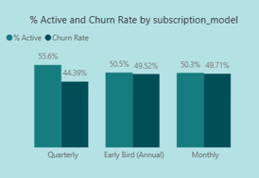
- Overall churn rate across all plans is 49.15%.
- Monthly has the highest churn at 49.71%, and Early Bird (Annual) is close behind at 49.52% — both well above Quarterly's 44.39%.
- Quarterly's lower churn suggests a middle-length commitment (more buy-in than month-to-month, less upfront risk than a full annual plan) may be the sweet spot for retention.
10.3 Are some locations performing better than others in engagement or profitability?
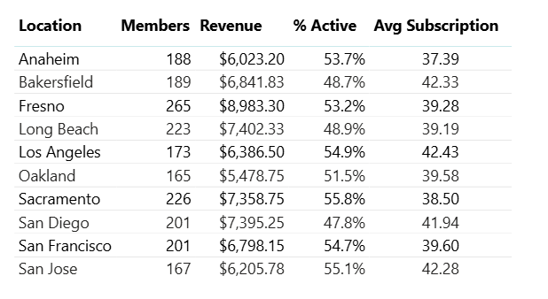
Table as shown in the analysis section

- Fresno leads in total revenue ($8,983), supported by its large member base (265) — this figure is consistent in both sources.
10.4 How does personal training or group class participation influence value?
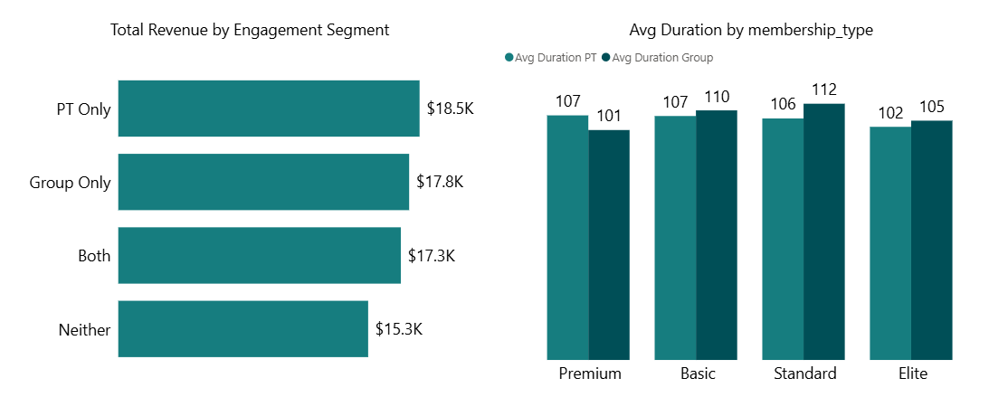
- PT Only members generate the highest total revenue ($18.5K), followed by Group Only ($17.8K), Both ($17.3K), and Neither ($15.3K) — structured, guided engagement correlates with higher spend.
- Members who participate in PT or group classes also stay longer on average. Standard and Basic plans show the longest durations among group participants (110-112 days).
- Elite members show the shortest average duration overall (approx. 102-105 days), suggesting their memberships may be shorter, more goal-specific commitments rather than long-term habits.

10.5 What effect do discount types have on final revenue?
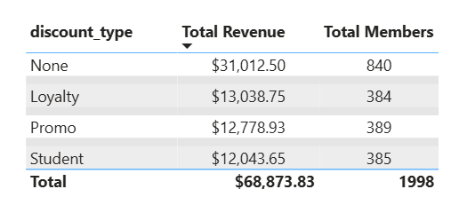
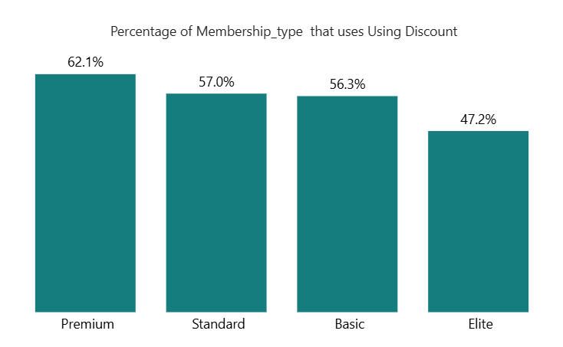
- Members with no discount generate the highest total revenue ($31K) and make up 42% of members (840 of 1,998) — non-discounted customers remain the core revenue driver.
- Loyalty and Promo discounts produce nearly equal revenue (~$13K each) from similar member counts (384 and 389).
- Student discounts reach a comparable number of members (385) but generate slightly less revenue ($12K), consistent with lower price points or spending capacity.
- Premium members are the most likely to use a discount (62.1%); Elite members are the least likely (47.2%), suggesting stronger price-insensitivity or brand loyalty at the top tier.

10.6 Do access types impact visit frequency?
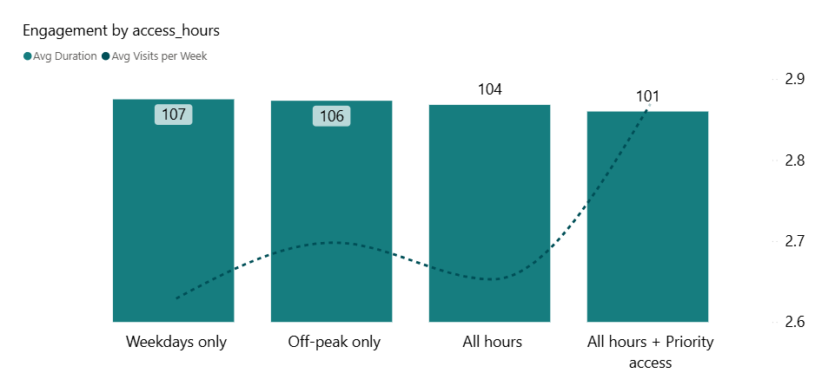
- All hours + Priority access members visit most frequently (2.9 visits/week) despite having the shortest average session length (101 minutes) — convenience appears to encourage more frequent, shorter visits.
- Off-peak only" access slightly outperforms Weekdays only and plain All hours" on visit frequency, possibly reflecting more intentional, less crowded usage.
- Plain All hours access (without priority) does not translate into higher engagement — its visit frequency is not the highest of the four options, suggesting flexibility alone isn't what drives frequent use.

10.7 How do different segments use the gym throughout the week?
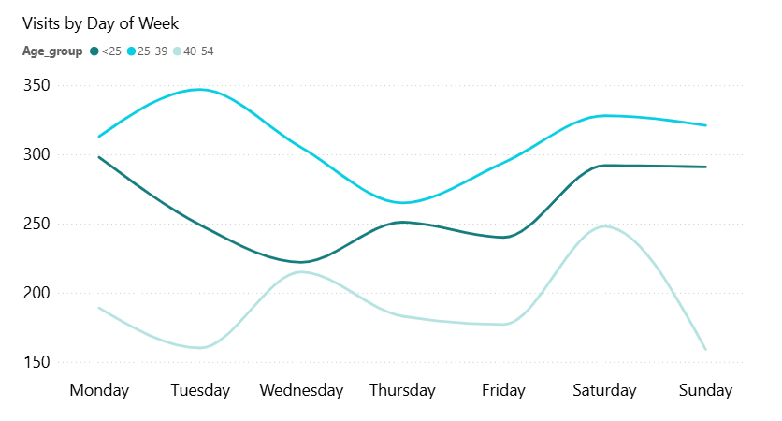
- The 25-39 age group is the most active segment on every day of the week, and its single highest day is Tuesday — this group drives the largest share of both engagement and, by extension, revenue.
- The <25 segment peaks on Monday, dips through midweek, and rises again toward the weekend.
- The 40-54 segment behaves differently from the other two: its lowest activity is Monday-Tuesday, it rises through midweek, and it has a single sharp peak on Saturday before dropping off on Sunday.

11. Dashboard Pages & Visuals
Revenue Page
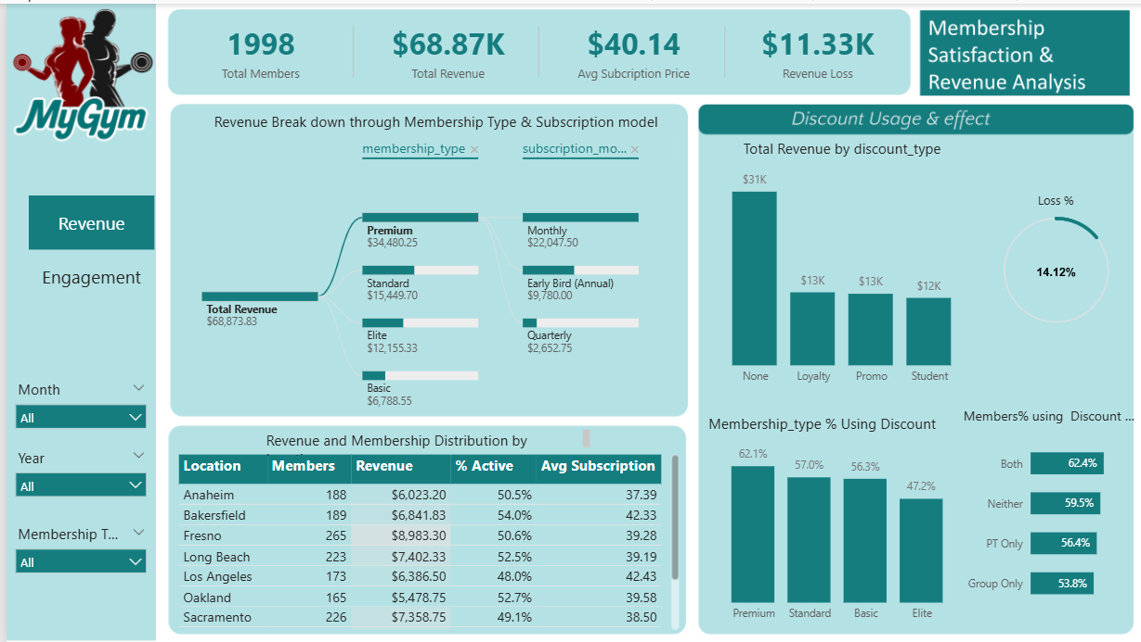
KPI cards: Total Members (1,998), Total Revenue ($68.87K), Avg. Subscription Price ($40.14), Revenue Loss ($11.33K).
- Revenue Break Down through Membership Type & Subscription Model — decomposition tree.
- Revenue and Membership Distribution by Location — table (Members, Revenue, % Active, Avg Subscription).
- Discount Usage & Effect — total revenue by discount type, loss %, and % of members using each discount, split by membership type.
- Slicers: Month, Year, Membership Type.

Engagement Page
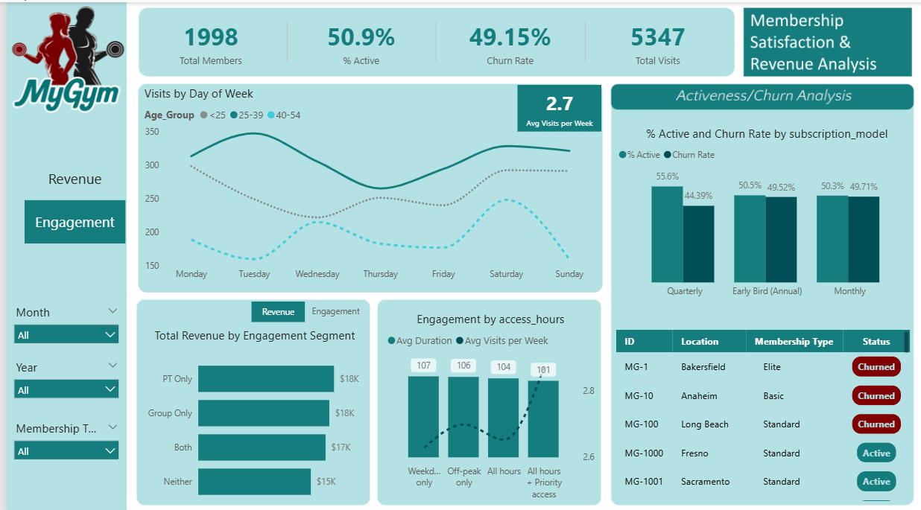
KPI cards: Total Members (1,998), % Active (50.9%), Churn Rate (49.15%), Total Visits (5,347).
- Visits by Day of Week — trend line split by Age_Group, with Avg Visits per Week (2.7).
- Total Revenue by Engagement Segment — PT Only / Group Only / Both / Neither.
- Engagement by Access Hours — Avg Duration and Avg Visits per Week.
- % Active and Churn Rate by Subscription Model.
- Member-level table with ID, Location, Membership Type, and Status (Active/Churned).
12. Key Findings
- Premium drives the most members and revenue but has below-average retention; Basic retains members best but monetizes them least; Elite is the smallest tier but by far the most valuable per member.
- Churn is lowest on Quarterly plans (44.4%) and highest on Monthly and Early Bird plans (49-50%).
- Structured engagement (PT and/or group classes) is associated with both higher revenue per member and longer membership duration than no engagement at all.
- Non-discounted members are still the largest single revenue contributor (42% of members, $31K); Loyalty discounts appear to offer the best retention-to-revenue balance among discount types.
- Priority access members visit most often but for the shortest sessions; unrestricted ("all hours") access alone doesn't translate into higher engagement.
- The 25-39 age group is the most consistently active segment across every day of the week.
13. Recommendations
- Premium: introduce flexible add-ons or loyalty incentives aimed specifically at this tier's large member base to convert its acquisition strength into stronger retention.
- Elite: position it explicitly as a boutique/VIP experience — given its high revenue per member, add exclusive perks that justify the price point and could attract more high-value members.
- Basic: since it already retains members well but generates the least revenue, focus on structured upsell paths (trial PT sessions, group-class credits) rather than treating it as a segment to fix across the board.
- Increase staffing and trainer availability on the days shown to be busiest for the dominant 25-39 segment (see Section 10.7 for the exact day-by-day pattern per age group).
- Revisit Student and Promo discount structuring — consider bundling with upsell offers to raise revenue per member without losing their role in driving membership volume.
- Once the location engagement figures are reconciled (Section 10.3), prioritize outreach and retention programs in whichever locations are confirmed as lowest-engagement.
- Target student/young-professional promotions on the days confirmed busiest for the 25-39 segment.
14. Limitations & Assumptions
- The dataset is a single point-in-time snapshot (1,000 source rows), not a time series, so week-over-week or month-over-month trend claims are directional rather than statistically tested.
- The data model is a single flat table, which limits deeper time-based visit analysis (see Section 8).

