

TRIBHUVAN UNIVERSITY
FACULTY OF HUMANITIES AND SOCIAL SCIENCES

A Project Proposal on
TRAFFIC-AWARE SHORTEST ROUTE MANAGEMENT SYSTEM

Submitted to
Department of Computer Application
Southwestern State College, Basundhara, Kathmandu

In partial fulfillment of the requirements for the Bachelors in Computer Application

Submitted by
Name: Elvish Shrestha

TU Reg. No: 6-2-530-13-2024

15/06/2026

BCA 4th semester

ACKNOWLEDGEMENT

Preliminary getting into the in depth of the matter, I’d like to express my sincere gratitude to everyone who contributed to the successful completion of this project titled “TRAFFIC-AWARE SHORTEST ROUTE MANAGEMENT SYSYEM.”
I would like to thank my project supervisor and faculty members for their valuable guidance, continuous support, and constructive suggestions throughout the development of this project. Their expertise and encouragement helped me understand the concepts and overcome various challenges.
I am also grateful to my college for providing the necessary resources, learning environment, and facilities required for conducting this project. The knowledge and skills gained during my academic studies played a significant role in the successful implementation of this system. Finally, I would like to thank everyone who directly or indirectly contributed to the completion of this project. This project has enhanced my knowledge of traffic management systems, route optimization, and software development, making it a valuable learning experience.

With Regards,
Elvish Shrestha
TU Reg. No: 6-2-530-13-2024

ABSTRACT
The Traffic-Aware Shortest Route Management System is a smart route planning solution designed to help users find the most efficient path between a source and destination by considering both distance and traffic conditions. The project is inspired by real-life experiences of delays while travelers face delays due to traffic congestion, road accidents, construction work, and road blockages, making traditional shortest-distance navigation ineffective. This system provides a digital solution by calculating the most efficient route while avoiding congested or restricted roads and suggesting alternative paths when necessary. Administrators can manage routes, locations, distances, traffic information, and road conditions through CRUD operations. The system is developed using HTML, CSS, JavaScript, PHP, and MySQL and is deployed on a local server environment for academic purposes. It incorporates route management, database connectivity, and shortest path calculation techniques to improve travel efficiency and demonstrate the practical application of web-based technologies in transportation management.

Keywords: CRUD Operations, MySQL, PHP, Traffic-Aware Routing Shortest Path, Traffic Congestion

Table of Contents
ACKNOWLEDGEMENT ii
ABSTRACT iii
LIST OF FIGURES v
LIST OF TABLES vi
LIST OF ABBREVIATIONS vii
1. INTRODUCTION 1
2. PROBLEM STATEMENT 2
3. OBJECTIVES 3
4. METHODOLOGY 4
a. Requirement Identification 5
i. Study of Existing System 5
ii. Requirement Collection 6
b. Feasibility study 8
i. Technical feasibility 8
ii. Operational feasibility 8
iii. Economic feasibility 8
System Flowchart 9
5. GANTT CHART 10
6. EXPECTED OUTCOMES 11
7. REFERENCES 12

LIST OF FIGURES

Figure 1: Waterfall Model of Traffic-Aware Shortest Route Management System 5
Figure 2: Use Case Diagram of Traffic-Aware Shortest Route Management System 7
Figure 3: System Flowchart of Traffic-Aware Shortest Route Management System 9

LIST OF TABLES

Table 1: Gantt chart of Traffic-Aware Shortest Route Management System 10

LIST OF ABBREVIATIONS

CRUD Create Read Update Delete
CSS Cascading Stylesheet
GPS Global Positioning System
HTML Hypertext Markup Language
MYSQL Structured Query Language
PHP Hypertext Preprocessor
XAMPP Cross-Platform Apache MySQL PHP and Perl

INTRODUCTION
With the rapid growth of urbanization and the increasing number of vehicles on roads, traffic congestion has become a major problem in many cities and towns. People often experience delays due to traffic jams, road accidents, construction work, and road blockages. Traditional navigation systems usually suggest routes based on distance without fully considering current traffic conditions, which can result in longer travel times and inconvenience for travelers.
The Traffic-Aware Shortest Route Management System is a web-based academic project designed to help users find the shortest and most efficient route between two locations. The system analyzes available routes and considers traffic-related factors such as traffic congestion, road closures, accidents, and road conditions before recommending a path. By avoiding heavily congested or blocked roads, the system helps users reach their destinations more quickly and efficiently.
I was inspired to develop this project after personally experiencing delays while traveling to college and other destinations due to unexpected traffic jams and road construction. Even when the shortest route was selected, it was not always the fastest option because of traffic conditions. This highlighted the need for a system that can provide smarter route suggestions based on both distance and traffic information.
The main goal of the Traffic-Aware Shortest Route Management System is to reduce travel time, improve route planning, and enhance transportation efficiency. The project will be developed using HTML, CSS, JavaScript, PHP, and MySQL. It will implement CRUD (Create, Read, Update and Delete) operations for route and traffic management, database connectivity, and shortest path algorithms to demonstrate the practical application of web-based and database technologies in solving real-world transportation problems.

PROBLEM STATEMENT
Traffic congestion has become a common problem in many cities and urban areas. People frequently experience delays due to traffic jams, road accidents, construction work, and temporary road closures. As a result, travelers often spend more time on the road than expected, leading to inconvenience, increased fuel consumption, and reduced productivity. Existing route planning methods do not always provide the most efficient path when traffic conditions change unexpectedly.
I personally experienced this problem while traveling to college and other destinations. There were many occasions when I followed the shortest route but still arrived late because of heavy traffic congestion or road maintenance activities. Sometimes alternative routes were available, but I was unaware of them until reaching the congested area. This highlighted the need for a system that can consider both distance and current traffic conditions before suggesting a route.
Many traditional navigation systems primarily focus on finding the shortest distance between two locations. However, the shortest distance does not always mean the shortest travel time. A route may be shorter in distance but heavily congested, while a slightly longer route may allow users to reach their destination faster. Without proper traffic information, users may face unnecessary delays and frustration during travel.
Therefore, this project proposes the development of a Traffic-Aware Shortest Route Management System that can analyze routes based on both distance and traffic conditions. The system will help users identify the most efficient path by avoiding congested or blocked roads and suggesting alternative routes. This will improve travel efficiency, reduce delays, and provide a smarter solution for route management.

OBJECTIVES
The main objective of the traffic-aware shortest route management system are as follows:

- To find the shortest and most efficient route between two locations.
- To analyze traffic conditions and identify congested roads.
- To provide alternative routes when traffic congestion occurs.
- To reduce travel time and fuel consumption.
- To improve the accuracy and efficiency of route planning.
- To help users make better travel decisions based on current road conditions.

METHODOLOGY
System Methodology
For the Traffic-Aware Shortest Route Management System, the Waterfall Model is selected as the development methodology because it provides a structured and systematic approach to software development. The project begins with the requirement analysis phase, where all functional and non-functional requirements are identified, such as route management, traffic monitoring, shortest path calculation, user interaction, and database operations. This phase helps define the scope and objectives of the system clearly.
After gathering the requirements, the system design phase is carried out. In this phase, the overall architecture of the system is planned, including the user interface, database structure, route management module, traffic information module, and shortest path algorithm. Various diagrams such as use case diagrams, and system flowcharts are prepared to visualize the system design.
The implementation phase involves developing the system using HTML, CSS, JavaScript, PHP, and MySQL. The database is created to store route information, traffic conditions, road status, and location details. The frontend and backend components are then integrated to perform CRUD operations and route calculations efficiently.
Once development is completed, the system undergoes testing to verify its functionality, reliability, and accuracy. The shortest route calculation, traffic-aware route selection, user interactions, and database operations are thoroughly tested. After successful testing, the system is deployed in a local server environment for academic demonstration and evaluation. Any identified issues are corrected during the maintenance phase to ensure smooth system performance.
The Waterfall Model is suitable for this project because the requirements are well-defined and the development process can be completed in a clear step-by-step manner, making the project easier to manage, document, and implement.

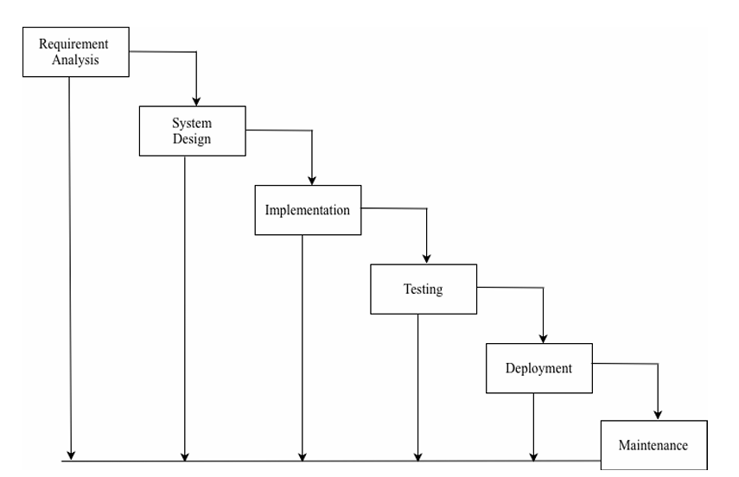
Figure 1: Waterfall Model of Traffic-Aware Shortest Route Management System

Requirement Identification

Study of Existing System
The existing system was studied by reviewing various navigation and route-planning applications such as Google Maps, Waze, and other GPS-based navigation systems. These systems are widely used to help users find routes between locations, estimate travel times, and provide navigation assistance. The study was conducted to understand how modern route management systems calculate routes and respond to changing traffic conditions.
Most existing navigation systems use shortest path algorithms and real-time traffic information to recommend routes. They analyze factors such as distance, travel time, traffic congestion, accidents, road closures, and construction work before suggesting the best route. Users can enter their source and destination, and the system automatically calculates multiple possible routes and recommends the most efficient one. Some systems also provide alternative routes when heavy traffic or road blockages are detected.
The study also revealed [1] that traffic congestion remains a major challenge in urban areas, particularly in Kathmandu Valley. Increasing numbers of private vehicles, limited road capacity, road maintenance activities, and insufficient public transportation contribute to frequent traffic jams. As a result, travelers often experience delays even when following the shortest-distance route. This highlights the importance of considering both distance and traffic conditions when selecting a route.
Although existing navigation systems offer advanced features and real-time services, they are large-scale commercial platforms requiring GPS integration, live traffic data collection, and complex infrastructure. Therefore, the proposed Traffic-Aware Shortest Route Management System aims to implement the core concepts of shortest path calculation and traffic-aware routing in a simplified academic environment. The system will help users identify the most efficient route while avoiding congested or blocked roads through effective route and traffic management.

Requirement Collection
Requirement collection is the process of gathering the necessary information, features, and expectations needed for the successful development of the Traffic-Aware Shortest Route Management System. The requirements were collected through personal experiences, discussions with students and daily commuters, observation of traffic-related problems, and research on existing navigation systems.
During the requirement collection phase, users expressed the need for a system that can provide the shortest and fastest route while considering current traffic conditions. They also highlighted the importance of receiving alternative route suggestions when roads are congested, under construction, or blocked due to accidents.
The collected functional requirements include route searching, traffic monitoring, route optimization, travel time estimation, and alternative route recommendations. The system should allow users to enter their source and destination locations and receive the most efficient route based on traffic conditions.
Functional Requirements
- The user shall be able to enter a source location and destination.
- The user shall be able to view the shortest available route.
- The user shall be able to view route distance and estimated travel information.
- The system shall detect traffic jams, accidents, and road blockages.
- The system shall avoid congested routes automatically.
- The system shall suggest alternative routes when necessary.
- The admin shall be able to log in to the system.
- The admin shall be able to add, update, view, and delete route information.
- The admin shall be able to manage traffic status and road conditions.
- The admin shall be able to manage locations and distances between locations.
- The system shall display the reason for avoiding a route.
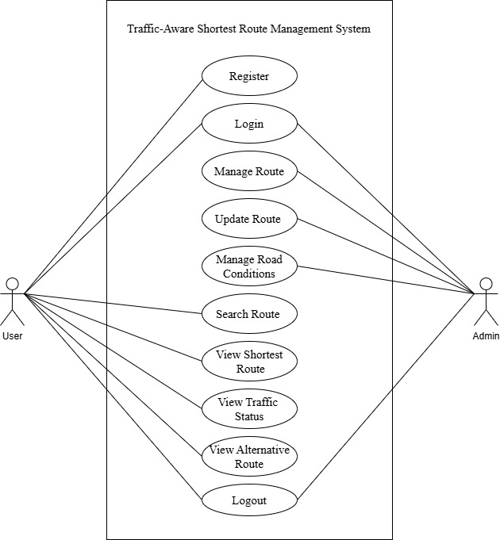
Figure 2: Use Case Diagram of Traffic-Aware Shortest Route Management System

Non-Functional Requirements
- The system must be user-friendly.
- The system must provide accurate route information.
- The system must be secure and reliable.
- The system must respond quickly to user requests.
- The system must be easy to maintain and update.

Feasibility study

Technical feasibility
The project can be developed using available technologies such as HTML, CSS, JavaScript, PHP, MySQL, mapping services, and route optimization algorithms. The required hardware and software resources are readily available, making the system technically feasible. The project will run on a local server environment using XAMPP, which is suitable for academic development and testing purposes.

Operational feasibility
The system is designed to be user-friendly and can be easily used by students, commuters, delivery personnel, and other travelers. Users can quickly enter their source and destination locations and receive optimized route suggestions, making the system practical for everyday use.

Economic feasibility
The development cost of the system is economically feasible because it uses free and open-source technologies such as HTML, CSS, JavaScript, PHP, and MySQL and existing mapping technologies. The project does not require expensive hardware or software, making it cost-effective and suitable for academic purposes.

System Flowchart
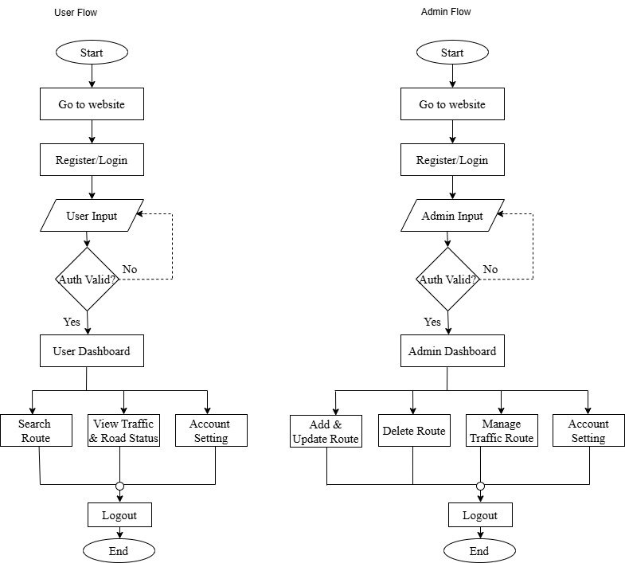

Figure 3: System Flowchart of Traffic-Aware Shortest Route Management System

GANTT CHART

Table 1: Gantt chart of Traffic-Aware Shortest Route Management System

EXPECTED OUTCOMES
The Traffic-Aware Shortest Route Management System is expected to provide users with an efficient way to find the best route between a source and destination by considering both distance and traffic conditions. The system will help users avoid traffic jams, road blockages, accidents, and other obstacles by suggesting alternative routes when necessary. It will reduce travel time, improve route planning, and enhance overall transportation efficiency. The project will also provide administrators with the ability to manage routes, locations, road conditions, and traffic information effectively through CRUD operations. The system will maintain organized route and traffic records, ensuring accurate route recommendations and a user-friendly experience for travelers.
The project is expected to improve route planning, enhance user convenience, and contribute to better traffic management by supporting informed travel decisions and more efficient use of road networks.

REFERENCES

[1] | arthapranali, "Kathmandu’s Traffic Jam Crisis: The Escalating Urban Gridlock in Nepal’s Capital," 03 08 2025. [Online]. Available: https://arthapranali.com/2025/08/17422/. [Accessed 26 06 2026].

