**PALLADIUM HEALTH CENTER PROJECT**

**Requirements.**

Platform used to develop the application is Visual studio 2015 and the language used is C#, ASP.NET and JavaScript.

MSSQL Server 2008 R2 or any later version.

IIIS 6.0

**How to run the project.**

* Restore the database into local MSSQL Server.
* Edit WebConfig file to set your User ID Password and Database to be able to connect to the server.
* Launch the project using login page and enter username: [Admin@gmail.com](mailto:Admin@gmail.com) and Password: admin.
* Navigate through the menu to do all the processes defined.

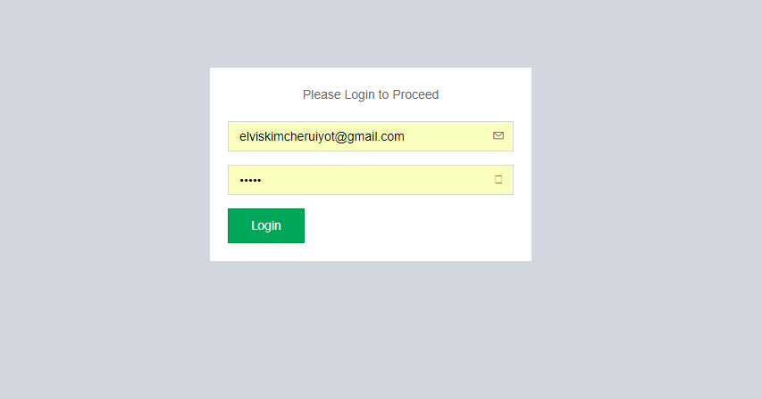

After successful Login you will be redirected to home page that looks like this one bellow.

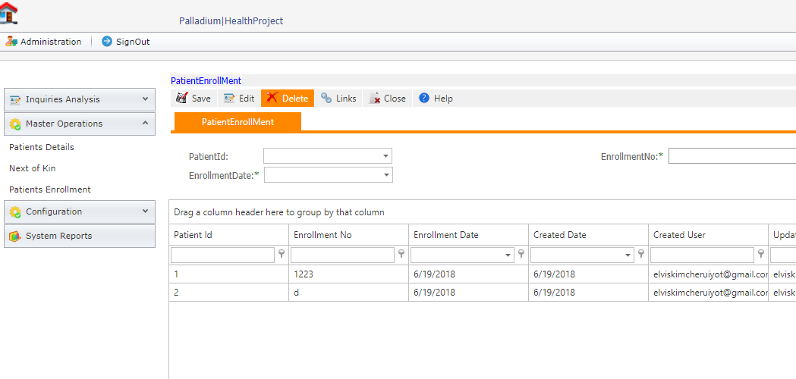

To add a new user Navigate to Configurations menu and select new user tab.

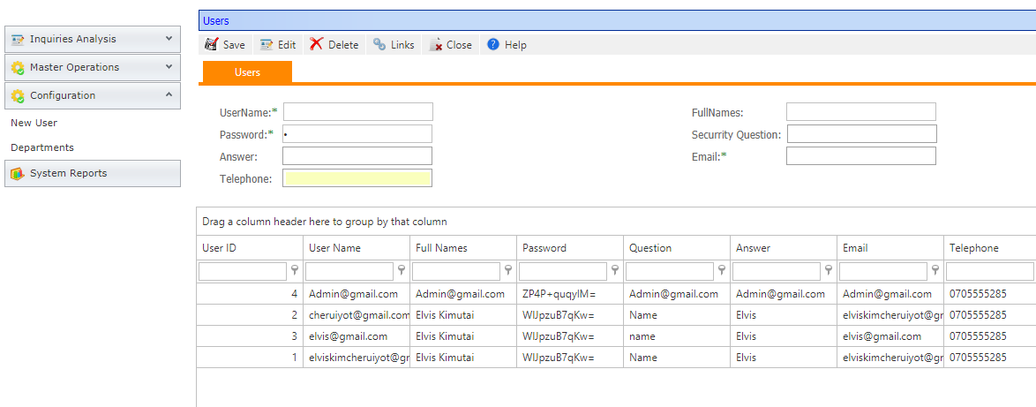

And to view all Inquiries tab the Inquiries Analysis menu.

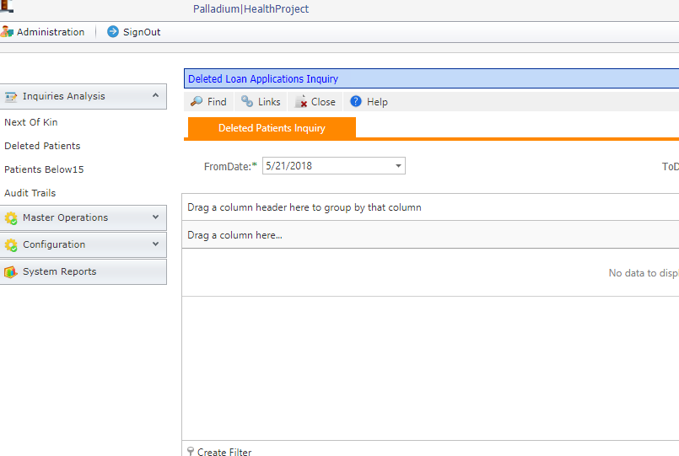

**Database Design**.

**Relationships:**

Patient belongs to a given Department.

Next of kin is registered for a given patient.

Therefor the order is that you first set up department under Configurations Menu while using the application then Register Patient details.

**Database Diagram.**

