Elvis Nunez

CPS4745

Lab report

14/12/2020

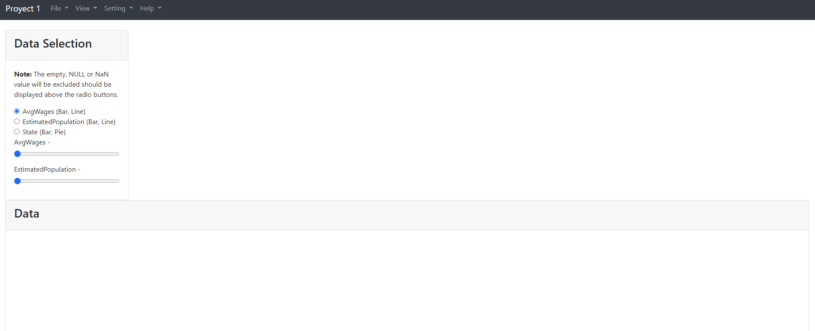

The website's layout is kind of the same, we only add a few bottoms, and the sliders at the top left are implemented in the second of the project. This layout can be found in the index.php file. Basically, it is made using bootstrap, so there’s no need to use any CSS code.

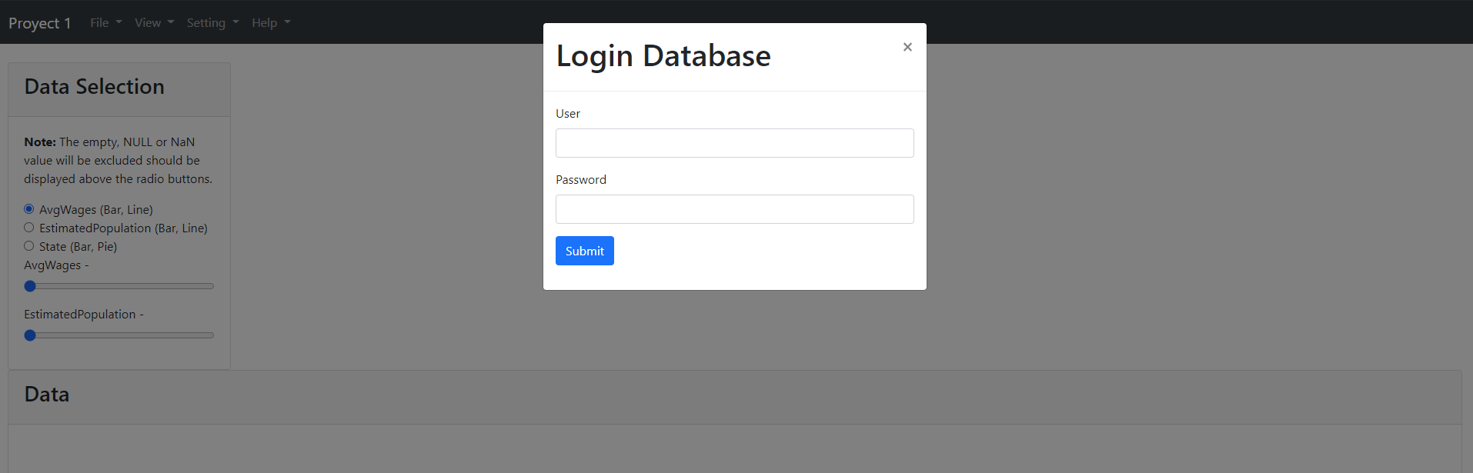

I added a login to DB that asked the user to put the login and the password. This function was implemented using the DV_user database, so the function compared the user and password typed with the user and password in the database. The function for the login database can be found in the login.php where the user receives a post method from a $user and $pass variables.

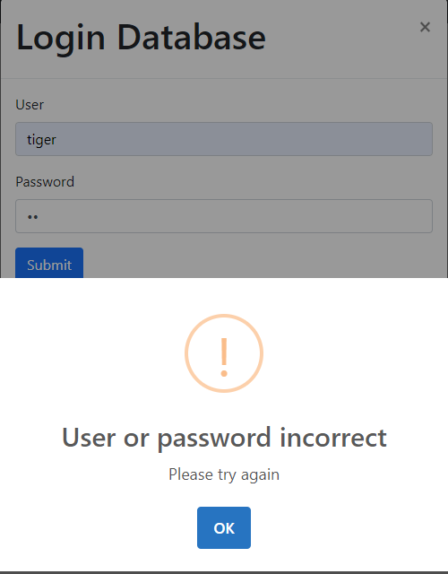

This is a function that verifies if the password is incorrect or not. If the password or username is not in the database, a message will pop out telling the user if it was successful or failed. When the user login successfully, the user information is stored in the web browser. This function can be found in the file app.js line 5, where we pass the value to the ajax function and then send the value to the login.php file.

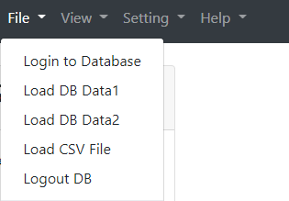

Two submenus were added under file, but the user needs to login in other to view those two submenus, we cannot show any information from the DB if the credentials are not correct.

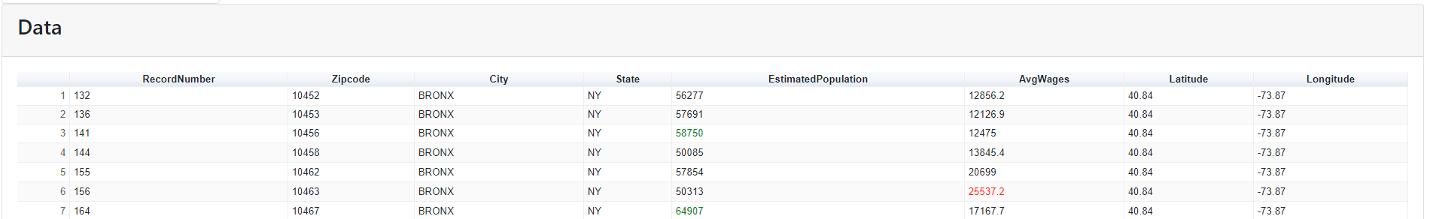The information displayed in the google table when the user clicks load DB data 1, there’s more data, but this is just an example that the programming is getting the data from the Views that are in the datamining database. The function for loadData1 can be found in the file app.js line 83, that’s the ajax function to show the event when the user clicks. Also, if the value is greater than the average, the number in the Estimated Population column must be colored in green, and the average wage should be less than that average and colored with red.

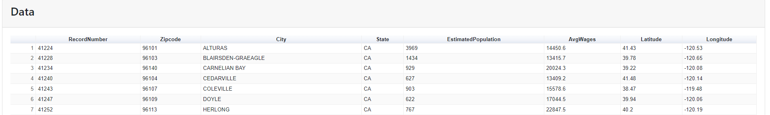

This load DB data 2, is the same process as the first one. The only difference is we are showing another different view, and the data is different, but the function is in the same file in line 138. There’s an ajax function that receives an ID of loadData2, so when the user clicks, it should call the ajax event and show it on the website.

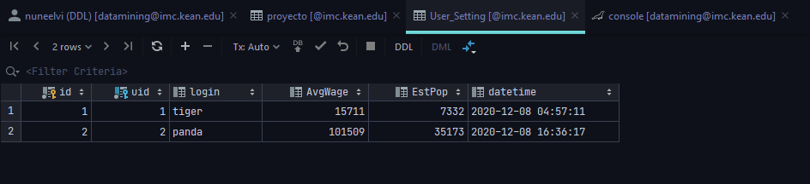

When the user clicks the save filter bottom, the numbers on the sliders that are referring to the AveWage and the EstPop are going to save on a schema I created to save the information that the user is manipulating.

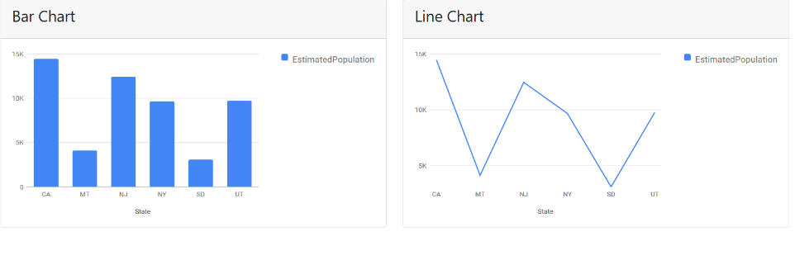

Also, there is a function that shows two tables on the website, and when you cross the mouse over the chart, it displays the average for the state. These functions can be found in the data.php and the app.js