HydroSeek
A desktop application for manual annotation of single-channel PAM recordings. It is a fully self-contained Python PyQt6 environment making it open source, with no license restrictions.

The tool is designed for annotators working with long audio files to streamline the annotation process from binary labels to bounding boxes for object detection. Files are auto divided into labelling frames through a user-defined config set up , and the annotator works through each frame in sequence applying binary presence/absence labels, event counts, confidence scores, free-text notes and point and bounding-box event annotations directly on the spectrograms.
- Label frame: the short window of audio shown at one time (e.g. 30 seconds). The annotator applies binary labels to each frame.
- Big chunk: HydroSeek divides long files into large processing chunks to keep memory usage manageable. Each chunk contains many label frames.
- Binary label: a presence/absence (1/0) flag per species or sound class, applied to a whole frame.
- Event annotation: a point or bounding box placed directly on a spectrogram to mark a specific acoustic event within a frame. Stored separately from binary labels. Metadata includes which spectrogram the box or point was applied to, so reconstruction can be done with the correct spectral parameters.
- Confidence: a 1/2/3 rating indicating the annotator's certainty for each frame (binary labels) or each event annotation (can apply per event annotation).

- Installation and Launching
HydroSeek requires Python 3.11 or later. All dependencies are listed in requirements.txt and can be installed into a virtual environment as follows.
  - Setting up the environment
- Clone or download the HydroSeek repository (https://github.com/elw1d23/HydroSeek_py.git)
- Create a virtual environment: python -m venv .venv_hydro
- Activate it and install dependencies: pip install -r requirements.txt
- Launch the application: python main.py
Note: On first launch, font aliasing may produce a brief console message. This is harmless and does not affect functionalality.

- Interface Overview
The application has 2 tabs, upon opening you will the setup tab, the labelling tab will be inactive (Fig 1).
Setup Tab:
- Load Audio: Select a local audio file (wav, mp3, flac). If 2 channel, auto selects channel 1.
- Session Parameters
- Spectrogram Settings: Visual parameters for acoustic data, across all spectrograms.
- Label configuration: User defined custom labels, up to 18 per session.
An exemplar config file is supplied in the hydroseek folder, you may load this in using the ‘Load config button’ to see exemplar values for each input. Once you have set your ideal config settings,use the export button to save this locally for your next use.
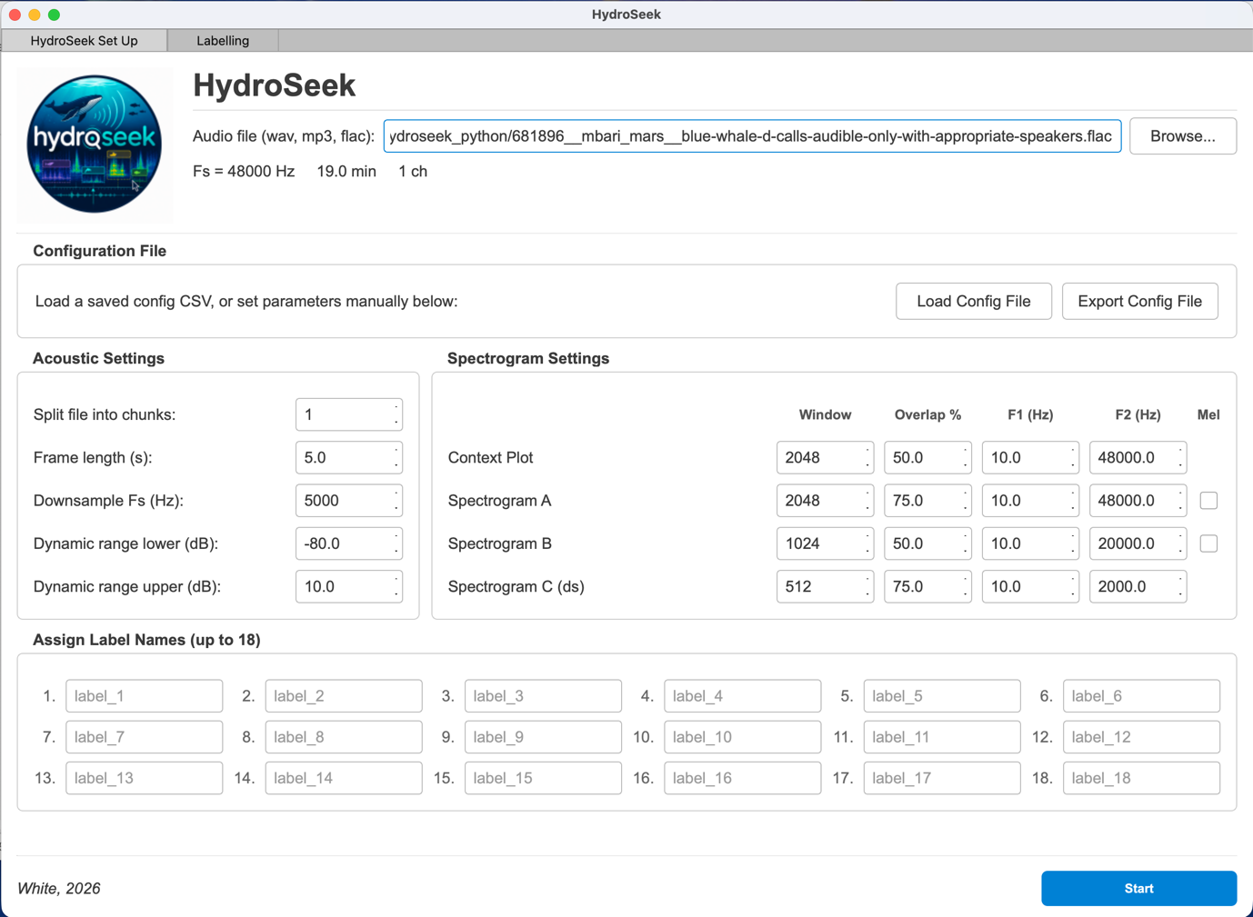
HydroSeek set up tab, with an audio file loaded and default settings input.

Note: If you load in an audio file that already has an associated labels file you will receive a warning, click ok and continue labelling but know that your original label file will be overwritten.
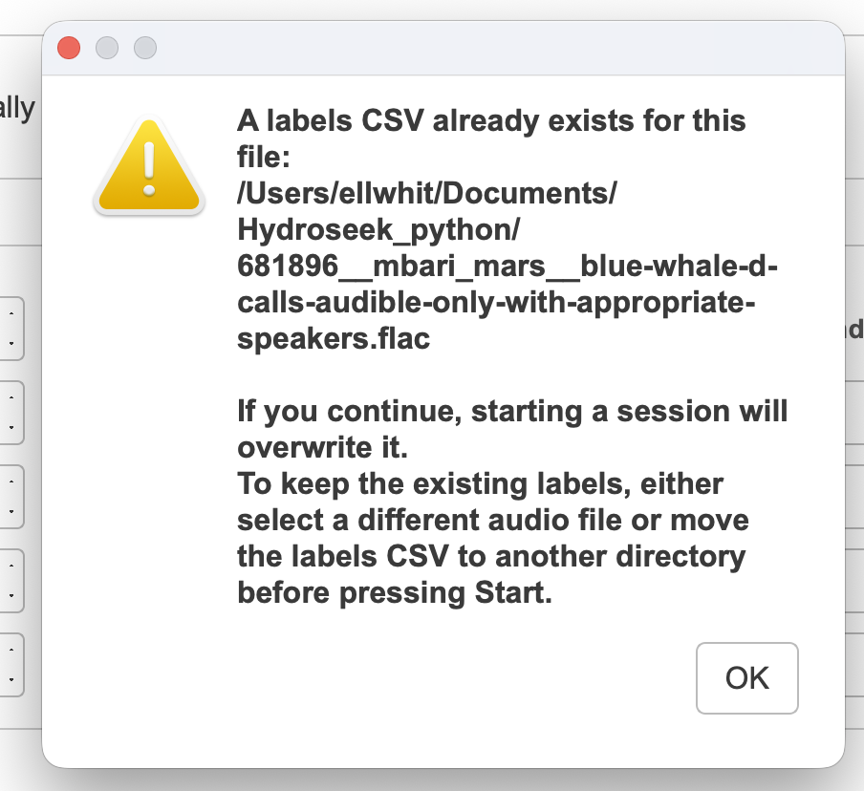

Labelling Tab:
The labelling tab contains all the displays and controls used during annotation. From top to bottom:
- A waveform strip showing the full audio file with a position marker.
- A large overview spectrogram of the current big chunk with the active frame highlighted.
- The Context plot: a mel-scale spectrogram of the surrounding audio context (current frame + next frame and previous frame, with duration set by user).
- Three configurable spectrogram panels (A, B, C) showing the current label frame at different resolutions (user specified in set up tab).
- A controls bar at the bottom containing four panels: Select Labels, Annotations, Event Annotations, and Navigation.

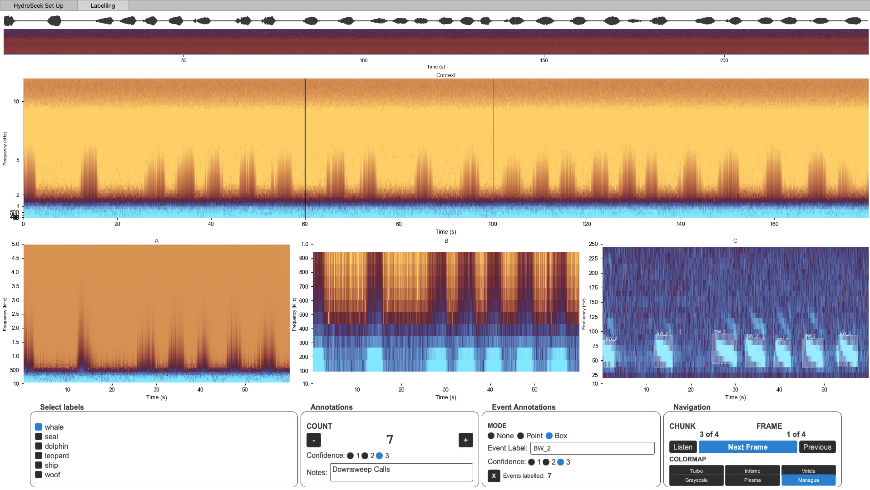
Labelling Tab Screenshot, with binary label ‘whale’ selected, 7 counted calls in the frame, set to low confidence and labelled ‘Downsweep Calls’. Seven Bounding boxes are applied in Spectrogram C with high confidence around each call.

- Configuring a Labelling Session

3.1 Loading an audio file
Click Browse next to the audio file path field. HydroSeek accepts WAV, MP3 and FLAC files. The file path is displayed once selected.
Acoustic parameters are displayed to help inform your user settings.
3.2 Session parameters
Parameter | Description
Label Frame Length (s) | Duration of each labelling window. Typically 20–60 s for marine mammal surveys.
Target Sample Rate (Hz) | Sample rate used for the downsampled C spectrogram. Set lower than the recording Fs to focus on low frequencies.
Dynamic Range Low (dB) | Lower bound of the colour scale, expressed as an offset from the signal peak.  Default -200
Dynamic Range High (dB) | Upper bound of the colour scale offset.  Default 0

3.3 Configuring labels
Type a label name into each active row in the Label Configuration section. Leave unused rows blank, they will not appear as checkboxes in the Labelling tab. You can configure up to 18 labels per session.
Note: Label names are written directly as column headers in the output CSV. Avoid special characters and leading spaces!!!

3.4 Spectrogram settings
Each of the four spectrogram panels has independent settings. The Context plot is always mel-scale. Spectrograms A and B have an optional Mel checkbox. Spectrogram C uses the downsampled signal and is intended for low-frequency zoomed views.
Window : FFT window size in samples. Larger values give better frequency resolution but poorer time resolution.
Overlap % : percentage overlap between successive windows. Higher values give smoother time display.
F1 / F2 : minimum and maximum display frequency in Hz. Ensure you check that your maximum display value is at maximum half your Fs, or you will have display issues. I.e. if your Fs is 48000, the upper limit of F2 is 24000.
Mel : tick to use mel-frequency scaling on spectrogram A or B.
Note: For low-frequency species (e.g. blue whale, fin whale), set Spectrogram C to a low F2 (e.g. 200 Hz) and match the target sample rate to at least 2 x F2.
3.5 Starting the session
Click Start Labelling once all settings are configured. HydroSeek loads and chunks the audio file, initialises the labels table and event annotations table, and writes the spectrogram configuration file to disk alongside the audio file. The Labelling tab then becomes active. The auto written configuration file is saved into the directory of the audio file, so that event annotations can be reconstructed using the preset user parameters.
5. Labelling Workflow
The standard labelling workflow moves left to right across the controls bar at the bottom of the Labelling tab: apply binary labels, annotate count, apply event annotations, then advance to the next frame.
5.1 Reading the spectrograms
When the session starts, the first label frame is loaded and all four spectrogram panels update. Use the spectrograms together to form a judgement about what is present:
Context plot: use to assess what is happening in the surrounding audio and locate the current frame (marked by vertical lines).
Spectrogram A: primary wideband view. Configured by the user for broadband or mid-frequency species.
Spectrogram B: secondary view, typically a different resolution or frequency range from A.
Spectrogram C : low-frequency downsampled view. Use for infrasonic or very low frequency signals.
5.2 Applying binary labels
The Select Labels panel on the left of the controls bar shows a checkbox for each label configured in the Set Up tab. Tick any label that is present in the current frame. A label does not need to occupy the full frame duration to be ticked, the frame is presence/absence only.

5.3 Counting features
The Annotations panel contains a COUNT section with + and - buttons. Use this to record how many discrete calls or events you can identify in the frame. The count resets to blank on each new frame. If you do not interact with the counter, the output CSV records NaN for that frame.
5.4 Setting confidence
The Confidence radio buttons (1, 2, 3) in the Annotations panel record your certainty for the binary label assignment of this frame. The scale is:
1 — High confidence. Signal is clear and unambiguous.
2 — Medium confidence. Signal is present but partially masked or degraded.
3 — Low confidence. Uncertain identification, possible false positive.
Note: Confidence defaults to 1 at the start of each frame. If you do not change it, 1 is recorded.
5.5 Adding notes
The Notes field in the Annotations panel accepts free text. Use this for any observation that cannot be captured by the binary labels or count, for example, unusual call types, interference, equipment noise, or ambiguous detections. Notes are saved per frame.
5.6 Navigating frames
The Navigation panel on the right of the controls bar shows the current chunk and frame position. Use the following controls:
- Next Frame: saves the current frame labels and advances to the next frame. This is the primary control and is highlighted in blue.
- Previous : moves back one frame. The previous frame's labels are removed from the table so they can be re-entered. Use this if you need to correct a mistake.
- Listen: plays the audio of the current label frame through the system audio output.
Note: When navigating backwards, binary labels and counts are cleared and must be re-entered. Event annotations (points and boxes) placed on previous frames are preserved and redrawn on the spectrograms when you return to that frame.
5.7 Changing the colourmap
The Colormap buttons in the Navigation panel switch the spectrogram colour palette across all four panels simultaneously. Six options are available: Turbo (default), Inferno, Viridis, Plasma, Grayscale, and Managua. Annotation overlay colours update automatically to maintain visibility against the selected palette.
For users who wish to change these defaults the dictionary of colourmaps is present in the labelling_tab.py script at the top.
6. Event Annotations
Event annotations allow you to mark specific acoustic events directly on the spectrograms with a point or a bounding box. These are stored in a separate output file from the binary frame labels and include precise time and frequency coordinates.
Event annotations can be placed on any of the four labelling spectrograms: Context, A, B, or C. They cannot be placed on the waveform strip or the large overview spectrogram.
6.1 Annotation mode
The Event Annotations panel contains three mode radio buttons:
- None : default mode. No interaction with the spectrograms. Select this when you are not placing event annotations.
- Point : a single click on a spectrogram places a point marker at that time and frequency position.
- Box : click and drag on a spectrogram to draw a rectangle. The box is defined by its time and frequency extents. You can drag in any direction and the coordinates are normalised automatically.
6.2 Applying an event annotation
- Select Point or Box mode in the Event Annotations panel.
- Type a label for the event in the Event Label field (e.g. "click", "whistle", "D call").
- Set the Confidence level (1, 2, or 3) for this event.
- Click (Point mode) or click and drag (Box mode) on the target spectrogram.
- The annotation appears immediately as an overlay. The Events labelled counter increments.
- Repeat for additional events. You can mix point and box annotations on the same frame. The label will remain set until you change it, so you can rapidly label multiple calls in a single frame.

Note: The Event Label and Confidence settings persist between annotations. You do not need to re-enter them if the next event is the same type.
6.3 Removing an annotation
Press the X button in the Event Annotations panel to remove the most recently placed annotation. Press it again to remove the one before that, and so on. There is no bulk delete for a frame in v2.
6.4 Persistence across frames
Event annotations are saved immediately when placed and are not affected by the Next Frame or Previous buttons. When you navigate back to a frame that already has annotations, they are redrawn on the spectrograms automatically. New annotations added on a revisited frame are appended to the event table in the order they were placed.
7. Output Files
At the end of a session,when the final frame is labelled and Next Frame is pressed, HydroSeek writes three CSV files to the same directory as the audio file. The audio filename stem is prepended to each output filename.
7.1 Frame labels: <stem>_labels.csv
One row per labelling frame. Columns are fixed regardless of session configuration.
Column | Description
ChunkNo | Sequential frame number, renumbered 1…N at export.
StartTime_sec | Absolute start time of the frame in the audio file (seconds).
EndTime_sec | Absolute end time of the frame (seconds).
<label_1> … <label_N> | One column per configured label. 1 = present, 0 = absent.
Confidence | Annotator confidence rating (1, 2, or 3).
Comment | Free-text note for the frame.
Count | Feature count for the frame. NaN if not entered.

7.2 Event labels: <stem>_Event_labels.csv
One row per event annotation. Written at session end alongside the frame labels file.
Column | Description
Event_ID | Globally unique integer for this annotation within the session.
Type | "point" or "box".
Plot | Which spectrogram the annotation was placed on: Context, A, B, or C.
ChunkIdx | Zero-based index of the big chunk containing this frame.
FrameNo | Frame index within the big chunk.
Frame_StartTime_sec | Absolute start time of the parent label frame (seconds).
Frame_EndTime_sec | Absolute end time of the parent label frame (seconds).
Event_Time_sec | Absolute time of the annotation in the audio file. For a box, this is the left (earlier) edge.
Event_Time_End_sec | Right edge of a bounding box (seconds). NaN for point annotations.
Freq_Hz_low | Frequency at the click position (point) or lower edge of the box (Hz).
Freq_Hz_high | Upper frequency edge of the bounding box (Hz). NaN for point annotations.
Event_Label | Free-text label entered by the annotator.
Confidence | Annotator confidence for this event (1, 2, or 3).
Comment | Contents of the Notes field at the time the annotation was placed.

7.3 Spectrogram config: <stem>_Event_labels_config.csv
Written once at session start. Records the spectrogram settings (window size, overlap, F1, F2, Mel flag) for each of the four labelling plots. This file allows the exact spectrogram view used during annotation to be reconstructed for any later analysis or quality check.

8. Tips and Best Practices
8.1 Spectrogram configuration
- For broadband data, set A to your full recording bandwidth and use B and C to zoom into species-specific or signal specific frequency bands.
- Spectrogram C is always downsampled, set the target sample rate to at least twice F2 of plot C. For a 200 Hz view, a target rate of 500–1000 Hz works well. If you don’t want to downsample, simply set the downsampling value to the same sampling rate as the audio file.
- Larger window sizes improve frequency resolution but reduce time resolution. For long calls (e.g. blue whale moans), favour large windows. For short clicks, use small windows.
- If spectrograms appear mostly one colour, adjust the dynamic range settings in the Set Up tab.

8.2 Labelling efficiency
- Set the mode back to None when you are not placing event annotations — this prevents accidental clicks from creating unwanted annotations.
- The Event Label field persists between frames. If you are annotating the same event type across many frames, leave the label set and just change the mode as needed.
- Use the Listen button on ambiguous frames before assigning a confidence of 1.
- If you need to revisit a frame, use Previous and re-enter the binary labels. Your event annotations on that frame will still be there.

8.3 Output file handling
- All three output files are written to the same directory as the audio file. Ensure you have write permission to that location before starting.
- The config CSV is written at session start, so it exists even if the session is aborted partway through.
- Column count in the labels CSV reflects only the labels you configured, unused label slots produce no columns.
- Output label files will only be written at the end of the labelling loop, so you must complete the full file labelling to store your work. Only start a file you know you will finish in full to avoid duplication of workload!

