3. Design

About Design

Design is a work process which has a user perspective and drives development based on your specific customers’ needs. (SVID, 2005)

Project Design Plan

The design phase has been planned by implementing various design methodologies. With the making of different design models, the design phase will be completed. The implemented design models are mentioned below as:

* Structural Modelling
* Behavioral Modelling
* Database Modelling
* Architectural Modelling
* User Interface Modelling

Structural Modelling

This modelling methodology represents the system in various components along with their communication. Class Diagram and Data Flow Diagram has been applied in order to produce the structural model of the system.

Final Class Diagram

Definition

It is a structure diagram that falls in the category of static diagram or static modelling where the system’s structure is represented by the classes, their attributes, operations and relationship among different class or objects.

Justification

The reasons for approaching this modelling methodology are mentioned below:

* It clearly states the major components of the system which may be classes or interfaces.
* The type of entity can be distinguished easily with the study of attributes of the class.
* The relationship among different classes is represented clearly with the help of different notations.
* Class Diagram also lists out possible operations of the entity or class in a system.

Notations

Actual Diagram

Diagram Description

Data Flow Diagram

Definition

Data Flow Diagram is also a diagram that falls in structural modelling. It shows the flow of a data from a process to another process or from a system to another system.

Justification

The reasons for approaching this modelling methodology are mentioned below:

* It helps to identify the processes involved to transfer data.
* DFD provides logical information flow of the system.
* It diagramming notations are simple and easily understandable.

Notations

The notations used for this methodology are tabulated below:

|  |  |  |
| --- | --- | --- |
| Name | Notation | Description |
| External Entity |  | Represents the entity that provides data or receive output to or from the system |
| Process | DFD Process | Represents a place where input data is processed to produce output |
| Data Flow | DFD Data Store Example | Arrow represents the path for flow of data in the system |
| Data Store |  | Represents a place to persist the data. |

Actual Diagram and Description

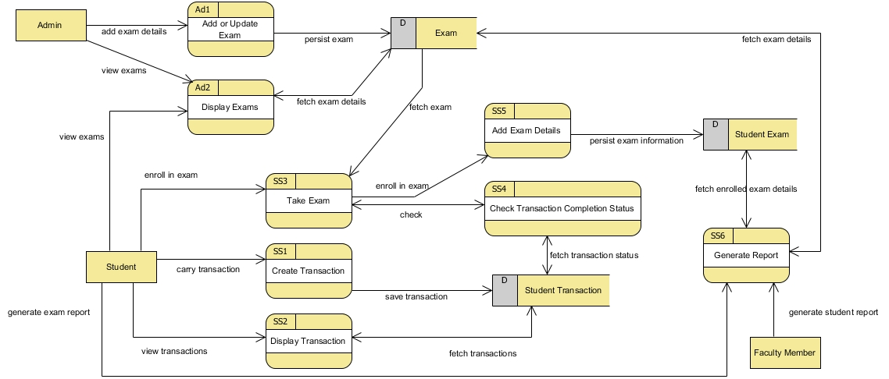

Img 1-Academic Data Flow Diagram

The diagram above shows the flow of data in the system while carrying out different academic operations. The external entities are Admin, Student, Faculty Member who carries out different processes affecting different data store such as Exam, Student Transaction, Student Exam.

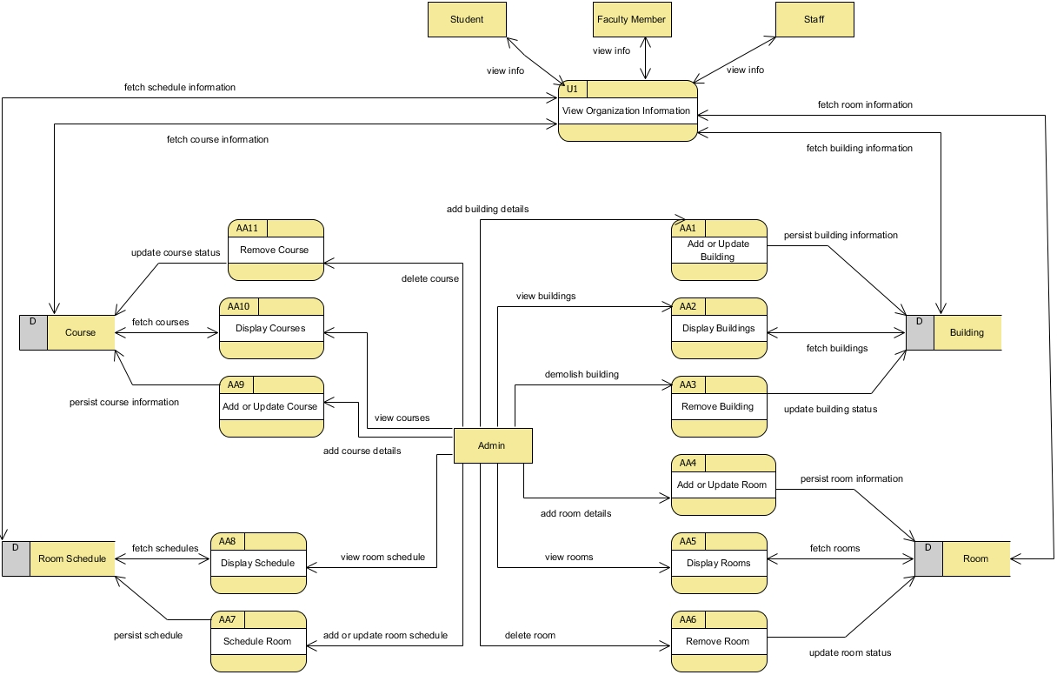

Img 2-Organization Data Flow Diagram

The data flow diagram above shows general processes of the system while managing fundamental information of the organization. In the diagram, Admin as an external entity triggers multiple processes affecting multiple data stores. Similarly, external entities like Student, Faculty Member, Staff carry out same single process that retrieves data from multiple data stores.

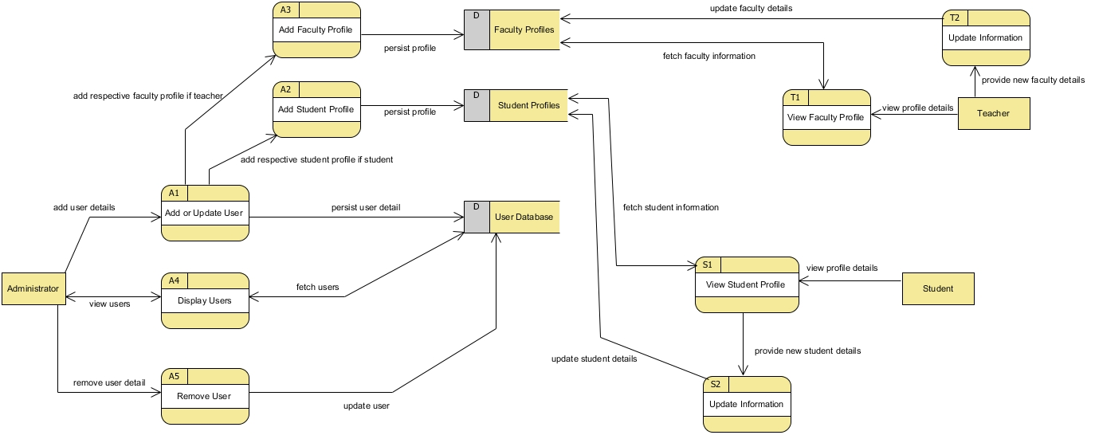

Img 3-User Profile Data Flow Diagram

The data flow diagram represents the flow of data in the system as per various access level in the system. As per access level of the external entity, the processes are carried out distinctively. The data flow diagram generally represents multiples processes that ultimately manages the user profiles in the system.

Behavioral Modelling

This modelling methodology describes the internal actions of the system with the help of models that represent the business process and change in data.

Activity Diagram

Definition

It is a diagram that falls in dynamic system modelling. Activity diagram shows the flow of program or flow of control in the system.

Justification

The reasons for approaching this modelling methodology are mentioned below:

* The business processes are clearly represented as each task is shown as a single activity within a diagram.
* It represents the dynamic view of the flow of the system.
* Activity Diagram shows the program flow from various task perspective.

Notations used

|  |  |  |
| --- | --- | --- |
| Name | Notation | Description |
| Action | Activity Diagram Notation - Action | Represents the action in the system |
| Control Flow | Activity Diagram Notation - Control Flow | Represents the sequence of execution |
| Initial Node | Activity Diagram Notation - Initial Node | Represents the beginning of action. |
| Activity Final Node | Activity Diagram Notation - Activity Final Node | Represents point where all control flows stops. |
| Decision Node | Activity Diagram Notation - Decision Node | Represents a condition so that control flow goes single way. |
| Fork Node | Activity Diagram Notation - Fork Node | Represents control flow split into parallel flows. |
| Join Node | Activity Diagram Notation - Join Node | Represents parallel flows brought together. |
| Swimlane | Activity Diagram Notation - Swimlane and Partition | Represents grouping of activities performed by same actor. |

Actual Diagram and Description

Sequence Diagram

Definition

Sequence Diagram shows the interaction of the objects within the program flow which helps to identify the message sequence.

Justification

The reasons for approaching this modelling methodology are mentioned below:

* Besides dynamic view of the system like shown by Activity diagram, it also keeps time sequence as an essential part of the diagram.
* It clearly shows the lifetime of the object in the system during task execution.
* It provides detail visual representation of how objects communicate with each other within the program flow.

Notations

|  |  |  |
| --- | --- | --- |
| Name | Notation | Description |
| Actor | Actor | Represents the entity’s role |
| Lifeline | Lifeline | Represents an individual participant. |
| Activations | Activation | Represents an operation period of an element. |
| Call Message | Call Message | Represents the invocation message that invocate communication between lifelines. |
| Return Message | Return Message | Represents the reply message to the caller. |
| Recursive Message | Recursive Message | Represents the message invocated in same lifeline. |
| Sequence Fragment | Fragment | Loop fragment represents that the fragment may execute multiple times. Alt fragment represents only single execution whenever the condition matches. Par fragment represents parallel execution. |

Actual Diagram and Description

Database Modelling

This modelling methodology presents the proposed logical design of the database along with the data dictionary. The logical database design is obtainable through **Entity Relationship Diagram (ER Diagram)**.

ER Diagram

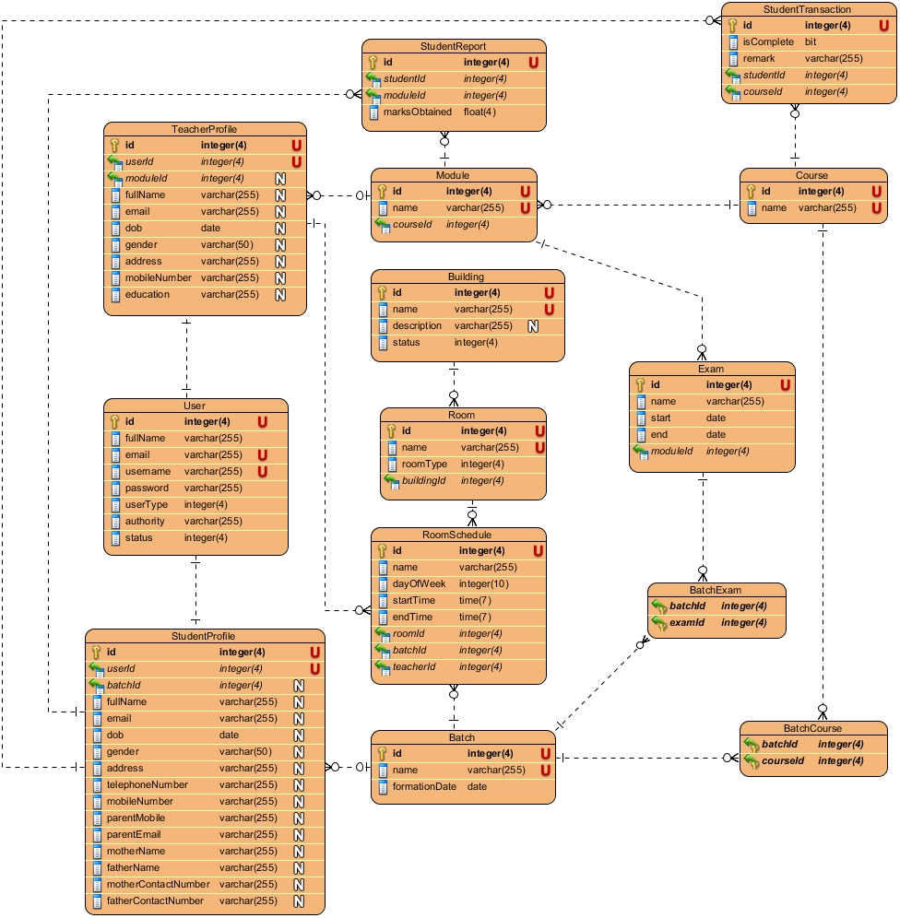

Img 16-ER Diagram

Data Dictionary

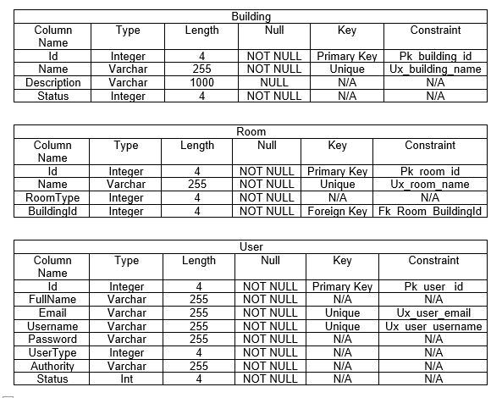

Img 17-Data Dictionary of Building, Room, User tables

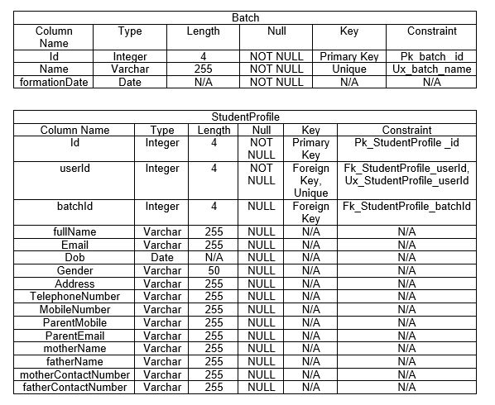

Img 18-Data Dictionary of Batch, Student Profile table

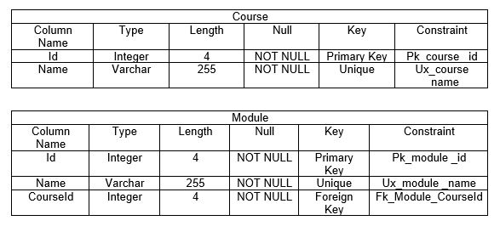

Img 19-Data Dictionary of Course, Module table

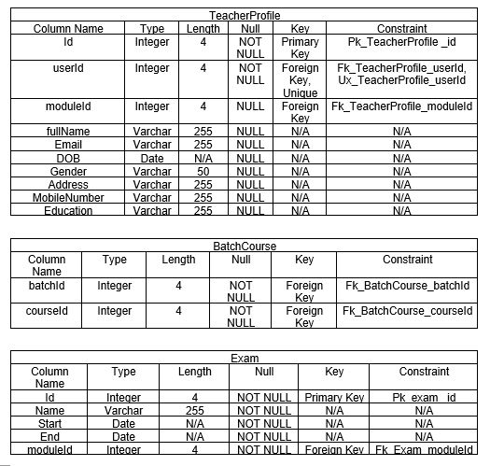

Img 20-Data Dictionary of TeacherProfile, BatchCourse, Exam tables

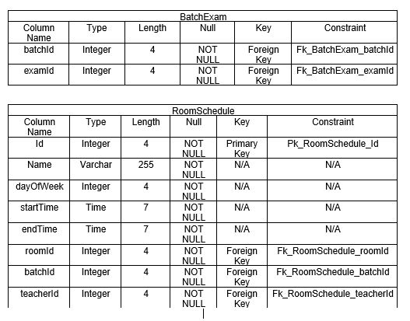

Img 21-Data Dictionary of BatchExam, RoomSchedule tables

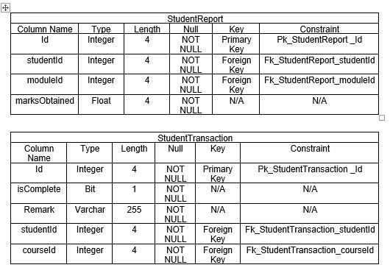

Img 22-Data Dictionary of StudentReport, StudentTransaction tables

Architectural Modelling

Definition

An architecture model is a partial abstraction of a system. It is an approximation, and it captures the different properties of the system. It is a scaled-down version and is built with all the essential details of the system. (ScienceDirect, 2018)

Justification

The reasons for approaching this modelling methodology are mentioned below:

* It helps to easily identify the characteristics of the system and model it.
* It helps to visualize the information with the help of models.
* The basic knowledge of the system can be extracted from this modelling methodology.

Notations used

The notations used for this modelling are tabulated below:

|  |  |  |
| --- | --- | --- |
| Name | Notation | Description |
| Component |  | This notation represents the components of the system. It is generalization of various others components like class, interface, services, repositories. |
| Database |  | This notation represents the database used by the system. |
| Data/Process Flow |  | This notation represents the program flow. |

Actual Diagram

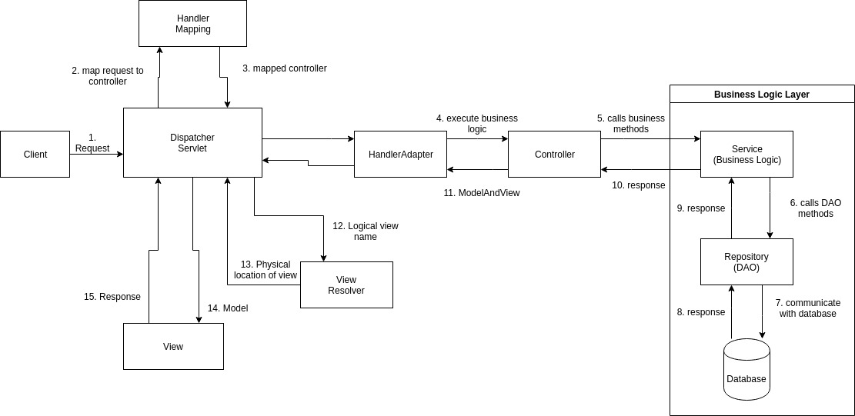

Img 23-Architectural Model

Diagram Description

The request of the client is handled by the DispatcherServlet, then appropriate controller is selected by HandlerMapping where the request URL is mapped and finally it returns the controller. DispatcherServlet forwards the process to HandlerAdapter where it calls Controller for executing the business logic. Controller executes the business logic. Business logic are implemented in different layers: Service layer, Repository layer or Data Access Object and the database. After the controller finishes executing business logic, it sets the result in Model and returns the logical view name to DispatcherServlet. With the application of ViewResolver, the physical page is returned into the view. Ultimately, the view is returned as the response.

User Interface Modelling

UI Modelling presents the proposed system with the possible design or layout of the user interface. The user interface is modelling through the prototyping methodology. The prototypes are mentioned below as:

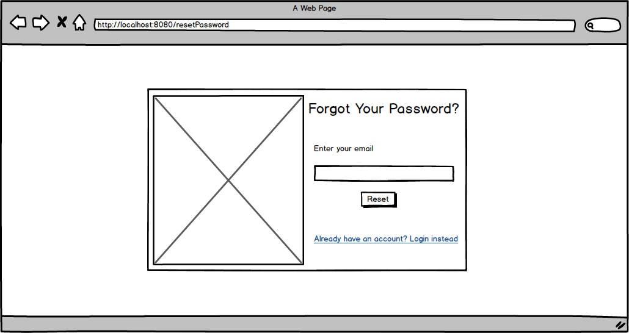

Img 4-Login Page Prototype

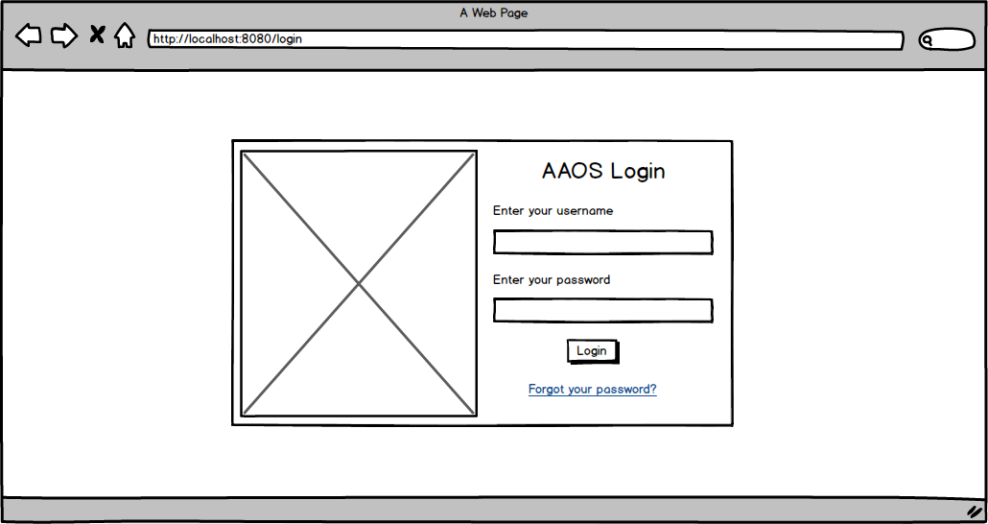

Img 5-Forgot Password Page

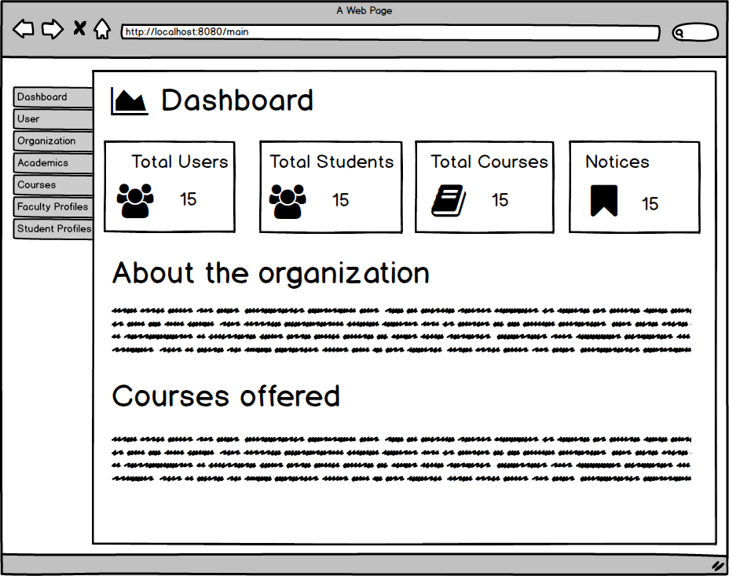

Img 6-Dashboard Page Prototype

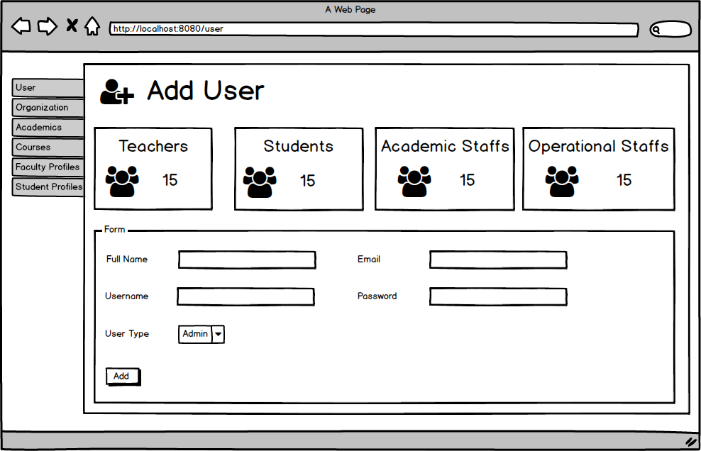

Img 7-Add User Page Prototype

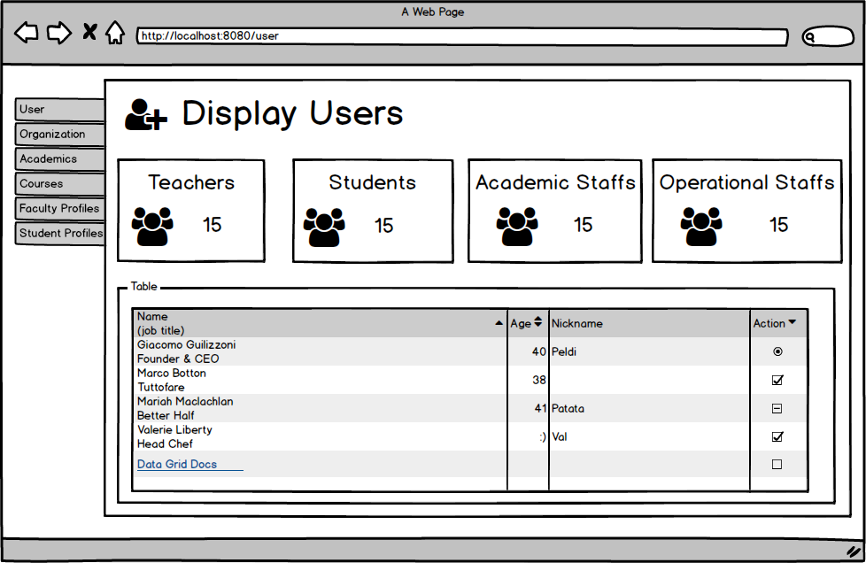

Img 8-Display User Page Prototype

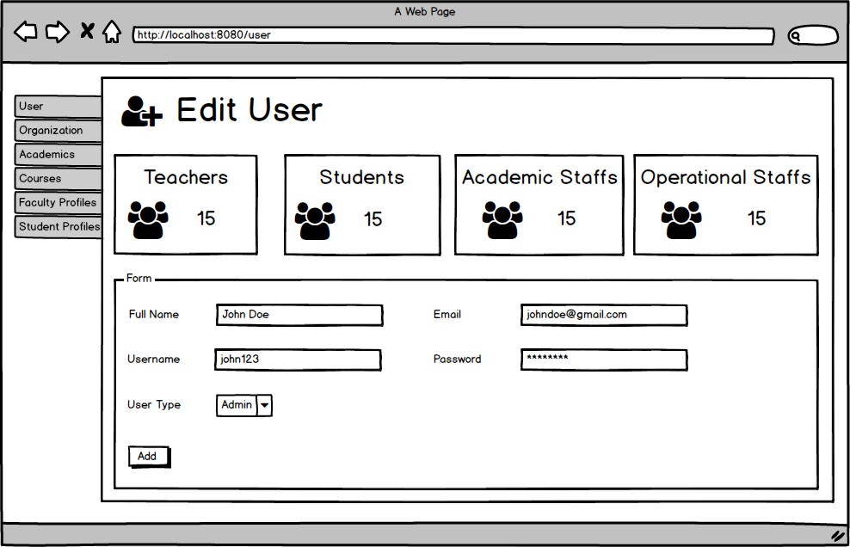

Img 9-Edit User Page Prototype

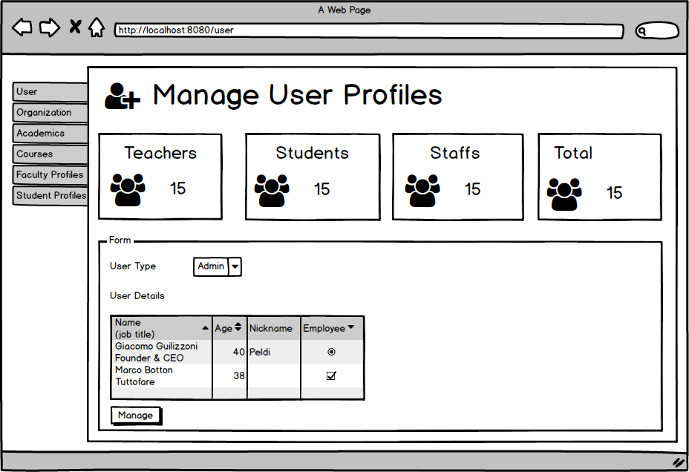

Img 10-Manage User Profile Page Prototype

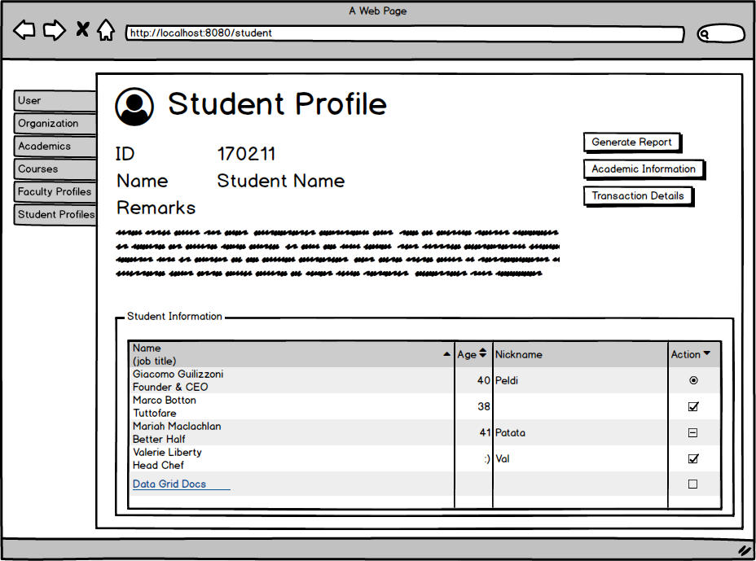

Img 11-Student Profile Page Prototype

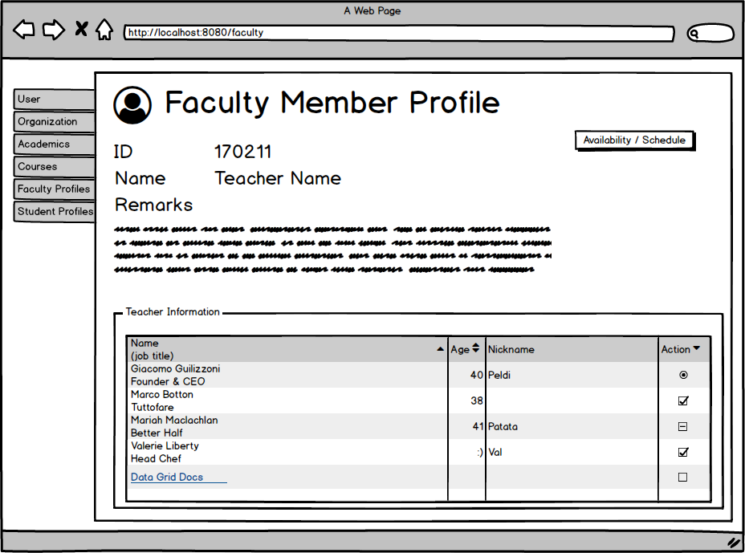

Img 12-Faculty Member Profile Page Prototype

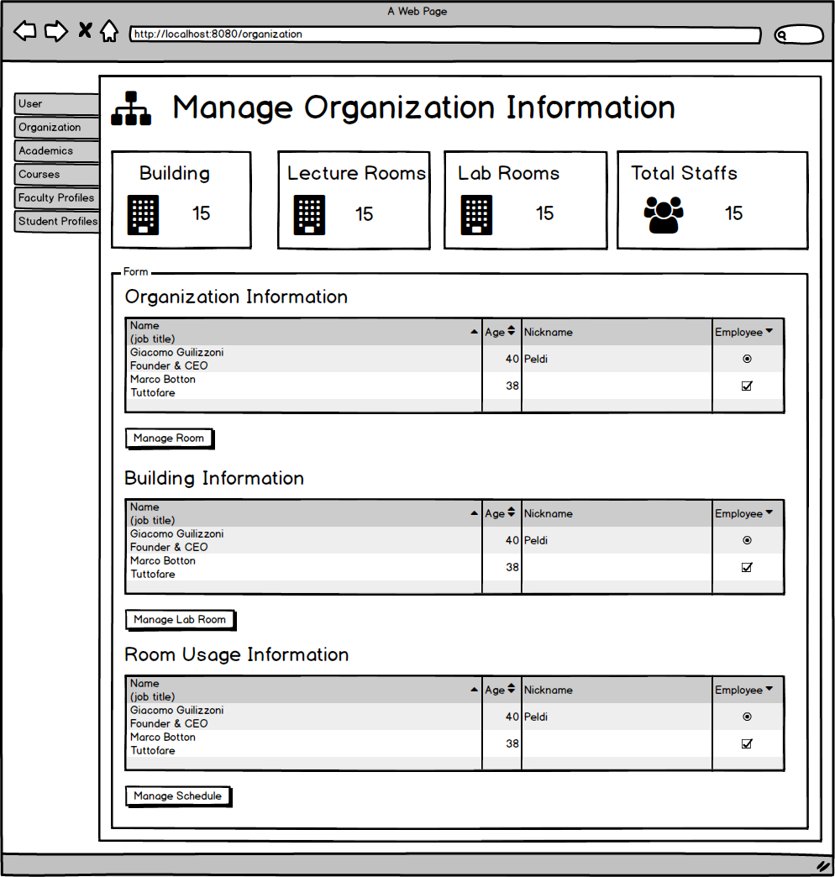

Img 13-Organization Information Page Prototype

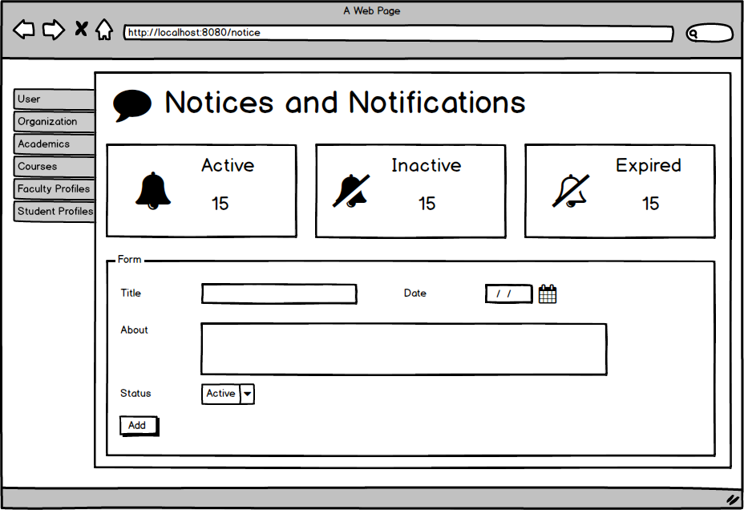

Img 14-Add Notice Page Prototype

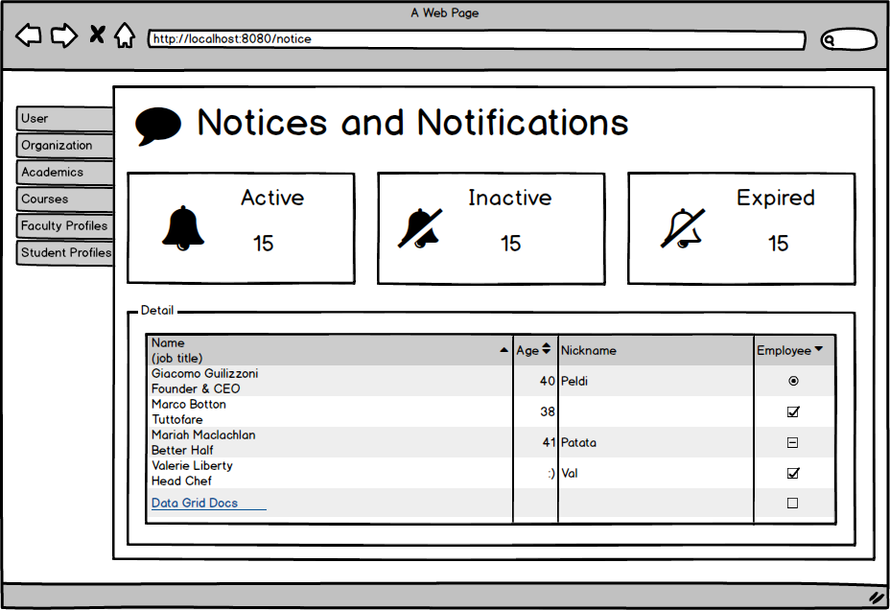

Img 15-Manage Notice Page Prototype