1. Introduction
   1. Project Introduction

**Expense Analyzer** is the android application which will be specifically featured with the collective package of expense tracking system and income tracking system along with their analysis. This application will be useful for every individual who want their financial or budget information to be tracked and analyzed.

* 1. Justification of the project

In the world of smartphones, every daily life transactions or monetary transactions are performed through the use of mobile phones. As per the research, most of the individual who wants to track their expenses still uses traditional spreadsheets. So, to address this problem, I’ve proposed an application which will help in storing the income and expenses information of an individual appropriately and analyze it to generate helpful information.

* + 1. Background of the project

The proposed application is supposed to work for every individual using Android operating system. This application is focused on providing convenient interface to keep their monetary details so that they can go through with their own expense pattern.

* + 1. Problem Statement

Individuals are not well aware about their daily expenses when they think about it later. If they want to recall their monetary transactions, then it gets very difficult to remember every transaction that they have made. So, to address this issue, this android application will provide user with an interface to entry their transaction so that they can view it later.

* 1. Description of the project

Expense Analyzer is proposed to be a mobile application which will provide with the features of web version of Expense Analyzer application. General activity can be automated on the basis of predefined transaction category and data representation can be undertaken effectively. In addition, additional features can be added as the application will be designed in modular way.

* + 1. Features of the project
* Manual Transaction Recording System for individual.
* Tabular representation of periodic expenses made by the individual.
* Centralized Expense Monitoring Application.
* Predefined set of income and expense categories.
* Graphical representation of expenses and income using charts.

1. Scope
   1. Aims of the project

* Build a user friendly mobile application to track daily expense and provide the user with the information of their expense habit on the basis of different categories.
  1. Objectives of the project
* To provide user-friendly interface for entering transactions.
* To provide analyzed data representation of the expenses made.
* To generate reports of the individual expenses and monetary status.
* To provide analyzed information through graphical representation.

1. Development Methodology
   1. Description of the methodology

For the development of the proposed system, the preferred methodology is **Waterfall model.** The Waterfall methodology is preferred because the application is scaled to be a small-scale application where the software development steps should not be strictly iterative to cope with the changing nature of development methodology. However, minor changes can be addressed even with the use of Waterfall methodology.

Waterfall model is linear and sequential life cycle model where development stage forwards only when the previous step gets completed successfully. This model is successful approach for small project. Waterfall model is chosen as appropriate software development model as this application is simple and can fulfill all the requirements.

The stages of waterfall methodology are as shown in the figure below:

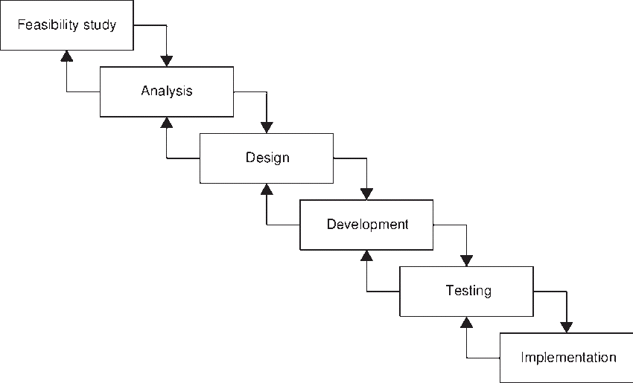

Figure - Waterfall Methodology

* 1. Design pattern

MVC

Model View Controller (MVC) design pattern provides specific software development method and also solve architectural complexities by dividing the complete system into three major divisions: Model consists of the entities that are directly connected to the database, View consists of graphical components such as activity, fragments and Controller is where program logics are implemented.

1. Configuration Management

The complete project directory structure is configured as per various stages of Software Development Lifecycle as shown in the figure below:

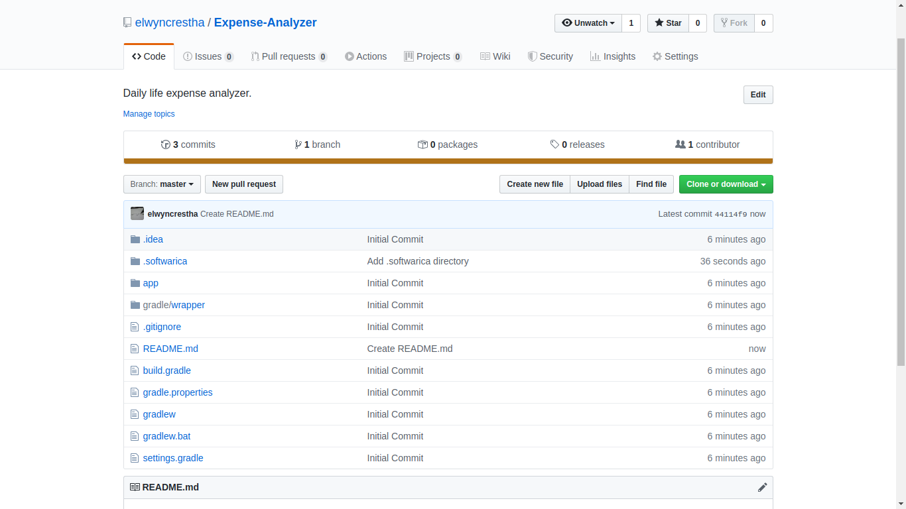

Figure - Configuration Management

The complete project resides in the given directory structure and also pushed in remote repository hosted in GitHub which can be accessed from <https://github.com/elwyncrestha/Epidemic-Analyzer>. The root folder of remote repository provides the implementation codes along with the directory named **.softwarica** where given project documents are stored.

1. Prototyping

The mock-ops were made using **balasamiq.cloud.** Some of the mock-ops are mentioned below as:

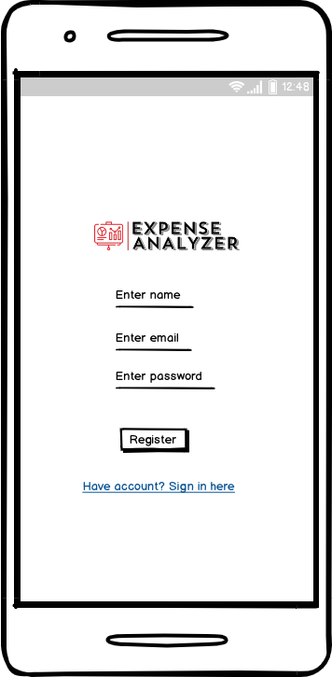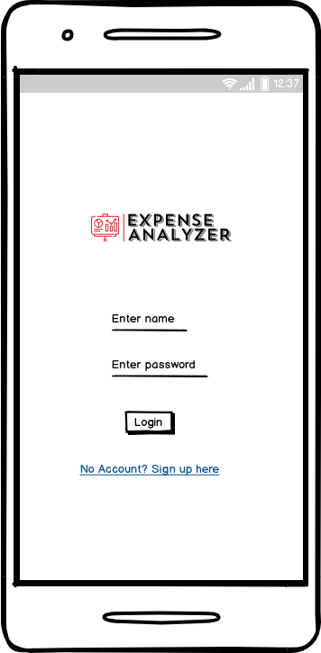

Figure 4 - Registration prototype

Figure 3 - Login prototype

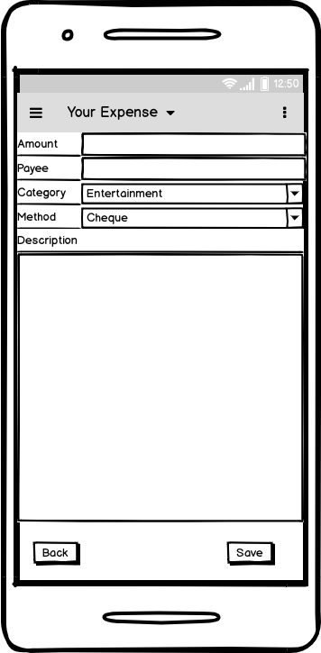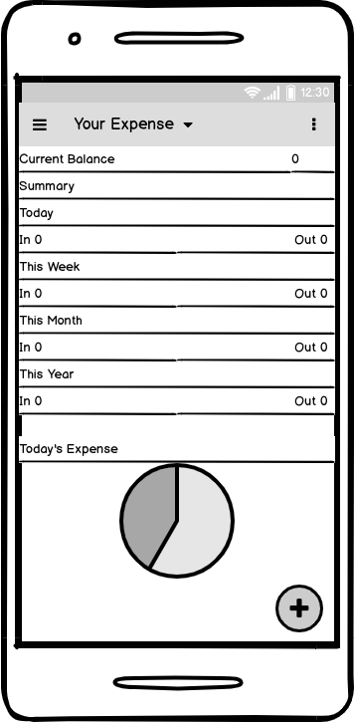

Figure 6 - Entry prototype

Figure 5 - Dashboard prototype

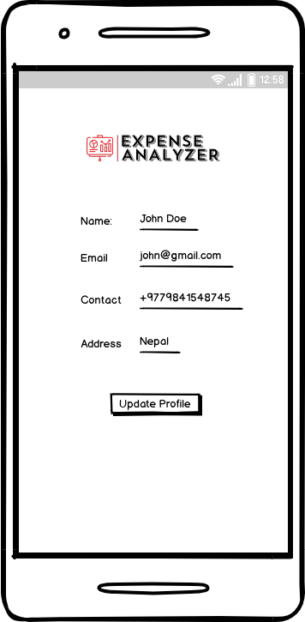

Figure 7 - Profile prototype

1. Conclusion

An Android application has been proposed in this document which will help individual manage their monetary activities effectively with the proper storage and analysis of their data. The proposal is initiated with the problem domain, enlisting all the scopes and coverage of the proposed application. From that the problem statement was identified. With a standard problem statement, scopes were listed along with the limitations. In addition, the development methodology was chosen to cope with the requirements. Ultimately, the project directory structure was discussed briefly in configuration management.