Introduction

International Space Station (ISS) is designed as the management system for ISS program which is a program operated by fifteen international countries tied by a complex set of agreements. This system manages different space center and sub sections located in different part of the world. For the proper management of ISS, software manager can get appropriate report about the missions and events, available crew members, space center and aircrafts.

This management application can be helpful for getting information about the space events, crew member involved in the event. This application will be made using MS Access database and VBA programming provided by Microsoft.

List of main features

* **Space center and department management**

Various space center located in different geographical locations can be viewed. Also, new space center and departments can be added and removed.

* **Crew management**

Information of available crew members including all the workers will be stored and managed properly.

* **Space event management**

A number of possible events will be managed by proper addition of the events. In addition, crew member can be assigned to the events. Furthermore, reports will be generated for all events after completion.

* **Aircraft Management**

Numerous aircraft which are going to be available in different space center will be managed by particular department of that space center.

Aims

The key aim of International Space Station application is to provide qualitative data about all the space events and manage all manpower effectively.

Objectives

I’ve listed major objectives of this project as follows:

* Perform proper planning and requirement analysis
* Appropriate system design including user interface and database
* Accurate development of the required system
* Testing of developed application

Development Methods

Waterfall model is chosen as appropriate software development model as this application is simple and can fulfil all the requirements. Waterfall model is linear and sequential life cycle model where development stage forwards only when the previous step gets completed successfully. This model is successful approach for small project. As ISS application is small application and all the requirements are clear, so Waterfall model is very appropriate.

The major stages of waterfall model is shown in figure 1.

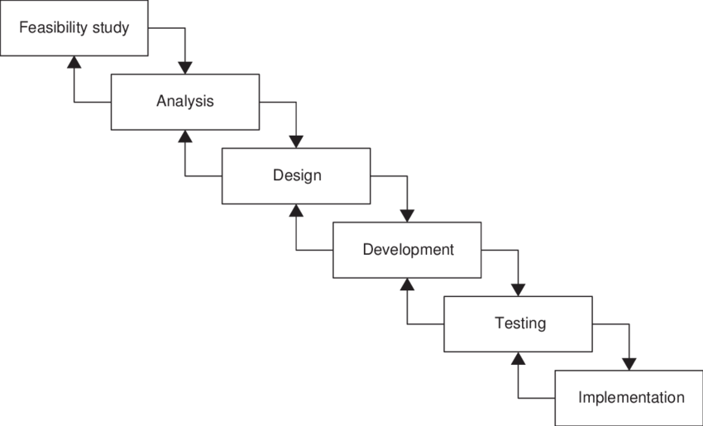

Figure 1 - Waterfall Model

Project Plan

Work Breakdown Structure (WBS)

The project plan is broken down and categorized as shown figure:

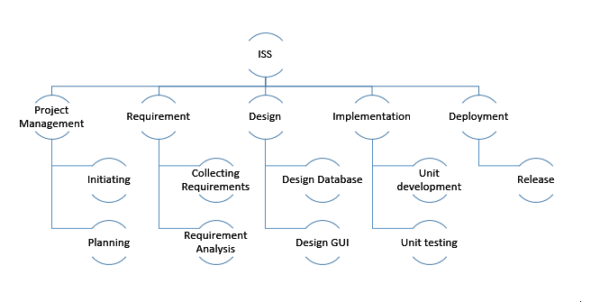

Figure 2 - Work Breakdown Structure

Time estimate

Estimation of time for different stages of the project is as shown in the figure 3.

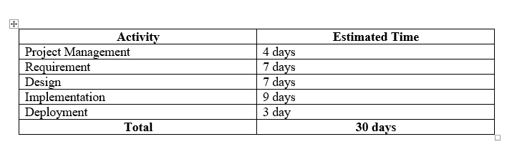

Figure 3 - Time estimation

Schedule

The schedule showing the making of the application is displayed through Gantt Chart.

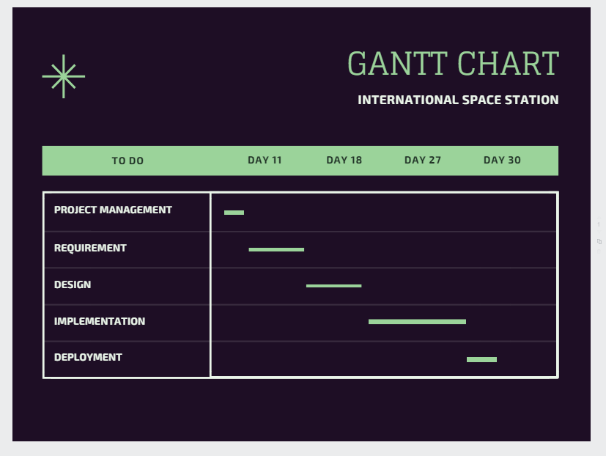

Figure 4 - Gantt Chart

Conclusion

The main motive of the project is to design and develop an application system for International Space Station for manipulating the data and information that flows when different activities are performed in organization like ISS program. All the development process will be strictly followed during the software development stage of this project.