Design Review

Submission Detail | Student Entry
GROUP ID | CSC12
GITHUB REPO LINK | https://github.com/elxShouko/INF2004-Embedded-Systems.git

Team Role and Subsystem Ownership
Identify each buddy’s primary subsystem responsibility. The role does not need to match the examples exactly, but every major hardware and software responsibility should have a clear owner.
Buddy | Student ID | Primary subsystem / responsibility
Tan Yan Ting | 2502699 | WiFi communication, MQTT, command handling, telemetry and connection recovery
Tan Wei You | 2501230 | Motor and encoder control, PID speed control, distance estimation and turning
Lincoln Leong Yuan Hao | 2500734 | IR line following, junction detection, barcode detection and decoding
Eddy Teo Hon Kai | 2501284 | IMU sensing, hump detection/measurement, motion and collision monitoring
Phan Kiah Fong Nicholas | 2501304 | Servo-ultrasonic obstacle scanning, profiling, avoidance and line recovery

1. Requirements
State what the system must do and the important quality or timing constraints. Requirements should be specific, testable, and traceable to the proposed design (you may add more FR and/or NFR as needed).

1.1 Functional Requirements
ID | Functional Requirement
FR1 | The robotic car shall autonomously follow the designated black line using the IR sensing subsystem.
FR2 | The line-following subsystem shall calibrate the IR sensors and estimate the robot's position relative to the line.
FR3 | The robotic car shall detect junctions and directional barcodes encountered along the course.
FR4 | The robotic car shall decode valid barcode commands and generate the corresponding navigation command, including Turn Left, Turn Right, Go Straight, and U-Turn.
FR5 | The motion-control subsystem shall control the left and right motors using wheel-encoder feedback.
FR6 | The motion-control subsystem shall estimate vehicle speed and distance travelled and support controlled straight-line motion and encoder-based turning.
FR7 | The IMU subsystem shall acquire and process motion data to detect vehicle tilt and motion state.
FR8 | The IMU subsystem shall detect hump events, determine a measurable hump-peak value from the IMU data, and retain the highest hump-peak value encountered during the run.
FR9 | The IMU subsystem shall detect and report relevant motion events, including turning and sudden impact/collision events.
FR10 | The ultrasonic sensing subsystem shall perform servo-based scanning to detect obstacles on or near the intended route.
FR11 | When an obstacle is detected, the ultrasonic subsystem shall perform a higher-resolution scan to improve obstacle localisation and profiling.
FR12 | The obstacle subsystem shall estimate relevant obstacle information, including position, width, closest point, and available left/right clearance.
FR13 | The robotic car shall determine and execute an appropriate obstacle-avoidance manoeuvre while avoiding collision.
FR14 | After bypassing an obstacle, the robotic car shall search for and reacquire the original line before resuming normal line-following operation.
FR15 | The communication subsystem shall establish and maintain a 2.4 GHz IEEE 802.11b/g/n Wi-Fi connection with the designated access point upon power-up.
FR16 | The communication subsystem shall publish vehicle telemetry frames over MQTT to designated topics at a configurable period of 100ms +- 10ms.
FR17 | The communication subsystem shall format outgoing telemetry payloads as serialised JSON objects containing timestamp (ms since boot), robot_state, left_motor_speed, right_motor_speed, left_encoder_count, right_encoder_count, line_status, hump_peak, and obstacle_distance.
FR18 | The communication subsystem shall subscribe to an MQTT command topic and forward incoming remote override messages (e.g. EMERGENCY_STOP, START_RUN, PAUSE) to the Vehicle Controller task queue within 50ms of arrival.
FR19 | The communication subsystem shall detect network disconnects and attempt automatic reconnection with exponential backoff (1s, 2s, 4s, up to 8s) without blocking motor control or navigation tasks.
FR20 | The communication subsystem shall publish a periodic Heartbeat frame (status: ALIVE, uptime_ms) to the MQTT status topic every 1000ms +- 50ms.
FR21 | The vehicle controller shall coordinate navigation, motion, sensing, obstacle handling, terrain monitoring, and telemetry according to the current mission state.

1.2 Non-Functional Requirements
ID | Non-Functional Requirement
NFR1 | The robotic car shall not depend on external computation or continuous operator input during an autonomous run.
NFR2 | The line-following subsystem shall maintain reliable operation under minor lighting changes, slight track imperfections, and variations in vehicle speed.
NFR3 | The motion-control subsystem shall provide consistent speed, accurate distance control, repeatable turning, and stable vehicle motion after calibration.
NFR4 | Barcode recognition shall remain reliable over the range of operating speeds used during normal autonomous navigation.
NFR5 | The IMU subsystem shall provide reliable hump detection, stable motion-event classification, and consistent peak-hump measurement.
NFR6 | The obstacle subsystem shall provide reliable obstacle detection, profiling, avoidance, and successful line reacquisition after an avoidance manoeuvre.
NFR7 | Inbound MQTT commands shall be processed and dispatched to the target internal queue within <= 50ms of network arrival.
NFR8 | Telemetry transmission shall achieve >= 98% successful frame delivery over a continuous 5-minute mission run under standard laboratory network conditions.
NFR9 | A complete Wi-Fi signal loss or broker disconnection shall consume <= 5% CPU utilization and shall not delay higher-priority RTOS execution by > 2ms.
NFR10 | The size of individual outgoing telemetry JSON payloads shall not exceed 256 Bytes.
NFR11 | The software shall be implemented in C using the Pico C SDK and µT-Kernel RTOS on the Raspberry Pi Pico / Robo Pico platform.
NFR12 | Embedded software shall conform to the required Barr C Coding Standard and the provided project repository structure.
NFR13 | Subsystems shall use clearly defined interfaces so that individual modules can be developed, tested, debugged, and integrated independently.
NFR14 | The software shall make prudent use of processor time, memory, communication bandwidth, and power due to the resource-constrained embedded platform.
NFR15 | The final system shall operate as one coordinated vehicle, with subsystem data and commands exchanged consistently through the integrated architecture.

2. Hardware Integration Pin Layout
Sketch how sensors, actuators, displays, communication modules, and power connections interface with the Robo Pico. Label pins and interfaces such as GPIO, ADC, PWM, I2C, SPI, and UART.

Device / Module | Type | Signal Name | Module Label / Connection | Pico GPIO Pin | Interface | Notes / RTOS Task Owner
Left DC Motor | Actuator | M1A, M1B | Motor 1 terminal | GP8, GP9 | Motor driver / PWM GPIO | Buddy 2 – Motion Control Task
Right DC Motor | Actuator | M2A, M2B | Motor 2 terminal | GP10, GP11 | Motor driver / PWM GPIO | Buddy 2 – Motion Control Task
Left Wheel Encoder | Sensor | Encoder A / B | Grove 7 | GP7, GP28 | GPIO digital input / interrupt | Buddy 2 – Encoder / Motion Control Task
Right Wheel Encoder | Sensor | Encoder A / B | Grove 1 | GP0, GP1 | GPIO digital input / interrupt | Buddy 2 – Encoder / Motion Control Task
IR Line Sensor 1 | Sensor | Line detection | D0 / DOUT, Grove 2 | GP2 | GPIO digital input | Buddy 3 – Line / Barcode Task
IR Line Sensor 2 | Sensor | Line detection | D0 / DOUT, Grove 3 | GP4 | GPIO digital input | Buddy 3 – Line / Barcode Task
IR Barcode Sensor | Sensor | Barcode detection | D0 / DOUT, Grove 6 | GP27 | GPIO digital input | Buddy 3 – Line / Barcode Task
LSM303DLHC IMU | Sensor | SDA | SDA, Grove 4 | GP16 | I²C SDA | Buddy 4 – IMU / Terrain Task
LSM303DLHC IMU | Sensor | SCL | SCL, Grove 4 | GP17 | I²C SCL | Buddy 4 – IMU / Terrain Task
HC-SR04 Ultrasonic | Sensor | Trigger | TRIG, Grove 5 | GP26 | GPIO output | Buddy 5 – Obstacle Monitor / Handling Task
HC-SR04 Ultrasonic | Sensor | Echo | ECHO, Grove 5 | GP6 | GPIO input | Buddy 5 – FObstacle Monitor / Handling Task
Ultrasonic Servo | Actuator | Servo PWM | Servo signal header | GP12–GP15, exact servo port to confirm | PWM GPIO | Buddy 5 – Obstacle Handling Task
Pico W WiFi | Communication | WiFi / MQTT | On-board CYW43 | Internal | WiFi | Buddy 1 – WiFi Telemetry & Command Task
Robo Pico Power | Power | VIN / Battery | VIN / LiPo | Board power input | Power | Shared system power
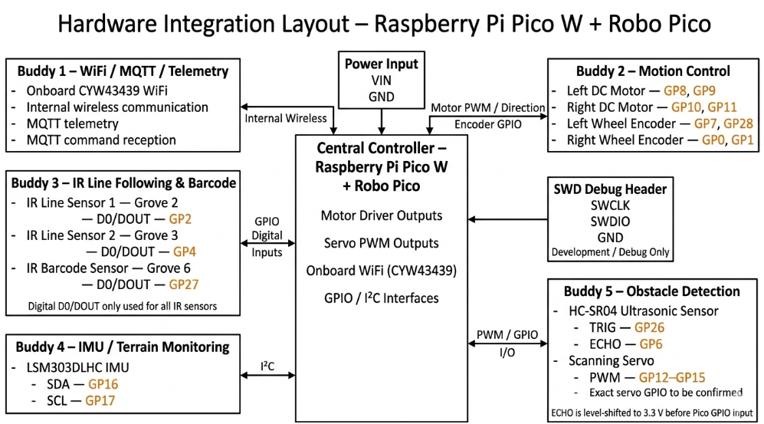

3. RTOS Task Table
List the proposed RTOS tasks. Priorities are preliminary at Week 6 and must be justified.

Task | Purpose | Inputs | Outputs | Trigger | Priority
Wi-Fi Telemetry & Command Task – Buddy 1 | Network Initialization & Liveness: Establish non-blocking Wi-Fi AP association and MQTT socket connection; monitor keepalive status and execute non-blocking exponential backoff recovery (1s - 8s) upon signal loss.  Telemetry Aggregation & Streaming: Collect telemetry from internal queues (speed, encoders, line sensors, etc), serialize into JSON payloads (<= 256 bytes), and publish to robot/telemetry every 100 ms +- 10ms.  Command Processing: Parse incoming remote MQTT control commands (e.g. EMERGENCY_STOP) and dispatch parsed tokens to the VehicleController Queue within <= 50 ms.  Heartbeat Reporting: Emit a periodic status frame (status: ALIVE, uptime) to robot/status every 1000 ms += 50 ms for subsystem liveness tracking | System Telemetry Queue (from Buddies 2 - 5), inbound MQTT command socket payloads (robot/cmd), CYW43 Wi-Fi connection state flags | MQTT JSON telemetry frames, periodic heartbeat frames, parsed command structs -> VehicleController Queue | Periodic (100 ms) + Event-driven (Network Rx) | Low
Motion Control Task – Buddy 2 | Performs closed-loop control of the left and right drive motors using wheel-encoder feedback. It calculates wheel speed and travelled distance, executes PID speed regulation, corrects straight-line motion, and performs controlled forward movement and encoder-based turning. It also handles motion completion and stop requests from the Mission Controller. | Left/right encoder counts, requested target speed, requested distance, requested turn direction/angle, stop command, mission motion request | Left/right motor PWM and direction signals, estimated wheel speed, travelled distance, motion status, manoeuvre-complete event | Periodic control loop, with event-driven motion commands from the Mission Controller | Very High
Line & Barcode Task – Buddy 3 | Sample and process the three IR sensors for line-position estimation, line following, junction detection, and barcode decoding. | Left, centre and right IR sensor values | Line position/status, barcode result, navigation command | Periodic | High
IMU / Terrain Task – Buddy 4 | Acquire and process IMU data for tilt, hump detection, peak measurement, turning detection, heading-change monitoring, and motion/collision events. | LSM303DLHC accelerometer / motion data | Hump status, peak measurement, tilt/motion events, collision event | Periodic | Medium–High
Obstacle Monitor Task – Buddy 5 | Measure forward distance, detect obstacles, and trigger detailed obstacle handling when needed. | HC-SR04 Echo timing | Distance measurement, obstacle-detected event | Periodic | High
Obstacle Handling Task – Buddy 5 | Perform servo-based scanning, obstacle profiling, avoidance decision generation, and line-recovery coordination. | Obstacle event, ultrasonic measurements, servo position, vehicle state | Obstacle profile, avoidance request, recovery status | Event-driven | Medium–High
Mission Controller Task – Shared / Integration | Maintain the overall vehicle mission state and coordinate navigation, motion, obstacle handling, terrain events, and subsystem transitions. | Navigation commands, line status, obstacle events, IMU events, motion status | Motion requests, subsystem mode/state commands, telemetry state updates | Event-driven / periodic supervisory execution | High

Priority and ownership justification:
The WiFi & Telemetry Task (Buddy 1) is assigned Low Priority because communication, MQTT publishing, heartbeat reporting, and reconnection are not timing-critical compared with vehicle control. Delays in telemetry are acceptable, whereas delays in motor control or line tracking could directly affect navigation stability.
The Motion Control Task (Buddy 2) is assigned Very High Priority because it executes the vehicle’s closed-loop motor-control functions. Encoder feedback must be sampled and processed at a predictable rate so that PID speed regulation, straight-line correction, distance control, and turning remain stable and repeatable. Excessive scheduling delay or jitter could cause inaccurate movement, unstable speed control, missed stopping points, or incorrect turning angles. For this reason, the Motion Control Task should pre-empt lower-priority tasks such as telemetry, IMU processing, or obstacle profiling when necessary. However, the task should remain short and deterministic and should avoid blocking operations so that other time-critical tasks, such as line sensing and obstacle monitoring, can still execute promptly.
The Line & Barcode Task (Buddy 3) is assigned High Priority because line position must be updated continuously while the vehicle is moving. Delayed IR sensor processing could cause the robot to deviate from the track or miss a junction/barcode. Barcode decoding is handled within the same subsystem because Buddy 3 owns both line sensing and barcode navigation processing.
The IMU / Terrain Task (Buddy 4) is assigned Medium–High Priority because IMU measurements must be processed regularly for hump detection, peak measurement, turn-rate monitoring, and motion/collision events, but these functions are generally less timing-critical than the motion-control loop and line-following feedback.
The Obstacle Monitor Task (Buddy 5) is assigned High Priority because obstacles must be detected early enough for the system to respond before collision. The Obstacle Handling Task is assigned Medium–High Priority because detailed scanning, profiling, avoidance planning, and line-recovery processing occur only after an obstacle event has been detected. Buddy 5 owns ultrasonic sensing and servo scanning so that one subsystem is responsible for interpreting obstacle data consistently, while actual motor actuation remains under Buddy 2's Motion Control subsystem to avoid conflicting motor commands.
The Mission Controller Task is assigned High Priority because it coordinates state transitions and resolves requests from navigation, obstacle handling, terrain monitoring, and motion subsystems. It should respond promptly to important events, but it should not pre-empt the timing-critical Motion Control Task.

4. Task Interaction Diagram
Show RTOS tasks, queues, semaphores, mutexes, event groups, notifications, and data flow. Clearly distinguish software tasks from hardware devices and interrupt service routines.
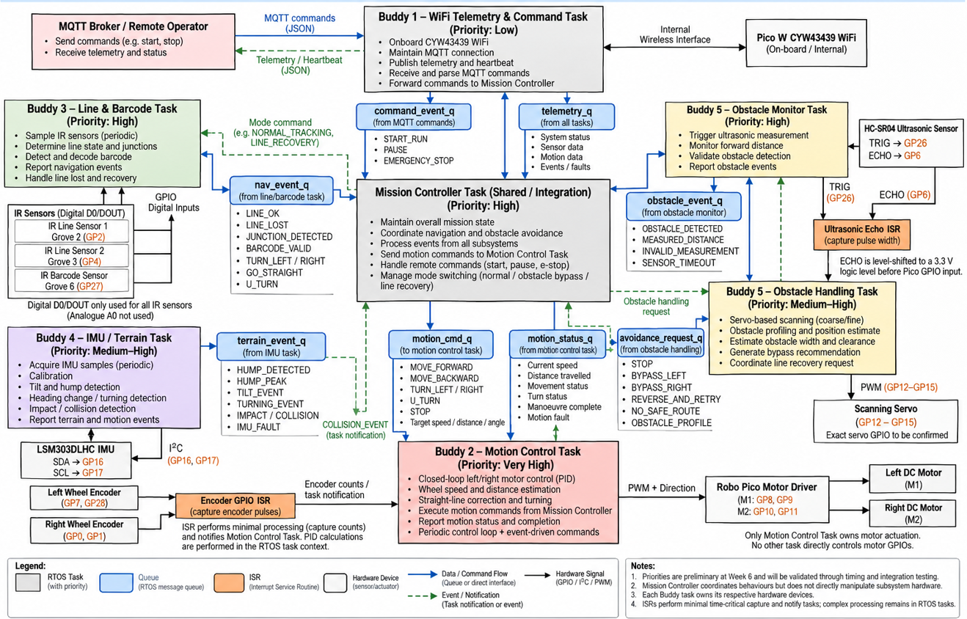
Brief explanation of the main communication paths:
The Mission Controller Task is the central coordination point of the system. It receives navigation events from Buddy 3, terrain and collision events from Buddy 4, obstacle events and avoidance requests from Buddy 5, motion status from Buddy 2, and remote command events from Buddy 1. It then issues movement requests to the Motion Control Task – Buddy 2 through motion_cmd_q and coordinates subsystem operating modes such as normal tracking, obstacle bypass, and line recovery.

The Line & Barcode Task – Buddy 3 reads the three digital IR inputs, processes line status, junctions, and barcode information, and sends validated navigation events through nav_event_q to the Mission Controller. It also reports LINE_LOST and LINE_FOUND during line-recovery operations. Buddy 3 does not directly actuate the motors.

The Motion Control Task – Buddy 2 receives motion commands through motion_cmd_q. Wheel-encoder signals are captured through the Encoder GPIO ISR, which performs minimal interrupt processing and provides encoder counts or task notifications to the Motion Control Task. The task then performs closed-loop speed, distance, straight-line, and turning control and drives the Robo Pico motor driver using PWM and direction signals. Motion state, distance, speed, faults, and manoeuvre-complete information are returned to the Mission Controller through motion_status_q and completion events. Buddy 2 is the only subsystem permitted to directly actuate the drive motors.

The IMU / Terrain Task – Buddy 4 communicates with the LSM303DLHC over I²C, processes tilt, hump, heading-change, and impact information, and sends terrain events to the Mission Controller through terrain_event_q. Critical impact or collision conditions may also generate a direct task notification so that the Mission Controller can initiate a safe-stop response.

The Obstacle Monitor Task – Buddy 5 periodically triggers the HC-SR04 and receives ECHO timing through the Ultrasonic Echo ISR. Validated obstacle information is sent to the Mission Controller through obstacle_event_q. When detailed handling is required, the Obstacle Handling Task performs servo-based scanning and obstacle profiling, then sends an avoidance_request_q message containing the recommended bypass action. The Mission Controller converts the approved manoeuvre into a normal motion request for Buddy 2, so Buddy 5 never directly controls the drive motors.

The WiFi Telemetry & Command Task – Buddy 1 collects subsystem and mission information through telemetry_q and publishes JSON telemetry and heartbeat messages to the MQTT broker. Incoming commands such as START_RUN, PAUSE, and EMERGENCY_STOP are parsed and forwarded to the Mission Controller through command_event_q. Temporary WiFi or MQTT loss is handled within Buddy 1 without blocking the timing-critical navigation and motor-control tasks.

5. System-Level Statechart
Model the operating states of the entire system. Label transition events or conditions. Include relevant fault, stop, or recovery behaviour.
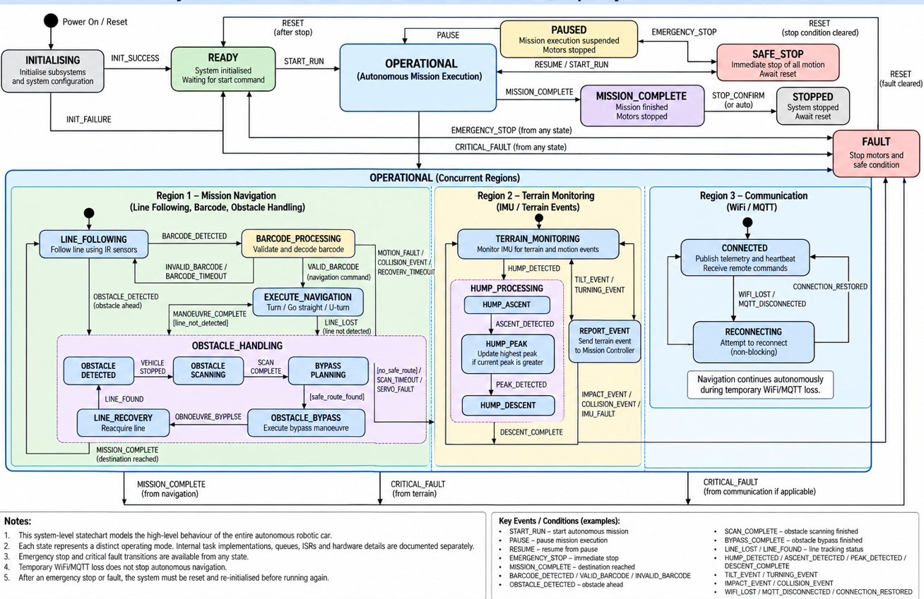
Explain the main states and any important assumptions:
The system begins in INITIALISING, where the controller, sensors, motor interfaces, communication functions, and RTOS resources are prepared. If initialisation succeeds, the system enters READY and waits for START_RUN; if initialisation fails, the system transitions to FAULT. From READY, an EMERGENCY_STOP causes a transition to SAFE_STOP, while a critical fault causes a transition to FAULT.

During OPERATIONAL mode, the system contains three concurrent regions: Mission Navigation, Terrain Monitoring, and Communication. In the Mission Navigation region, the system normally operates in LINE_FOLLOWING. Detection of a barcode causes a transition to BARCODE_PROCESSING, followed by EXECUTE_NAVIGATION when a valid barcode is decoded. Once the manoeuvre is complete, the system returns to LINE_FOLLOWING if the line is detected, or enters LINE_RECOVERY if the line must be reacquired. An obstacle causes the system to enter the obstacle-handling sequence: OBSTACLE_DETECTED → OBSTACLE_SCANNING → BYPASS_PLANNING → OBSTACLE_BYPASS → LINE_RECOVERY. Normal line following resumes only after LINE_FOUND. If no safe route is available, scanning fails, or recovery times out, the system enters FAULT.

The Terrain Monitoring region runs in parallel with navigation. It continuously monitors IMU-derived terrain and motion events. When a hump is detected, the system enters HUMP_PROCESSING, progressing through HUMP_ASCENT, HUMP_PEAK, and HUMP_DESCENT before returning to TERRAIN_MONITORING. At HUMP_PEAK, the current hump-peak measurement is compared with the highest value recorded during the run. Tilt and turning events are reported without interrupting normal navigation, while serious impact, collision, or IMU faults cause a transition to FAULT.

The Communication region also runs concurrently. In CONNECTED, the system publishes telemetry and heartbeat data and receives supported MQTT commands. If WiFi or MQTT connectivity is lost, it enters RECONNECTING and attempts non-blocking reconnection. Autonomous navigation continues during temporary communication loss, and the system returns to CONNECTED once the connection is restored.

A PAUSE command moves the system from OPERATIONAL to PAUSED, where mission execution is suspended and the motors are stopped safely. RESUME or START_RUN returns the system to OPERATIONAL. An EMERGENCY_STOP from an active state causes immediate transition to SAFE_STOP, where all drive motion is stopped and autonomous movement cannot resume until the stop condition is cleared and the system is reset.

When the course is completed, the system transitions from OPERATIONAL to MISSION_COMPLETE, then to STOPPED. Any critical condition that could compromise safe motion—including collision, motion fault, unrecoverable line loss, obstacle-handling failure, or subsystem fault—causes the system to enter the top-level FAULT state, where the motors are stopped and the vehicle is placed in a safe condition. Recovery from FAULT requires the fault to be cleared and the system to be reset back through INITIALISING rather than resuming directly into autonomous operation.

The main assumptions are that temporary WiFi/MQTT loss does not stop autonomous navigation, transition events are processed deterministically, line reacquisition must succeed before normal line following resumes, emergency stop never automatically resumes motion, and any fault that could compromise safe vehicle movement results in a safe motor stop.

6. Subsystem Statecharts

6.1 Subsystem Statechart 1
Field | Student Entry
Subsystem name | Adaptive Ultrasonic Obstacle Detection and Avoidance
Related RTOS task(s) | Obstacle Monitor Task – Buddy 5; Obstacle Handling Task – Buddy 5
Purpose | Detect obstacles using the HC-SR04 ultrasonic sensor, perform servo-based obstacle scanning and profiling, determine available clearance, generate an avoidance request, and coordinate recovery to the original line after bypassing the obstacle.
Reason a statechart is needed | The subsystem contains sequential and event-driven behaviour including continuous monitoring, detection validation, vehicle stopping, obstacle scanning, profile generation, bypass planning, avoidance execution, and line recovery. A statechart clearly defines the events and conditions that control transitions between these behaviours and the response to sensor or recovery failures.

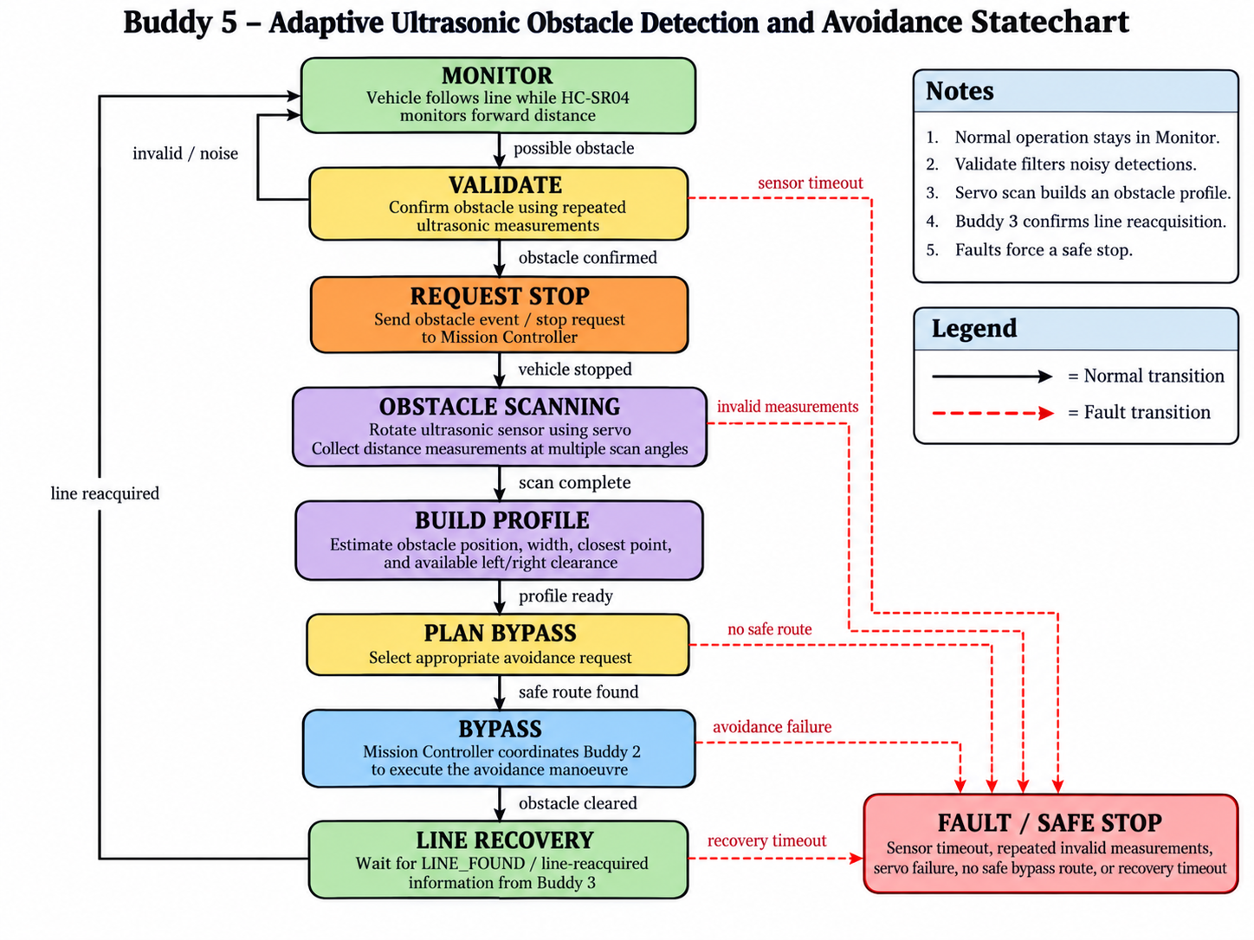
Brief explanation of states, events, and fault handling:
The subsystem normally remains in the MONITOR state while the vehicle follows the line. The Obstacle Monitor Task periodically measures the forward distance using the HC-SR04 ultrasonic sensor. When a possible obstacle is detected, the subsystem enters VALIDATE, where repeated measurements are used to reject isolated or noisy readings. If the obstacle is confirmed, an obstacle event is sent to the Mission Controller and the vehicle is requested to stop.
Once the vehicle has stopped, the Obstacle Handling Task enters OBSTACLE SCANNING and controls the scanning servo to obtain ultrasonic measurements at multiple angles. The measurements are processed in BUILD PROFILE to estimate the obstacle position, approximate width, closest point, and available left and right clearance. In PLAN BYPASS, the subsystem generates an appropriate avoidance request and sends it to the Mission Controller.
The actual motor manoeuvre is performed by Buddy 2 under Mission Controller coordination during BYPASS, ensuring that Buddy 5 does not directly control the drive motors. After the obstacle has been cleared, the subsystem enters LINE RECOVERY and waits for line-reacquisition information from Buddy 3. Once the original line is detected, normal obstacle monitoring resumes. Sensor timeouts, repeated invalid measurements, servo failure, inability to identify a safe bypass route, or line-recovery timeout cause the subsystem to request a FAULT / SAFE STOP condition.

6.2 Subsystem Statechart 2
Field | Student Entry
Subsystem name | Wi-Fi Communication, Command and Telemetry Subsystem
Related RTOS task(s) | Wi-Fi Telemetry & Command Task – Buddy 1
Purpose | Manage network association, maintain MQTT broker connection liveness, stream telemetry data, process remote control operations, and handle automatic link recovery without blocking navigation.
Reason a statechart is needed | Wireless communication involves multi-stage initialization (AP join -> IP assigned -> MQTT connected) and non-deterministic network drops.  A statechart guarantees clear recovery behavior, defined timeout logic, and non-blocking state transitions.

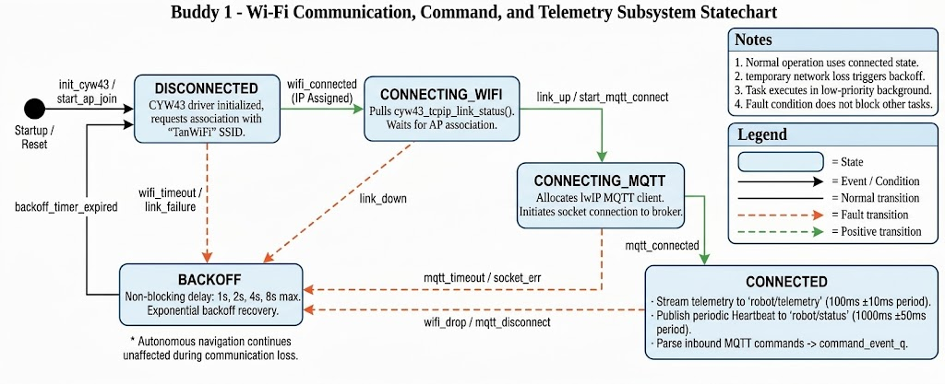
Brief explanation of states, events, and fault handling:
DISCONNECTED (Initialization): Upon system boot or hard reset, the subsystem enters DISCONNECTED. The CYW43439 Wi-Fi hardware is powered on, initialized via the Pico C SDK, and configured for STA (Station) mode with static IP parameters.
CONNECTING_WIFI (AP Association): The state machine triggers an asynchronous, non-blocking Wi-Fi association request to the designated 2.4 GHz Access Point. It polls the connection status via cyw43_tcpip_link_status(). If successful (CYW43_LINK_UP), it transitions to CONNECTING_MQTT. If the link fails or times out, it moves to BACKOFF.
CONNECTING_MQTT (Broker Socket Handshake): Once IP connectivity is established, the subsystem allocates an IwIP MQTT client and initiates an asynchronous TCP connection to the Mosquitto broker. Upon receiving an MQTT_CONNECT_ACCEPTED status in the connection callback, it subscribes to robot/cmd and transitions to CONNECTED. If socket establishment times out (ERR_TIMEOUT) or fails, it transitions to BACKOFF.

CONNECTED (Operational Streaming & Ingestion): In this primary state, the task executes three concurrent responsibilities:
- Telemetry Streaming: Collects system telemetry from internal queues, serializes it into a JSON String (<= 256 bytes), and publishes it to robot/telemetry every 100ms +- 10ms.
- Heartbeat Reporting: Emits a periodic status frame({“status”:”ALIVE”,”uptime_ms:...}) to robot/status every 1000ms +- 50ms.
- Command Processing: Receives inbound MQTT commands (e.g. EMERGENCY_STOP), parses the payload, and pushes the tokenized commands to command_event_q for Mission Controller handling with <= 50ms.
BACKOFF (Fault Recovery & Uninterrupted Navigation): If a Wi-Fi disconnect occurs of the MQTT broker connection drops, the subsystem enters BACKOFF. It executes a non-blocking exponential back-off sequence (1s->2s->4s->8s delay cap) before re-attempting connection from DISCONNECTED.
Fault Handling & Isolation Principle
Crucially, the communication task operates at a Low RTOS priority. During network loss or while residing in BACKOFF, the network state polling consumes <= 5% CPU utilization and never blocks execution. Autonomous navigation (handled by higher-priority tasks like Motion Control and Line Following) continues running safely and independently during temporary Wi-Fi or MQTT signal loss.

6.3 Subsystem Statechart 3
Field | Student Entry
Subsystem name | IR Line Following and Barcode Navigation
Related RTOS task(s) | Line & Barcode Task
Purpose | Calibrate and read the three IR sensors, estimate the vehicle’s position relative to the line, detect junctions and barcodes, and report line status and navigation commands to the Mission Controller.
Reason a statechart is needed | The subsystem changes between calibration, normal line tracking, barcode decoding, waiting for a navigation manoeuvre, and line recovery. A statechart defines when commands are issued, how invalid readings are handled, and when the Mission Controller must respond to line loss or sensor failure.

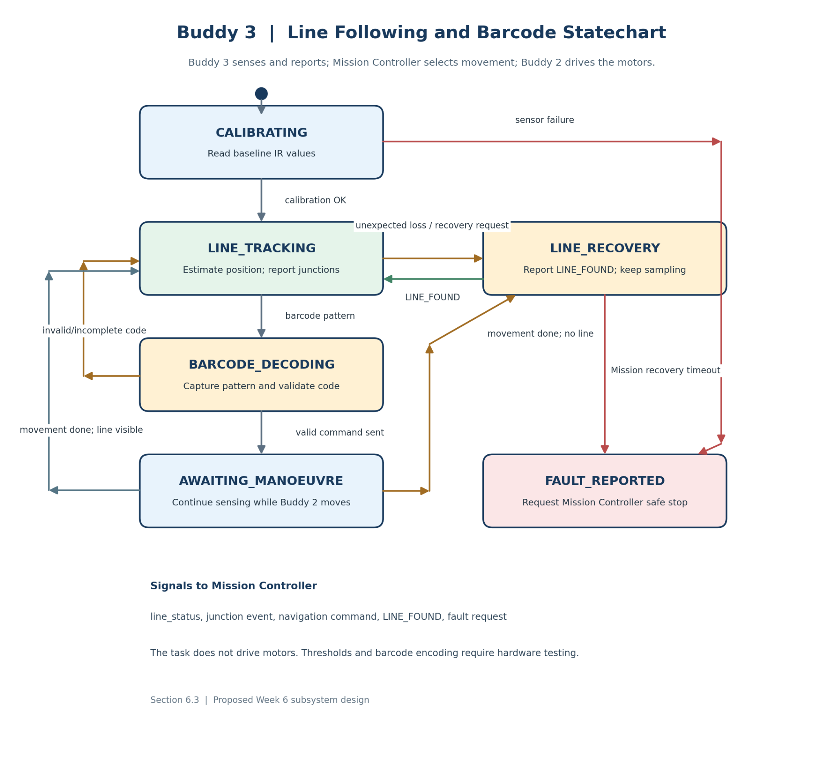
Brief explanation of states, events, and fault handling:
On startup, the Line & Barcode Task calibrates the three IR sensors before entering LINE_TRACKING. During normal operation, it repeatedly reads the sensors, estimates the vehicle’s position relative to the line, and reports line status and detected junctions to the Mission Controller. When it detects a barcode pattern, it enters BARCODE_DECODING to capture and validate the complete code. A valid code is sent as a navigation command to the Mission Controller; an invalid or incomplete code is reported without issuing a turn command.
After sending a valid command, the task enters AWAITING_MANOEUVRE but continues reading the IR sensors while the Mission Controller coordinates movement through Buddy 2’s Motion Control Task. Once the manoeuvre is complete and the line is visible, normal tracking resumes. If the line is unexpectedly lost during line following, or the Mission Controller requests line reacquisition after an obstacle bypass, the task enters LINE_RECOVERY and continues checking for the line. It reports LINE_FOUND when the line is detected again. Sensor failure or a recovery timeout is reported to the Mission Controller for a safe stop. Buddy 3 does not directly drive the motors.

6.4 Subsystem Statechart 4
Field | Student Entry
Subsystem name | IMU-Based Motion and Terrain Monitoring
Related RTOS task(s) | IMU / Terrain Task – Buddy 4
Purpose | Monitor vehicle motion and terrain conditions using IMU data, detect and measure humps, identify tilt, turning, heading changes, and collision events, and report relevant motion information to the Mission Controller.
Reason a statechart is needed | IMU monitoring involves continuous sensing together with different event-driven behaviours such as hump detection, tilt, turning and collision detection. A statechart clearly defines how the subsystem transitions between normal monitoring, hump processing, event reporting and fault handling.

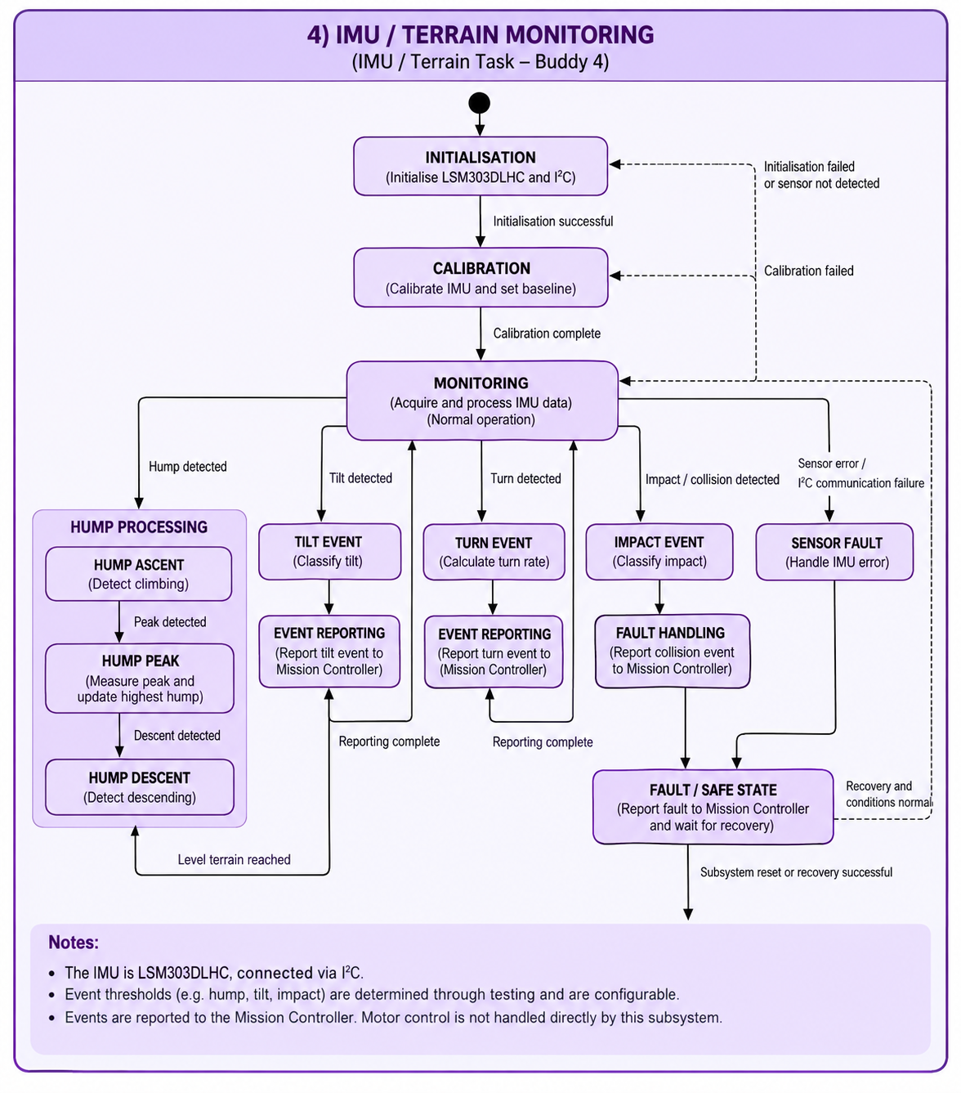
Brief explanation of states, events, and fault handling:
The subsystem begins in the INITIALISATION state, where the LSM303DLHC IMU and I²C interface are prepared. After successful initialisation, the subsystem enters CALIBRATION to establish the required sensor baseline. Once calibration is complete, it enters MONITORING, where IMU data is periodically acquired and processed for vehicle motion and terrain events. This matches the current Buddy 4 RTOS task, which handles tilt, hump detection, peak measurement, turning detection, heading-change monitoring, and motion/collision events.
During MONITORING, the subsystem checks for hump, tilt, turning, impact/collision, and sensor-fault conditions. When a hump is detected, the subsystem enters the hump-processing sequence, progressing through HUMP ASCENT, HUMP PEAK, and HUMP DESCENT. At the peak, the measured value is compared with the highest hump peak recorded during the run and the stored maximum is updated when required. This supports the existing requirement for detecting humps and determining the highest hump peak encountered.
Tilt and turning conditions are classified and reported to the Mission Controller before the subsystem returns to normal monitoring. If a sudden impact or collision is detected, the subsystem reports the event and enters fault handling. An IMU or I²C communication failure also causes the subsystem to enter the SENSOR FAULT and FAULT / SAFE STATE path. The subsystem does not directly stop or control the motors; it reports events to the Mission Controller, while motor actuation remains under Buddy 2.
After the fault condition has been handled and the sensor is successfully recovered, the subsystem can return to normal monitoring. If the fault remains unresolved, the system stays in the fault/safe state until recovery is possible.

6.5 Subsystem Statechart 5
Field | Student Entry
Subsystem name | Closed-Loop Motion Control and Encoder-Based Navigation
Related RTOS task(s) | Motion Control Task – Buddy 2
Purpose | Control the left and right DC motors using wheel-encoder feedback; estimate wheel speed and distance travelled; perform PID speed regulation and straight-line correction; execute controlled forward, reverse, left-turn, right-turn and U-turn manoeuvres; stop the vehicle when required; and report motion status and manoeuvre completion to the Mission Controller.
Reason a statechart is needed | The motion-control subsystem operates in distinct modes including initialisation, calibration, idle, straight-line movement, turning, stopping, completion and fault handling. A statechart defines how movement commands from the Mission Controller cause transitions between these modes, how encoder feedback determines movement completion, how stop requests are handled safely, and how motion or encoder faults prevent uncontrolled motor operation.
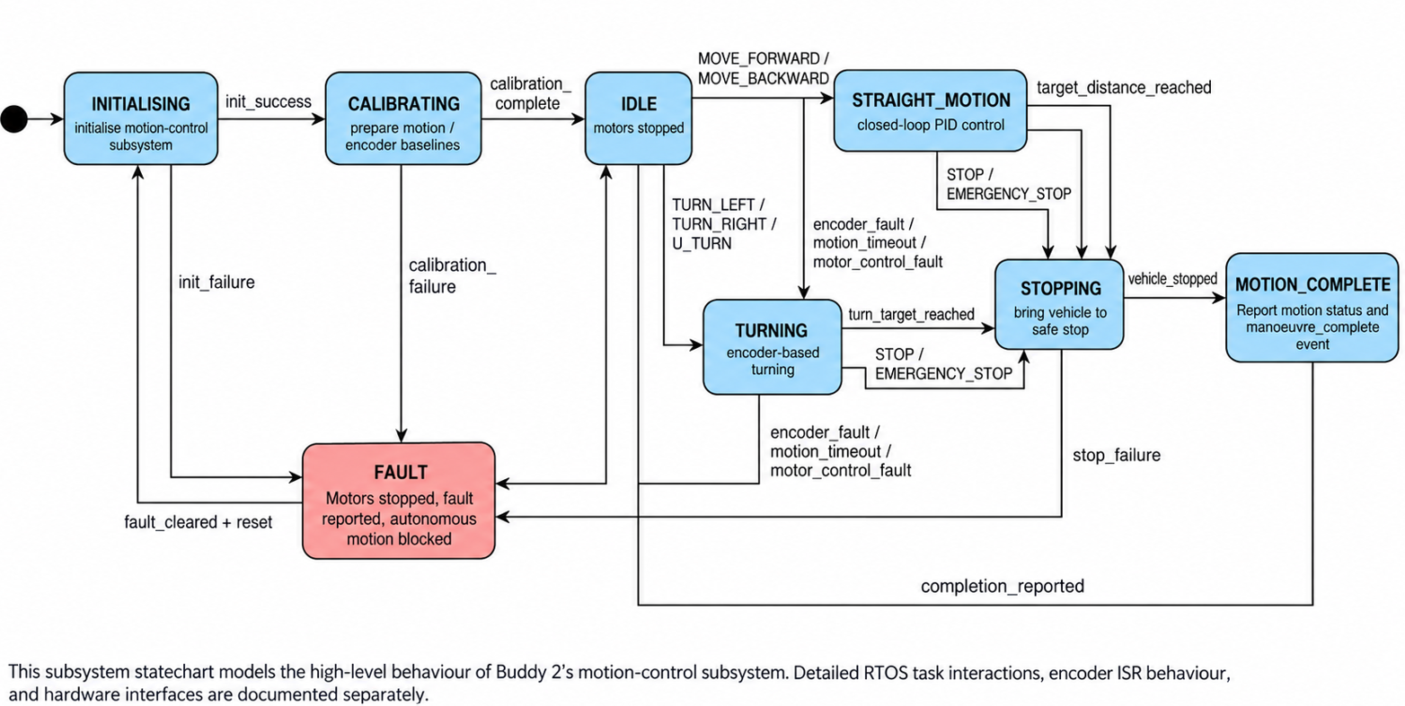

The subsystem begins in INITIALISING, where the motor-control interfaces, encoder inputs, PWM outputs, and internal control parameters are prepared. After successful initialisation, it enters CALIBRATING to establish the motion-control and encoder baselines required for reliable speed, distance, straight-line, and turning control. Once calibration is complete, the subsystem enters IDLE, where both motors remain stopped while waiting for a valid movement command from the Mission Controller.
When a forward or reverse command is received, the subsystem enters STRAIGHT_MOTION, where wheel-encoder feedback is used to estimate speed and distance travelled and to perform PID speed regulation and straight-line correction. When the requested distance is reached, the subsystem enters STOPPING, brings the vehicle to a controlled stop, and then enters COMPLETE. For left-turn, right-turn, or U-turn commands, the subsystem enters TURNING and uses encoder feedback until the required turn target is reached before stopping and reporting completion.
In COMPLETE, the Motion Control Task reports the final motion status and manoeuvre-complete event to the Mission Controller before returning to IDLE. A STOP or EMERGENCY_STOP request from any active motion state causes an immediate transition to STOPPING. Encoder failure, motion timeout, or motor-control fault causes a transition to FAULT, where both motors remain stopped and the fault is reported. The subsystem does not resume motion until the fault has been cleared and the subsystem has been reset and reinitialised.

7. Assumptions
List assumptions that the design depends on. Each assumption must state the risk if it is wrong and how the team will validate it before full integration. Have at least 1 assumption per buddy.
ID | Assumption | Risk if wrong | Validation method | Owner | Status
A-B1-1 | Wi-Fi signal strength (RSSI) on the test track remains >= - 70 dBm, allowing background MQTT publishing within 100 ms +- 10 ms. | Telemetry packets will back up in the queue, and exhaust heap/RAM or cause data dropouts. | Log MQTT round-trip latency and dropped packet count across 10 continuous test runs on the physical track | Buddy 1 | Open
A-B1-2 | Incoming MQTT command payloads arrive over the TCP socket without packet fragmentation and can be parsed within <= 50ms. | Command dispatch to command_event_q will delay, exceeding the non-functional latency requirements during critical overrides. | Benchmark command packet injection latency using mosquitto_pub while running full 10 Hz telemetry background streaming. | Buddy 1 | Open
A-B1-3 | Non-blocking CYW43 background polling (cyw43_arch_poll()) consumes <= 5% CPU utilization during network disconnection or backoff. | Signal loss will starve higher-priority RTOS tasks (e.g. Motion Control), degrading vehicle control. | Monitor CPU task execution cycles using uT-Kernel trace/timer profiling during simulated Wi-Fi AP power-downs. | Buddy 1 | Open
A-B2-1 | Wheel-encoder readings are sufficiently accurate and repeatable to estimate vehicle speed and distance at the intended operating speeds. | Incorrect encoder readings may cause inaccurate distance control, unstable speed regulation, or missed stopping points. | Drive the vehicle over known distances at different speeds and compare encoder-based distance and speed estimates with the actual measurements. | Buddy 2 | Open
A-B2-2 | Encoder-based turn targets can produce repeatable left, right and U-turn manoeuvres after calibration. | The vehicle may under-turn or over-turn, causing it to miss the intended path or fail to reacquire the line. | Perform repeated left, right and U-turn tests and compare the achieved turn with the commanded target before tuning the encoder thresholds. | Buddy 2 | Open
A-B3-1 | The three IR sensors can distinguish the line, junctions, and barcode patterns at the vehicle’s intended operating speeds and under expected course lighting. | The car may drift off the line, miss a junction, or issue an incorrect navigation command. | Calibrate the sensors, then run repeated line, junction, and barcode trials at the intended speeds and lighting conditions. Record line-loss events and correct versus incorrect barcode decodes. | Buddy 3 | Open
A-B3-2 | The IR subsystem can reliably detect when the original line has been reacquired after a manoeuvre or obstacle bypass. | The vehicle may remain in line recovery or resume normal line following before the original line has actually been found. | Perform repeated line-recovery tests after turns and obstacle bypasses and verify that LINE_FOUND is generated only when the line is correctly reacquired. | Buddy 3 | Open
A-B4-1 | IMU calibration and mounting provide a sufficiently stable baseline to distinguish normal vehicle motion from tilt, hump, turning and impact events. | Sensor noise or mounting variation may cause false motion events or missed hump/collision detections. | Record IMU readings while stationary and during repeated normal driving, turning, hump and controlled impact tests, then compare the measured ranges before setting thresholds. | Buddy 4 | Open
A-B4-2 | Repeated passes over the same hump produce sufficiently consistent IMU peak measurements to identify the highest hump encountered during a run. | Measurement variation may cause the subsystem to record the wrong hump as the highest peak. | Drive over known humps multiple times at a controlled speed and compare the measured peak values for repeatability. | Buddy 4 | Open
A-B5-1 | The expected obstacle surfaces produce sufficiently strong ultrasonic reflections for reliable HC-SR04 detection. | Some obstacles may be missed or may generate unstable distance measurements. | Test the ultrasonic sensor against the expected obstacle materials at different distances and angles and record detection reliability. | Buddy 5 | Open
A-B5-2 | Repeated ultrasonic measurements are sufficiently stable to support obstacle localisation and approximate width/clearance estimation | Noise may cause incorrect obstacle position, width, or clearance estimates and lead to an unsafe bypass decision. | Record repeated measurements at known distances and scan angles and compare the calculated obstacle profile with the actual obstacle position and dimensions. | Buddy 5 | Open

8. AI-Supported Design Evidence
Document how AI was used to support the design. The aim is not to show that AI produced perfect answers, but to show that the team used AI critically, corrected weak suggestions, and made final engineering decisions.

8.1 Pre-Submission AI Ideation
Buddy | AI prompt or discussion used | Useful AI ideas | Weak or unrealistic AI ideas | Team decision
Buddy 1 | Asked AI to propose an RTOS-based communication architecture for Pico W over MQTT, including command handling and telemetry streaming. | AI suggested that separating telemetry publishing into a periodic non-blocking task and using non-blocking socket select calls for commands | AI suggested storing all the telemetry frames into a large dynamic queue during Wi-Fi disconnects, which would exhaust the RP2040 RAM. | The team accepted the non-blocking separation and rejected dynamic queuing. Instead, we decided to implement a fixed ring-buffer that overwrites old frames during extended network disconnects.
Buddy 2 | Asked AI to review the motion-control subsystem for the Robo Pico and propose an RTOS-based design covering encoder feedback, PID speed control, distance estimation, straight-line correction, turning, stopping, task priority, and a subsystem statechart. | AI suggested keeping all drive-motor actuation under a single Motion Control Task, using encoder feedback for closed-loop control, and separating high-level motion commands from low-level motor actuation. It also suggested modelling the subsystem with states such as IDLE, STRAIGHT_MOTION, TURNING, STOPPING, MOTION_COMPLETE, and FAULT. | Initial AI suggestions introduced fixed PID gains, control periods, acceleration/deceleration behaviour, stopping distances, and encoder thresholds before any physical calibration or testing had been performed. Some suggested states were also more detailed than necessary for the Week 6 architecture design. | The team retained the single-owner motor-control architecture, encoder-based feedback, PID-based speed regulation, and the high-level motion-control statechart. Exact PID gains, control-loop period, encoder thresholds, turn targets, stopping behaviour, and calibration values will be determined through hardware testing rather than fixed from AI-generated assumptions.
Buddy 3 | Asked AI to review the IR line-following and barcode subsystem and develop a statechart covering sensor calibration, line tracking, barcode decoding, navigation commands, and line recovery. | AI suggested separating calibration, normal tracking, barcode decoding, and recovery into clear states. It also clarified that Buddy 3 reports line and barcode information to the Mission Controller, while Buddy 2 controls the motors. | An initial suggestion treated absence of the line as a fault without distinguishing unexpected line loss from the car intentionally leaving the line during obstacle bypass. The suggested detection thresholds were also not based on sensor testing. | The team retained the state-based design but distinguished normal obstacle bypass from unexpected line loss. Buddy 3 will report validated navigation commands and LINE_FOUND to the Mission Controller without directly controlling the motors. Sensor thresholds and barcode recognition will be confirmed through hardware testing.  bud
Buddy 4 | Asked AI to propose an IMU subsystem design for hump detection, motion monitoring, collision detection, and RTOS integration using the LSM303DLHC. | AI suggested a periodic IMU task to process sensor data and report hump, tilt, turn, and impact events to the Mission Controller. | AI suggested fixed thresholds and sampling values before hardware testing, which may be inaccurate due to sensor noise, mounting position, speed, and track conditions. | The team kept the periodic monitoring and event-reporting approach. Thresholds, sampling rates, calibration, and filtering values will be finalised through hardware testing.
Buddy 5 | Asked AI to propose an RTOS task structure, state machine, subsystem interfaces, and obstacle-profiling approach for Buddy 5 using an HC-SR04 ultrasonic sensor mounted on a scanning servo on a Raspberry Pi Pico-based autonomous robotic car. | AI suggested separating continuous forward obstacle monitoring from event-driven obstacle handling. It proposed using servo-based multi-angle ultrasonic measurements to build an obstacle profile and sending high-level obstacle information and avoidance requests to the Mission Controller rather than allowing Buddy 5 to directly control the drive motors. | Initial AI suggestions assumed specific scan angles, ultrasonic sampling periods, obstacle thresholds, stopping distances, and servo timing values without hardware measurements. It also initially treated obstacle-width estimation as more precise than can be guaranteed by an ultrasonic sensor because the HC-SR04 has a finite sensing beam and reflections depend on obstacle shape and surface. | The team retained the separation between the high-priority Obstacle Monitor Task and the event-driven Obstacle Handling Task. Servo-based scanning will be used to obtain measurements at multiple angles, while Buddy 5 will generate an obstacle profile and avoidance request for the Mission Controller. Exact scan angles, distance thresholds, timing parameters, filtering values, and width-estimation parameters will be finalised through hardware calibration and testing rather than assumed during the design review.

8.2 Team-Reviewed Architecture Freeze
AI or initial idea | Team decision | Engineering reason | Affected artefact
Dynamically allocate RAM/heap memory for every incoming telemetry frame during Wi-Fi disconnects. | Rejected | Continuous allocation during long network outages could exhaust the RP2040’s limited RAM. A fixed-size ring buffer is used instead. | Buddy 1 RTOS Task, Task Interaction Diagram
Use blocking Wi-Fi reconnection loops during network loss. | Rejected | Blocking reconnection could delay higher-priority control tasks. Non-blocking polling and exponential backoff are used instead. | Buddy 1 Statechart, RTOS Task Table
Allow multiple subsystems to directly command the drive motors. | Rejected | Motor actuation must have one clear owner to prevent conflicting commands. Buddy 2 remains the only subsystem that directly controls the motors. | Buddy 2 RTOS Task, Task Interaction Diagram
Use fixed PID gains, encoder thresholds and turn targets before hardware testing. | Deferred / Needs validation | Motor behaviour depends on actual encoder response, vehicle load and track conditions. These parameters must be calibrated experimentally. | Buddy 2 RTOS Task, Buddy 2 Statechart
Treat every loss of the line as a fault. | Modified | The line may be intentionally lost during obstacle bypass. Buddy 3 distinguishes expected line recovery from unexpected line loss. | Buddy 3 Statechart, System Statechart
Fix IR thresholds and barcode-detection values before sensor testing. | Deferred / Needs validation | Sensor readings depend on lighting, mounting height, surface reflectivity and vehicle speed. Thresholds will be finalised through calibration. | Buddy 3 Statechart, Assumptions
Allow the IMU subsystem to directly stop or control the motors when a collision is detected. | Modified | Buddy 4 reports collision or terrain events to the Mission Controller, while Buddy 2 retains exclusive motor control. This avoids conflicting actuator commands. | Buddy 4 Statechart, Task Interaction Diagram
Use fixed IMU thresholds, sampling rates and filtering values before hardware testing. | Deferred / Needs validation | IMU readings depend on sensor noise, mounting position, vehicle speed and track conditions. Values will remain configurable until calibration and testing are completed. | Buddy 4 Statechart, Assumptions
Allow Buddy 5 to directly control the drive motors during obstacle avoidance. | Modified | Buddy 5 generates obstacle information and an avoidance request, while the Mission Controller coordinates Buddy 2 to execute the manoeuvre. | Buddy 5 Statechart, Task Interaction Diagram
Use fixed scan angles, obstacle thresholds and servo timing values before hardware testing. | Deferred / Needs validation | Ultrasonic reflections, servo accuracy, stopping distance and obstacle geometry affect the appropriate values. These parameters will be finalised through hardware testing. | Buddy 5 Statechart, Assumptions

8.3 Final AI-Vetted Gap Check
After completing the design, ask AI to act as a strict embedded systems reviewer. The review should identify missing requirements, unclear interfaces, untested assumptions, weak mitigations, timing concerns, task conflicts, or resource contention.
Act as a strict embedded systems reviewer for a Raspberry Pi Pico-based autonomous robotic car running µT-Kernel RTOS. Review the functional and non-functional requirements, hardware pin layout, RTOS task table, task interaction diagram, system-level statechart, subsystem statecharts, assumptions, and AI-supported design evidence. Identify missing requirements, unclear subsystem interfaces, inconsistent task ownership, unsafe electrical assumptions, timing risks, task conflicts, unvalidated sensor assumptions, state-transition gaps, and shared-resource problems. Pay particular attention to motor control, line following, IMU monitoring, servo-based ultrasonic obstacle scanning, MQTT communication, and the Mission Controller. Do not redesign the system; list only gaps that the team should review and justify.

AI-identified gap | Team response | Action taken | Evidence or reason
High-rate telemetry during extended broker outages could overflow available memory or cause important frames to be lost. | Fixed in design | Use a fixed-size ring buffer that overwrites older regular telemetry frames instead of dynamically storing unlimited frames. | Buddy 1 RTOS design and Section 8.1 use bounded buffering to avoid excessive RP2040 RAM use.
Wi-Fi or MQTT reconnection could block higher-priority vehicle-control tasks. | Fixed in design | Use non-blocking connection polling and exponential backoff while keeping the communication task at Low priority | NFR9 and the Buddy 1 statechart require communication loss to avoid delaying higher-priority RTOS execution.
PID gains, encoder thresholds and turn targets have not yet been validated using the physical vehicle.control if Buddy 5 directly commands the motors. | Needs validation | Keep the values configurable and determine them through repeated speed, distance and turning test | Assumptions A-B2-1 and A-B2-2 require encoder and turning behaviour to be validated experimentally.
More than one subsystem could attempt to command the drive motors and create conflicting actuator requests. | Fixed | Restrict direct motor actuation to Buddy 2. Other subsystems send requests or events through the Mission Controller. | The task interaction design states that Buddy 2 is the only subsystem permitted to directly actuate the drive motors.
Line loss during obstacle bypass could be incorrectly treated as an unexpected line-following fault.` | Fixed | Distinguish intentional line recovery after obstacle bypass from unexpected line loss during normal tracking. | Buddy 3's statechart contains a dedicated LINE_RECOVERY state and reports LINE_FOUND before normal tracking resumes.
IR and barcode detection thresholds may not remain reliable under different lighting conditions and operating speeds. | Needs validation | Calibrate the IR sensors and test line, junction and barcode detection repeatedly under expected speeds and lighting. | Assumptions A-B3-1 and A-B3-2 require sensor and line-recovery behaviour to be confirmed through testing.
IMU thresholds, sampling rates and filtering values have not yet been validated on the moving vehicle. | Needs validation | Keep these parameters configurable and determine them using stationary, normal-driving, turning, hump and controlled-impact measurements. | Assumption A-B4-1 requires IMU behaviour to be measured before final detection thresholds are selected.
Variation in IMU hump measurements could cause the wrong hump to be recorded as the highest peak. | Needs validation | Repeat passes over known humps at controlled speeds and compare the recorded peak values for consistency. | Assumption A-B4-2 and NFR5 require consistent peak-hump measurement and reliable hump detection.
Ultrasonic readings may be unstable because reflections depend on obstacle material, angle and shape. | Needs validation | Test the HC-SR04 against expected obstacle surfaces at different distances and angles before finalising detection behaviour. | Assumption A-B5-1 requires obstacle reflection reliability to be verified experimentally.
Noisy ultrasonic measurements could produce an inaccurate obstacle profile or clearance estimate. | Partially fixed / Needs validation | Use repeated measurements and validation before accepting obstacle information, then verify the calculated profile against known obstacle positions. | Assumption A-B5-2 requires repeated ultrasonic measurements to be sufficiently stable for localisation and clearance estimation.

9. Design Consistency
Use this section to demonstrate that the design artefacts describe one coherent system rather than independent diagrams.
Check | Student Response
Which task owns each hardware device? | Buddy 1 owns the Pico W onboard CYW43 Wi-Fi interface through the Wi-Fi Telemetry & Command Task. Buddy 2 owns the left and right DC motors and wheel encoders through the Motion Control Task. Buddy 3 owns the three IR sensors used for line following and barcode detection through the Line & Barcode Task. Buddy 4 owns the LSM303DLHC IMU through the IMU / Terrain Task. Buddy 5 owns the HC-SR04 ultrasonic sensor and scanning servo through the Obstacle Monitor and Obstacle Handling Tasks. The Mission Controller does not directly own hardware; it coordinates commands and events between the subsystems.
Which task has the highest priority, and why? | The Motion Control Task – Buddy 2 has the highest priority at Very High because closed-loop motor control, encoder processing, speed regulation, distance control, and turning require predictable timing. The Line & Barcode Task and Obstacle Monitor Task are High priority because line and obstacle information must be processed promptly. The Mission Controller is also High priority for coordination. The IMU / Terrain Task and Obstacle Handling Task are Medium–High, while the Wi-Fi Telemetry & Command Task is Low because communication is less timing-critical than vehicle control.
Which subsystem statechart corresponds to which RTOS task or subsystem? | The Wi-Fi Communication, Command and Telemetry statechart corresponds to Buddy 1’s Wi-Fi Telemetry & Command Task. The Closed-Loop Motion Control and Encoder-Based Navigation statechart corresponds to Buddy 2’s Motion Control Task. The IR Line Following and Barcode Navigation statechart corresponds to Buddy 3’s Line & Barcode Task. The IMU-Based Motion and Terrain Monitoring statechart corresponds to Buddy 4’s IMU / Terrain Task. The Adaptive Ultrasonic Obstacle Detection and Avoidance statechart corresponds to Buddy 5’s Obstacle Monitor and Obstacle Handling Tasks.
How are functional requirements reflected in the task and statechart design? | FR1–FR4 are reflected in Buddy 3’s line-following, barcode-decoding and navigation-command states. FR5–FR6 are handled by Buddy 2’s encoder-based motion control, speed, distance and turning states. FR7–FR9 are reflected in Buddy 4’s IMU monitoring, hump processing, peak measurement, tilt, turning and collision-event handling. FR10–FR14 are handled by Buddy 5’s obstacle detection, scanning, profiling, bypass planning and line-recovery states. FR15–FR20 are implemented by Buddy 1’s Wi-Fi/MQTT connection, telemetry, command-processing and reconnection states. FR21 is supported by the Mission Controller, which coordinates events and commands between all subsystems.
What changes are still expected after the Week 6 review? | Some implementation parameters still require hardware validation. Buddy 1 may refine communication behaviour based on Wi-Fi latency, packet delivery and CPU-load testing. Buddy 2 will tune PID gains, control-loop timing, encoder thresholds, turn targets and stopping behaviour. Buddy 3 will refine IR and barcode-detection thresholds after sensor calibration. Buddy 4 will finalise IMU thresholds, sampling rates, calibration and filtering values through physical testing. Buddy 5 will refine ultrasonic thresholds, scan angles, servo timing, filtering and obstacle-profile parameters. The exact servo port also remains to be confirmed. Major architectural changes should only be made if supported by test evidence.

