**Class: DIT/FT/1B/03**

**Admission Number: 2026453**

**Name: Phan Kiah Fong Nicholas**

1st Page



2nd Page

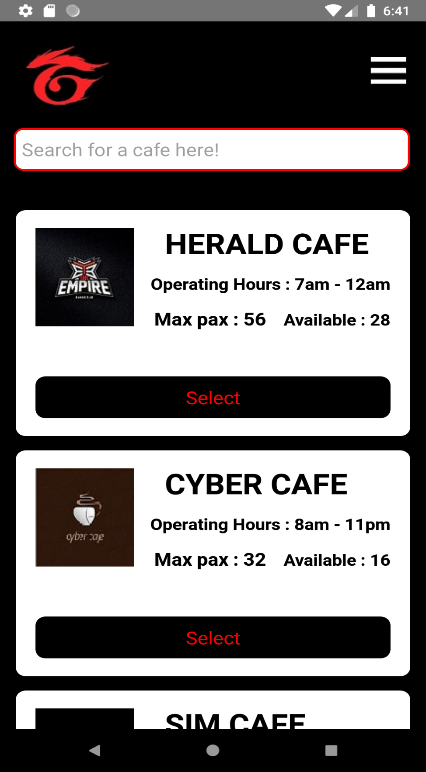

3rd Page



4th Page

