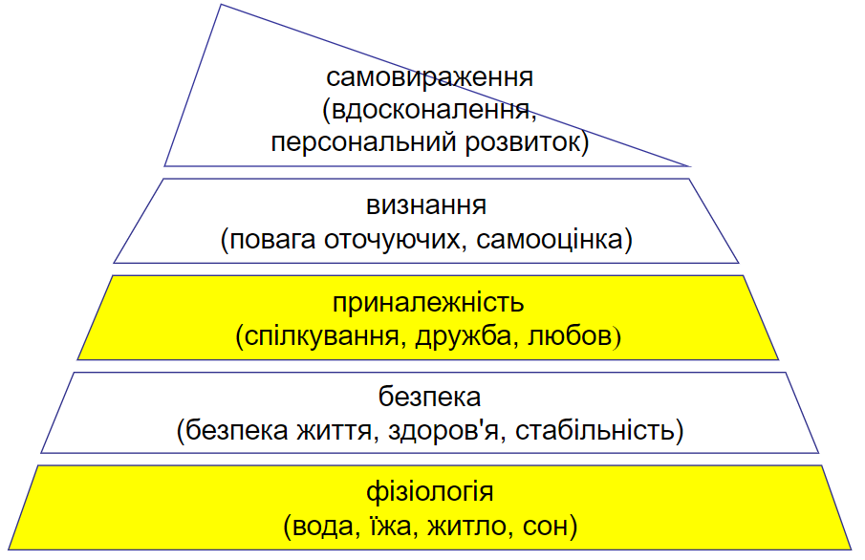

Here we see that have been changed physiology and affiliation.   
Our software, potentially, makes new contacts, respect from other people, support.  
Also, while user using our software, he got relaxation, brain takes new interesting information by interests.