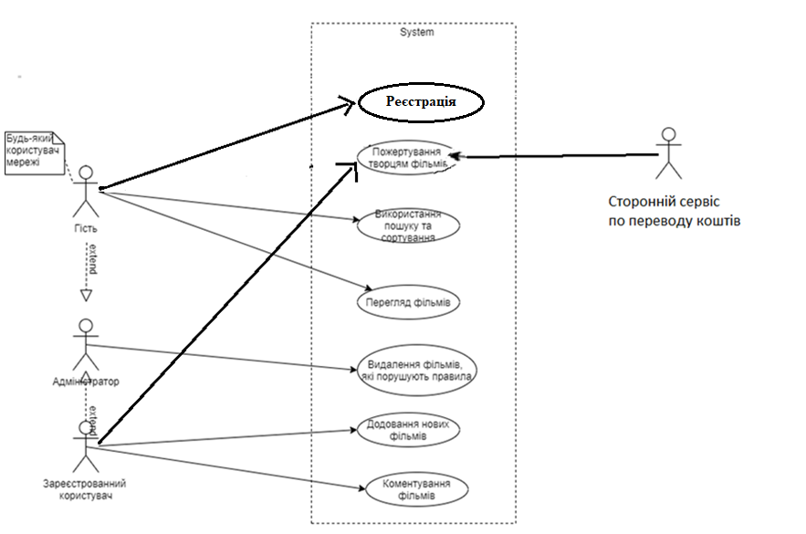

Pic. 1 – use case diagram.