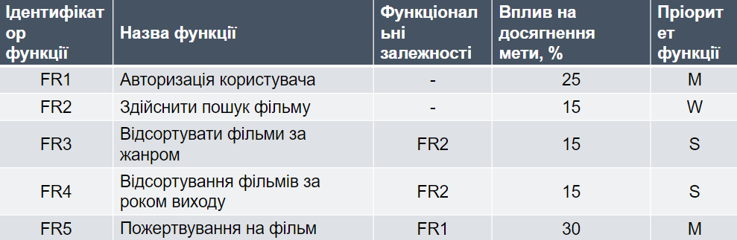

Pic. 1 – WBS – structure.