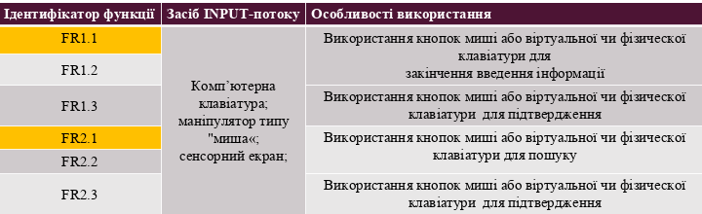

Pic. 1 – INPUT 1.

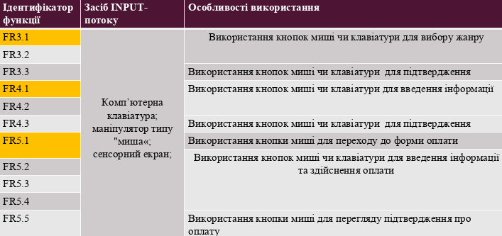

Pic. 2 – INPUT 2.