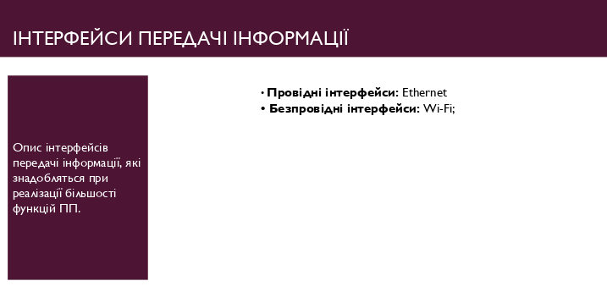

Pic. 1 – Interfaces.