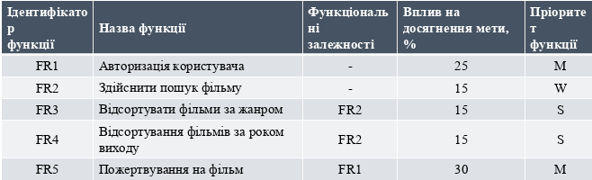

Pic. 1 – Planning iterations.