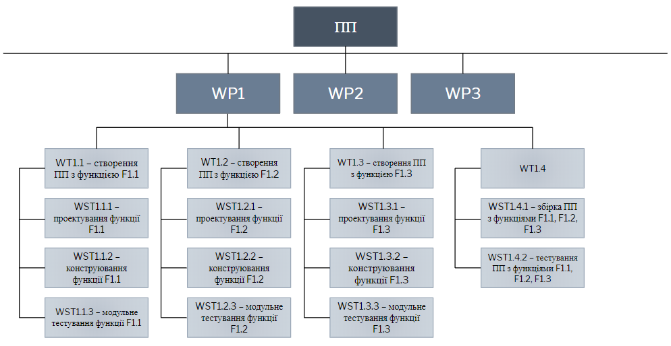

Pic. 1 – Defining tree.