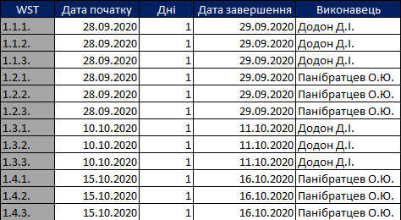

Pic. 1 – Table with work schedule.