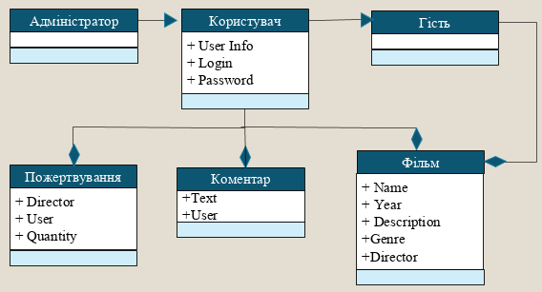

Pic. 1 – Conceptual design.