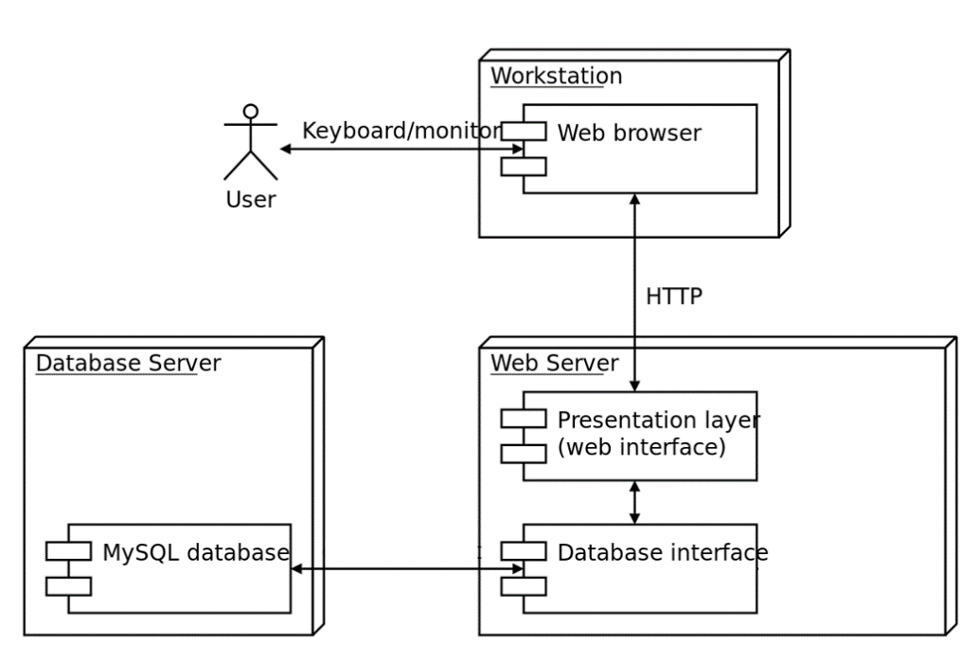

1. Go to the XAMPP developer's website and download the file.

2. Install XAMPP on your PC.

3. Launch XAMPP and we can go to the MySQL database and start the site by clicking on the Admin button.

Installing a site for developers:

1. Go to the GitHub repository of this project.

2. We make a clone for our computer.

3. Move the template folder that was cloned together with the project to the htdocs folder of the XAMPP program.