OBJ

1. Option B - C is compiled at once to machine language and can be run without need for the compiler but python is done on a line by line basis which requires the compiler at very moment when run.
2. Option D – A is converting a code seen as a C code to assembly language while B is converting the assembly to machine language
3. Option A – C has the first syntax, Assembly language has the second and Machine language deals with zero’s and one’s
4. Option B – The response time of the multiple versions of the same processor remains the same although he does more overall work.
5. Option D – Declarative deals with letting the computer do its thing by just telling it the goal while imperative requires knowing how to tell the computer to do what it should do
6. Option D – MATLAB generally works with vector arrays and matrices and is called MATrix LABoratory
7. Option C – It says whenever the condition is true, run the loop block which is characteristic of a while loop
8. Option B – Snippet A doesn’t search for primality to reduce the set before doing the search
9. Option B – Tuples are data types that can’t be editted when after created which is different from list in that case as list can be added to and removed from.
10. Option D – Bosection method shorts the number of steps taken by halving the list and checking if the required answer is within the updated list
11. Option A – There appears to be just one data colum which is the sensor data from the gyroscope
12. Option A – There should be a stop symbol at the end of the code
13. Option A – If we are trying to find answers closer to the actual answer, we would need to deal with the value aassigned to the epsilon
14. Option D - “==” is a comparison operator used to compare the equality of the two values or variables at its left or right
15. Option B – “clear” is used to clear everything written in memory, but “clc” declusters the present working window without having anything to do with the window
16. option B – simulink deals with simulations as it would occur in real situations

THEORY

1. 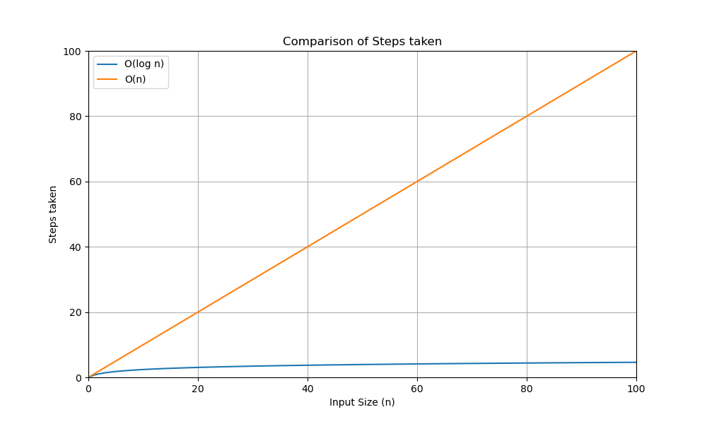# Comment A – return None for negative numbers and also even numbers

# Comment B – Assign the mid point of the range of numbers between the high and low

# Comment C – While the difference between the guess and the actual number is larger than epsilon, we keep the loop going

# Comment D – get the minimum number between the variable “x” and -1

# Comment E - Assign the mid point of the range of numbers between the high and low

1. a. x = a(3)

b. y = b(:,3)

c. z = b(3,:)

d. q = zeroes(3)

for i = 1:3

q(i,i) = b(i,i)

end

e. k = zeroes(3)

k(1,:) = a’(1:3)

k(2:3,:) = b(2:3,:)

1. def is_pal(s):

if len(s) <= 1: # return true for a string containing 1 character, also for an empty string

return True

else:

return s[0] == [s[-1] and is_pal(s[1:-1]) # check the first character and the last character and recurse which moves to the second character and next to the last character