

Metro sUPER sTORE

Muhammad Ali Ramzan

SP23-BCS-083



**Case Study**

**Date: 9-10-2023**

**Digital Transformation of Inventory Management at Metro Superstore**

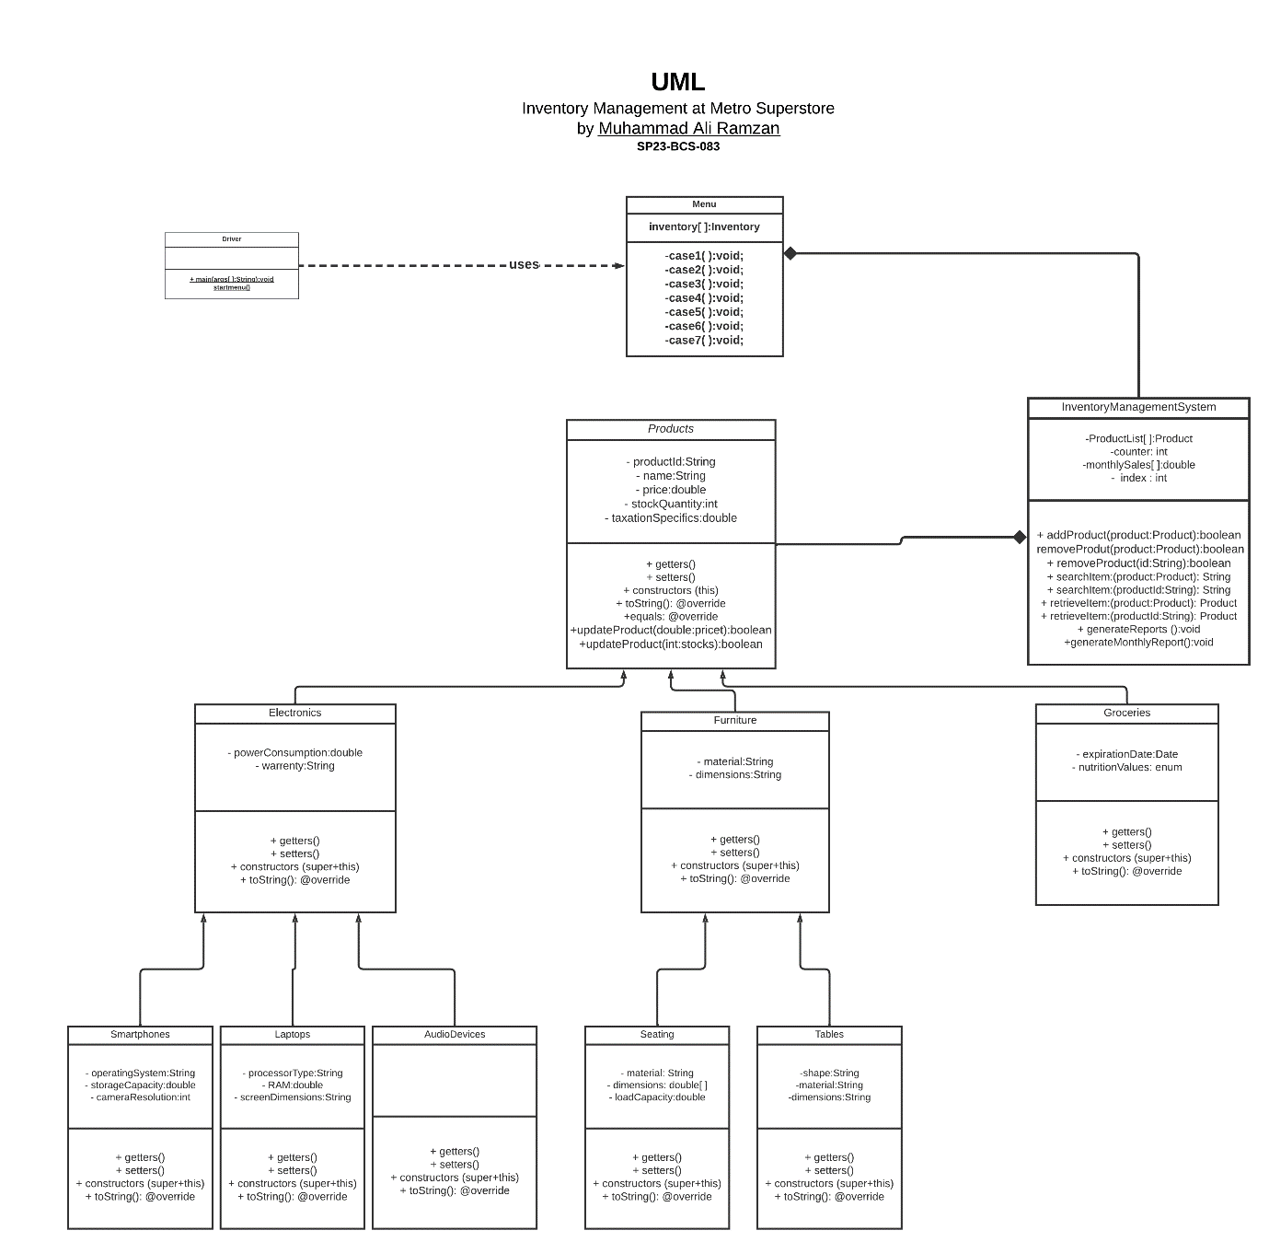

Link to my UML Diagram: (https://lucid.app/lucidchart/31f69c4f-955b-4484-ac6d-af4752d698ee/edit?beaconFlowId=DAC7F71D2539DD4D&invitationId=inv_410034f1-9061-4618-bced-4111e829d1ea&page=HWEp-vi-RSFO#)

**Documentation:**

**1. Product Class:**

* Attributes:
  + String name
  + String productId
  + double price
  + int stockQuantity
  + double taxation
* Methods:
  + getName(): String
  + getPrice(): double
  + getStockQuantity(): int
  + getProductId(): String
  + setName(String name): void
  + setPrice(double price): void
  + setStockQuantity(int stockQuantity): void
  + setProductId(String uniqueIdentifier): void
  + updatePrice(double newPrice)
  + updateStockQuantity(int newQuantity)

**2. Electronics Class (Inherited from Product):**

* Attributes:
  + String powerConsumption
  + Date warranty
* Methods:
  + getPowerConsumption(): String
  + getWarranty(): Date
  + setPowerConsumption(String powerConsumption): void
  + setWarranty(Date warranty): void

**3. Furniture Class (Inherited from Product):**

* Attributes:
  + String material
  + String dimension
* Methods:
  + getMaterial(): String
  + getDimensions(): String
  + setMaterial(String material): void
  + setDimensions(String dimension): void

**4. Groceries Class:**

* Attributes:
  + Date expDate
  + String nutrition
* Methods:
  + getExpDate(): Date
  + getNutrition(): String
  + setExpDate(Date expDate): void
  + setNutrition(String nutrition): void

**5. Laptops Class (Inherited from Electronics):**

* Attributes:
  + String processorType
  + int RAM size
  + String screenDimensions
* Methods:
  + getProcessorType(): String
  + getRAMSize(): int
  + getScreenDimensions(): String
  + setProcessorType(String processorType): void
  + setRAMSize(int RAMSize): void
  + setScreenDimensions(String screenDimensions): void

**6. Smartphones Class (Inherited from Electronics):**

* Attributes:
  + String operatingSystem
  + int storage
  + int cameraResolution
* Methods:
  + getOperatingSystem(): String
  + getStorage(): int
  + getCameraResolution(): int
  + setOperatingSystem(String operatingSystem): void
  + setStorage(int storage): void
  + setCameraResolution(int cameraResolution): void

**7. Tables Class (Inherited from Furniture):**

* Attributes:
  + String shape
* Methods:
  + getShape(): String
  + setShape(String shape): void

**8. Seating Class (Inherited from Furniture):**

* Attributes:
  + int loadCapacity
* Methods:
  + getLoadCapacity(): int
  + setLoadCapacity(int loadCapacity): void

**9. Inventory Class(Composes Product Class):**

**Attributes:**

productList[ ]:Product  
counter: int  
monthlySales[ ]:double  
 index : int

**Methods:**

* removeProduct()
* generateReport()
* addProduct(Product product)
* searchProduct(String query)

**10. Menu Class:**

**Attributes:**

inventory[ ]:Inventory

**Methods:**

startmenu():void;

-case1( ):void;

-case2( ):void;

-case3( ):void;

-case4( ):void;

-case5( ):void;

-case6( ):void;

-case7( ):void;

**11.Main(Runs the code)**

Public static main void();

startMenu (calls)