**--1) Составьте на выборку данных с использованием рефлексивного соединения для таблицы из задания 5 лабораторной работы №2 (academy.oracle.com\iLearning\2013-2014 Oracle Academy Database Programming with SQL – Student\Section 3 Executing Database Joins\Self Joins and Hierarchical Queries).**

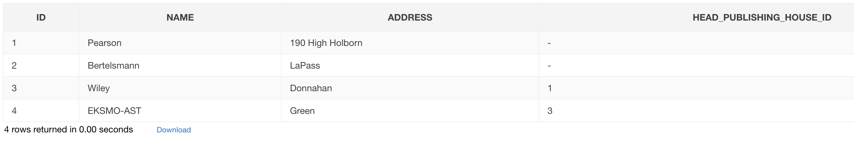

SELECT NAME || NVL2(HEAD_PUBLISHING_HOUSE_ID ,' is department of ' || PRIOR NAME , ' is head') AS PUBLISHING_HOUSE_TREE

FROM PUBLISHING_HOUSE

START WITH HEAD_PUBLISHING_HOUSE_ID IS NULL

CONNECT BY PRIOR ID = HEAD_PUBLISHING_HOUSE_ID;

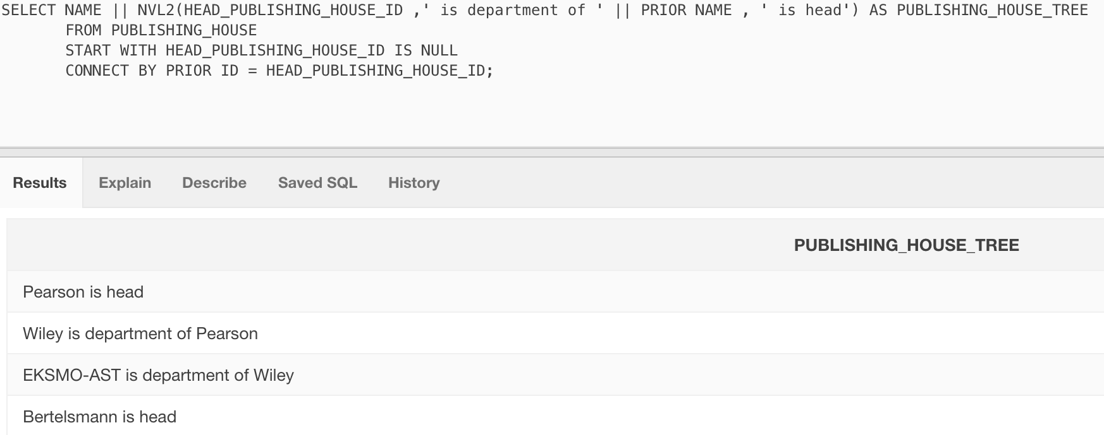

*Составьте запросы на выборку данных с использованием следующих операторов, конструкций функций языка SQL:*

**--2) Простого оператора CASE ();**

SELECT NAME,

(CASE NAME WHEN 'Белая гвардия' THEN 'Читал'

WHEN 'Евгений Онегин' THEN 'Читал'

ELSE 'Не читал'

END) AS STATUS

FROM BOOK;

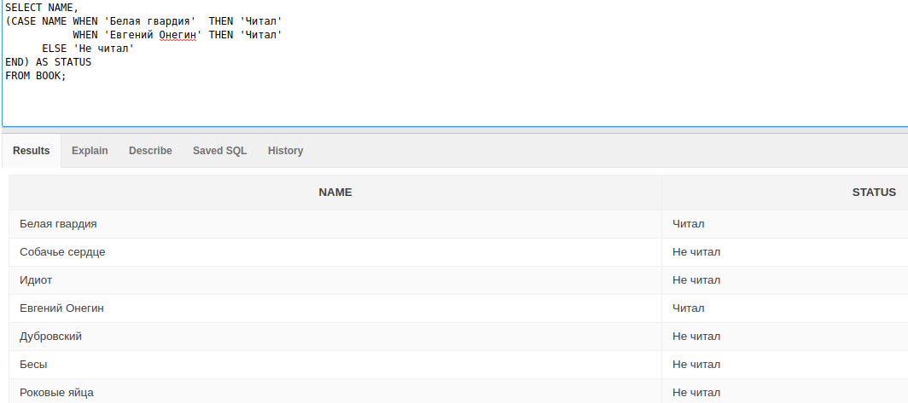

**--3) Поискового оператора CASE();**

SELECT b.NAME,

(CASE

WHEN SUM(o.AMOUNT) <= 3 THEN 'Мало, купите еще'

WHEN SUM(o.AMOUNT) >= 4 AND SUM(o.AMOUNT) < 20 THEN 'Достаточно'

ELSE 'Очень много, книг'

END) AS STATUS

FROM BOOK b

JOIN OWNER_BOOK_INFO o

ON b.ID = o.BOOK_ID

GROUP BY b.NAME;

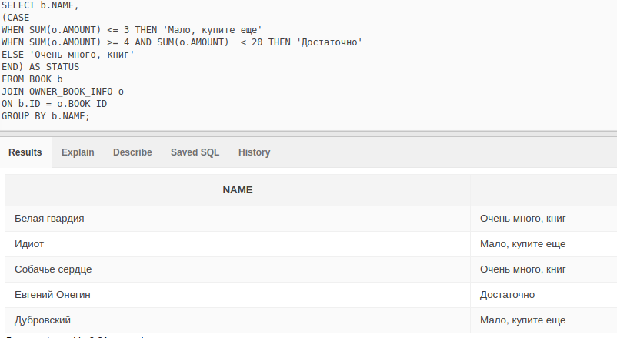

**-4) Оператора WITH();**

WITH EXTENDED_BOOK_INFO AS (SELECT b.ID, b.NAME, a.FIO

FROM BOOK b

JOIN AUTHOR a

ON b.AUTHOR_ID = a.ID)

SELECT * FROM EXTENDED_BOOK_INFO;

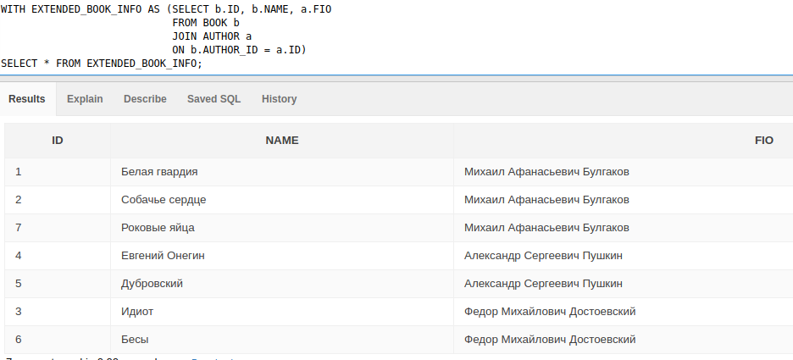

**--5) встроенного представления();**

CREATE OR REPLACE VIEW BOOK_INFO AS

(SELECT b.ID, b.NAME, a.FIO AS AUTHOR, pub.NAME AS PUBLISHING_HOUSE, pub.ADDRESS as PUBLISHING_HOUSE_ADDRESS

FROM BOOK b

JOIN AUTHOR a

ON b.AUTHOR_ID = a.ID

JOIN PUBLISHING_HOUSE pub

on b.PUBLISHING_HOUSE_ID = pub.ID);

SELECT b.ID,

b.NAME,

b.AUTHOR,

b.PUBLISHING_HOUSE_ADDRESS,

i_d.AMOUNT,

i.SELLING_PRICE,

i.BUYING_PRICE,

i.OPERATION_DESCRIPTION AS TYPE

FROM BOOK_INFO b

JOIN INVOICE_DETAILS i_d

ON b.ID = i_d.BOOK_ID

JOIN INVOICE i

ON i.ID = i_d.INVOICE_ID

ORDER BY b.ID;

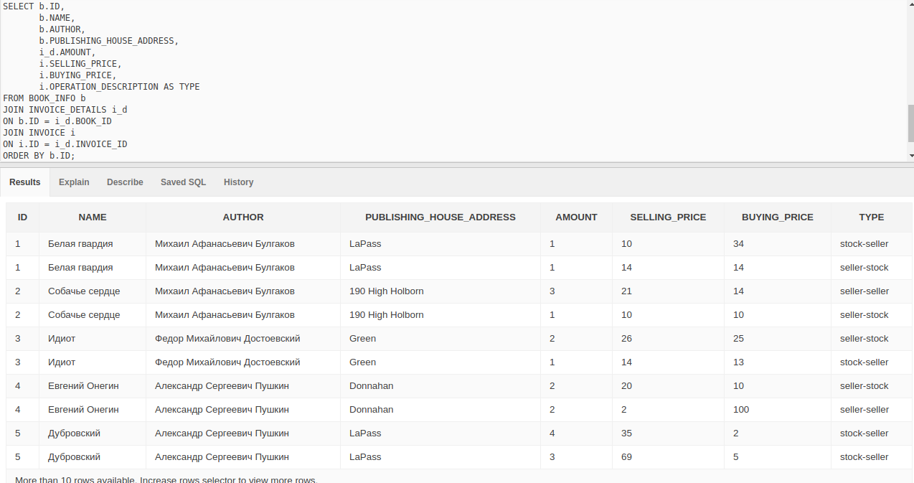

**--6) некоррелированного запроса(academy.oracle.com\iLearning\2013-2014 Oracle Academy Database Programming with SQL – Student\Section 6 Creating Subqueries);**

SELECT NAME, AMOUNT FROM BOOK b

JOIN OWNER_BOOK_INFO o

ON b.ID = o.BOOK_ID

WHERE o.AMOUNT = (SELECT MAX(AMOUNT) FROM OWNER_BOOK_INFO);

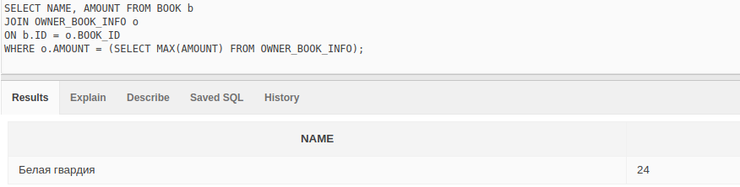

**--7) коррелированного запроса(academy.oracle.com\iLearning\2013-2014 Oracle Academy Database Programming with SQL – Student\Section 6 Creating Subqueries).);**

SELECT * FROM OWNER o

JOIN OWNER_INVOICE o_i

ON o.ID = o_i.OWNER_ID

JOIN INVOICE i

ON i.ID = o_i.INVOICE_ID

WHERE o_i.INVOICE_ID IN (SELECT i1.ID FROM INVOICE i1

JOIN OWNER_INVOICE o_i1

ON i1.ID = o_i1.INVOICE_ID

JOIN OWNER o1

ON o1.ID = o_i1.OWNER_ID

WHERE o.ADDRESS = o1.ADDRESS AND o.ID != o1.ID)

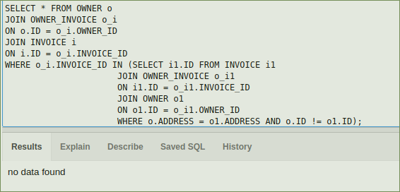

из одного города

**--8) функции NULLIF (academy.oracle.com\iLearning\2013-2014 Oracle Academy Database Programming with SQL – Student\Section 2 Using Single-Row Functions);**

SELECT ID, FIO FROM OWNER

NATURAL JOIN SELLER

WHERE NULLIF(ADDRESS, 'Minsk') IS NOT NULL

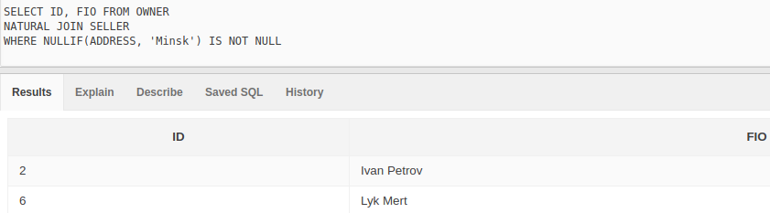

**--9) функции NVL2 (academy.oracle.com\iLearning\2013-2014 Oracle Academy Database Programming with SQL – Student\Section 2 Using Single-Row Functions);**

SELECT ID, NVL2(NULLIF(ADDRESS, 'Minsk'), ADDRESS, 'My town' ) AS ADDRESS FROM OWNER

NATURAL JOIN SELLER

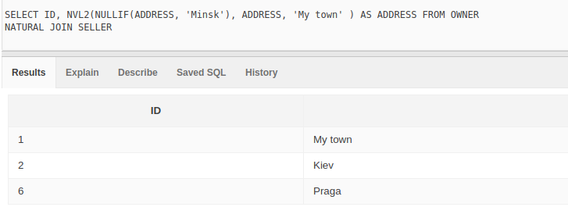

**--10) TOP-N анализа();**

SELECT ID, NAME

FROM (SELECT * FROM BOOK

ORDER BY BOOK.ID DESC)

WHERE ROWNUM <= 2

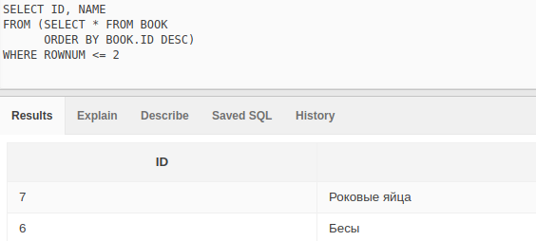

**-11) функции ROLLUP().**

SELECT b.NAME, SUM(AMOUNT) FROM BOOK b

JOIN OWNER_BOOK_INFO o

ON o.BOOK_ID = b.ID

GROUP BY ROLLUP(b.NAME);

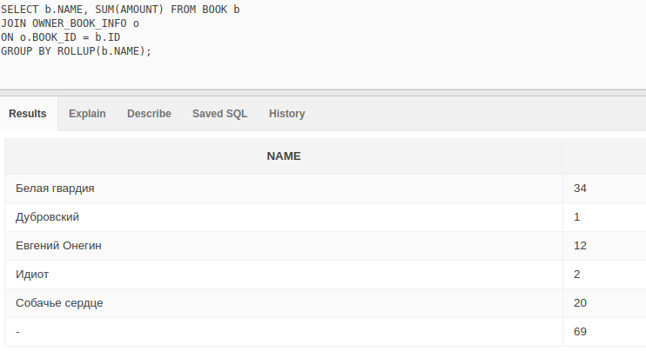

**--12) Составьте запрос на использование оператора MERGE языка манипулирования данными.**

CREATE TABLE AUTHOR_TMP AS SELECT * FROM AUTHOR

SELECT * FROM AUTHOR_TMP

UPDATE AUTHOR_TMP

SET BIRTH_DATE = SYSDATE

WHERE ID = 2

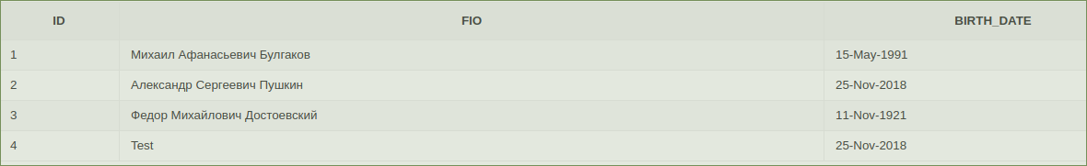

MERGE INTO AUTHOR a

USING ( SELECT * FROM AUTHOR_TMP) a1

ON (a.ID = a1.ID)

WHEN MATCHED THEN UPDATE SET a.BIRTH_DATE = a1.BIRTH_DATE

WHEN NOT MATCHED THEN INSERT (a.ID, a.FIO, a.BIRTH_DATE)

VALUES (a1.ID, a1.FIO, a1.BIRTH_DATE)

