**--1) Добавьте в таблицу SALARY столбец TAX (налог) для вычисления ежемесячного**

**подоходного налога на зарплату по прогрессивной шкале. Налог вычисляется по**

**следующему правилу:**

налог равен 9% от начисленной в месяце зарплаты, если суммарная зарплата с

начала года до конца рассматриваемого месяца не превышает 20 000;

налог равен 12% от начисленной в месяце зарплаты, если суммарная зарплата с

начала года до конца рассматриваемого месяца больше 20 000, но не превышает 30

000; налог равен 15% от начисленной в месяце зарплаты, если суммарная зарплата с

начала года до конца рассматриваемого месяца больше 30 000.

ALTER TABLE SALARY ADD (TAX NUMBER(15));

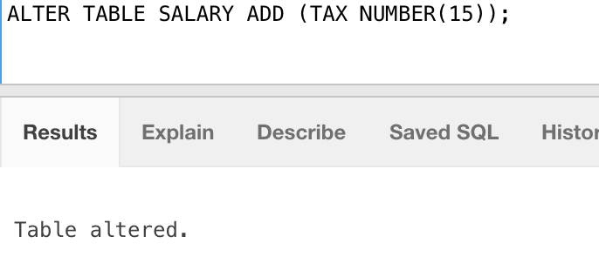

**--2) Составьте программу вычисления налога и вставки её в таблицу SALARY:**

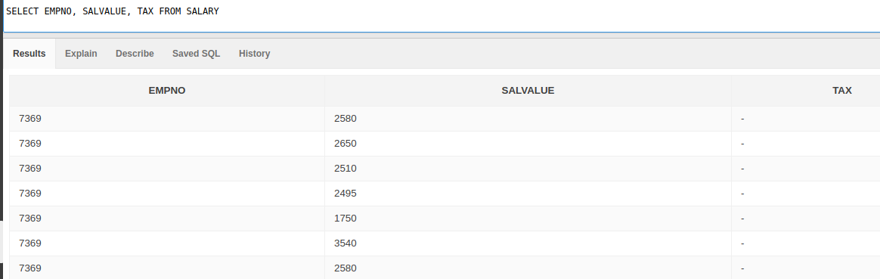

**a) с помощью простого цикла (loop) с курсором и оператора if;**

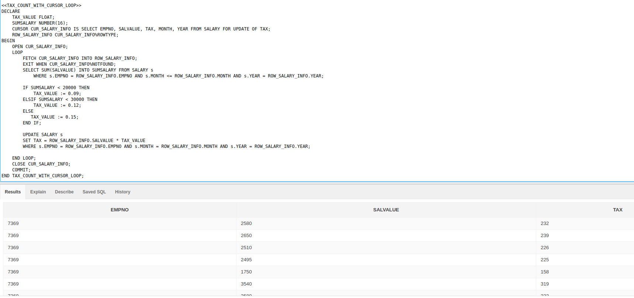

<<TAX_COUNT_WITH_CURSOR_LOOP_IF>>

DECLARE

TAX_VALUE FLOAT;

SUMSALARY NUMBER(16);

CURSOR CUR_SALARY_INFO IS SELECT EMPNO, SALVALUE, TAX, MONTH, YEAR FROM SALARY FOR UPDATE OF TAX;

ROW_SALARY_INFO CUR_SALARY_INFO%ROWTYPE;

BEGIN

OPEN CUR_SALARY_INFO;

LOOP

FETCH CUR_SALARY_INFO INTO ROW_SALARY_INFO;

EXIT WHEN CUR_SALARY_INFO%NOTFOUND;

SELECT SUM(SALVALUE) INTO SUMSALARY FROM SALARY s

WHERE s.EMPNO = ROW_SALARY_INFO.EMPNO AND s.MONTH <= ROW_SALARY_INFO.MONTH AND s.YEAR = ROW_SALARY_INFO.YEAR;

IF SUMSALARY < 20000 THEN

TAX_VALUE := 0.09;

ELSIF SUMSALARY < 30000 THEN

TAX_VALUE := 0.12;

ELSE

TAX_VALUE := 0.15;

END IF;

UPDATE SALARY s

SET TAX = ROW_SALARY_INFO.SALVALUE * TAX_VALUE

WHERE s.EMPNO = ROW_SALARY_INFO.EMPNO AND s.MONTH = ROW_SALARY_INFO.MONTH AND s.YEAR = ROW_SALARY_INFO.YEAR;

END LOOP;

CLOSE CUR_SALARY_INFO;

COMMIT;

END TAX_COUNT_WITH_CURSOR_LOOP_IF;

**b) с помощью простого цикла (loop) с курсором и оператора case;**

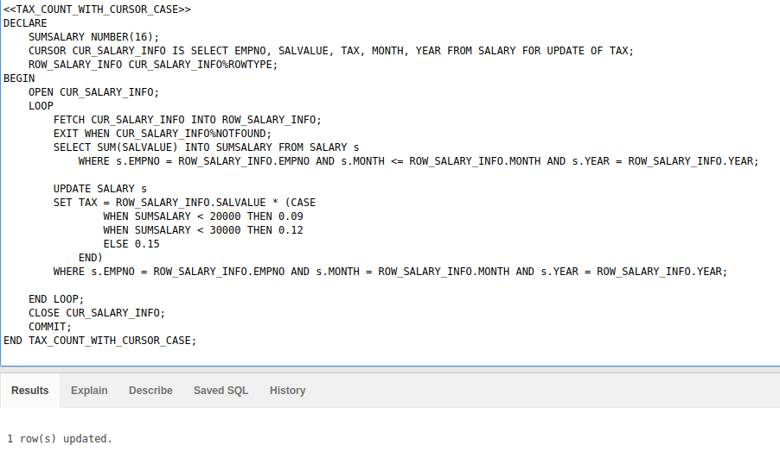

<<TAX_COUNT_WITH_CURSOR_CASE>>

DECLARE

SUMSALARY NUMBER(16);

CURSOR CUR_SALARY_INFO IS SELECT EMPNO, SALVALUE, TAX, MONTH, YEAR FROM SALARY FOR UPDATE OF TAX;

ROW_SALARY_INFO CUR_SALARY_INFO%ROWTYPE;

BEGIN

OPEN CUR_SALARY_INFO;

LOOP

FETCH CUR_SALARY_INFO INTO ROW_SALARY_INFO;

EXIT WHEN CUR_SALARY_INFO%NOTFOUND;

SELECT SUM(SALVALUE) INTO SUMSALARY FROM SALARY s

WHERE s.EMPNO = ROW_SALARY_INFO.EMPNO AND s.MONTH <= ROW_SALARY_INFO.MONTH AND s.YEAR = ROW_SALARY_INFO.YEAR;

UPDATE SALARY s

SET TAX = ROW_SALARY_INFO.SALVALUE * (CASE

WHEN SUMSALARY < 20000 THEN 0.09

WHEN SUMSALARY < 30000 THEN 0.12

ELSE 0.15

END)

WHERE s.EMPNO = ROW_SALARY_INFO.EMPNO AND s.MONTH = ROW_SALARY_INFO.MONTH AND s.YEAR = ROW_SALARY_INFO.YEAR;

END LOOP;

CLOSE CUR_SALARY_INFO;

COMMIT;

END TAX_COUNT_WITH_CURSOR_CASE;

c) с помощью курсорного цикла FOR;

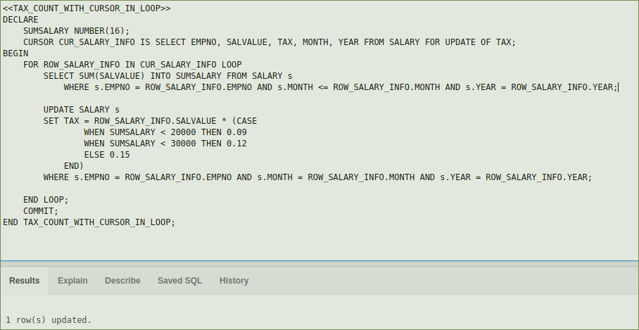

<<TAX_COUNT_WITH_CURSOR_IN_LOOP>>

DECLARE

SUMSALARY NUMBER(16);

CURSOR CUR_SALARY_INFO IS SELECT EMPNO, SALVALUE, TAX, MONTH, YEAR FROM SALARY FOR UPDATE OF TAX;

BEGIN

FOR ROW_SALARY_INFO IN CUR_SALARY_INFO LOOP

SELECT SUM(SALVALUE) INTO SUMSALARY FROM SALARY s

WHERE s.EMPNO = ROW_SALARY_INFO.EMPNO AND s.MONTH <= ROW_SALARY_INFO.MONTH AND s.YEAR = ROW_SALARY_INFO.YEAR;

UPDATE SALARY s

SET TAX = ROW_SALARY_INFO.SALVALUE * (CASE

WHEN SUMSALARY < 20000 THEN 0.09

WHEN SUMSALARY < 30000 THEN 0.12

ELSE 0.15

END)

WHERE s.EMPNO = ROW_SALARY_INFO.EMPNO AND s.MONTH = ROW_SALARY_INFO.MONTH AND s.YEAR = ROW_SALARY_INFO.YEAR;

END LOOP;

COMMIT;

END TAX_COUNT_WITH_CURSOR_IN_LOOP;

**d) с помощью курсора с параметром, передавая номер сотрудника, для которого**

**необходимо посчитать налог.**

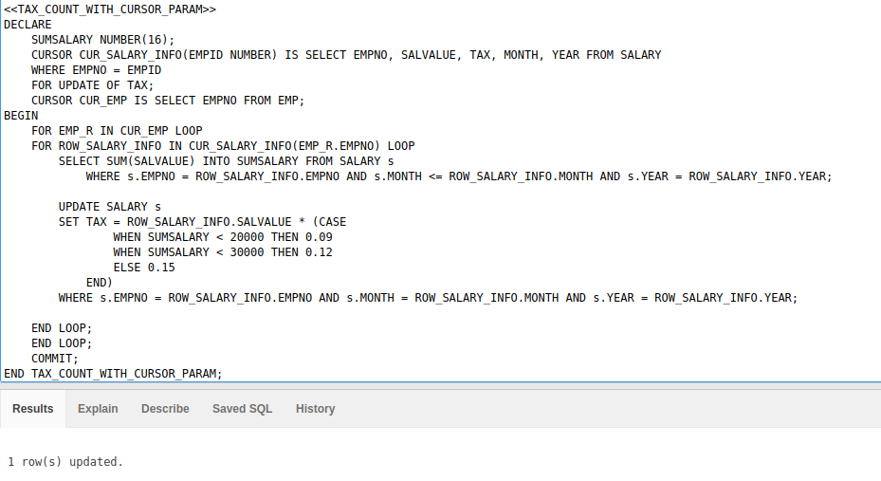

<<TAX_COUNT_WITH_CURSOR_PARAM>>

DECLARE

SUMSALARY NUMBER(16);

CURSOR CUR_SALARY_INFO(EMPID NUMBER) IS SELECT EMPNO, SALVALUE, TAX, MONTH, YEAR FROM SALARY

WHERE EMPNO = EMPID

FOR UPDATE OF TAX;

CURSOR CUR_EMP IS SELECT EMPNO FROM EMP;

BEGIN

FOR EMP_R IN CUR_EMP LOOP

FOR ROW_SALARY_INFO IN CUR_SALARY_INFO(EMP_R.EMPNO) LOOP

SELECT SUM(SALVALUE) INTO SUMSALARY FROM SALARY s

WHERE s.EMPNO = ROW_SALARY_INFO.EMPNO AND s.MONTH <= ROW_SALARY_INFO.MONTH AND s.YEAR = ROW_SALARY_INFO.YEAR;

UPDATE SALARY s

SET TAX = ROW_SALARY_INFO.SALVALUE * (CASE

WHEN SUMSALARY < 20000 THEN 0.09

WHEN SUMSALARY < 30000 THEN 0.12

ELSE 0.15

END)

WHERE s.EMPNO = ROW_SALARY_INFO.EMPNO AND s.MONTH = ROW_SALARY_INFO.MONTH AND s.YEAR = ROW_SALARY_INFO.YEAR;

END LOOP;

END LOOP;

COMMIT;

END TAX_COUNT_WITH_CURSOR_PARAM;

**--3) Оформите составленные программы в виде процедур.**

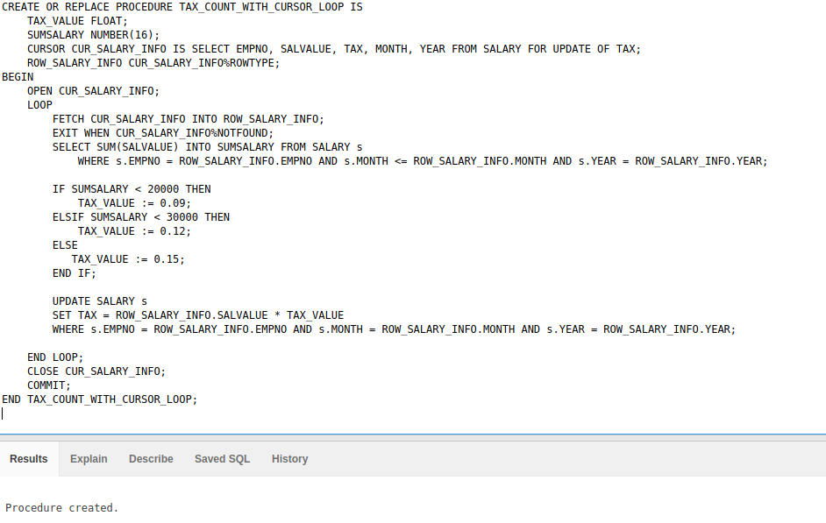

CREATE OR REPLACE PROCEDURE TAX_COUNT_WITH_CURSOR_LOOP_IF IS

TAX_VALUE FLOAT;

SUMSALARY NUMBER(16);

CURSOR CUR_SALARY_INFO IS SELECT EMPNO, SALVALUE, TAX, MONTH, YEAR FROM SALARY FOR UPDATE OF TAX;

ROW_SALARY_INFO CUR_SALARY_INFO%ROWTYPE;

BEGIN

OPEN CUR_SALARY_INFO;

LOOP

FETCH CUR_SALARY_INFO INTO ROW_SALARY_INFO;

EXIT WHEN CUR_SALARY_INFO%NOTFOUND;

SELECT SUM(SALVALUE) INTO SUMSALARY FROM SALARY s

WHERE s.EMPNO = ROW_SALARY_INFO.EMPNO AND s.MONTH <= ROW_SALARY_INFO.MONTH AND s.YEAR = ROW_SALARY_INFO.YEAR;

IF SUMSALARY < 20000 THEN

TAX_VALUE := 0.09;

ELSIF SUMSALARY < 30000 THEN

TAX_VALUE := 0.12;

ELSE

TAX_VALUE := 0.15;

END IF;

UPDATE SALARY s

SET TAX = ROW_SALARY_INFO.SALVALUE * TAX_VALUE

WHERE s.EMPNO = ROW_SALARY_INFO.EMPNO AND s.MONTH = ROW_SALARY_INFO.MONTH AND s.YEAR = ROW_SALARY_INFO.YEAR;

END LOOP;

CLOSE CUR_SALARY_INFO;

COMMIT;

END TAX_COUNT_WITH_CURSOR_LOOP_IF;

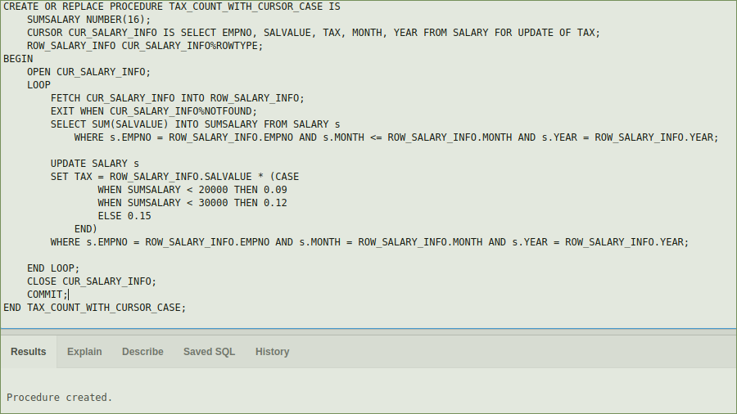

CREATE OR REPLACE PROCEDURE TAX_COUNT_WITH_CURSOR_CASE IS

SUMSALARY NUMBER(16);

CURSOR CUR_SALARY_INFO IS SELECT EMPNO, SALVALUE, TAX, MONTH, YEAR FROM SALARY FOR UPDATE OF TAX;

ROW_SALARY_INFO CUR_SALARY_INFO%ROWTYPE;

BEGIN

OPEN CUR_SALARY_INFO;

LOOP

FETCH CUR_SALARY_INFO INTO ROW_SALARY_INFO;

EXIT WHEN CUR_SALARY_INFO%NOTFOUND;

SELECT SUM(SALVALUE) INTO SUMSALARY FROM SALARY s

WHERE s.EMPNO = ROW_SALARY_INFO.EMPNO AND s.MONTH <= ROW_SALARY_INFO.MONTH AND s.YEAR = ROW_SALARY_INFO.YEAR;

UPDATE SALARY s

SET TAX = ROW_SALARY_INFO.SALVALUE * (CASE

WHEN SUMSALARY < 20000 THEN 0.09

WHEN SUMSALARY < 30000 THEN 0.12

ELSE 0.15

END)

WHERE s.EMPNO = ROW_SALARY_INFO.EMPNO AND s.MONTH = ROW_SALARY_INFO.MONTH AND s.YEAR = ROW_SALARY_INFO.YEAR;

END LOOP;

CLOSE CUR_SALARY_INFO;

COMMIT;

END TAX_COUNT_WITH_CURSOR_CASE;

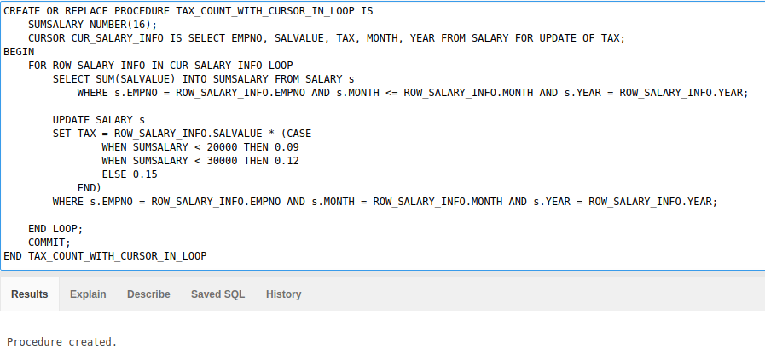

CREATE OR REPLACE PROCEDURE TAX_COUNT_WITH_CURSOR_IN_LOOP IS

SUMSALARY NUMBER(16);

CURSOR CUR_SALARY_INFO IS SELECT EMPNO, SALVALUE, TAX, MONTH, YEAR FROM SALARY FOR UPDATE OF TAX;

BEGIN

FOR ROW_SALARY_INFO IN CUR_SALARY_INFO LOOP

SELECT SUM(SALVALUE) INTO SUMSALARY FROM SALARY s

WHERE s.EMPNO = ROW_SALARY_INFO.EMPNO AND s.MONTH <= ROW_SALARY_INFO.MONTH AND s.YEAR = ROW_SALARY_INFO.YEAR;

UPDATE SALARY s

SET TAX = ROW_SALARY_INFO.SALVALUE * (CASE

WHEN SUMSALARY < 20000 THEN 0.09

WHEN SUMSALARY < 30000 THEN 0.12

ELSE 0.15

END)

WHERE s.EMPNO = ROW_SALARY_INFO.EMPNO AND s.MONTH = ROW_SALARY_INFO.MONTH AND s.YEAR = ROW_SALARY_INFO.YEAR;

END LOOP;

COMMIT;

END TAX_COUNT_WITH_CURSOR_IN_LOOP

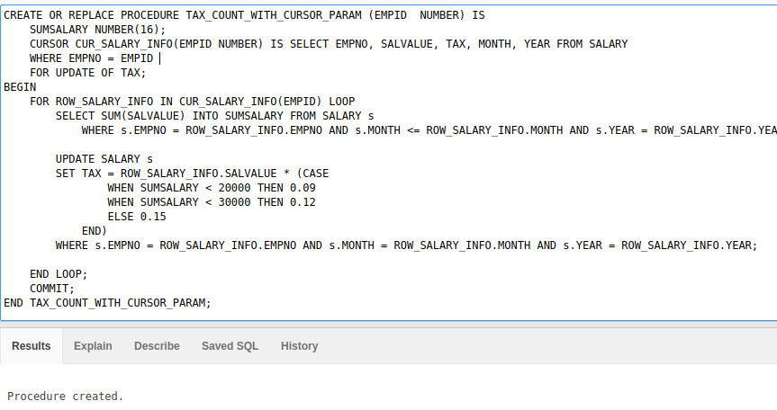

CREATE OR REPLACE PROCEDURE TAX_COUNT_WITH_CURSOR_PARAM (EMPID NUMBER) IS

SUMSALARY NUMBER(16);

CURSOR CUR_SALARY_INFO(EMPID NUMBER) IS SELECT EMPNO, SALVALUE, TAX, MONTH, YEAR FROM SALARY

WHERE EMPNO = EMPID

FOR UPDATE OF TAX;

BEGIN

FOR ROW_SALARY_INFO IN CUR_SALARY_INFO(EMPID) LOOP

SELECT SUM(SALVALUE) INTO SUMSALARY FROM SALARY s

WHERE s.EMPNO = ROW_SALARY_INFO.EMPNO AND s.MONTH <= ROW_SALARY_INFO.MONTH AND s.YEAR = ROW_SALARY_INFO.YEAR;

UPDATE SALARY s

SET TAX = ROW_SALARY_INFO.SALVALUE * (CASE

WHEN SUMSALARY < 20000 THEN 0.09

WHEN SUMSALARY < 30000 THEN 0.12

ELSE 0.15

END)

WHERE s.EMPNO = ROW_SALARY_INFO.EMPNO AND s.MONTH = ROW_SALARY_INFO.MONTH AND s.YEAR = ROW_SALARY_INFO.YEAR;

END LOOP;

COMMIT;

END TAX_COUNT_WITH_CURSOR_PARAM;

**-- 4) Создайте функцию, вычисляющую налог на зарплату за всё время начислений для конкретного сотрудника. В качестве параметров передать процент налога (до 20000, до 30000, выше 30000, номер сотрудника).**

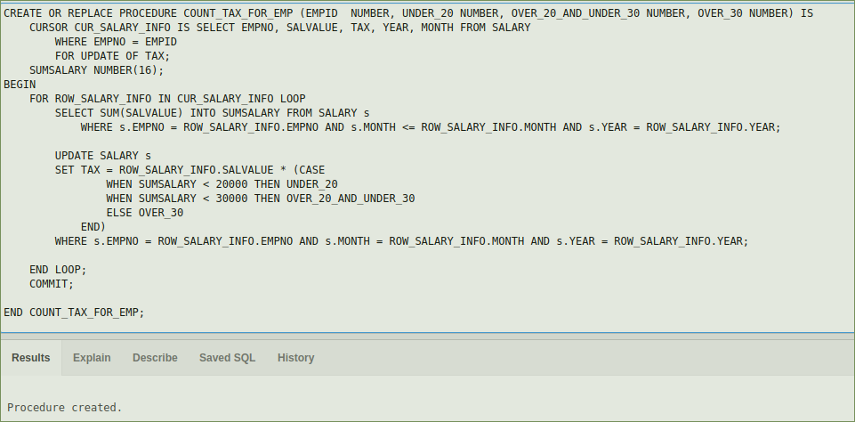

CREATE OR REPLACE PROCEDURE COUNT_TAX_FOR_EMP (EMPID NUMBER, UNDER_20 NUMBER, OVER_20_AND_UNDER_30 NUMBER, OVER_30 NUMBER) IS

CURSOR CUR_SALARY_INFO IS SELECT EMPNO, SALVALUE, TAX, YEAR, MONTH FROM SALARY

WHERE EMPNO = EMPID

FOR UPDATE OF TAX;

SUMSALARY NUMBER(16);

BEGIN

FOR ROW_SALARY_INFO IN CUR_SALARY_INFO LOOP

SELECT SUM(SALVALUE) INTO SUMSALARY FROM SALARY s

WHERE s.EMPNO = ROW_SALARY_INFO.EMPNO AND s.MONTH <= ROW_SALARY_INFO.MONTH AND s.YEAR = ROW_SALARY_INFO.YEAR;

UPDATE SALARY s

SET TAX = ROW_SALARY_INFO.SALVALUE * (CASE

WHEN SUMSALARY < 20000 THEN UNDER_20

WHEN SUMSALARY < 30000 THEN OVER_20_AND_UNDER_30

ELSE OVER_30

END)

WHERE s.EMPNO = ROW_SALARY_INFO.EMPNO AND s.MONTH = ROW_SALARY_INFO.MONTH AND s.YEAR = ROW_SALARY_INFO.YEAR;

END LOOP;

COMMIT;

END COUNT_TAX_FOR_EMP;

BEGIN

COUNT_TAX_FOR_EMP(7369, 0.20, 0.40, 0.75);

END;

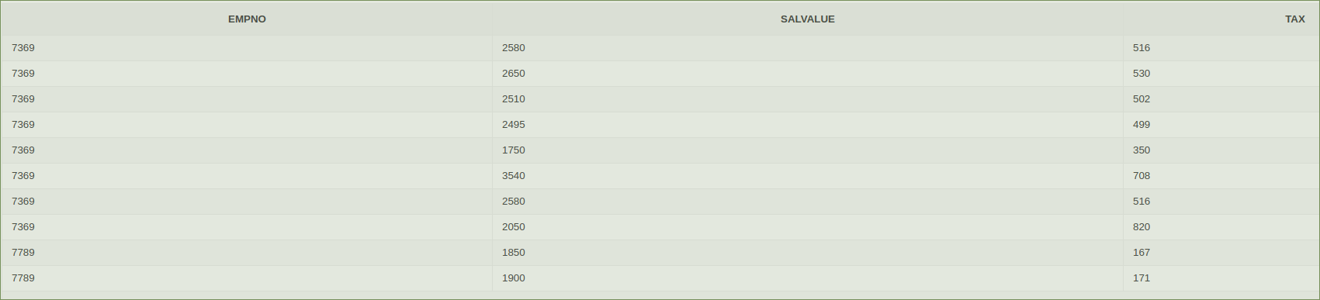

**--5. Создайте подпрограмму, вычисляющую суммарный налог на зарплату сотрудника**

**за всё время начислений. В качестве параметров передать процент налога (до 20000, до 30000, выше 30000, номер сотрудника). Возвращаемое значение – суммарный налог.**

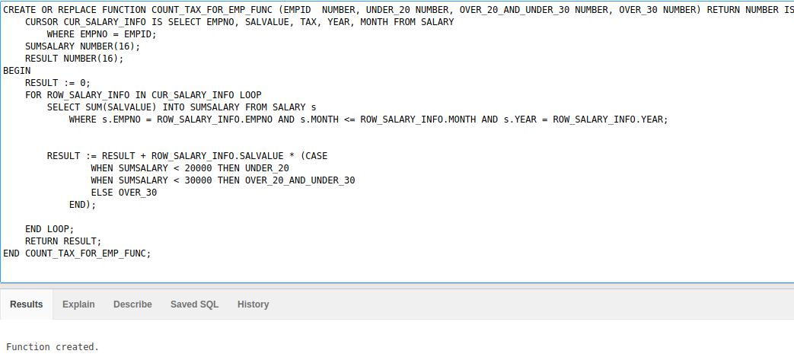

CREATE OR REPLACE FUNCTION COUNT_TAX_FOR_EMP_FUNC (EMPID NUMBER, UNDER_20 NUMBER, OVER_20_AND_UNDER_30 NUMBER, OVER_30 NUMBER) RETURN NUMBER IS

CURSOR CUR_SALARY_INFO IS SELECT EMPNO, SALVALUE, TAX, YEAR, MONTH FROM SALARY

WHERE EMPNO = EMPID;

SUMSALARY NUMBER(16);

RESULT NUMBER(16);

BEGIN

RESULT := 0;

FOR ROW_SALARY_INFO IN CUR_SALARY_INFO LOOP

SELECT SUM(SALVALUE) INTO SUMSALARY FROM SALARY s

WHERE s.EMPNO = ROW_SALARY_INFO.EMPNO AND s.MONTH <= ROW_SALARY_INFO.MONTH AND s.YEAR = ROW_SALARY_INFO.YEAR;

RESULT := RESULT + ROW_SALARY_INFO.SALVALUE * (CASE

WHEN SUMSALARY < 20000 THEN UNDER_20

WHEN SUMSALARY < 30000 THEN OVER_20_AND_UNDER_30

ELSE OVER_30

END);

END LOOP;

RETURN RESULT;

END COUNT_TAX_FOR_EMP_FUNC;

SELECT EMPNAME, COUNT_TAX_FOR_EMP_FUNC(EMPNO, 0.20, 0.40, 0.75) AS TAXES FROM EMP;

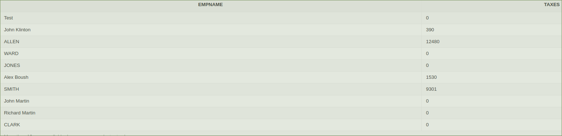

**--6) Создайте пакет, включающий в свой состав процедуру вычисления налога для всех**

**сотрудников, процедуру вычисления налогов для отдельного сотрудника,**

**идентифицируемого своим номером, функцию вычисления суммарного налога на**

**зарплату сотрудника за всё время начислений.**

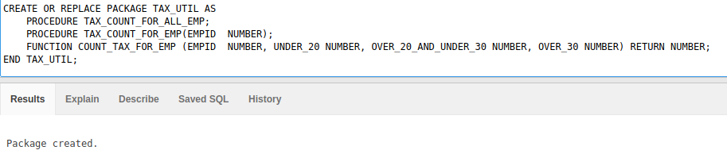

CREATE OR REPLACE PACKAGE TAX_UTIL AS

PROCEDURE TAX_COUNT_FOR_ALL_EMP;

PROCEDURE TAX_COUNT_FOR_EMP(EMPID NUMBER);

FUNCTION COUNT_TAX_FOR_EMP (EMPID NUMBER, UNDER_20 NUMBER, OVER_20_AND_UNDER_30 NUMBER, OVER_30 NUMBER) RETURN NUMBER;

END TAX_UTIL;

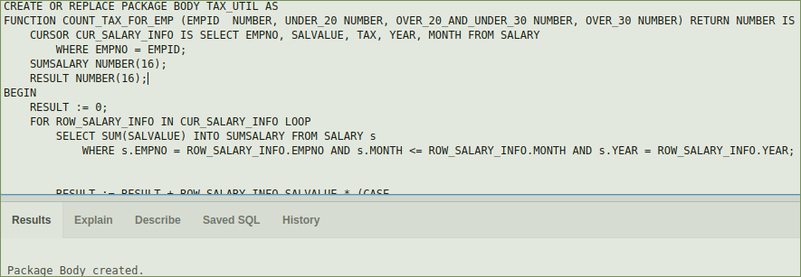

CREATE OR REPLACE PACKAGE BODY TAX_UTIL AS

FUNCTION COUNT_TAX_FOR_EMP (EMPID NUMBER, UNDER_20 NUMBER, OVER_20_AND_UNDER_30 NUMBER, OVER_30 NUMBER) RETURN NUMBER IS

CURSOR CUR_SALARY_INFO IS SELECT EMPNO, SALVALUE, TAX, YEAR, MONTH FROM SALARY

WHERE EMPNO = EMPID;

SUMSALARY NUMBER(16);

RESULT NUMBER(16);

BEGIN

RESULT := 0;

FOR ROW_SALARY_INFO IN CUR_SALARY_INFO LOOP

SELECT SUM(SALVALUE) INTO SUMSALARY FROM SALARY s

WHERE s.EMPNO = ROW_SALARY_INFO.EMPNO AND s.MONTH <= ROW_SALARY_INFO.MONTH AND s.YEAR = ROW_SALARY_INFO.YEAR;

RESULT := RESULT + ROW_SALARY_INFO.SALVALUE * (CASE

WHEN SUMSALARY < 20000 THEN UNDER_20

WHEN SUMSALARY < 30000 THEN OVER_20_AND_UNDER_30

ELSE OVER_30

END);

END LOOP;

RETURN RESULT;

END COUNT_TAX_FOR_EMP;

PROCEDURE TAX_COUNT_FOR_EMP (EMPID NUMBER) IS

SUMSALARY NUMBER(16);

CURSOR CUR_SALARY_INFO(EMPID NUMBER) IS SELECT EMPNO, SALVALUE, TAX, MONTH, YEAR FROM SALARY

WHERE EMPNO = EMPID

FOR UPDATE OF TAX;

BEGIN

FOR ROW_SALARY_INFO IN CUR_SALARY_INFO(EMPID) LOOP

SELECT SUM(SALVALUE) INTO SUMSALARY FROM SALARY s

WHERE s.EMPNO = ROW_SALARY_INFO.EMPNO AND s.MONTH <= ROW_SALARY_INFO.MONTH AND s.YEAR = ROW_SALARY_INFO.YEAR;

UPDATE SALARY s

SET TAX = ROW_SALARY_INFO.SALVALUE * (CASE

WHEN SUMSALARY < 20000 THEN 0.09

WHEN SUMSALARY < 30000 THEN 0.12

ELSE 0.15

END)

WHERE s.EMPNO = ROW_SALARY_INFO.EMPNO AND s.MONTH = ROW_SALARY_INFO.MONTH AND s.YEAR = ROW_SALARY_INFO.YEAR;

END LOOP;

COMMIT;

END TAX_COUNT_FOR_EMP;

PROCEDURE TAX_COUNT_FOR_ALL_EMP IS

SUMSALARY NUMBER(16);

CURSOR CUR_SALARY_INFO IS SELECT EMPNO, SALVALUE, TAX, MONTH, YEAR FROM SALARY FOR UPDATE OF TAX;

BEGIN

FOR ROW_SALARY_INFO IN CUR_SALARY_INFO LOOP

SELECT SUM(SALVALUE) INTO SUMSALARY FROM SALARY s

WHERE s.EMPNO = ROW_SALARY_INFO.EMPNO AND s.MONTH <= ROW_SALARY_INFO.MONTH AND s.YEAR = ROW_SALARY_INFO.YEAR;

UPDATE SALARY s

SET TAX = ROW_SALARY_INFO.SALVALUE * (CASE

WHEN SUMSALARY < 20000 THEN 0.09

WHEN SUMSALARY < 30000 THEN 0.12

ELSE 0.15

END)

WHERE s.EMPNO = ROW_SALARY_INFO.EMPNO AND s.MONTH = ROW_SALARY_INFO.MONTH AND s.YEAR = ROW_SALARY_INFO.YEAR;

END LOOP;

COMMIT;

END TAX_COUNT_FOR_ALL_EMP;

END TAX_UTIL;

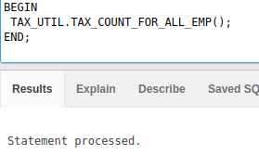

**--7) Создайте триггер, действующий при обновлении данных в таблице SALARY. А именно, если происходит обновление поля SALVALUE, то при назначении новой зарплаты, меньшей чем должностной оклад (таблица JOB, поле MINSALARY), изменение не вносится и сохраняется старое значение, если новое значение зарплаты больше должностного оклада, то изменение вносится.**

**WHEN**

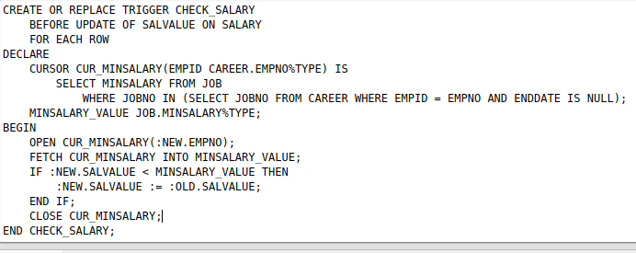

CREATE OR REPLACE TRIGGER CHECK_SALARY

BEFORE UPDATE OF SALVALUE ON SALARY

FOR EACH ROW

DECLARE

CURSOR CUR_MINSALARY(EMPID CAREER.EMPNO%TYPE) IS

SELECT MINSALARY FROM JOB

WHERE JOBNO IN (SELECT JOBNO FROM CAREER WHERE EMPID = EMPNO AND ENDDATE IS NULL);

MINSALARY_VALUE JOB.MINSALARY%TYPE;

BEGIN

OPEN CUR_MINSALARY(:NEW.EMPNO);

FETCH CUR_MINSALARY INTO MINSALARY_VALUE;

IF :NEW.SALVALUE < MINSALARY_VALUE THEN

:NEW.SALVALUE := :OLD.SALVALUE;

END IF;

CLOSE CUR_MINSALARY;

END CHECK_SALARY;

SELECT * FROM SALARY

WHERE EMPNO = 7369 AND MONTH = 5 AND YEAR = 2007;



UPDATE SALARY

SET SALVALUE = 100

WHERE EMPNO = 7369 AND MONTH = 5 AND YEAR = 2007;



UPDATE SALARY

SET SALVALUE = 99999

WHERE EMPNO = 7369 AND MONTH = 5 AND YEAR = 2007;



**--8) Создайте триггер, действующий при удалении записи из таблицы CAREER. Если в удаляемой строке поле ENDDATE содержит NULL, то запись не удаляется, в противном случае удаляется.**

CREATE OR REPLACE TRIGGER HANDLE_DELETE_FOR_WORKERS

BEFORE DELETE ON CAREER

FOR EACH ROW

WHEN (OLD.ENDDATE IS NULL)

BEGIN

RAISE_APPLICATION_ERROR(-20001,'Worker can not be deleted');

END HANDLE_DELETE_FOR_WORKERS;

DELETE FROM CAREER

WHERE ENDDATE IS NULL

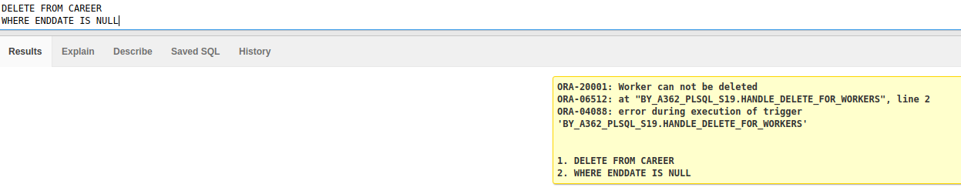

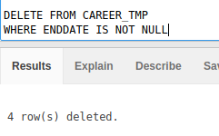

**--9) Создайте триггер, действующий на добавление или изменение данных в таблице**

**EMP. Если во вставляемой или изменяемой строке поле BIRTHDATE содержит NULL, то после вставки или изменения должно быть выдано сообщение ‘BERTHDATE is NULL’. Если во вставляемой или изменяемой строке поле BIRTHDATE содержит дату ранее ‘01- 01-1940’, то должно быть выдано сообщение ‘PENTIONA’. Во вновь вставляемой строке имя служащего должно быть приведено к заглавным буквам.**

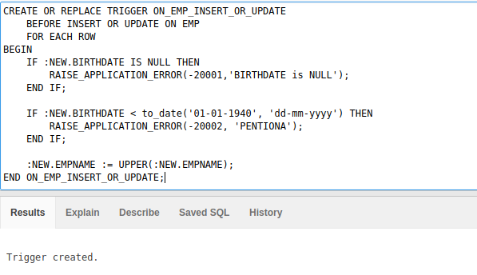

CREATE OR REPLACE TRIGGER ON_EMP_INSERT_OR_UPDATE

BEFORE INSERT OR UPDATE ON EMP

FOR EACH ROW

BEGIN

IF :NEW.BIRTHDATE IS NULL THEN

RAISE_APPLICATION_ERROR(-20001,'BIRTHDATE is NULL');

END IF;

IF :NEW.BIRTHDATE < to_date('01-01-1940', 'dd-mm-yyyy') THEN

RAISE_APPLICATION_ERROR(-20002, 'PENTIONA');

END IF;

:NEW.EMPNAME := UPPER(:NEW.EMPNAME);

END ON_EMP_INSERT_OR_UPDATE;

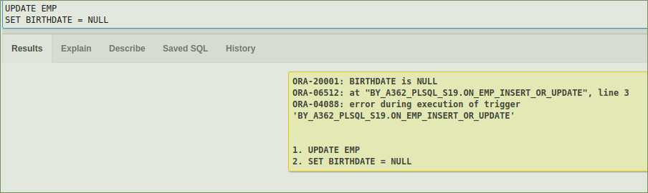

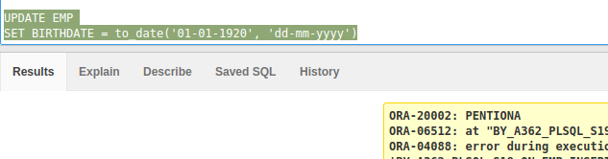

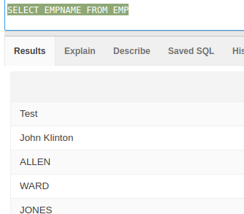

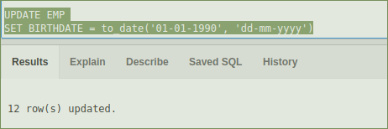

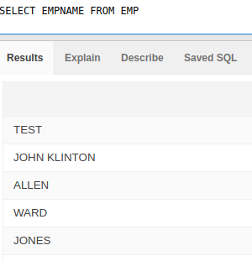

**--10) Создайте программу изменения типа заданной переменной из символьного типа**

**(VARCHAR2) в числовой тип (NUMBER). Программа должна содержать раздел**

**обработки исключений. Обработка должна заключаться в выдаче сообщения ‘ERROR:**

**argument is not a number’ . Исключительная ситуация возникает при задании строки в виде числа с запятой, разделяющей дробную и целую части.**

CREATE OR REPLACE FUNCTION VARCHAR2_TO_NUMBER (str in VARCHAR2) return NUMBER IS

BEGIN

RETURN CAST(str AS NUMBER);

EXCEPTION

WHEN VALUE_ERROR THEN

RAISE_APPLICATION_ERROR(-20108, 'ERROR: argument is not a number: ' || str);

WHEN OTHERS THEN

RAISE_APPLICATION_ERROR(-20103, 'Unexpected error');

END VARCHAR2_TO_NUMBER;

BEGIN

DBMS_OUTPUT.PUT_LINE(VARCHAR2_TO_NUMBER( '1234123' ));

DBMS_OUTPUT.PUT_LINE(VARCHAR2_TO_NUMBER( '5.1' ));

DBMS_OUTPUT.PUT_LINE(VARCHAR2_TO_NUMBER('4,123'));

END;

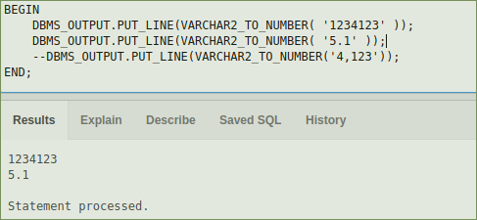

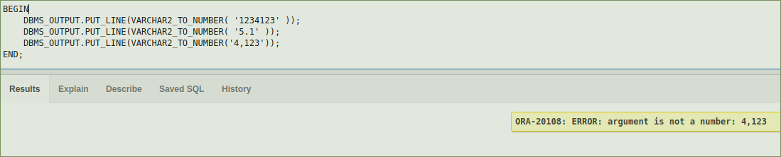

**PLSQL8**

**--Лоточная торговля книгами**

**--Триггер должен препятствовать удалению продавца, если остаток книг,**

**числящийся за этим продавцом, не пуст**.

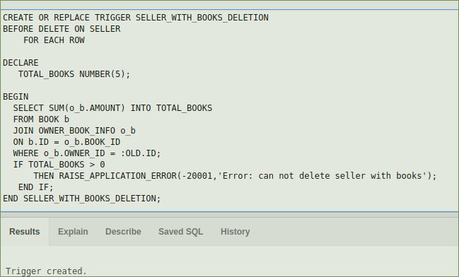

CREATE OR REPLACE TRIGGER SELLER_WITH_BOOKS_DELETION

BEFORE DELETE ON SELLER

FOR EACH ROW

DECLARE

TOTAL_BOOKS NUMBER(5);

BEGIN

SELECT SUM(o_b.AMOUNT) INTO TOTAL_BOOKS

FROM BOOK b

JOIN OWNER_BOOK_INFO o_b

ON b.ID = o_b.BOOK_ID

WHERE o_b.OWNER_ID = :OLD.ID;

IF TOTAL_BOOKS > 0

THEN RAISE_APPLICATION_ERROR(-20001,'Error: can not delete seller with books');

END IF;

END SELLER_WITH_BOOKS_DELETION;

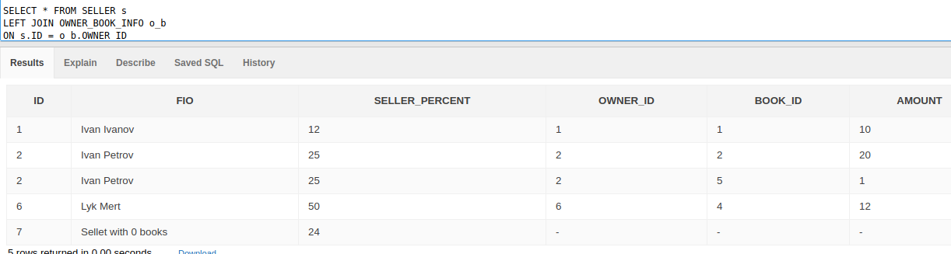

SELECT * FROM SELLER s

LEFT JOIN OWNER_BOOK_INFO o_b

ON s.ID = o_b.OWNER_ID

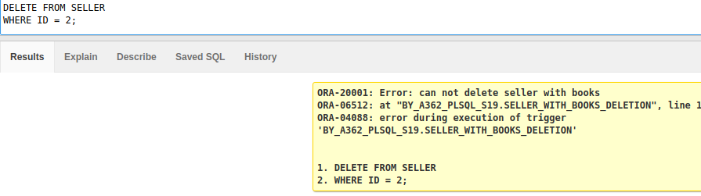

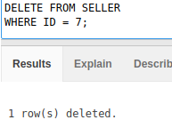

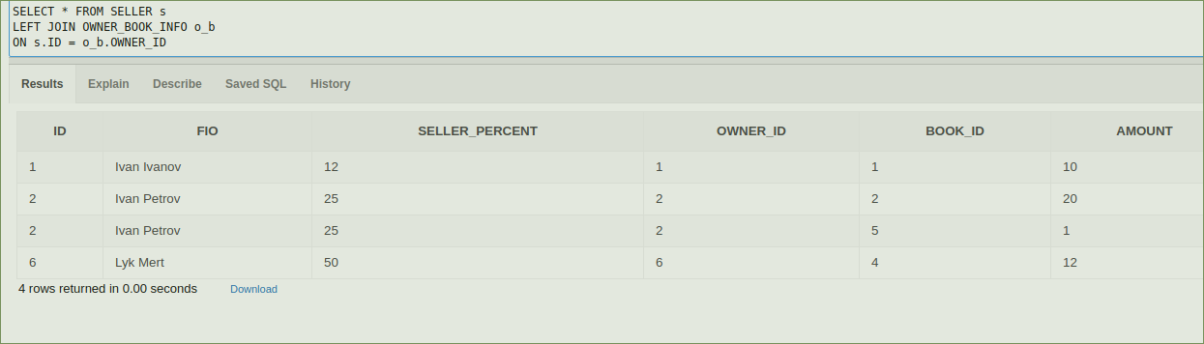

SELECT VARCHAR2_TO_NUMBER(str) AS NUMBER_FROM_VARCHAR FROM VARCHAR_NUMBER