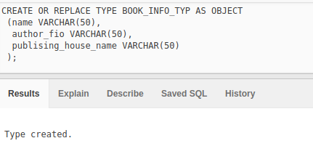

CREATE TABLE BOOK_INFO_OBJ_TABLE of BOOK_INFO_TYP;

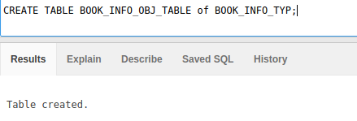

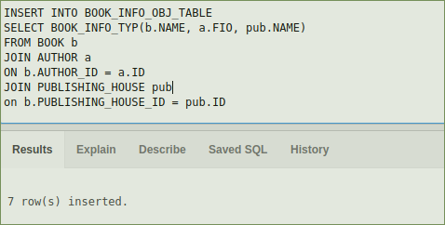

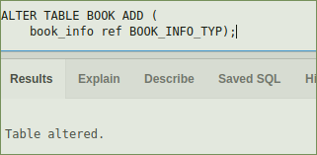

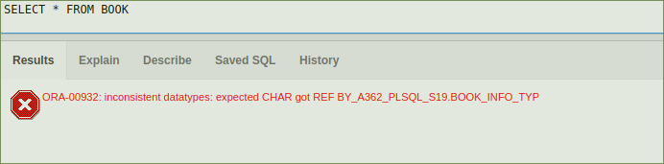

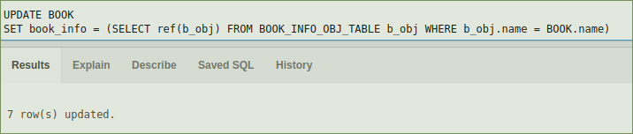

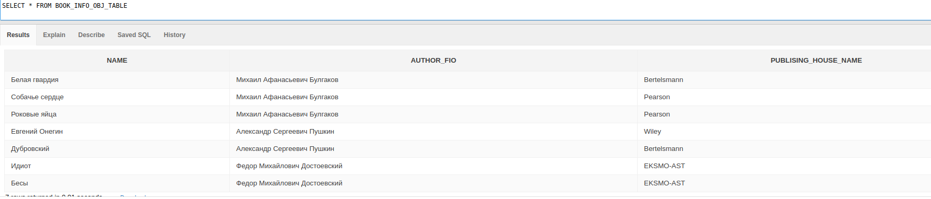

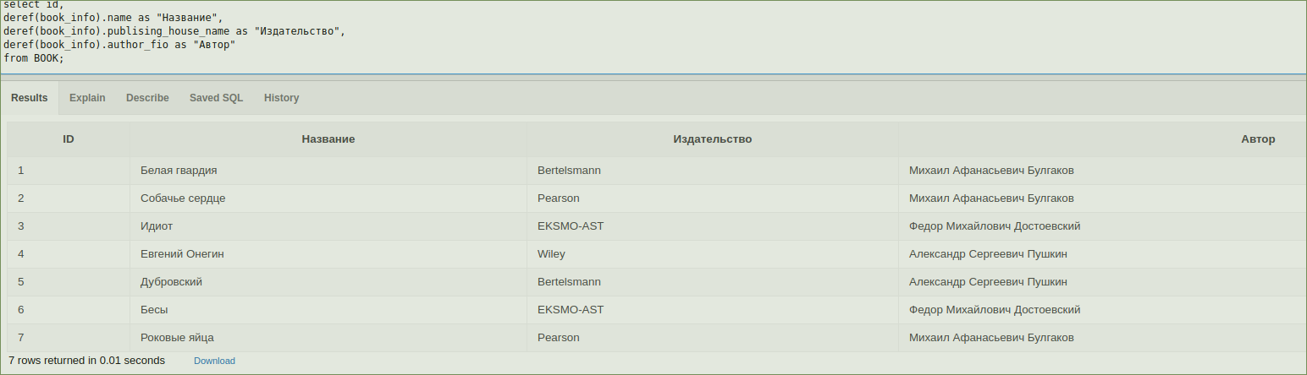

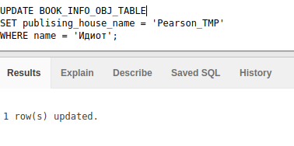

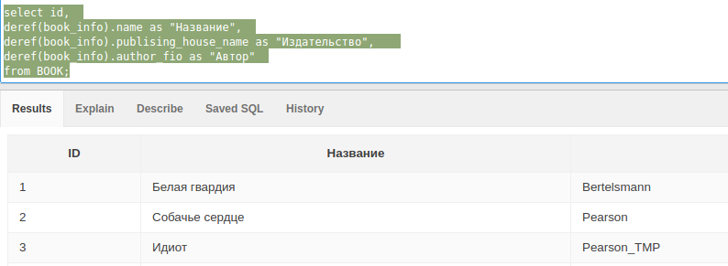

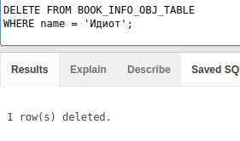

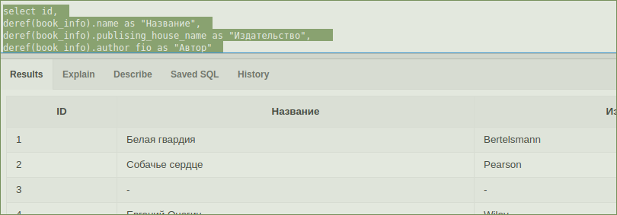

DROP TABLE BOOK_INFO_OBJ_TABLE;

DROP TABLE BOOK_INFO_REF_TABLE;

CREATE OR REPLACE TYPE BOOK_INFO_TYP AS OBJECT

(name VARCHAR(60),

author_fio VARCHAR(60),

publising_house_name VARCHAR(60)

);

CREATE TABLE BOOK_INFO_OBJ_TABLE of BOOK_INFO_TYP;

SELECT * FROM BOOK

INSERT INTO BOOK_INFO_OBJ_TABLE

SELECT BOOK_INFO_TYP(b.NAME, a.FIO, pub.NAME)

FROM BOOK b

JOIN AUTHOR a

ON b.AUTHOR_ID = a.ID

JOIN PUBLISHING_HOUSE pub

on b.PUBLISHING_HOUSE_ID = pub.ID

ALTER TABLE BOOK ADD (

book_info ref BOOK_INFO_TYP);

UPDATE BOOK

SET book_info = (SELECT ref(b_obj) FROM BOOK_INFO_OBJ_TABLE b_obj WHERE b_obj.name = BOOK.name)

SELECT * FROM BOOK_INFO_OBJ_TABLE

select id,

deref(book_info).name as "Название",

deref(book_info).publising_house_name as "Издательство",

deref(book_info).author_fio as "Автор"

from BOOK;

UPDATE BOOK_INFO_OBJ_TABLE

SET publising_house_name = 'Pearson_TMP'

WHERE name = 'Идиот';

DELETE FROM BOOK_INFO_OBJ_TABLE

WHERE name = 'Идиот';