BWA Supplies Pty Ltd (ACN 654 926 691) Trading as Builders Warehouse Australia
ABN 30 654 926 691


Showroom & Office - 214 High St, Cranbourne. 3977 www.builderswarehouseaustralia.com.au
Tel: 03 8764 9142

Contact: Michaella Guerrieri
COMMERCIAL QUOTATION
QUOTE NUMBER: |  |  |  |  |  |  |  | Q 278-25
DATE: |  | 30TH OCTOBER 2025 |  |  | QUOTE VALID: |  | 30TH NOVEMBER 2025
 |  |  |  |  | PROJECT
Contact Name: Company: Address:  Tel Number: |  | BAQIR |  |  | Reference:
 |  | PD CON |  |  | Address: | 23 CASERTA DVE
 |  |  |  |  |  | BERWICK
 |  | 0408 255 259 |  |  | Email: | baqir@pdcon.com
QTY | Product Code |  | Product Name | Picture | Dimension |  | Unit Price (EX GST) | Total Price
 | VANITY OPTIONS
1 | BWA O2 HAMPSHIRE 1800 |  | Hampshire 1800mm Satin White Wall Hung Curve Vanity with Stone Top | 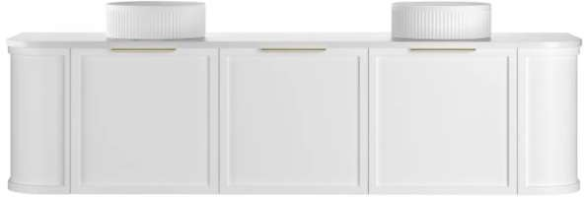 | STONE TOP OPTIONS    HANDLE OPTIONS  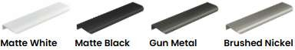 |  | $ 2,132.73 | $ 2,132.73
4 | BWA O3 HAMPSHIRE 1200 |  | Hampshire 1200mm Satin White Wall Hung Curve Vanity with Stone Top | 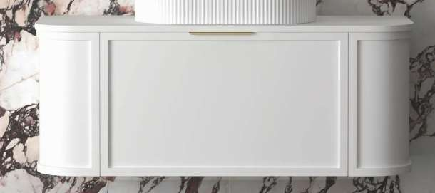 | STONE TOP OPTIONS  HANDLE OPTIONS |  | $ 1,054.09 | $ 4,216.36
1 | BWA A8 CWH66- 1500DWM |  | Plateau wall hung Matt White 1500mm Double Bowl Vanity with Stone Top & Brushed Gold Handles | 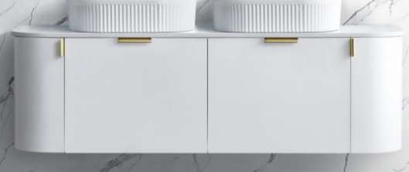 | Stone Top Available in 4 Colours  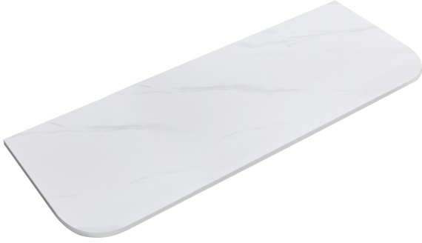  Handle Options  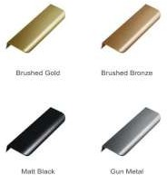 |  | $ 1,370.45 | $ 1,370.45
1 | BWA A8 CWH66- 1200WM |  | Plateau wall hung matt white 1200mm with Stone Top & Brushed Gold Handles | 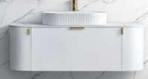 | Stone Top Available in 4 Colours  Handle Options |  | $ 1,077.27 | $ 1,077.27
3 | BWA A8 CWH66- 900WM |  | Plateau wall hung Matt White 900mm Vanity with Stone Top & Brushed Gold Handles |  | Stone Top Available in 4 Colours  Handle Options |  | $ 844.77 | $ 2,534.32
 | BASINS
6 | TBC |  | BASINS |  |  |  |  | $ -
6 | TBC |  | POP UP WASTE |  |  |  |  | $ -

QTY | Product Code | Product Name | Picture | Dimension | Unit Price (EX GST) | Total Price
 | TAPWARE & ACCESSORIES
2 | BWA J1 JTV08PBB | VENEZIA SWIVEL BATH SPOUT BRUSHED BRASS | 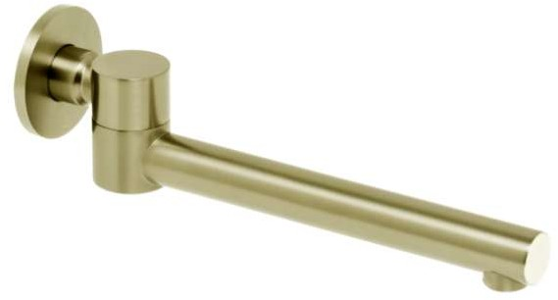 |  | $ 112.73 | $ 225.45
6 | BWA J1 JTV02PBB | VENEZIA BATH SPOUT BRUSHED BRASS | 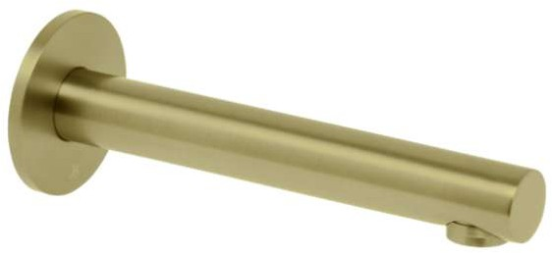 |  | $ 112.73 | $ 676.36
1 | BWA E1 SH G004 | DOCCIA 600MM ROUND CEILING DROPPER | 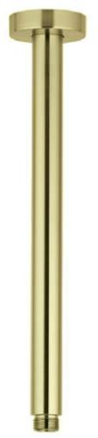 |  | $ 51.77 | $ 51.77
1 | BWA E1 SH RS300 | DOCCIA 300MM ROUND SHOWER HEAD | 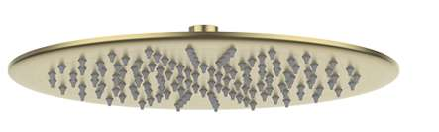 |  | $ 180.00 | $ 180.00
1 | BWA J1 JTV18PBB | VENEZIA HAND SHOWER WITH WALL BRACKET BRUSHED BRASS | 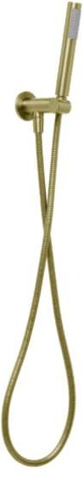 |  | $ 201.18 | $ 201.18
4 | BWA J1 JTV12PBB.JTV09PBB | VENEZIA OVERHEAD RAIN SHOWER WITH 300MM WALL ARM BRUSHED BRASS | 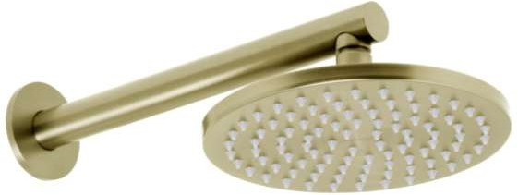 |  | $ 261.91 | $ 1,047.64
1 | BWA E1 WT700BB | JESS FLOOR STANDING BATH FILLER BRUSHED BRASS | 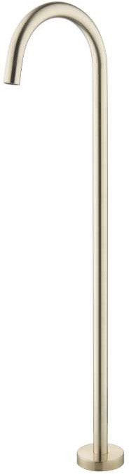 |  | $ 232.50 | $ 232.50
15 | BWA J1 JTV705PBB.UB | VENEZIA MIXER COMPLETE KIT BRUSHED GOLD | 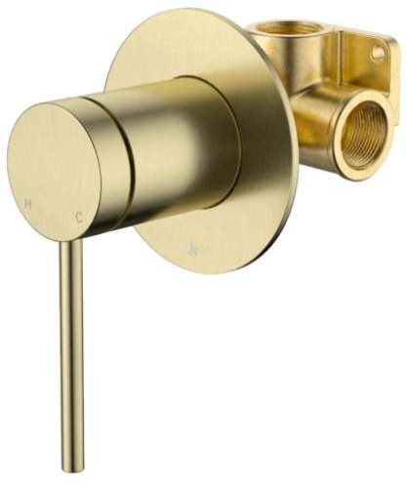 |  | $ 146.50 | $ 2,197.50
5 | BWA J1 JACV111PBB | VENEZIA TOILET ROLL HOLDER BRUSHED BRASS | 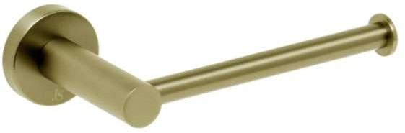 |  | $ 37.82 | $ 189.09
 | TOILETS
1 | BWA Z1 JAVA- 3178SBG | JAVA IN WALL CISTERN WITH SQUARE GOLD BUTTONS | 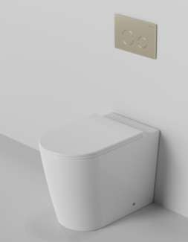 | 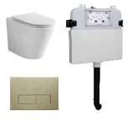 | $ 718.50 | $ 718.50
4 | BWA Z1 MB021 | SANDRA BACK TO WALL TOILET WITH GOLD BUTTONS | 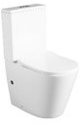 |  | $ 330.00 | $ 1,320.00

QTY | Product Code | Product Name | Picture | Dimension | Unit Price (EX GST) | Total Price
4 | BWA Z1 A3626BG-B | SQUARE GOLD BUTTONS TO SUIT SANDRA BTW TOILET SUITE | 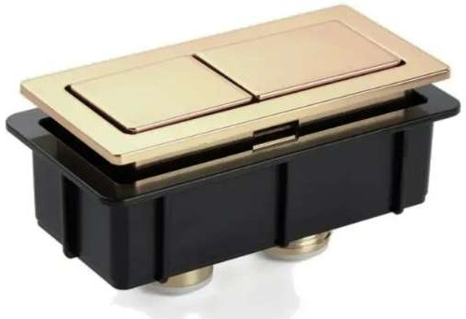 |  | $ 22.50 | $ 90.00
 | BATHS
1 | BWA C1 MWBT-5- 1700 | STELLA FREESTANDING BATH MATT 1700MM (NO OVERFLOW) | 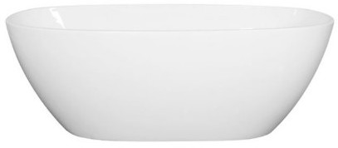 |  | $ 1,200.00 | $ 1,200.00
1 | BWA C1 MWBT-5- 1500 | STELLA FREESTANDING BATH MATT 1500MM (NO OVERFLOW) |  |  | $ 1,125.00 | $ 1,125.00
2 | BWA J1 PW8PBB | BATH PLUG & WASTE 40MM POP- DOWN INCL CONNECTOR BRUSHED BRASS | 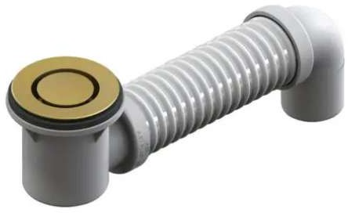 |  | $ 176.41 | $ 352.82
Cost of Goods:  NB: DELIVERY FEE IS NOT INCLUDED IN THIS QUOTATION  PLUS GST:  TOTAL: |  |  |  |  | $21,138.95  $2,113.90
 |  |  |  |  | $23,252.85

Please refer to Builders Warehouse Australia (BWA) Terms & Conditions Of Sale
BWA will not accept any responsibility for quantity calculations. Quantities must be confirmed by a qualified tradesman
Payment Terms: Due and payable prior to receiving goods Electronic Funds Transfer details:
BSB: 013542 - Account: 430892002 - Account Name: Builders Warehouse Australia

